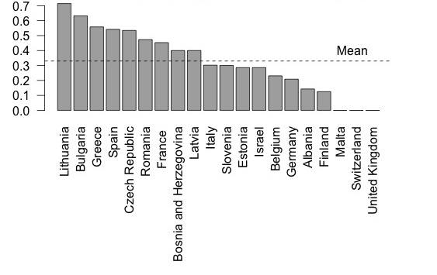

Figure S1: Country percentages of respondents undertaking psychotherapy training on own initiative.

