Nonlinear modulation of interacting between COMT and depression on brain function
This supplemental materials include:
Supplemental Table 1
Supplemental Fig. 1-4

Supplemental Table 1. Brain areas with significant disease effect on global functional connectivity density.

Brain regions | Brodmann area | Cluster size (voxels) | MNI coordinates (x, y, z) | Peak F-score
Left rectal gyrus | 11 | 88 | -6, 33, -24 | 13.96
Left fusiform gyrus | 37 | 71 | -45, -39, -18 | 29.64
Right fusiform gyrus | 37 | 67 | 45, -39, -12 | 25.16
Left superior temporal gyrus | 38 | 60 | -54, 3, -9 | 18.92
Right postcentral gyrus | 3 | 84 | 36, -24, 45 | 19.73
Left postcentral gyrus | 3 | 93 | -18, -33, 66 | 17.97
Right precentral gyrus | 4 | 80 | 21, -39, 60 | 16.89
Right ventrolateral prefrontal cortex | 10 | 47 | 33, 57, -6 | 12.94

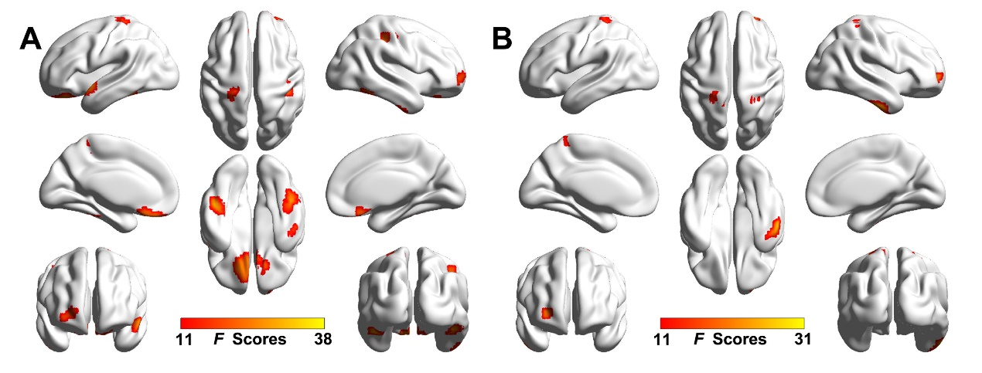
Supplemental Fig 1. The group differences of global FCD between CN and MDD groups at the connection thresholds at 0.5 (A) and 0.7 (B) (3dClustSim correction, p < 0.001). Abbreviations: FCD, functional connectivity density; CN, cognitively normal; MDD, major depressive disorder.
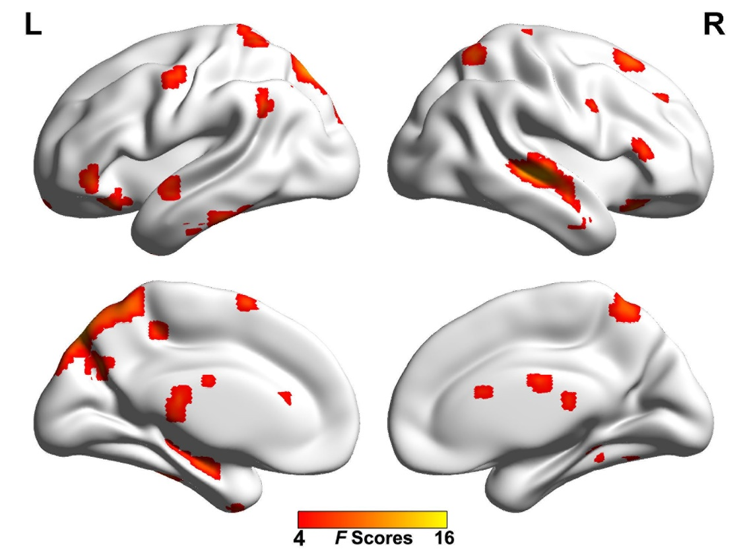
Supplemental Fig. 2. The main effect of COMT on global functional connectivity density at the connection thresholds at 0.6 (p < 0.05, uncorrected)

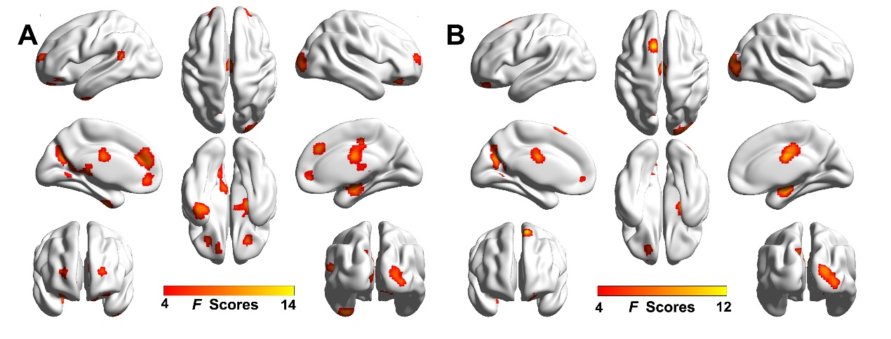
Supplemental Fig. 3. The Disease × COMT interaction effects on global functional connectivity density with the connection threshold of 0.5 (A) and 0.7 (B). (3dCulstSim correction, p < 0.05).
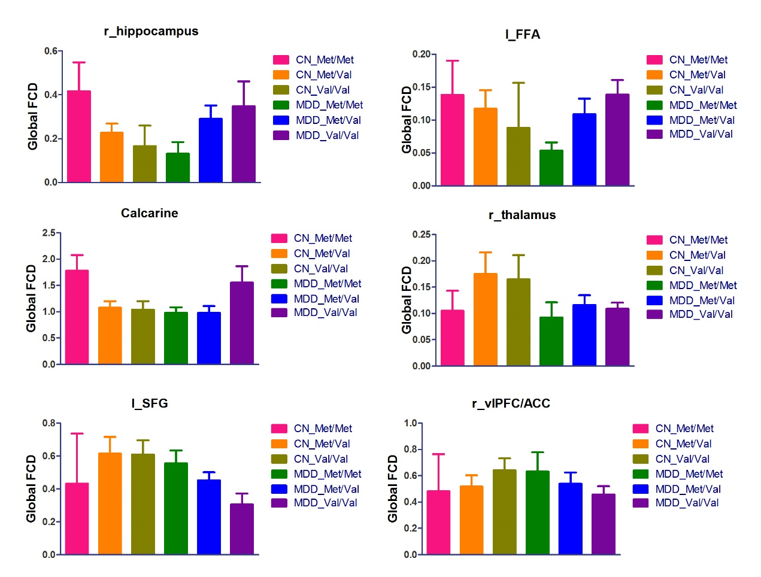
Supplemental Fig. 4. The modulation pattern of gFCD in different brain regions by the presumed dopamine signaling from high to low. Abbreviation: CN, cognitively normal; MDD, major depressive disorder; gFCD, global functional connectivity density. l_FFA, left fusiform area; l_SFG, left superior frontal gyrus; r_vlPFC/ACC, right ventrolateral prefrontal cortex / anterior cingulate cortex.

