Supplementary information
Resting-state functional connectivity of emotion regulation networks in euthymic and non-euthymic bipolar disorder patients

Gwladys Rey, Camille Piguet, Andrea Benders, Sophie Favre, Simon B. Eickhoff, Jean-Michel Aubry, Patrik Vuilleumier

This material supplements but does not replace the content of the peer-reviewed paper published in European Psychiatry

Data acquisition

The Blood Oxygenation Level Dependent (BOLD) contrast was evaluated using a T2*-weighted echo-planar sequence (EPI). Two hundred and fifty resting-state EPI volumes of 36 axial slices each (TR/TE/flip angle=2100 ms/30 ms/80°, FOV=192 mm, resolution=64×64, 3.2 mm isotropic voxels, distance factor 20%) were acquired for each participant, as well as one high-resolution T1-weighted anatomical image (TR/TI/TE/flip angle=1900 ms/900 ms/2.27 ms/9°, FOV=230mm, resolution=256×256, slice thickness=0.9 mm, 192 sagittal slices). During the resting-state functional acquisition, which lasted 9 min., participants were instructed to keep their eyes closed and let their mind wander without falling asleep.
Table S1. Psychometric evaluations in the non-euthymic group of patients depending on mood.

Scale | Hypomanic (n=3) |  | Depressed (n=7) |  |  | Mixed state (n=2)
MADRS-S | 4.8 | ±1.6 |  | 13.5 | ±1.2 | 7.1 | ±2.7
YMRS | 9.3 | ±2.1 |  | 1.7 | ±1.6 | 5.5 | ±0.7
BAI | 12.3 | ±11.0 |  | 14.6 | ±8.9 | 6.5 | ±4.9
RRS | 49.3 | ±10.4 |  | 61.3 | ±10.4 | 56.5 | ±2.1
RRS-Brooding | 12.3 | ±3.5 |  | 13.0 | ±3.4 | 13.3 | ±0.4
RRS-Reflection | 7.7 | ±3.1 |  | 13.4 | ±3.9 | 14.0 | ±1.4
RRS-Depression | 29.3 | ±7.8 |  | 36.4 | ±8.6 | 32.0 | ±0.0

Figure S2. Location of the seed ROIs. Left panel: bilateral VLPFC, sgACC and amygdala; middle panel: PCC and MPFC, right panel: bilateral amygdala.
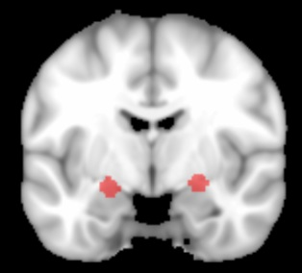
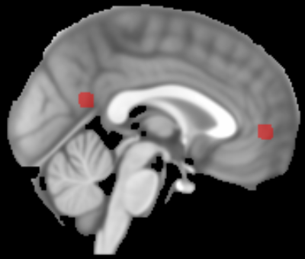
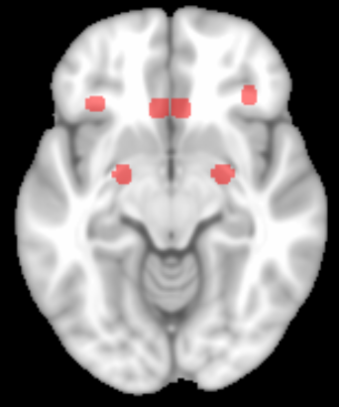
L
R

Figure S3. Functional connectivity (Z score) between the R amygdala and L sgACC in non-euthymic patients (NE) –depressed or non-depressed, and in matched-controls (HC_{NE}).

Figure S4

a) L sgACC-L amygdala FC values as a function of brooding scores in non-euthymic patients, with mood defined as depressed or non-depressed (hypomanic or mixed), and corresponding linear regressions.

b) L sgACC-PCC FC values as a function of brooding scores in non-euthymic patients and corresponding linear regressions.

