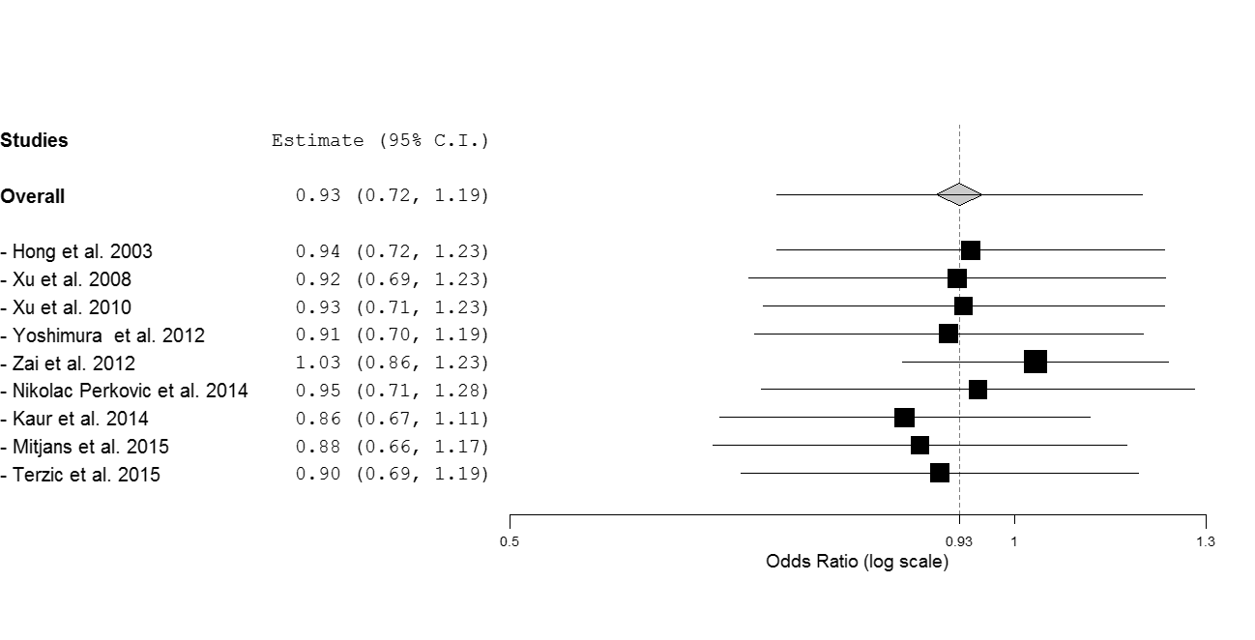
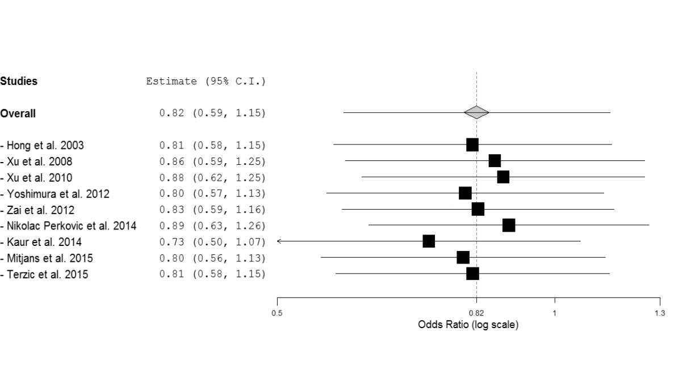
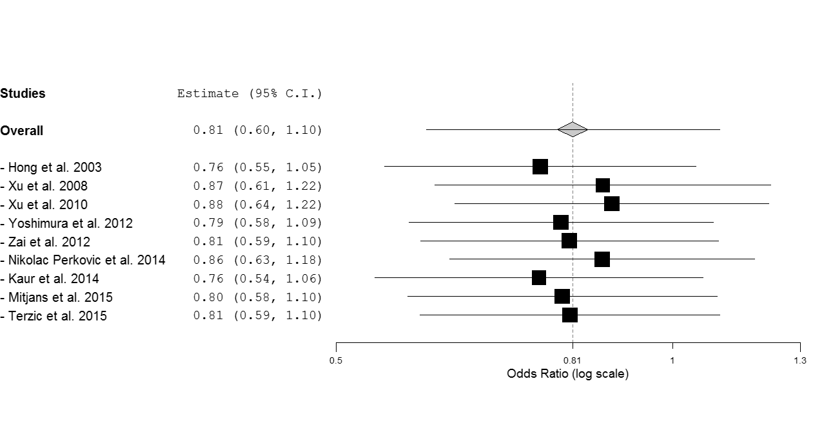
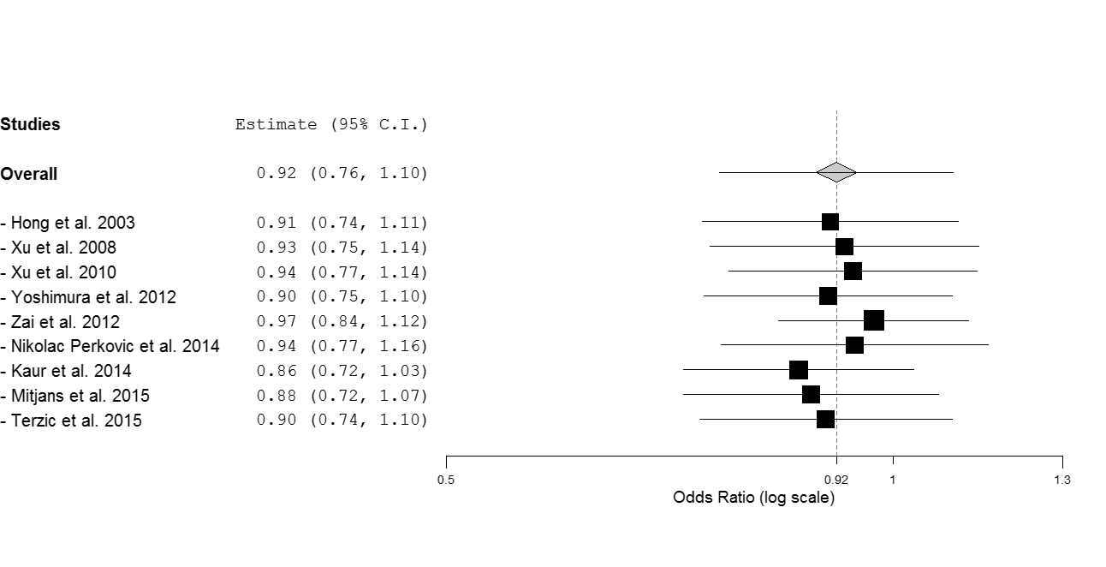
Supplemental Figure 1. Leave-one-out sensitivity analysis of the association between rs6265 and response to antipsychotics, by excluding individual studies one at a time and recalculating the pooled odds ratio estimates for the remaining studies. A) Dominant contrast: G/A+A/A vs G/G; B) codominant contrast: A/A vs G/G; C) recessive contrast: A/A vs G/A+G/G; D) allelic contrast: A vs G. Pooled estimates (odds ratio) are from the random-effects model.
A
B
C
D

