Supplemenary Materials

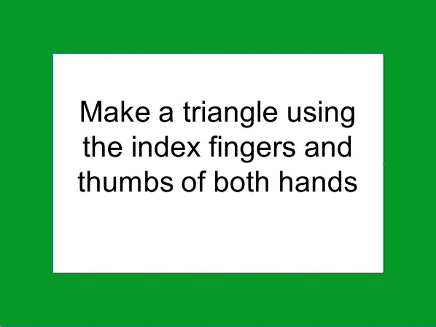

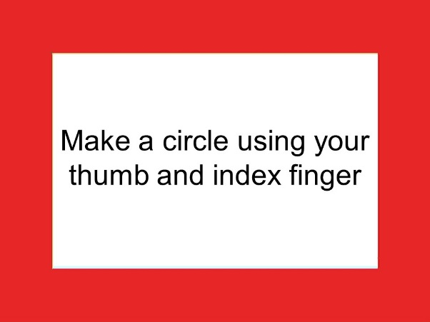

Fig 1. The Acton Memory Task – stimuli examples.
Note: stimulus in green frames had to be performed; stimulus in red frames had to be imagined.

Table 1. Correlations between old/new recognition in self-monitoring and symptoms severity.
 | Positive symptoms | Negative symptoms | Affect | Resistance | Activation | BPRS total scores
Correctly recognized new actions | 0.04 | 0.09 | 0.06 | - 0.01 | - 0.27 | - 0.01
Performed actions recognized as new | -0.03 | - 0.13 | 0.02 | 0.11 | - 0.04 | 0.06
Imagined actions recognized as new | 0.08 | - 0.10 | 0.13 | 0.12 | 0.11 | 0.12
% of hits | - 0.04 | 0.13 | - 0.10 | - 0.14 | - 0.06 | - 0.11
% of false alarms | 0.02 | - 0.10 | - 0.04 | 0.02 | 0.22 | 0.02
d’ | - 0.02 | 0.07 | - 0.03 | - 0.10 | 0.07 | - 0.12
C | - 0.01 | 0.01 | 0.04 | 0.01 | - 0.20 | - 0.04
Note: d’ and C indexes were calculated according to the signal detection theory. Higher values of d’ denote higher sensitivity to recognize old actions. higher (positive) values of the C index refer to a tendency to respond ‘new action’

Table 2. Correlations between self-monitoring judgments and symptoms severity.
 | Positive symptoms | Negative symptoms | Affect | Resistance | Activation | BPRS total scores
Correctly recognized imagined actions | - 0.08 | 0.17 | - 0.16 | - 0.16 | - 0.08 | - 0.15
Correctly recognized performed actions | 0.07 | 0.18 | 0.06 | - 0.08 | - 0.02 | 0.01
Imagined actions recognized as performed | 0.05 | - 0.17 | 0.13 | 0.14 | - 0.01 | 0.12
Performed actions recognized imagined | - 0.08 | - 0.15 | - 0.11 | 0.01 | 0.06 | - 0.06

Table 3. Correlations between confidence indexes and symptoms severity.
 | Positive symptoms | Negative symptoms | Affect | Resistance | Activation | BPRS total scores
KCI | - 0.01 | - 0.14 | 0.01 | 0.07 | 0.05 | 0.05
Confidence Gap | 0.02 | 0.20 | -0.02 | - 0.07 | - 0.07 | - 0.04
Note: KCI – knowledge corrupt index (the proportion of failure self-monitoring responses that were followed by a high degree of confidence (‘sure’) to all other responses given with high confidence). Confidence Gap - the difference score between correct high confidence responses and incorrect high confidence responses

