eTable1. TRIPOD checklist
Section/Topic | Item | Development  Or Validation? | Checklist item
Title and abstract
Title | 1 | D;V | The study is identified as developing a prediction model (including clinical variables) in a clinical high risk for psychosis (CHR-P) Polish cohort. The outcome is identified as transition from CHR-P to full blown psychosis
Abstract | 2 | D;V | A summary of objectives, study design, settings, participants, sample size, predictors, outcome, statistical analysis, results and conclusions is provided
Introduction
Background and objectives | 3a | D;V | The medical context and rationale for developing the model including references to existing models is described.  In order to improve the prognostic accuracy for CHR-P individuals, innovative risk estimation tools are required which are universally valid
 | 3b | D;V | The objective of the study is specified as developing a clinically-based risk estimation model that could refine the ability of the clinician to predict the onset of psychosis in Polish CHR-P individuals
Methods
Source of data | 4a | D;V | The study is specified as a prospective cohort study (cohort of Polish CHR-P individuals)
 | 4b | D;V | The key study dates, including start and end of accrual (March 2010 - July 2015) as well as end of follow-up (May 2017) are specified
Participants | 5a | D;V | Study settings are briefly described. The study was contacted in the Programme of Recognition and Therapy (PORT) affiliated with the Medical University of Lodz. Detailed information regarding the PORT has been published previously (references provided)
 | 5b | D;V | The eligibility criterion for participants was to meet the criteria of CHR-P for psychosis according to the Comprehensive Assessment of At Risk Mental State- CAARMS/2006. Exclusion criteria are also provided
 | 5c | D;V | Treatment applied in the sample is described.  No standardised treatment was provided for participants but only needs-based interventions. Antidepressants, mood stabilizers and antipsychotic medications (in strictly defined clinical situations) were used in the sample
Outcome | 6a | D;V | The outcome predicted in the study was transition from a CHR-P to psychotic disorder which was determined on the basis of CAARMS criteria for psychosis threshold and evaluated at the end of the follow-up period
 | 6b | D;V | Subsequent follow-up assessments were performed by clinicians who were blind to the baseline evaluation of predictors
Predictors | 7a | D;V | Predictors included in the model were preselected on the basis of existing clinical knowledge, as currently recommended. The number of predictors was a priori limited to two, to allow an event per variable (EPV) ratio of 10 and above, which is recommended to develop robust prognostic models. The rationale for selection was described in detail in the Results section. Preselected predictors were: disorganized speech (DS) and unusual thought content (UTC). Both parameters were measured at baseline with CAARMS.
 | 7b | D;V | Baseline and follow-up assessments with CAARMS were carried out by different clinicians. Both were blind to the results of their evaluations
Sample size | 8 | D;V | Study participants were 105 individuals subsequently referred to the PORT between March 2010 and July 2015
Missing data | 9 | D;V | There was no missing data in the study
Statistical analysis methods | 10a | D | Predictors were treated as continuous variables which ranged between 0 and 6. Predictors proved to be non-collinear
 | 10b | D | Model building procedures included:  - A priori selected variables based on literature review  - The model was developed on the dataset after Synthetic Minority Over-sampling Technique  -Time-to-event model developed with Cox proportional hazard method  -The model was internally validated on 1000 bootstrap resamples
 | 10c | V | The model was internally validated on 1000 bootstrap resamples
 | 10d | D;V | Measures used to assess model’s performance included:  -Harrell's concordance index,  -Receiver-operating characteristics (ROC) curves in a function of time,  -Calibration of the model (calibration plots) with optimism correction
 | 10e | V | Non-applicable
Risk groups | 11 | D;V | Non-applicable
Development vs validation | 12 | V | Non-applicable: for this study only internal validation on the original dataset was performed
Results
Participants | 13a | D;V | The median follow-up period for the entire sample was 36 months (IQR: 10-59 months; mean time: 35.4 ± 25.0 months). The outcome rates in subsequent time points (24 and 12, 36 and 48 months) are presented.
 | 13b | D;V | Basic demographic and clinical characteristics of participants are presented in Table 1.
 | 13c | V | Non-applicable
Model development | 14a | D | 105 individuals participated in the study, 20 transitioned to psychosis
 | 14b | D | Non-applicable (only adjusted associations were calculated)
Model specification | 15a | D | The prediction model was presented as:  -Hazard ratios with 95% CI -Risk calculator for estimation of the likelihood of transition
 | 15b | D | Based on the model, an algorithm was generated allowing the probability of transition from a CHR-P to psychosis to be estimated. The risk calculator is provided
Model performance | 16 | D;V | Performance measures included:  -Harrell’s concordance index (c-index)  -Receiver-operating characteristics (ROC) curves against time with sensitivity, specificity, accuracy and AUCs for subsequent time points (Figure 1)  -Internal validation with 1000 bootstrap resamples: calibration plots with a correction for optimism (Figure 2)
Model updating | 17 | V | C- index for the model is established as high (0.79) and its performance is satisfactory (Figure1)  Consistency between the observed probabilities and the model-predicted probabilities derived from 1000 bootstrap resamples is high (Figure2)
Discussion
Limitations | 18 | D;V | Limitations of the study are discussed
Interpretation | 19a | V | Non-applicable
 | 19b | D;V | An overall interpretation of the results with references to similar studies is presented
Implications | 20 | D;V | The potential clinical use of the model and implications for future research are discussed
Other information
Supplementary information | 21 | D;V | Supplementary data includes:  -Schoenfeld residuals plot confirming assumptions of Cox modelling for both preselected predictors (Suppl. Figure 1)  - Results of the proportional hazard assumption test for a Cox regression model fit (Suppl. Table 1)  Web risk calculator is available at: https://link.konsta.com.pl/psychosis
Funding | 22 | D;V | Funding source is specified

eTable2. Detailed sociodemographic and clinical characteristics of the clinical high risk for psychosis sample (N=105).

Characteristic | Median (25th-75th percentile) or  Number (proportion)
Age (years)  Mean ± SD | 18 (16-20)  18.8 ± 3.5
Gender (male/female) | 49 (46.7%) / 56 (53.3%)
Education (years)  Mean ± SD | 11 (9-12)  10.6 ± 2.4
Occupation
Student | 78 (74.3%)
Employed | 20 (19.0%)
No educationally/vocationally active | 7 (6.7%)
First-degree relative with psychotic disorder | 17 (16.2%)
Intake group
APS only | 63 (60.0%)
BLIPS only | 3 (2.9%)
GRD only | 20 (19.0%)
APS plus GRD | 18 (17.1%)
BLIPS plus GRD | 1 (1.0%)
CAARMS severity score
Positive symptoms
Unusual thought content | 3 (0-4)
Non-bizarre ideas | 3 (0-4)
Perceptual abnormalities | 0 (0-4)
Disorganized speech | 2 (0-3)
Subjective cognitive change | 4 (2-4)
Observed cognitive change | 2 (1-3)
Emotional disturbance
Subjective emotional disturbance | 3 (0-4)
Observed blunted affect | 3 (2-4)
Observed inappropriate affect | 0 (0-0)
Negative symptoms
Alogia | 2 (1-4)
Avolition/Apathy | 4 (2-5)
Anhedonia | 4 (3-5)
Behavioural change
Social isolation | 4 (3-4)
Impaired role function | 4 (3-5)
Disorganised/Odd behaviour | 2 (0-3)
Aggression/Dangerous behaviour | 2 (0-3)
Motor/physical changes
Subjective motor change | 0 (0-2)
Observed changes in motor functioning | 0 (0-1)
Subjective complaints of impaired bodily sensations | 0 (0-0)
Subjective complaints of impaired autonomic functioning | 0 (0-3)
General psychopathology
Mania | 0 (0-0)
Depression | 3 (2-4)
Suicidality and self harm | 2 (0-3)
Mood swings/Lability | 0 (0-2)
Anxiety | 3 (2-4)
OCD symptoms | 0 (0-0)
Dissociative symptoms | 0 (0-2)
Impaired tolerance to normal stress | 4 (3-4)
Fulfilling APS criteria
Unusual thought content | 57 (54.3%)
Non-bizarre ideas | 63 (60.0%)
Perceptual abnormalities | 41 (39.0%)
Disorganized speech | 11 (10.5%)
SOFAS score  Mean ± SD | 50 (45-55)  49.4 ± 7.6
IQ | 106 (98-112)
Mean ± SD | 104.7 ± 14.3
DSM – IV comorbid disorder
Depression only | 30 (28.6%)
Anxiety only | 15 (14.3%)
Depression/Anxiety | 7 (6.7%)
Conduct | 3 (2.9%)
Conduct/Depression | 9 (8.6%)
Bipolar | 2 (1.9%)
Body Dysmorphic | 1 (1.0%)
No Axis-I comorbid disorder | 38 (36.2%)
Personality
Schizotypal | 23 (21.9%)
Borderline | 4 (3.8%)
Mixed | 5 (4.8%)
Use of psychoactive substances | 14 (13.3%)
Medication
Antipsychotic (all atypical) | 24 (22.9%)
Antidepressant (SSRI) | 41 (39.0%)
Mood stabilizer | 4 (3.8%)

APS - attenuated psychotic symptoms;
BLIPS - brief limited intermittent psychotic symptoms;
CAARMS - Comprehensive Assessment of At Risk Mental States;
GRD - genetic risk and deterioration syndrome;
IQ: intelligence quotient;
SOFAS - Social and Occupational Functioning Assessment Scale.

eTable 3. Results of the proportional hazards assumption test for a Cox regression model fit. P-values higher than 0.05 show that modelling met the assumptions.
 | Rho | Chi² | P-value
Unusual thought content | -0.1735 | 1.8670 | 0.172
Disorganized speech | -0.0287 | 0.0538 | 0.817
Global |  | 1.8875 | 0.389

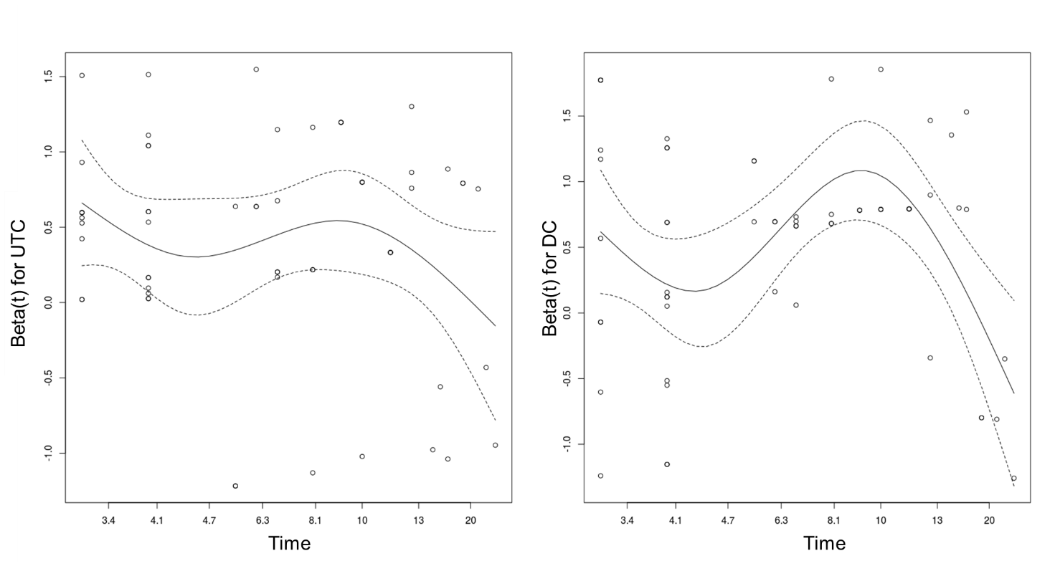
eFigure 1. Schoenfeld residuals plot confirming assumptions of Cox modelling for both unusual thought content (UTC) UTC and Disorganized Communication (DC). Time in months was transformed using classical KM transformation.

