SUPPLEMENTARY APPENDIX A

Table A1. Baseline characteristics of clustering of BD patients based on their mood instability

Baseline characteristics | Cluster 1  “High Instability”  (N=43) | Cluster 2  “Low Instability”  (N=43) | p value¹
Demographical variables
Age at onset - years (mean, SD) | 25.9 (8.0) | 23.3 (7.8) | 0.366
Male sex – (%) | 13 (30.2) | 14 (32.6) | 1.000
Length of follow up (yr) (mean, SD) | 6.0 (2.9) | 5.9 (2.6) | 0.807
Education (mean, SD)  Baseline clinical variables | 14.69 (2.7) | 14.6 (3.5) | 0.849
BD type I – (%) | 18 (39.1) | 28 (60.8) | 0.052
Psychotic symptoms – no. (%) | 20 (47.6) | 25 (59.5) | 0.191
Hospitalizations per yr (mean, SD) | 0.1 (0.2) | 0.1 (0.2) | 0.465
Total number of episodes per yr (mean, SD)* | 1.0 (0.6) | 0.4 (0.4) | <0.001*
TEMPS cyclothimia (mean, SD)* | 10.8 (5.6) | 7.5 (3.7) | 0.043*
Suicide attempts during follow up (mean, SD) | 0.4 (0.6) | 0.3 (0.6) | 0.124
Functional outcomes
GAF total score (mean, SD)  Mood instability variables | 79.1 (11.8) | 83.6 (8.9) | 0.04 *
Mood Instability Factor (mean, SD) | 5.2 (2.4) | 1.7 (1.2) | <0.01*
Max. Weeks in Euthymia (mean, SD) | 7.8 (3.5) | 26.1 (11.2) | <0.01*
- Two-sided p values. Mean values are compared with Student’s T-test and proportions with X² test.
Abbreviations: SD = Standard Deviation, yr= Years, GAF = Global Assessment of Functioning, BD = Bipolar Disorder

Table A2. Mood symptomatology across different clusters

Baseline characteristic | Cluster I  “High Instability”  (N=43) |  | Cluster II  “Low Instability”  (N=43) | p value¹
Follow-up Mood Variables  % time depressive symptoms (mean, SD) | 22.7 (16.4) | 7.5 (7.5) |  | <0.001
% time hypo/manic symptoms (mean, SD) | 7.2 (7.5) | 2.9 (4.3) |  | 0.002
% time mixed symptoms (mean, SD) | 4.4 (5.3) | 1.2 (2.7) |  | 0.001
% time euthymia (mean, SD) | 65.8 (14.3) | 88.4 (7.8) |  | <0.001
% of follow up with sub-syndromal depression (mean, SD)  % of follow up with sub-syndromal mania  (mean, SD)  % of follow up with sub-syndromal mixed  (mean, SD)  % of follow up with mild depressive symptoms (mean, SD) | 14.4 (13.7)  5.1 (5.4)  3.9 (5.0)  6.3 (5.5) | 4.6 (4.4)  1.8 (2.8)  - (2.6)  1.9 (3.4) |  | <0.001  0.001  0.002  <0.001
% of follow up with mild manic symptoms (mean, SD) | 1.4 (1.8) | 0.8 (1.5) |  | 0.06
% of follow up with moderate depressive symptoms (mean, SD) | 1.9 (3.3) | 0.9 (2.6) |  | 0.11
% of follow up with moderate manic symptoms (mean, SD) | 0.6 (1.4) | 0.3 (1.2) |  | 0.42
% of follow up with moderate mixed symptoms (mean, SD) | 0.3 (0.7) | 0.1 (0.3) |  | 0.07
% of follow up with severe depressive symptoms (mean, SD) | 0.1 (0.5) | 0.1 (0.6) |  | 0.98
% of follow up with severe manic symptoms  (mean, SD) | 0.1 (0.3) | 0.0 (0.7) |  | 0.17
% of follow up with severe mixed symptoms  (mean, SD) | 0.2 (1.1) | 0.0 (0.0) |  | 0.07
- Two-sided p values. Mean values are compared with Student’s T-test and proportions with X² test.
Abbreviations: SD = Standard Deviation

Figure A1. Dendogram using Hierarchichal Cluster Analysis to determine appropriate cluster number
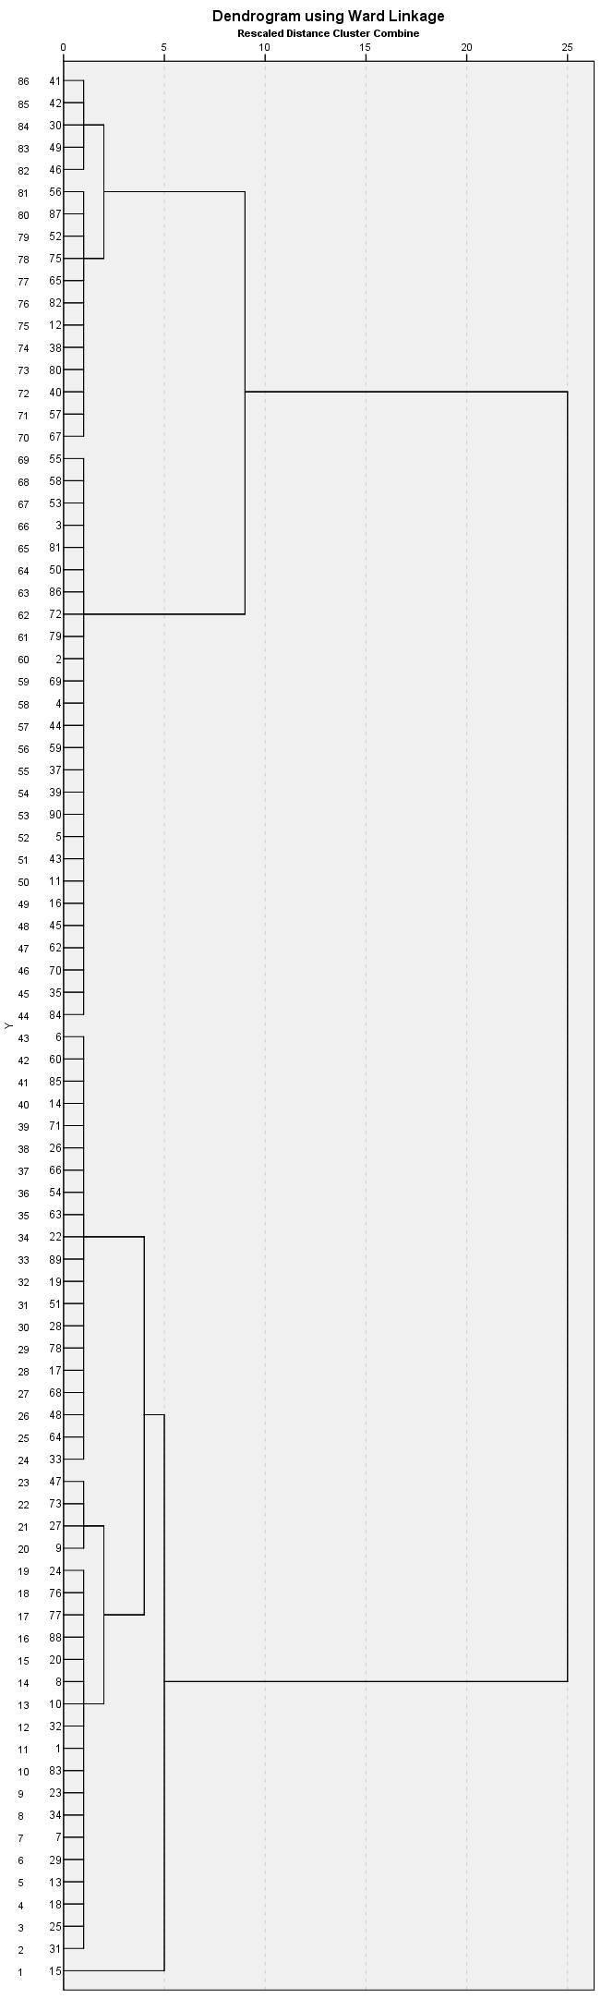
Rows (or leaves) represent individual patients, and branches represent similarities between observations. As we move up, braches begin to merge with each other or with an individual leaf. The earlier the fusion, the more similar those observations are. To identify the optimal number of clusters, we make a vertical cut across the dendogram and observe the resulting clusters. The height of the cut will determine the numbers of clusters. In this case, a two-cluster solution is observed throughout the majority of the axis.
Figure A2. Different combinations of mood instability factor (MIF), subsyndromal density symptoms (SD) and episodic density (ED)

