UNMET NEEDS IN PATIENTS WITH BRIEF PSYCHOTIC DISORDERS: TOO ILL FOR CLINICAL HIGH RISK SERVICES AND NOT ENOUGH ILL FOR FIRST EPISODE SERVICES
Amedeo Minichino, Grazia Rutigliano, Sergio Merlino, Cathy Davies, Dominic Oliver, Andrea De Micheli, Philip McGuire, and Paolo Fusar-Poli
Supplementary Material
eTable 1. The RECORD statement – checklist of items, extended from the STROBE statement, that should be reported in observational studies using routinely collected health data.

eMethods

eResults. Detection and treatment of ATPDs by mental health services: age-based stratification. Long term health outcomes other than transition to persistent psychosis: differences among ATPDs subtypes.

eFigure1. Cumulative incidence (Kaplan-Meier failure function) of discharges from SLaM Treatment over the follow-up period
eFigure2. Cumulative incidence (Kaplan Meier failure function) of discharges from SLaM Treatment teams stratified (Early Intervention Services-EIS vs Others) over the follow-up period
eFigure3. Cumulative incidence (Kaplan Meier failure function) of first antipsychotic prescription over the follow-up period
eFigure4. Antipsychotics (molecules in detail) prescription at the time points of interest

eTable 1. The RECORD statement – checklist of items, extended from the STROBE statement, that should be reported in observational studies using routinely collected health data.

 | Item no. | STROBE items | Location in manuscript where items are reported | RECORD items | Location in manuscript where items are reported
Title and abstract
 | 1 | (a) Indicate the study’s design with a commonly used term in the title or the abstract.  (b) Provide in the abstract an informative and balanced summary of what was done and what was found. | Abstract | RECORD 1.1: The type of data used should be specified in the title or abstract. When possible, the name of the databases used should be included.  RECORD 1.2: If applicable, the geographic region and timeframe within which the study took place should be reported in the title or abstract.  RECORD 1.3: If linkage between databases was conducted for the study, this should be clearly stated in the title or abstract. | Abstract  Abstract  NA
Introduction
Background rationale | 2 | Explain the scientific background and rationale for the investigation being reported. | Introduction
Objectives | 3 | State specific objectives, including any pre-specified hypotheses. | Introduction and Methods (Study Measures)
Methods
Study Design | 4 | Present key elements of study design early in the paper. | Abstract and Methods (Data Source and Study Population)
Setting | 5 | Describe the setting, locations, and relevant dates, including periods of recruitment, exposure, follow-up, and data collection. | Abstract and Methods
Participants | 6 | (a) Cohort study – Give the eligibility criteria, and the sources and methods of selection of participants. Describe methods of follow-up.  Case-control study - Give the eligibility criteria, and the sources and methods of case ascertainment and control selection. Give the rationale for the choice of cases and controls.  Cross-sectional study - Give the eligibility criteria, and the sources and methods of selection of participants.  (b) Cohort study – For matched studies, give matching criteria and number of exposed and unexposed.  Case-control study – For matched studies, give matching criteria and the number of controls per case. | Abstract and Methods  NA  NA  NA  NA | RECORD 6.1: The methods of study population selection (such as codes or algorithms used to identify subjects) should be listed in detail. If this is not possible, an explanation should be provided.  RECORD 6.2: Any validation studies of the codes or algorithms used to select the population should be referenced. If validation was conducted for this study and not published elsewhere, detailed methods and results should be provided.  RECORD 6.3: If the study involved linkage of databases, consider use of a flow diagram or other graphical display to demonstrate the data linkage process, including the number of individuals with linked data at each stage. | Methods (Study Population)  Methods (Data Source) referenced previous publications which used the same codes and algorithms.  NA
Variables | 7 | Clearly define all outcomes, exposures, predictors, potential confounders, and effect modifiers. Give diagnostic criteria, if applicable. | Methods (Study Measures) | RECORD 7.1: A complete list of codes and algorithms used to classify exposures, outcomes, confounders, and effect modifiers should be provided. If these cannot be reported, an explanation should be provided. | Methods (Study Measures)
Data Sources/ measurement | 8 | For each variable of interest, give sources of data and details of methods of assessment (measurement). Describe comparability of assessment methods if there is more than one group. | Methods (Data Source and Study Measures)  NA
Bias | 9 | Describe any efforts to address potential sources of bias | Methods
Study Size | 10 | Explain how the study size was arrived at. | Methods and Results
Quantitative variables | 11 | Explain how quantitative variables were handled in the analyses. If applicable, describe which groupings were chosen, and why. | Methods
Statistical Methods | 12 | (a) Describe all statistical methods, including those used to control for confounding.  (b) Describe any methods used to examine subgroups and interactions.  (c) Explain how missing data were addressed.  (d) Cohort study – If applicable, explain how loss to follow-up was addressed.  Case-control study – If applicable, explain how matching of cases and controls was addressed.  Cross-sectional study – If applicable, describe analytical methods taking account of sampling strategy  (e) Describe any sensitivity analyses | Methods (Statistical Analysis)  Methods (Statistical Analysis)  NA  NA  NA  NA  NA
Data access and cleaning methods |  |  |  | RECORD 12.1: Authors should describe the extent to which the investigators had access to the database population used to create the study population.  RECORD 12.2: Authors should provide information on the data cleaning methods used in the study | Methods (Data Source)  NA
Linkage |  |  |  | RECORD 12.3: State whether the study included person-level, institutional-level, or other linkage across two or more databases. The methods of linkage and the methods of linkage quality evaluation should be provided. | NA
Results
Participants | 13 | (a) Report the numbers of individuals at each stage of the study (e.g., numbers potentially eligible, examined for eligibility, confirmed eligible, included in the study, completing follow-up, and analysed)  (b) Give reasons for non-participation at each stage.  (c) Consider use of a flow diagram | Results  NA  NA | RECORD 13.1: Describe in detail the selection of the persons included in the study (i.e., study population selection) including filtering based on data quality, data availability and linkage. The selection of included persons can be described in the text and/or by means of the study flow diagram. | NA
Descriptive data | 14 | (a) Give characteristics of study participants (e.g., demographic, clinical, social) and information on exposures and potential confounders.  (b) Indicate the number of participants with missing data for each variable of interest.  (c) Cohort study – summarize follow-up time (e.g., average and total amount). | Results  Table 1  Results
Outcome data | 15 | Cohort study – Report numbers of outcome events or summary measures over time.  Case-control study – Report numbers in each exposure category, or summary measures of exposure.  Cross-sectional study – Report numbers of outcome events or summary measures. | Results and Supplementary material  NA  NA
Main Results | 16 | (a) Give unadjusted estimates, and, if applicable, confounder-adjusted estimates and their precision (e.g., 95% CI). Make clear which confounders were adjusted for and why they were included.  (b) Report category boundaries when continuous variables were categorized.  (c) If relevant, consider translating estimates of relative risk into absolute risk for a meaningful time period | Results  NA  NA
Other analyses | 17 | Report other analyses done – e.g., analyses of subgroups and interactions, and sensitivity analyses | Results and supplementary material
Discussion
Key results | 18 | Summarize key results with reference to study objectives | Discussion
Limitations | 19 | Discuss limitations of the study, taking into account sources of potential bias or imprecisions. Discuss both direction and magnitude of any potential bias. | Discussion | RECORD 19.1: Discuss the implications of using data that were not created or collected to answer the specific research question(s). Include discussion of misclassification bias, unmeasured confounding, missing data, and changing eligibility over time, as they pertain to the study being reported. | Discussion
Interpretation | 20 | Give a cautious overall interpretation of results considering objectives, limitations, multiplicity of analyses, results from similar studies, and other relevant evidence. | Discussion
Generalisability | 21 | Discuss the generalizability (external validity) of the study results. | Discussion
Other Information
Funding | 22 | Give the source of funding and the role of the funders for the present study and, if applicable, for the original study on which the present article is based. | Declaration of interest
Accessibility of protocol, raw data, and programming code |  |  |  | RECORD 22.1: Authors should provide information on how to access any supplemental information such as the study protocol, raw data, or programming code. | Supplemental information regarding the data extraction and cleaning is available at the Maudsley Biomedical Reseach Centre

eMethods. Supplementary analyses were performed with log-rank test for survival curves, parametric or non-parametric analyses for continuous variables (depending on the outcome of normality tests), Pearson χ² tests for categorical variables (2-tailed, P < .05). Normality was assessed with the Shapiro-Francia test. Continuous variables are presented as mean ± standard deviation.

eResults. Detection and treatment of ATPDs by mental health services: age-based stratification. Long term health outcomes other than transition to persistent psychosis: differences among ATPDs subtypes.

- Detection and treatment of ATPDs by mental health services: age-based stratification.

The sample was divided into three age-ranges: <18 years old; 18-65 years old; and > 65 years old.
Among the total of 2561 individuals, 232 (9.0%) were <18 years old; 2232 (87.2%) were 18-65 years old; and 97 (3.8%) > 65 years old.

1a. Age-based differences in assessment teams
Data on assessment teams were available on 2561 patients
Among patients <18 years old (N=232), ATPDs were mainly detected by Children and Adolescent mental health services (46.6%, N=105), a tiny minority (6.2%, N=14) by Early Intervention services, the remaining by the other services (48.2%; N=113)
Among patients 18-65 years old (N=2232), ATPDs were mainly detected by Adult Community Mental Health services (39.8%; N=882), Physical Health services (21.5%; N=477); and Accident and Emergency services (16.7%; N=371). Only a tiny minority (8.7%, N=193) were detected by Early Intervention services.
Among patients > 65 years old (N=97), ATPDs were mainly detected by Older Adults Mental Health services (42.3%; N=41) and by Adult Community Mental Health services (24.7%; N=24). None was detected by Early Intervention services.

1b. Age-based differences in treatment teams
Data on treatment teams were available on 2114 patients
Among patients <18 years old (N=179), ATPDs were mainly treated by Children and Adolescent mental health services (48.1%, N=86), a tiny minority (12.8%, N=23) by Early Intervention services, the remaining by the other services (40.1%; N=109)
Among patients 18-65 years old (N=1845), ATPDs were mainly detected by Adult Community Mental Health services (54.4%; N=1004) and a minority (19.4%; N=358) by Early Intervention services.
Among patients > 65 years old (N=90), ATPDs were mainly detected by Older Adults Mental Health services (55.6%; N=50) and by Adult Community Mental Health services (20.0%; N=18). None was detected by Early Intervention services.

- Long term health outcomes other than transition to persistent psychosis: differences among ATPDs subtypes.

Based on previous evidence suggesting different prognostic outcomes between ATPDs with and without symptoms of schizophrenia, the total ATPDs sample (N=2561) was divided in two main subcategories: ATPDs with symptoms of schizophrenia (19.4%; N=497), which included APPD with symptoms of Schizophrenia and Acute Schizophrenia-like Psychotic Disorder (see Table 1 in main manuscript); and ATPDs without symptoms of schizophrenia (80.6%; N=2064), which included the remaining ATPDs categories.
2a. ATPDs with symptoms of schizophrenia (N=497)
The percentage of ATPDs with symptoms of schizophrenia that received at least one mental health hospitalization and one compulsory mental admission (MHA) over 8 years of follow-up were 36.8% (N=183) and 34.8% (N=173), respectively. The mean duration of mental health hospitalization within SLaM was 59.40±197.39 days.
2b. ATPDs without symptoms of schizophrenia (N=2064)
The percentage of ATPDs with symptoms of schizophrenia that received at least one mental health hospitalization and one compulsory mental admission (MHA) over 8 years of follow-up were 31.9% (N=659) and 27.3% (N=558), respectively. The mean duration of mental health hospitalization within SLaM was 68.10±248.52 days.

eFigure1. Cumulative incidence of (Kaplan-Meier failure function) discharges from SLaM Treatment over the follow-up period
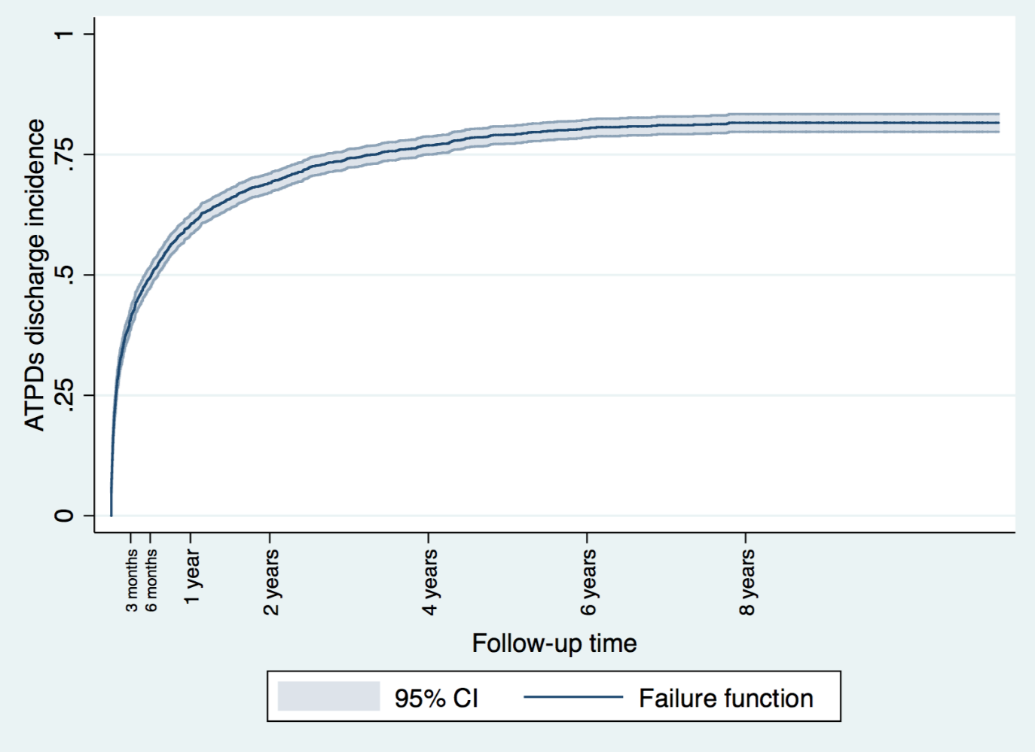
The cumulative incidence of discharges from Treatment teams was 40.94% at 3 months (95% CI 38.86-43.09%), 49.61% at 6 months (95%CI 47.48-51.78%%), 60.48% at 1 year (95%CI 58.39-62.59%), 69.13% at 2 years (95%CI 67.12-71.12%), 76.92% at 4 years (95%CI 75.03-78.76%), 80.40% at 6 years (95%CI 78.55-82.19%), 81.59% at 8 years (95%CI 79.70-83.39%). There were 1231 subjects at risk at 3monts, 1048 at 6months, 811 at 1 year, 599 at 2 years, 369 at 4years, 224 at 6 years, 133 at 8 years.
eFigure2. Cumulative incidence of (Kaplan Meier failure function) discharges from SLaM Treatment teams stratified across Early Intervention Services-EIS vs Others over the follow-up period
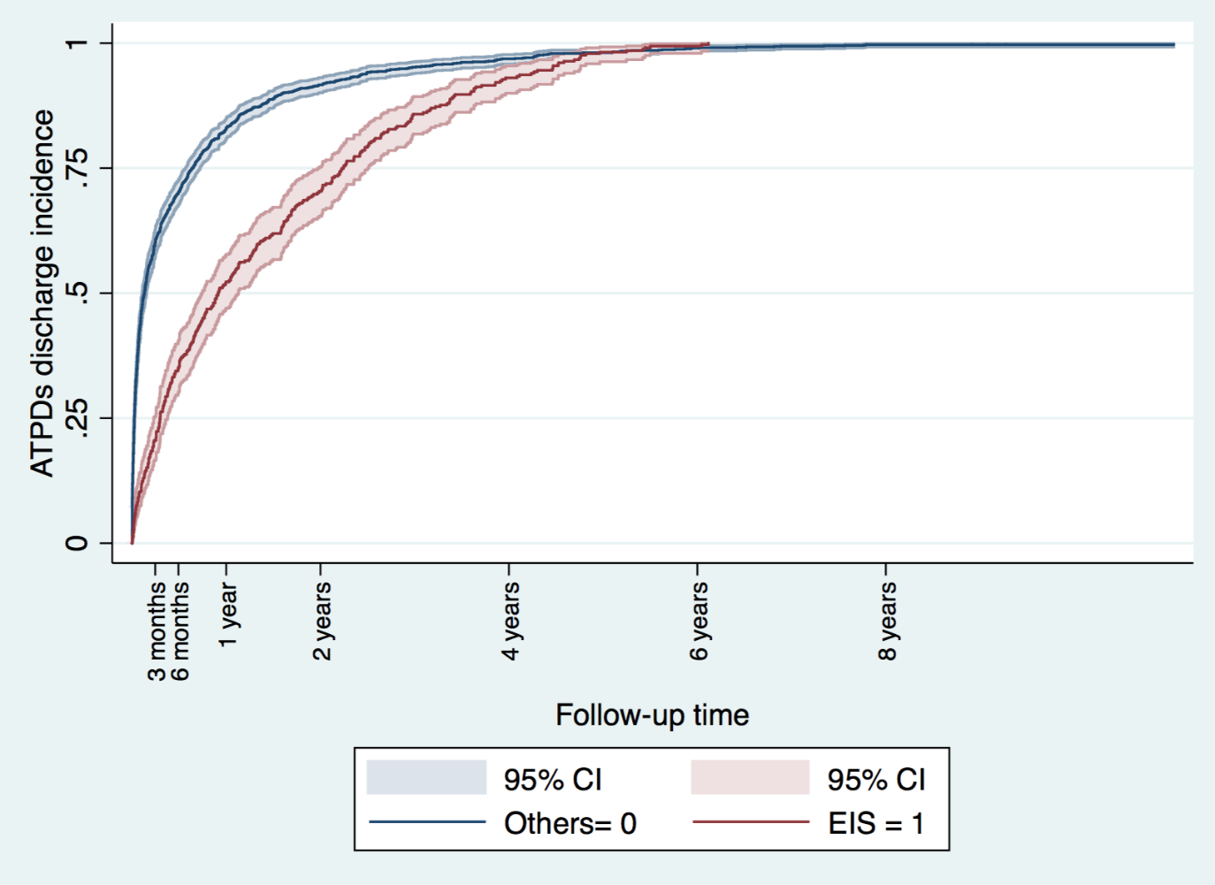
eFigure2 presents the Kaplan-Meier estimates of the failure functions for time to discharge in patients treated with EIS vs Others, which were significantly different (Log-Rank test=109.86; P<0.01).
The average clinical follow-up provided by EIS (i.e., mean length of stay before discharge) was 652.28±502.70 days. For patients treated with EIS, the cumulative incidence of discharges was 21.15% at 3 months (95% CI 17.13-25.95%), 35.35% at 6 months (95%CI 30.46-40.76%), 52.27% at 1 year (95% CI 47.31-58.04%), 70.39% at 2 years (95% CI 65.42-75.22), 93.05% at 4 years (95% CI 89.98-95.46), 99.70% at 6 years (CI 98.41-99.97) and 100% at 8 years. There were 71 subjects at risk at 3mo, 118 at 6mo, 175 at 1 year, 235 at 2 years, 310 at 4 years, 332 at 6 years, 334 at 8 years.
The average clinical follow-up provided by Treatment teams other than EIS (i.e., mean length of stay before discharge) was 284.03±587.05 days. For patients treated with Treatment teams other than EIS, the cumulative discharge rates were: 60.11% at 3 months (95% CI 57.46-62.77%), 70.21% at 6 months (95%CI 67.72-72.67%), 83.00% at 1 year (95% CI 80.91-84.98%), 91.65% at 2 years (95% CI 90.07-93.07%), 96.94% at 4 years (95% CI 95.90-97.77%), 99.08% at 6 years (95%CI 98.44-99.49%) and 99.69% at 8 years (95% CI 99.25-99.89%). There were 263 subjects at risk at 3mo, 215 at 6mo, 159 at 1 year, 98 at 2 years, 24 at 4years, 2 at 6 years, 1 at 8 years

eFigure3. Cumulative incidence (Kaplan Meier failure function) of first antipsychotic prescription over the follow-up period
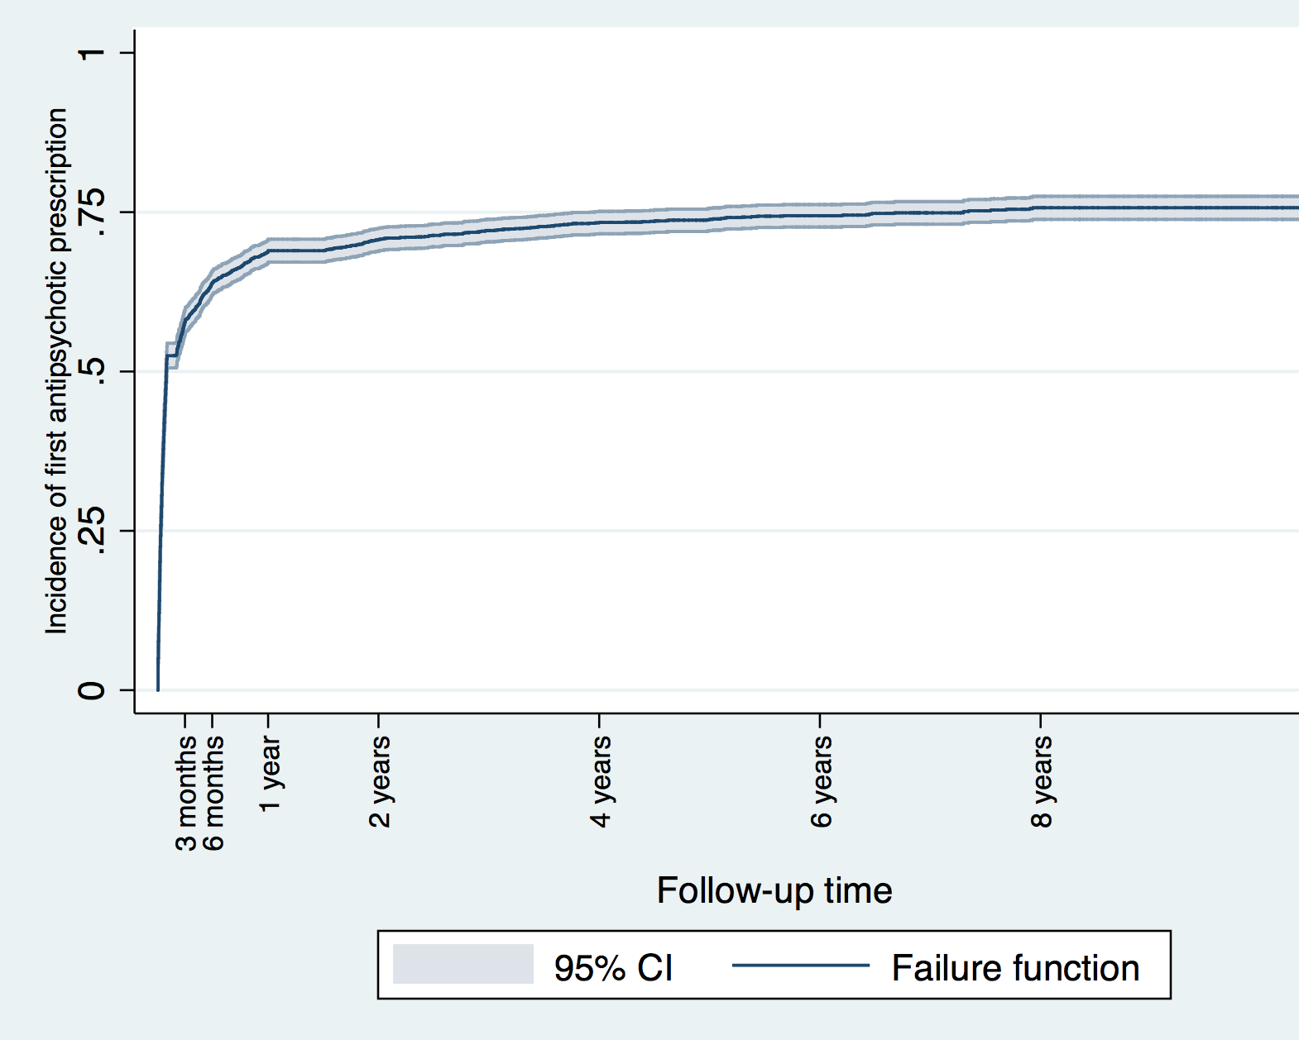
The cumulative incidence of first antipsychotic prescription was 57.77% at 3 months (95% CI 55.86-59.69%); 63.88% at 6 months (95% CI 62.02-65.74); 68.95% at 1 year (95% CI 67.15-70.74%); 70.71 at 2 years (95% CI 68.93-72.48); 73.98% at 4 years (95% CI 71.61-75.12%); 74.44% at 6 years (95% CI 72.62-76.18%); 75.69% at 8 years (95% CI 73.86-77.48%)
eFigure4. Antipsychotics (molecules in detail) prescription at the time points of interest. The overall percentage of patients treated with antipsychotics per each time point is reported in detail in the main manuscript and in Figure 2.

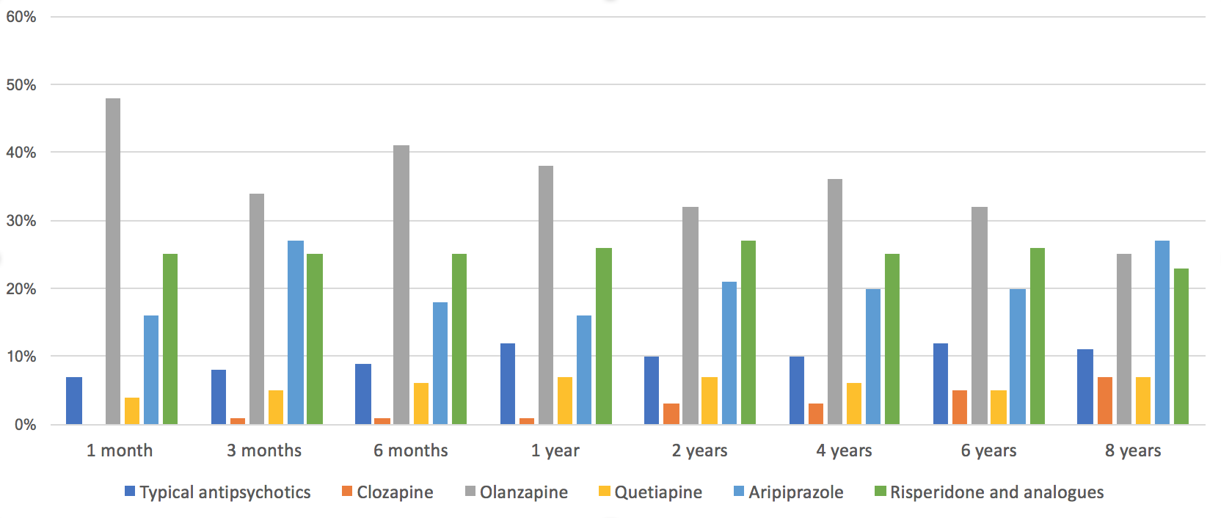
Typical antipsychotics: Amisulpride, Zuclopenthixol, Chlorpromazine, Flupenthixol, Haloperidol, Fluphenazine, Trifluoperazine, Levomepromazine, Pipotiazine, Prochlorperazine; Risperidone and analogues: Risperidone, Paliperidone, Ziprasidone

Rutigliano G, Merlino S, Minichino A, Patel R, Davies C, Oliver D, De Micheli A, McGuire P, Fusar-Poli P. Long term outcomes of acute and transient psychotic disorders: The missed opportunity of preventive interventions. Eur Psychiatry. 2018 Aug; 52:126-133.

