SUPPLEMENT
Definitions of covariates
Sociodemographic characteristics
- Age
- Gender (men vs. women)
- Education (years)
- Type of residence (rural: rural area or village vs. urban: a big city / the suburbs or outskirts of a big city / a large town / a small town)
- Immigration (not born in the country of interview vs. born in the country of interview)
- Current job situation (not working: retired / unemployed / permanently sick / homemaker / other vs. working: employed / self-employed)
- Household income: expressed in EUR per year; calculated as follows: All individual income components per year were aggregated at the household level. Second, this result was adjusted for purchasing power parity (PPP) by multiplication with exchange rate and division by PPP-adjusted exchange rate. Third, it was equivalised by using square root scale [1].

Social characteristics
- Family status (partner: married and living with spouse / registered partnership vs. alone: married and not living with spouse / never married / divorced / widowed),
- Number of children
- Number of grandchildren
- Number of persons with whom the person has a daily contact
Comorbidities
- Cardiovascular disease: considered when the individuals were diagnosed at least with one of 5 diseases (hypertension, diabetes mellitus, stroke, hypercholesterolemia and coronary disease). Data about the diagnoses were acquired by combining information about their history with the use of drugs.
- Cancer: considered if the participants reported that they have ever been told by a doctor that they have cancer.
- Cognitive impairment: based on a composite cognitive score that contains results from 5 cognitive measures: verbal learning, delayed recall (both gained from an adapted 10-word delay recall test), verbal fluency (from an animal word fluency test), temporal orientation (with regard to the day of month, month, year and day of the week) and numeracy (obtained from serial sevens subtraction test). Based on an algorithm constructed by Doblhammer et al[2], we assigned the maximum of 4 points for each test, creating a scale ranging from 0-20 points. Individuals that scored less than 14 points were classified as having cognitive impairment.
- Total number of chronic diseases
- Pain: considered if the participants reported that they are troubled by pain

General health-related factors
- Physical inactivity: considered if the participants reported that they never do vigorous nor moderate physical activity.
- Body mass index (BMI): calculated from self-reported height and weight.
- Alcohol use: defined when the participants reported that they consumed at least 1 alcoholic beverage during the past 7 days.
- Smoking: considered when participants answered that they have ever smoked daily.
- Limitations of instrumental activities of daily living (IADL): assessed by an index[3] that describes the number of limitations with instrumental activities of everyday life. The modified version used here includes seven activities[4], the score ranges from 0 to 7, with a higher index indicating more difficulties.
- Grip strength: measured by using a handheld dynamometer on each hand (Smedley, S Dynamometer, TTM, Tokyo, 100 kg). Two measurements were taken on each hand. The maximum value of the grip strength measurements of both hands was generated for participants with two valid measures for each hand and if the two measures for one hand do not differ more than 20 kg, taking up a value between 0 and 100 kg.
- Computer use: derived from a variable concerning how the participants perceive their computer skills. The answers ranged from excellent to poor or the participants answered that they have never used a computer. Here we use the variable as never used a computer vs. other.

Some continuous variables are presented as binary variable with an arbitrary cut-off in the univariate analysis, but all were used as continuous variables in the models.
- Household income: lowest decile vs. other
- Number of children: 2 and more vs. other
- Number of grandchildren: 3 and more vs. other
- Total number of chronic diseases: 2 and more vs. other
- BMI: obesity (BMI ≥ 30)
- IADL: 4 and more vs. other

Supplemental Table S1 Associations of covariates with depression in the whole sample as well as stratified by gender
 |  | OR (95% CI)
 | Characteristics (n=28 796) | Whole sample | Men | Women
Female gender, n (%) | 15 350 (53) | 1.30 (1.19; 1.42)** | / | /
Age, mean ± SD | 73.9 ± 6.7 | 0.98 (0.98; 0.99)** | 0.99 (0.99; 1.00) | 0.98 (0.97; 0.98)**
Household net income, median (IQR) | 12 707 (12 515) | 1.00 (1.00; 1.00)** | 1.00 (1.00; 1.00)* | 1.00 (1.00; 1.00)**
Family status: alone, n (%) | 8 904 (31) | 1.08 (1.01; 1.15)* | 1.21 (1.08; 1.36)* | 1.05 (0.97; 1.13)
CVD, n (%) | 21 127 (73) | 0.92 (0.85; 1.00)* | 0.92 (0.81; 1.06) | 0.92 (0.84; 1.02)
Cancer, n (%) | 1 488 (5) | 1.15 (1.01; 1.30)* | 1.13 (0.94; 1.35) | 1.16 (0.98; 1.37)
Cognitive impairment, n (%) | 8 274 (29) | 1.59 (1.49; 1.70)** | 1.57 (1.41; 1.75)** | 1.59 (1.46; 1.74)**
Number of chronic diseases, median (IQR) | 2 (2) | 1.25 (1.22; 1.27)** | 1.25 (1.21; 1.29)** | 1.24 (1.21; 1.28)**
BMI, mean ± SD | 27.1 ± 4.4 | 0.99 (0.99; 1.00) | 1.00 (0.99; 1.02) | 0.99 (0.98; 1.00)*
Physical inactivity, n (%) | 3 101 (11) | 1.56 (1.43; 1.71)** | 1.87 (1.61; 2.16)** | 1.41 (1.25; 1.58)**
IADL, median (IQR) | 0 (0) | 1.22 (1.19; 1.25)** | 1.24 (1.19; 1.29)** | 1.21 (1.17; 1.25)**
Pain, n (%) | 13 697 (48) | 1.97 (1.85; 2.09)** | 1.96 (1.77; 2.16)** | 1.97 (1.82; 2.13)**
Grip strength, mean ± SD | 31.2 ± 10.9 | 0.98 (0.97; 0.98)** | 0.98 (0.98; 0.99)** | 0.97 (0.96; 0.98)**
Never used a computer, n (%) | 11 933 (41) | 1.35 (1.26; 1.44)** | 1.33 (1.20; 1.48)** | 1.36 (1.25; 1.47)**
*p<0.05; **p<0.001
OR, odds ratio; CI, confidence interval; CVD, cardiovascular disease, BMI, body mass index; IADL, instrumental activities of daily living

Supplemental Table S2 Associations of covariates with depression stratified by region
 | OR (95% CI)
 | Western Europe | Southern Europe | CEE | Scandinavia
Female gender | 1.45 (1.24; 1.69)** | 1.33 (1.14; 1.56)** | 1.30 (1.11; 1.54)* | 1.27 (0.94; 1.71)
Age | 0.98 (0.97; 0.99)** | 0.98 (0.97; 0.99)** | 0.98 (0.97; 0.99)** | 1.02 (1.00; 1.03)*
Household net income | 1.00 (1.00; 1.00)* | 1.00 (1.00; 1.00)* | 1.00 (1.00; 1.00)** | 1.00 (1.00; 1.00)
Family status: alone | 1.11 (0.99; 1.23) | 1.16 (1.02; 1.33)* | 1.00 (0.89; 1.13) | 1.00 (0.81; 1.23)
CVD | 0.88 (0.77; 1.00) | 1.03 (0.88; 1.21) | 0.87 (0.75; 1.02) | 0.93 (0.73; 1.19)
Cancer | 1.15 (0.94; 1.42) | 1.65 (1.26; 2.18)** | 0.94 (0.75; 1.19) | 1.16 (0.81; 1.66)
Cognitive impairment | 1.54 (1.36; 1.75)** | 1.56 (1.38; 1.76)** | 1.63 (1.44; 1.85)** | 1.34 (1.05; 1.72)*
Number of chronic diseases | 1.25 (1.20; 1.30)** | 1.24 (1.18; 1.29)** | 1.26 (1.21; 1.31)** | 1.20 (1.11; 1.29)**
BMI | 0.98 (0.97; 0.99)* | 1.01 (0.99; 1.02) | 0.99 (0.98; 1.00) | 1.01 (0.99; 1.04)
Physical inactivity | 1.48 (1.25; 1.75)** | 1.63 (1.39; 1.91)** | 1.42 (1.19; 1.69)** | 2.26 (1.62; 3.16)**
IADL | 1.20 (1.14; 1.26)** | 1.38 (1.30; 1.47)** | 1.20 (1.15; 1.25)** | 1.19 (1.09; 1.31)**
Pain | 2.11 (1.90; 2.34)** | 1.73 (1.53; 1.95)** | 2.00 (0.78; 2.25)** | 1.86 (1.53; 2.26)**
Grip strength | 0.98 (0.98; 0.99)** | 0.98 (0.98; 0.99)** | 0.97 (0.97; 0.98)** | 0.97 (0.96; 0.99)**
Never used a computer | 1.08 (0.96; 1.22) | 1.54 (1.36; 1.74)** | 1.36 (1.21; 1.53)** | 0.79 (0.59; 1.06)
*p<0.05; **p<0.001
OR, odds ratio; CI, confidence interval; CVD, cardiovascular disease; BMI, body mass index; IADL, instrumental activities of daily living

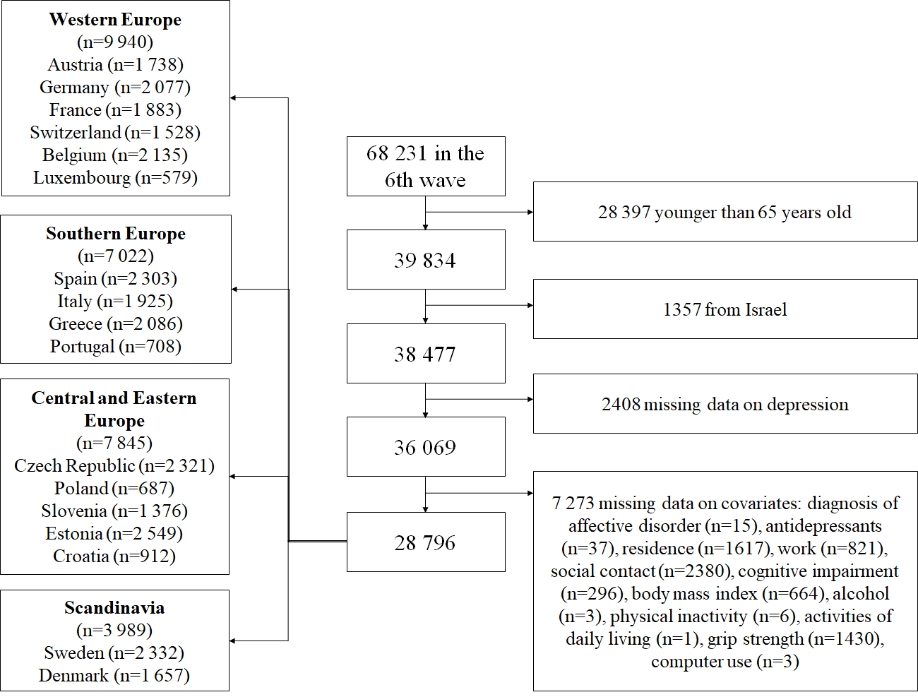

Supplemental Figure S1 Selection of the analytical sample

REFERENCES
[1] Rodrigues R, Ilinca S, Schmidt AE. Income-rich and wealth-poor? The impact of measures of socio-economic status in the analysis of the distribution of long-term care use among older people. Health economics. 2018;27:637-46.
[2] Doblhammer G, van den Berg GJ, Fritze T. Economic conditions at the time of birth and cognitive abilities late in life: evidence from ten European countries. PloS one. 2013;8:e74915.
[3] Lawton MP, Brody EM. Assessment of older people: self-maintaining and instrumental activities of daily living. The gerontologist. 1969;9:179-86.
[4] Taylor R, Conway L, Calderwood L, Lessof C, Cheshire H, Cox K, et al. Health, wealth and lifestyles of the older population in England: The 2002 English Longitudinal Study of Ageing Technical Report. London: Institute of Fiscal Studies. 2007.

