Supplementary data

Supplementary Figure 1: Flow-diagram of inclusion and exclusion process of selected articles

PubMed hits: 5612
Pre-selected articles: 52
Selected articles: 24
Excluded articles: 28
Headlines and abstracts read by AF and BC

Supplementary Table 1: List of excluded studies

Reason for exclusion | Author, year | Journal
Duplicate sample set | Dyrbye et al., 2010 | Medical Education
 | Dyrbye et al., 2011 | Medical teacher
 | Dyrbye et al., 2012 | Academic Medicine
 | Dyrbye et al., 2016 | Academic Medicine
 | Jackson et al., 2016 | Academic Medicine,
 | Reed et al., 2011 | Academic Medicine,
 | West et al., 2015 | J Gen Intern Med
No information about prevalence | Arbabisarjou et al., 2016 | Global Journal of Health Science
 | Backović et al., 2012 | Psychiatria Danubina
 | Brazeau et al., 2010 | Academic Medicine,
 | Bughi et al., 2017 | Education for Health
 | Chang et al., 2012 | Academic Psychiatry
 | Dahlin et al., 2012 | BMC Medical Education
 | Fang et al., 2012 | Academic Psychiatry
 | Goel et al., 2016 | J Neurosci Rural Pract
 | Győrffy et al., 2016 | BMC Medical Education
 | Ilic et al., 2016 | Behavioral Medicine
 | Lin et al., 2016 | BMC Medical Education
 | Lin et Lin, 2016 | BMC Medical Education
 | Pagnin et al., 2013 | Medical Teacher
 | Pagnin et al., 2014 | Academic Psychiatry
 | Pagnin et al., 2015 | SpringerPlus
 | Prinz et al., 2012 | GMS Z Med Ausbild
 | Santen et al., 2010 | Southern Medical Journal
 | Seo et al., 2015 | Psychiatry Investigation
 | Shad et al., 2015 | Cureus
 | Villwock et al., 2017 | International Journal of Medical Education
 | Von Harsher et al., 2015 | Psychology, Health & Medicine

Supplementary Figure 2: Meta-analysis of burnout symptoms
a: Emotional exhaustion
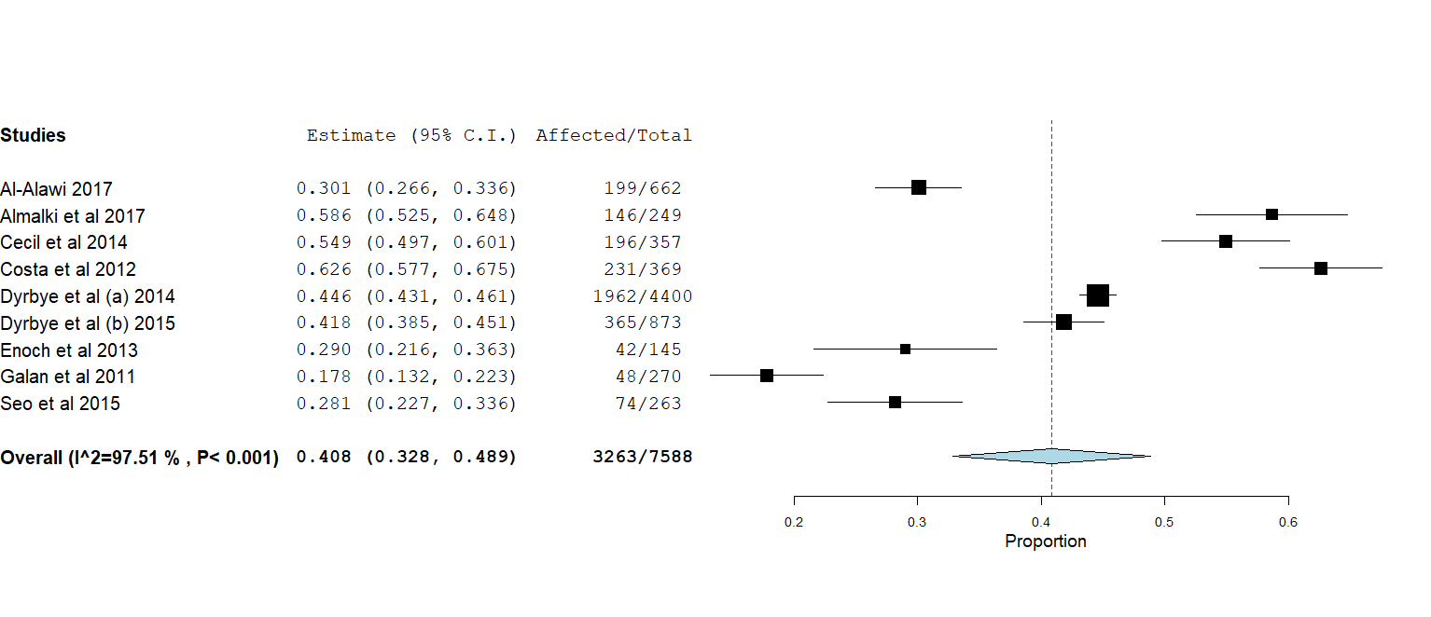
b: depersonalization
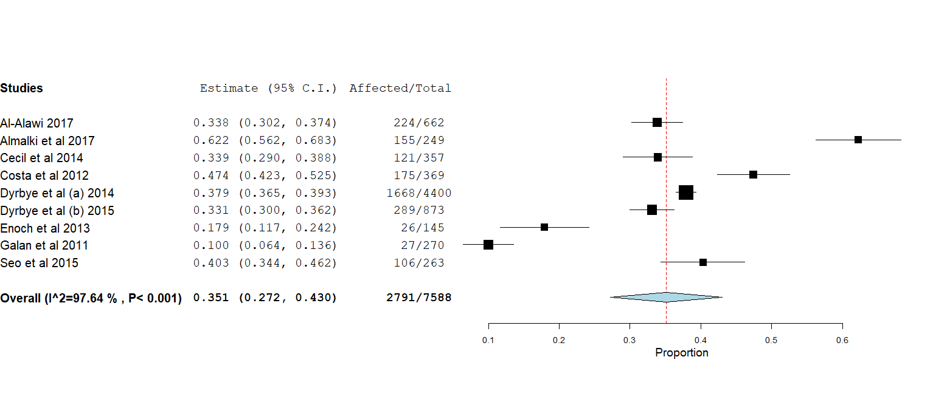
c: personal accomplishment
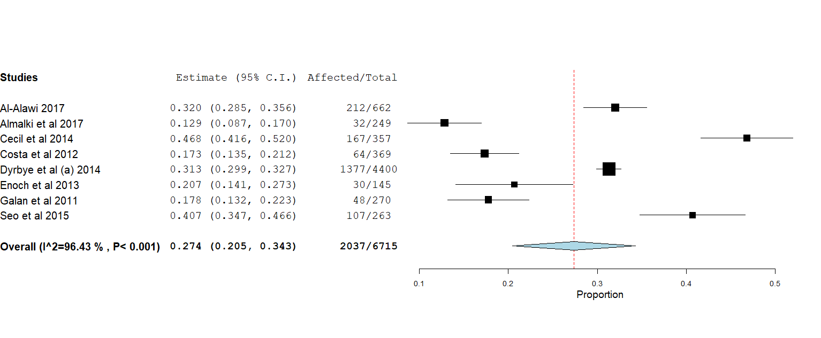
Supplementary Figure 3: Leave-one-out analysis
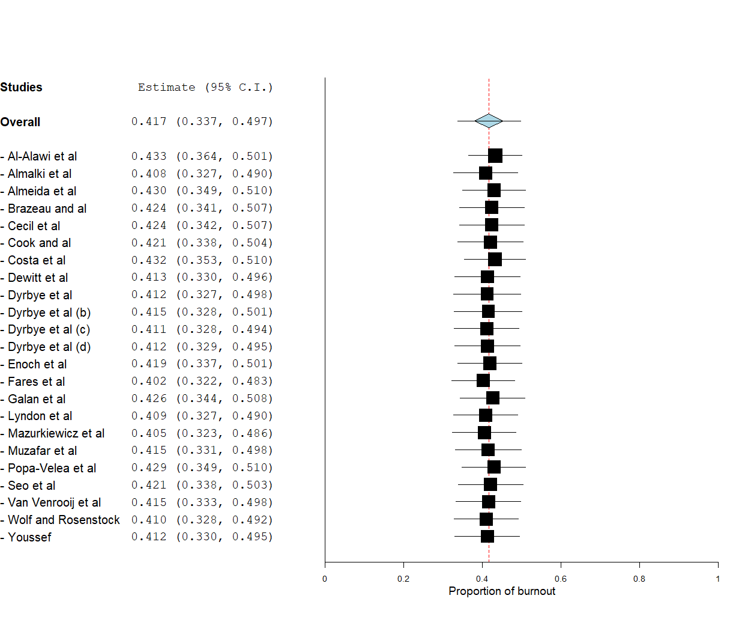
Supplementary Figure 4: Funnel plot
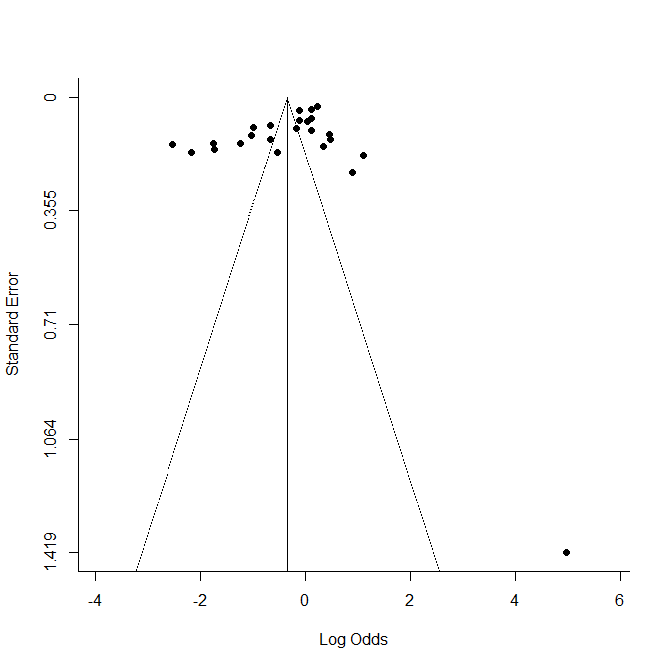
The studies were plotted after a logit transformation of their proportions. The red-boxed area corresponds to the 2016 study by Asencio-Lopez et al.⁴⁶. This study diverges from the other studies with a prevalence estimated to be 100%. It was excluded from further analyses (subgroup meta-analysis and meta-regression).

Supplementary Figure 5: Subgroup meta-analysis based on assessment scale
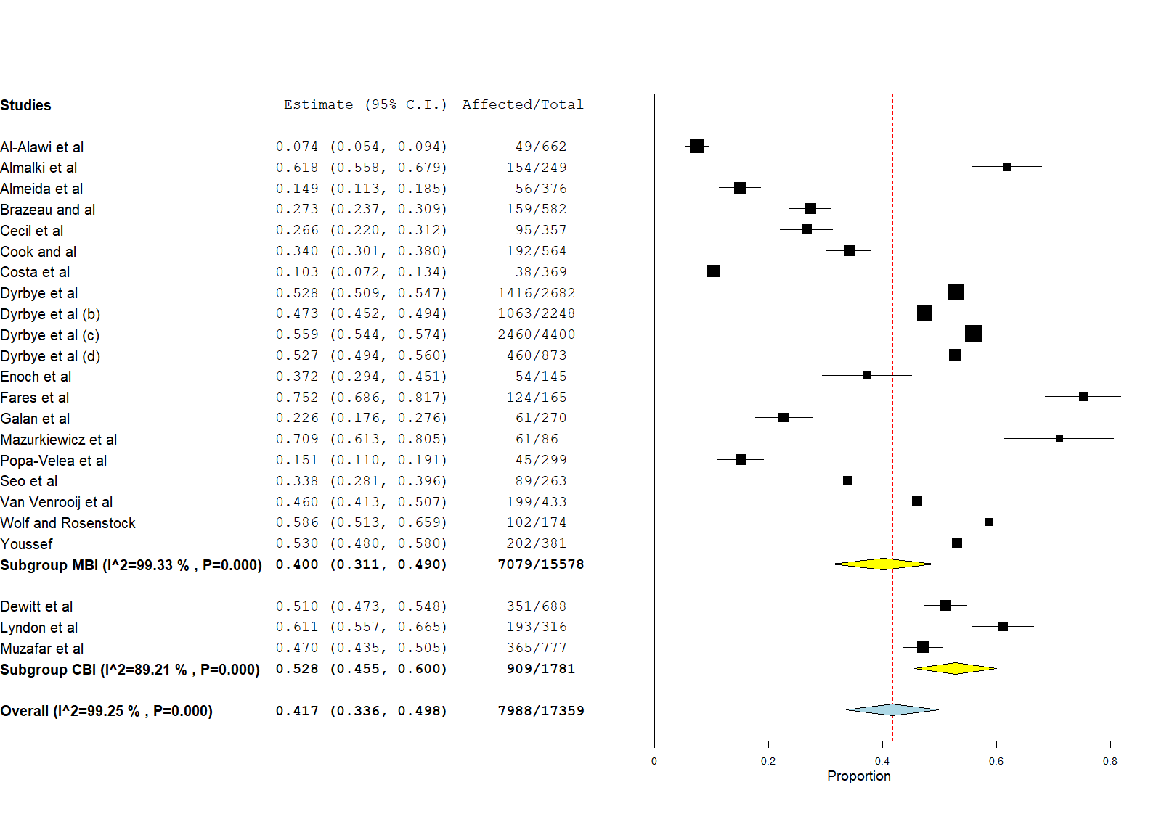
Supplementary Figure 6: Meta-regression analysis of the year of publication
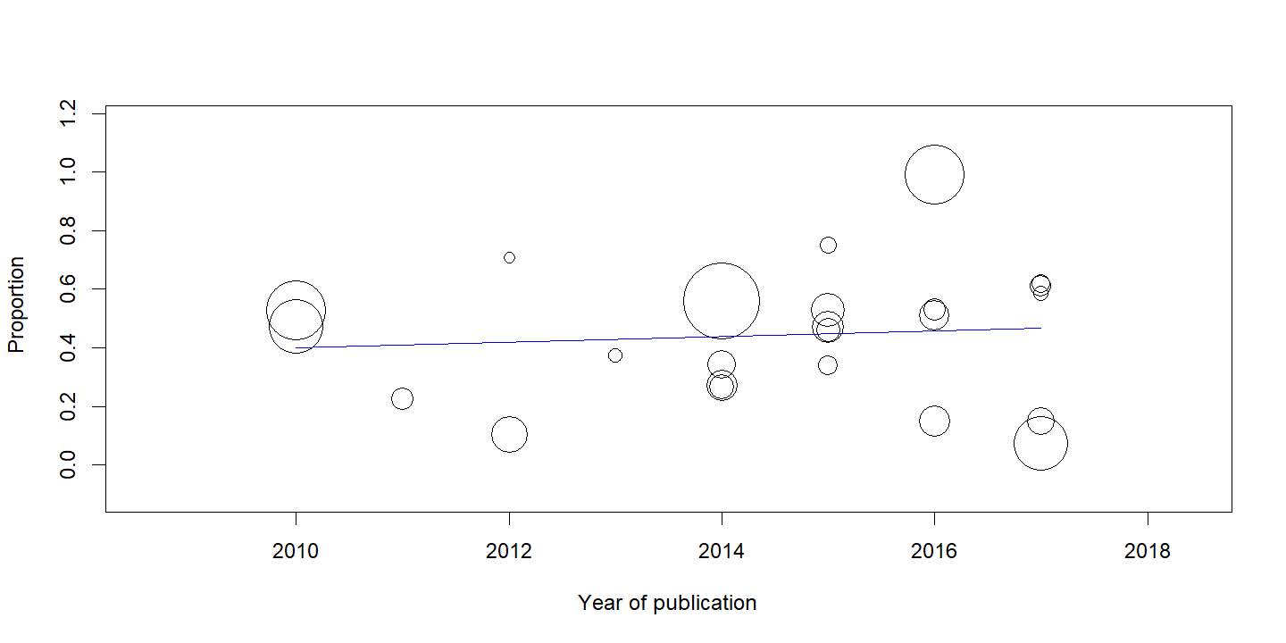

Supplementary Figure 7: Meta-regression analysis of the response rate (number of participants divided by number of solicited individuals)
