Supplementary materials

Table S1. Network ROI analysis
 | AN (25) | BN (16) | CN (17) | F | p | Post hoc
SS | -0.362 ± 0.090 | -0.351 ± 0.046 | -0.347 ± 0.073 | 0.257 | .774
Sal | -0.399 ± 0.063 | -0.396 ± 0.584 | -0.448 ± 0.042 | 4.839 | .012 | AN, BN < CN
DMN | -0.237 ± 0.047 | -0.247 ± 0.051 | -0.228 ± 0.046 | 0.621 | .541
Audi | -0.445 ± 0.044 | -0.463 ± 0.052 | -0.478 ± 0.039 | 2.808 | .069
VA | -0.372 ± 0.047 | -0.380 ± 0.049 | -0.425 ± 0.038 | 7.311 | .002 | AN, BN < CN
MR | -0.277 ± 0.111 | -0.314 ± 0.081 | -0.311 ± 0.105 | 0.872 | .424
DA | -0.418 ± 0.050 | -0.392 ± 0.059 | -0.411 ± 0.056 | 1.156 | .322
Sub | -0.353 ± 0.076 | -0.362 ± 0.085 | -0.407 ± 0.070 | 2.660 | .079
FPTC | -0.351 ± 0.055 | -0.343 ± 0.047 | -0.383 ± 0.048 | 2.930 | .062
COTC | -0.395 ± 0.048 | -0.385 ± 0.068 | -0.436 ± 0.053 | 4.190 | .020 | BN < CN
CB | -0.479 ± 0.058 | -0.469 ± 0.074 | -0.509 ± 0.049 | 1.993 | .146
AN= Anorectic Patients; BN= Bulimic Patients; CN= Healthy Controls. CB= Cerebellum Network; COTC= Cingular Operculum Task Control Network; FPTC= Frontal Parietal Temporal Network; SUB= Subcortical Network; DA= Dorsal Attention Network; MR= Medial Regional Network; (MR), VAN= Ventral Attention Network; AUD= Auditory Network; DMN= Default Mode Network; SAL= Salience Network; SS = Somato Sensitive Network.

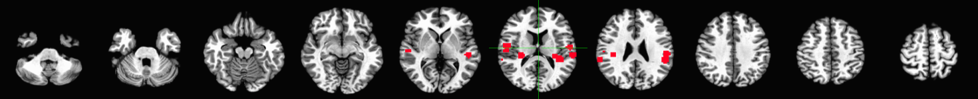
Figure S1. Regions of interest (ROI) of the sample.
1. Auditory Network
2. Cerebellum Network
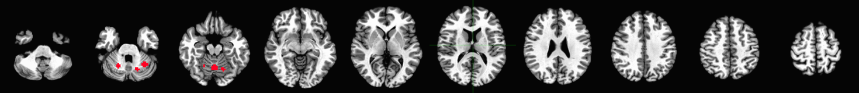
3. Cingular Operculum Task Control Network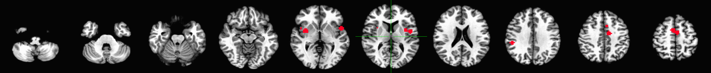
4. Dorsal Attention Network
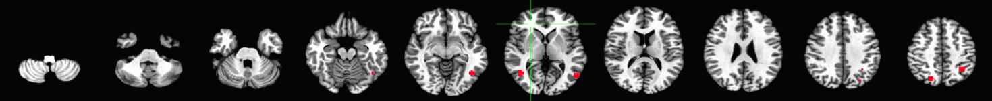
5. Default Mode Network
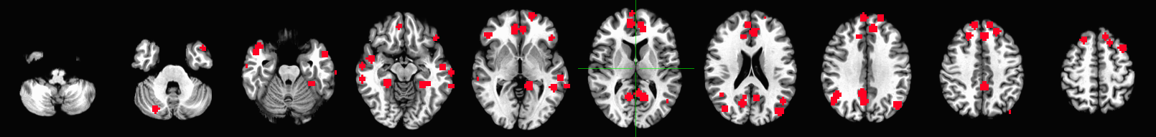
6. Ventral Attention Network
7. FPTC= Frontal Parietal Temporal Network
8. Medial Region Network

9. Salience Network
10. Subcortical Network
11. Somato Sensitive Network
12. Visual network
fMRI analysis on the whole sample by the extraction of signal from 11 specified regions of interest (ROI) and their characteristics.

Table S2. Comparison of neuronal variability of Slow 5 and Slow 4 within Ventral Attention Network between patients and controls (a) and between the three subgroups.

 | Patients | Controls | t | p
Slow 5 | -0.348 ± 0.093 | -0.382 ± 0.077 | -1.305 | .197
Slow 4 | -0.359 ± 0.052 | -0.401 ± 0.049 | -2.754 | 0.008
Table S4 a. Patients = Patients with Anorexia Nervosa + Patients with Bulimia Nervosa; Controls = Healthy controls.

 | AN | BN | CN | f | P
Slow 5 | -0.349 ± 0.095 | -0.345 ± 0.096 | -0.381 ± 0.075 | .820 | .446
Slow 4 | -0.365 ± 0.044 | -0.351 ± 0.065 | -0.400 ± 0.048 | 4.119 | .022
Table S4 b. AN= Anorectic Patients; BN= Bulimic Patients; CN= Healthy Controls.

