**Supplementary Table 1** Validation of estimates extrapolated from 5 years of follow-up and those obtained using the Kaplan-Meier method.

|  |  |  |  |  |
| --- | --- | --- | --- | --- |
| Schizophrenia  cohort size | | 9-year (2000–2008) follow-up Kaplan–Meier estimate: mean (SE) months | Estimate using extrapolation based on the first 5 years of follow-up: mean (SE) months | Relative biasa (%) |
| All patients | 42,339 | 103.98 (0.10) | 103.33 (0.04) | -0.63 |
| Male | 23,586 | 103.40 (0.14) | 102.88 (0.04) | -0.50 |
| Female | 18,753 | 104.73 (0.13) | 104.14 (0.04) | -0.56 |

aRelative bias = (estimate from extrapolation–K-M estimate) / K-M estimate.

**Supplementary Table 2** Estimation of life expectancy (LE), expected years of life lost (EYLL), and expected years of living with disability (EYLD) stratified by functional disability (mean and SE) in a random sample of 100 patients.

|  |  |
| --- | --- |
|  | All patients (*n* = 100) |
| LE, mean (SE) years | 28.16 (0.02) |
| EYLL, mean (SE) years | 16.93 (0.03) |
| EYLD, mean (SE) years |  |
| Four domains of functioning |  |
| Socially-useful activities |  |
| Years with mild difficulty (PSP: 1–2) | 11.17 (1.55) |
| Years with manifested disability (PSP: 3–6) | 17.14 (1.29) |
| Personal and social relationships |  |
| Years with mild difficulty (PSP: 1–2) | 11.03 (1.66) |
| Years with manifested disability (PSP: 3–6) | 17.28 (1.59) |
| Self-care |  |
| Years with mild difficulty (PSP: 1–2) | 21.82 (1.18) |
| Years with manifested disability (PSP: 3–6) | 6.28 (1.3) |
| Disturbing and aggressive behavior |  |
| Years with mild difficulty (PSP: 1–2) | 25.55 (0.73) |
| Years with manifested disability (PSP: 3–6) | 2.42 (0.67) |
| *Global score* |  |
| Years with mild difficulty (PSP: 71–100) | 7.97 (1.28) |
| Years with manifested disability (PSP: ≤ 70) | 20.37 (1.48) |

PSP=Personal and Social Performance Scale.

Supplementary Figure 1. Curve of dynamic change of the proportion of patients with functional disability.



Note: the curve of dynamic change of the proportion of patients with functional disability was obtained by applying a kernel-smoothing method. The bandwidth parameter was set at 10%. The score of 1 represents the functional level of manifested disability (global score ≤ 70 or domain score: 3–6); the score of 0 represents another functional level (global score: 71–100 or domain score: 1–2). The curve illustrates the change in the proportion of patients with functional disability, and a higher score indicates that a greater proportion of patients are of a manifested disability status at time *t*.

Supplementary Figure 2. Expected years of living with disability in patients with schizophrenia.

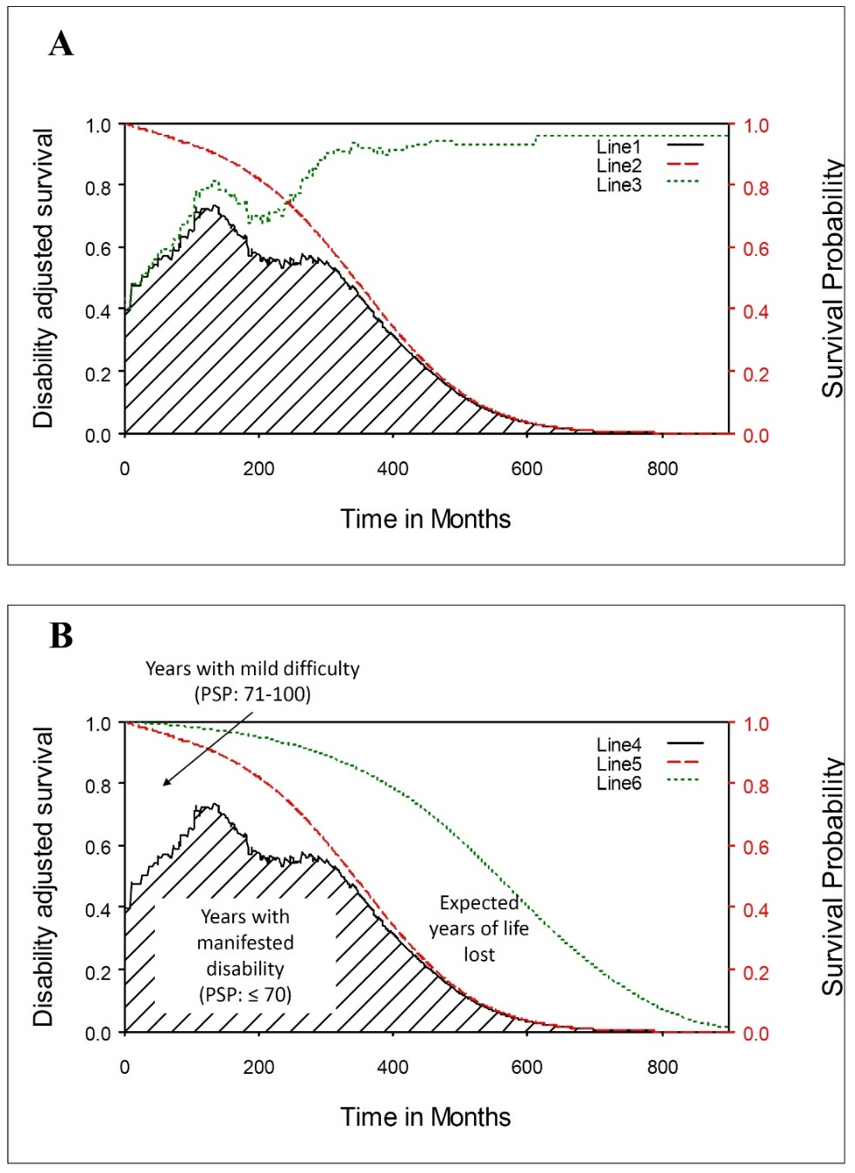

Note: (A) the survival probability at each time point was multiplied by the proportion of functionality to obtain a lifetime functional disability-adjusted survival (solid curve); (B) the panel illustrates the expected years of life lost (the area between the red dashed and green dotted curves), the expected years of living with mild difficulty (the area between the red dashed and solid curve), and the expected years of living with manifested disability (shaded area under solid curve) for the patients with schizophrenia.

PSP: Personal and Social Performance Scale; Line 1= functional disability-adjusted survival; Line 2 = life expectancy of patients with schizophrenia; Line 3 = proportion of patients with functional disability; Line 4 = functional disability-adjusted survival; Line 5 = life expectancy of patients with schizophrenia; Line 6 = life expectancy of reference population.

Supplementary Figure 3.The concept of expected years of living with disability.

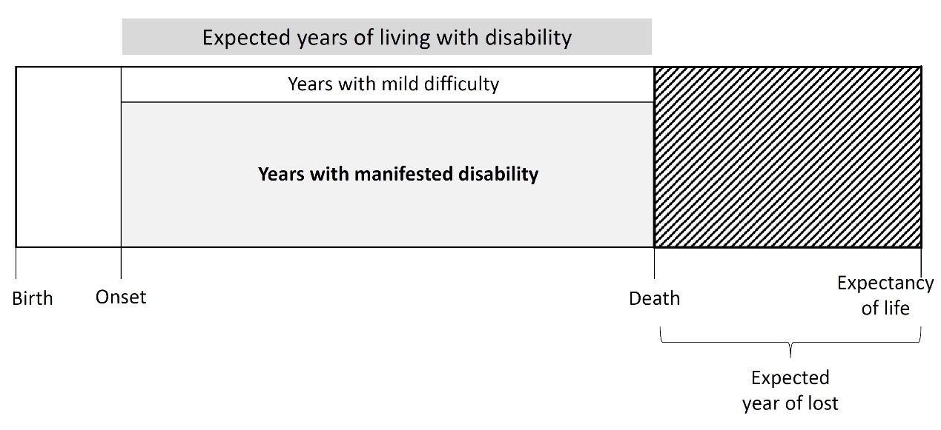

Note: the figure illustrates the number of years spent with functional disability from the onset of disease to premature death due to schizophrenia. The expected years of living with disability is simply calculated by multiplying the life expectancy of patients with schizophrenia by the proportions of patients with functional disability at different functional levels (e.g., mild difficulty or manifested disability).