Appendix 1: Databases and search terms
Database |  | Search terms
Medline/PubMed | #1  #2  #3 | MeSH ‘professional burnout’ OR MeSH ‘stress, psychological’ OR ‘burnout’ OR ‘stress’ OR ‘morale’ OR ‘compassion fatigue’ OR ‘job satisfaction’  AND  MeSH ‘mental health service’ OR MeSH ‘community mental health services’ OR MeSH ‘mental health’ OR MeSH ‘psychiatric hospital’ OR MeSH ‘psychiatric department’ OR MeSH ‘psychiatry professional’ OR MeSH ‘psychiatric nursing’ OR ‘occupational therapist’ OR MeSH ‘social worker’ OR ‘mental health professional’ OR ‘psychiatric staff’ OR ‘psychiatric personnel’ OR ‘psychologist’ OR ‘psychiatrist’  #1 AND #2
PsychINFO/OVID | #1  #2  #3 | ‘professional burnout’ OR ‘burnout’ OR ‘stress’ OR ‘morale’ OR ‘compassion fatigue’ OR ‘fatigue’ OR ‘job satisfaction’  AND  ‘mental health professional’ OR ‘mental health service’ OR ‘psychiatric staff’ OR ‘psychiatric personnel’ OR ‘mental health personnel’ OR ‘psychiatric hospital’ OR ‘psychiatric nursing’ OR ‘occupational therapist’ OR ‘social worker’ OR ‘psychiatrist’ OR ‘psychologist’  #1 AND #2
EMBASE | #1  #2  #3 | ‘professional burnout’ OR ‘burnout’ OR ‘stress’ OR ‘morale’ OR ‘fatigue’ OR ‘job satisfaction’  AND  ‘mental health professional’ OR ‘mental health service’ OR ‘psychiatric staff’ OR ‘psychiatric personnel’ OR ‘psychiatric hospital’ OR ‘psychiatric nursing’ OR ‘occupational therapist’ OR ‘social worker’ OR ‘psychiatrist’ OR ‘psychologist’  #1 AND #2
CINAHL/EBSCO | #1  #2  #3 | ‘professional burnout’ OR ‘burnout’ OR ‘stress’ OR ‘morale’ OR ‘fatigue’ OR ‘job satisfaction’  AND  ‘mental health professional’ OR ‘mental health service’ OR ‘psychiatric staff’ OR ‘psychiatric personnel’ OR ‘psychiatric hospital’ OR ‘psychiatric nursing’ OR ‘occupational therapist’ OR ‘social worker’ OR ‘psychiatrist’ OR ‘psychologist’  #1 AND #2
Web of Science | #1  #2  #3 | ‘professional burnout’ OR ‘burnout’ OR ‘stress’ OR ‘morale’ OR ‘fatigue’ OR ‘job satisfaction’  AND  ‘mental health professional’ OR ‘mental health service’ OR ‘psychiatric staff’ OR ‘psychiatric personnel’ OR ‘psychiatric hospital’ OR ‘psychiatric nursing’ OR ‘occupational therapist’ OR ‘social worker’ OR ‘psychiatrist’ OR ‘psychologist’  #1 AND #2

Appendix 2
NEWCASTLE - OTTAWA QUALITY ASSESSMENT SCALE (adapted for cross sectional studies)
Selection: (Maximum 5 stars)
- Representativeness of the sample:
a) Truly representative of the average in the target population. * (all subjects or random sampling)
b) Somewhat representative of the average in the target population. * (non- random sampling)
c) Selected group of users.
d) No description of the sampling strategy.
- Sample size:
a) Justified and satisfactory. *
b) Not justified.
- Non-respondents:
- Comparability between respondents and non-respondents characteristics is established, and the response rate is satisfactory. *
- The response rate is unsatisfactory, or the comparability between respondents and non-respondents is unsatisfactory.
- No description of the response rate or the characteristics of the responders and the non-responders.
4) Ascertainment of the exposure (burnout):
a) Validated measurement tool. **
b) Non-validated measurement tool, but the tool is available or described.*
c) No description of the measurement tool.

Comparability: (Maximum 2 stars)
- The subjects in different outcome groups are comparable, based on the study
design or analysis. Confounding factors are controlled.
a) The study controls for the most important factor (select one). *
b) The study control for any additional factor. *

Outcome: (Maximum 3 stars)
1) Assessment of the outcome:
a) Independent blind assessment. **
b) Record linkage. **
c) Self report. *
d) No description.
2) Statistical test:
a) The statistical test used to analyze the data is clearly described and
appropriate, and the measurement of the association is presented, including
standard deviations and the probability level (p value). *
b) The statistical test is not appropriate, not described or incomplete.

This scale has been adapted from the Newcastle-Ottawa Quality Assessment Scale for cohort studies to perform a quality assessment of cross-sectional studies for the systematic review, “Burnout in mental health professionals: A systematic review and meta-analysis.

Appendix 3

Normative scores for mental health workers on the subscales of the MBI HSS

Subscales | Normative  low | Normative  medium | Normative  high
Emotional exhaustion | <13 | 14-20 | >21
Depersonalisation | <4 | 5-7 | >8
Personal accomplishment | <28 | 33-29 | >34

Note: Maslach & Jackson, 1996

Appendix 4: Sensitivity analyses

Appendix 5: Subgroup analyses

- Forest plot for mean of Emotional Exhaustion. Subgroup by quality of study

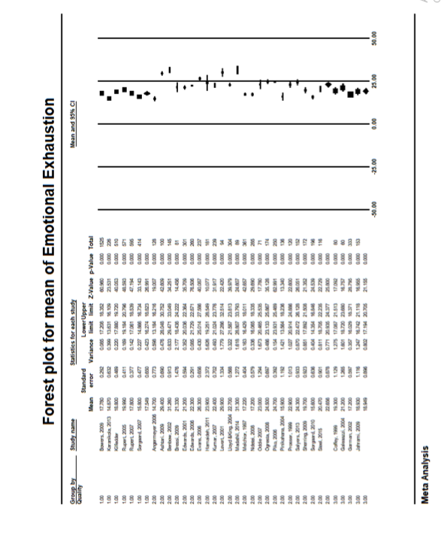

Forest plot of mean scores on MBI-HSS EE subscale. Random effects analysis. Quality 1 studies are those rated as good (≥8) on Newcastle Ottawa Quality Assessment Scale (NOS) (I²=73%, p<0.001). Quality 2 studies are those rated as moderate (6-7) on NOS (I²=97.0, p<0.001). Quality 3 studies are those rated as poor (≤5) on the NOS (I²=69, p<0.02).

- Forest plot for mean on MBI-EE subscale. Subgroup by geographical region.
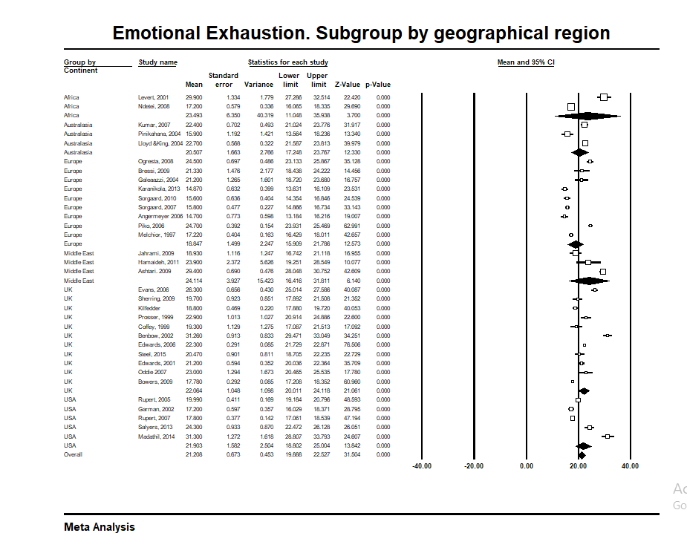

Forest plot of mean scores on MBI-HSS EE subscale. Random effects analysis.
Africa (I² =98.6%, p<0.001), Australasia (I²=92.7, p<0.001), Europe (I²=98.2, p<0.001), Middle East (I²=96.9, p<0.001), UK (I²=97.2, p<0.001), USA (I²=97.3, P<0.001)

- Forest plot for means of Depersonalisation. Subgroup by quality

Forest plot of mean scores on MBI-HSS DP subscale. Random effects analysis. Quality 1 studies are those rated as good (≥8) on Newcastle Ottawa Quality Assessment Scale (NOS) (I²=83%, p<0.001). Quality 2 studies are those rated as moderate (6-7) on NOS (I²=97%, p<0.001). Quality 3 studies are those rated as poor (≤5) on the NOS (I²=76%, p<0.005).

- Mean on Depersonalisation subscale. Subgroup by geographical region
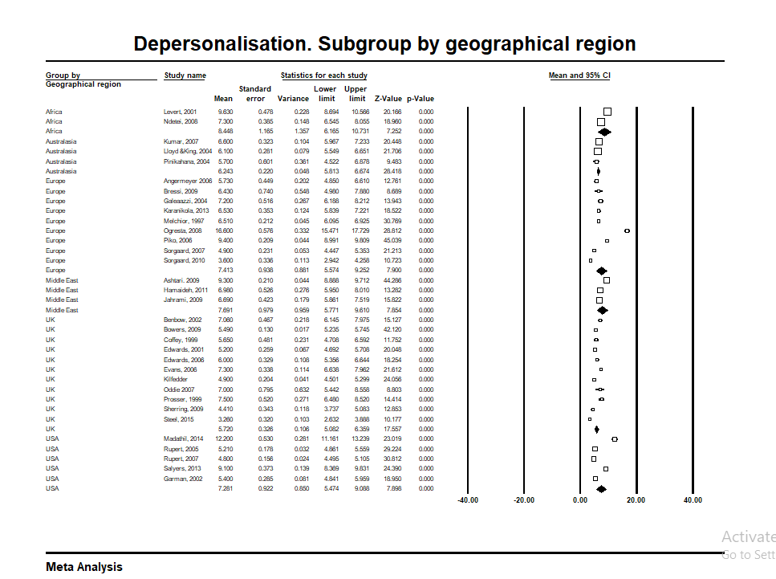

Forest plot of mean scores on MBI-HSS DP subscale. Random effects analysis. Africa (I² =93% p<0.001), Australasia (I² =12%, p=0.32), Europe (I² = 98.69, p<0.001), Middle East (I² =95.12, p<0.001), UK (I² =92.2, P<0.001), USA (I² =98.5, p<0.001)

- Forest plot for means of Personal Accomplishment. Subgroup by quality

Forest plot of mean scores on MBI-HSS PA subscale. Random effects analysis. Quality 1 studies are those rated as good (≥8) on Newcastle Ottawa Quality Assessment Scale (NOS) (I² =99%, p<0.001). Quality 2 studies are those rated as moderate (6-7) on NOS (I² =99%, p<0.001). Quality 3 studies are those rated as poor (≤5) on the NOS (I² =96%, p<0.001).
.

- Forest plot for means of Personal Accomplishment. Subgroup by geographical region

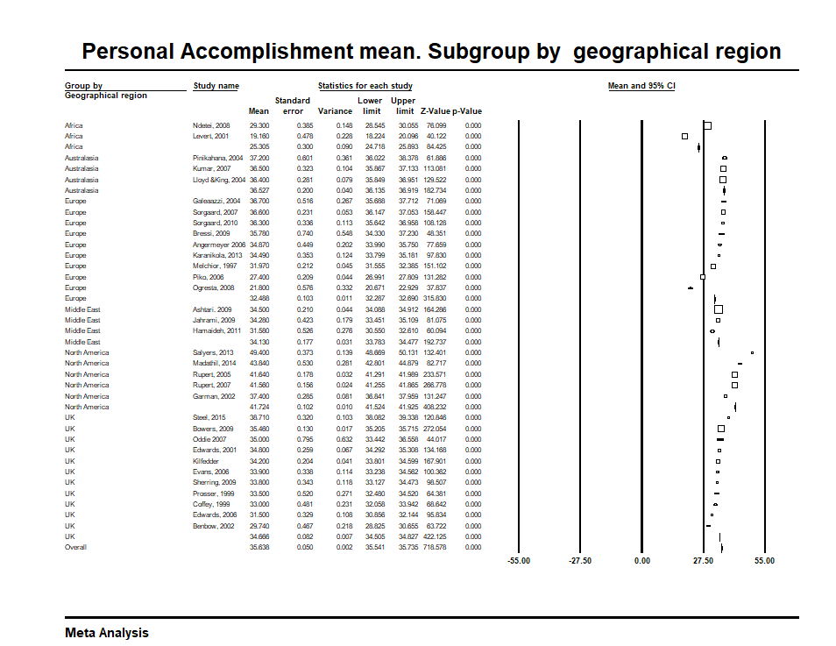

Forest plot of mean scores on MBI-HSS PA subscale. Random effects analysis. Africa (I² =99%, p<0.001), Australasia (I² =0, p=0.48), Europe (I² =99%, p<0.001), Middle East (I² =92.5, p<0.001), North America (I² =99%, p<0.001), UK (I² =97%, P<0.001)

Appendix 6: Results of meta-regression analyses

 | Meta-regression
MBI-EE | Slope | Z | p | LCI | UCI | Q | R²
Percent male | 0.04 | 0.84 | 0.4 | -0.05 | 0.132 | 0.70 | 0.00
Average age | -0.16 | -1.11 | 0.27 | -0.46 | 0.1297 | 1.23 | 0.00
Percent nurses | -0.02 | -2.19 | 0.02* | -0.037 | -0.0017 | 4.8 | 0.17
Percent doctors | 0.07 | 0.65 | 0.54 | -0.14 | 0.29 | 0.43 | 0.00
Percent psychologists | -0.003 | -0.4 | 0.68 | -0.01 | 0.01 | 0.16 | 0.00
Study size | -0.01 | 2.46 | 0.03* | -0.01 | -0.0004 | 4.53 | 0.03
MBI-DP
Percent male | -0.02 | -0.77 | 0.44 | -0.07 | 0.03 | 0.59 | 0.00
Average age | 0.34 | 0.75 | 0.45 | -0.5 | 1.25 | 0.56 | 0.00
Percent nurses | -0.01 | -2.65 | 0.008** | -0.019 | -0.003 | 7.01 | 0.27
Percent doctors | 0.004 | 0.31 | 0.75 | -0.2 | 0.03 | 0.10 | 0.00
Percent psychologists | -0.004 | -1.96 | 0.04* | -0.08 | -0.000 | 3.84 | 0.66
Study size | -0.002 | -1.8 | 0.06 | -0.005 | 0.002 | 3.3 | 0
MBI-PA
Percent male | 0.09 | 1.12 | 0.26 | -0.01 | 0.03 | 1.24 | 0.00
Average age | 0.36 | 2.86 | 0.01* | 0.11 | 0.62 | 6.52 | 0.52
Percent nurses | 0.01 | 1.33 | 0.18 | -0.005 | 0.03 | 1.77 | 0.00
Percent doctors | -0.003 | -0.24 | 0.82 | -0.03 | 0.02 | 0.06 | 0.00
Percent psychologists | 0.01 | 24.96 | <0.001*** | 0.011 | 0.013 | 622.8 | 1.0
Study size | -2.78 | -0.89 | 0.36 | -8.89 | 3.33 | 3.21 | 0.07

*<0.05, **<0.001, ***<0.005

Appendix 7

Prevalence of emotional exhaustion. Sub group by cut off on MBI-HSS EE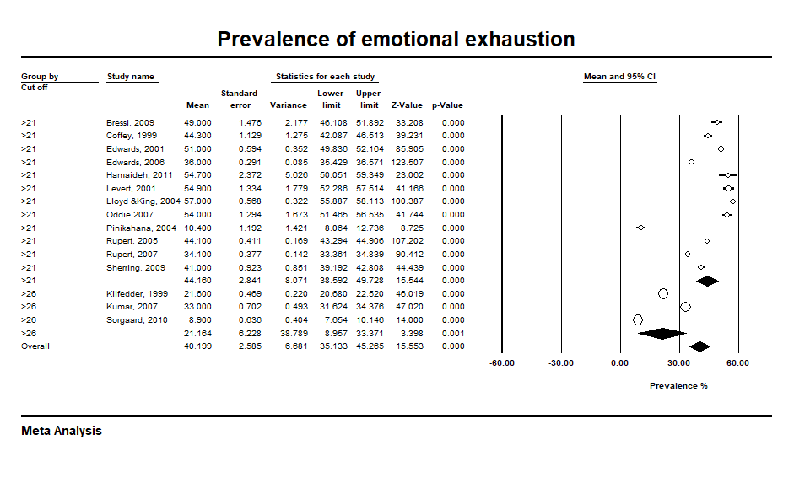

Prevalence of depersonalisation. Subgroup by cut off score

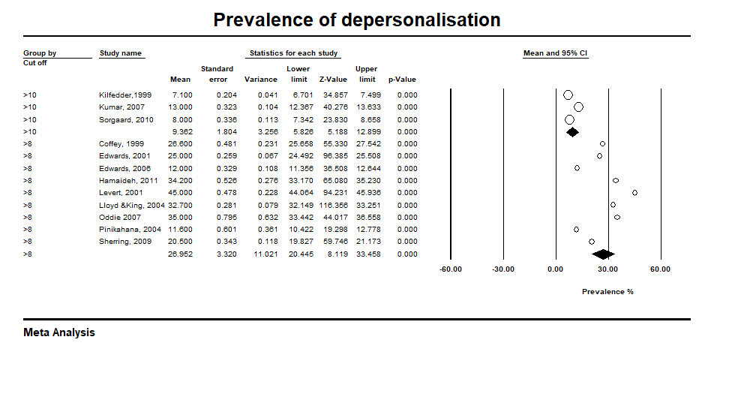

Prevalence of low personal accomplishment

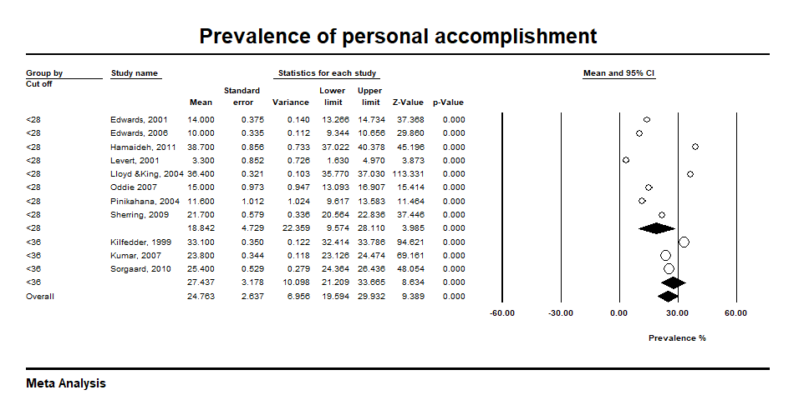

Appendix 8: Funnel Plots

- Funnel plot of means on MBI-EE

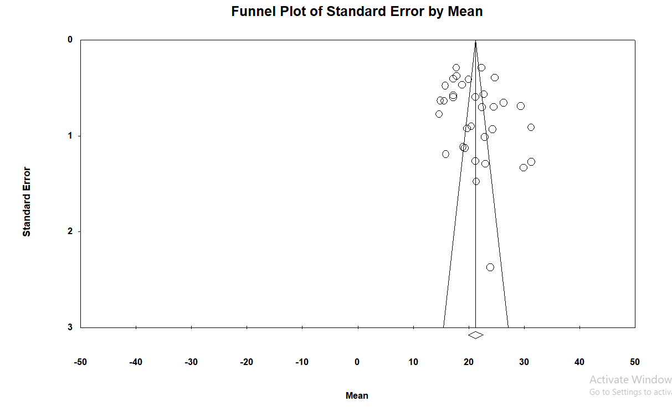

The Eggers test was not significant for bias for the means of MBI-EE (t=1.43, df=31, p=0.08)

- Funnel plot of means on MBI-DP

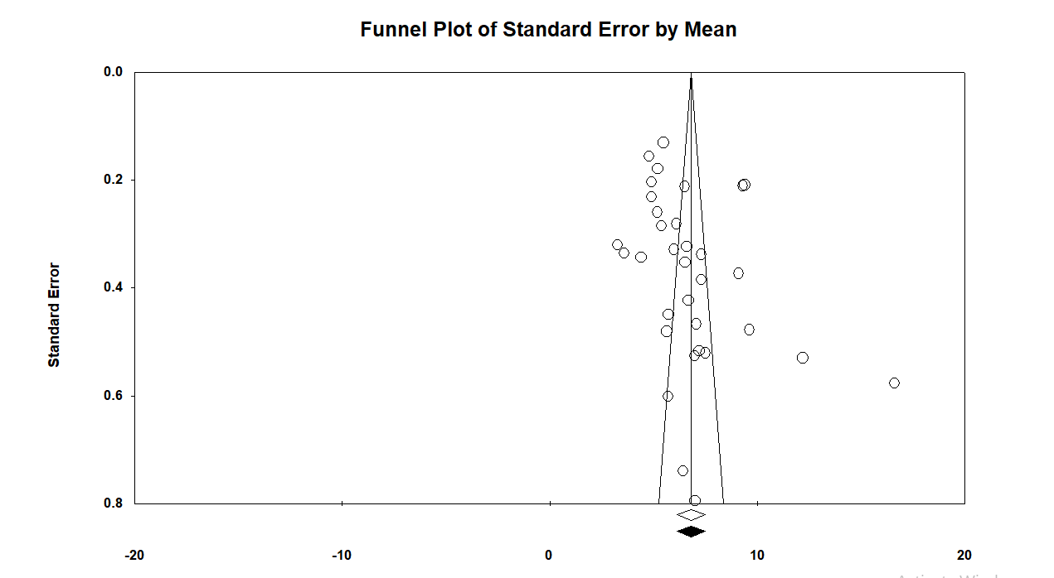

The Eggers test was not significant for bias for the means of MBI-DP (t=1.94, df=31, p=0.06)

- Funnel plot of means on MBI-PA

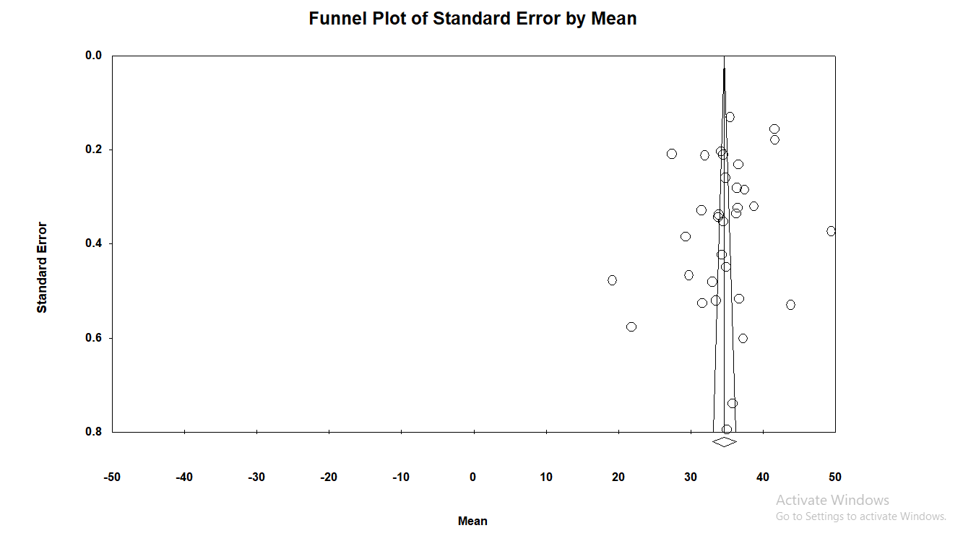

The Eggers test was not significant for bias for the means of MBI-PA (t=1.37, df=31, p=0.09).

- Funnel Plot of emotional exhaustion prevalence

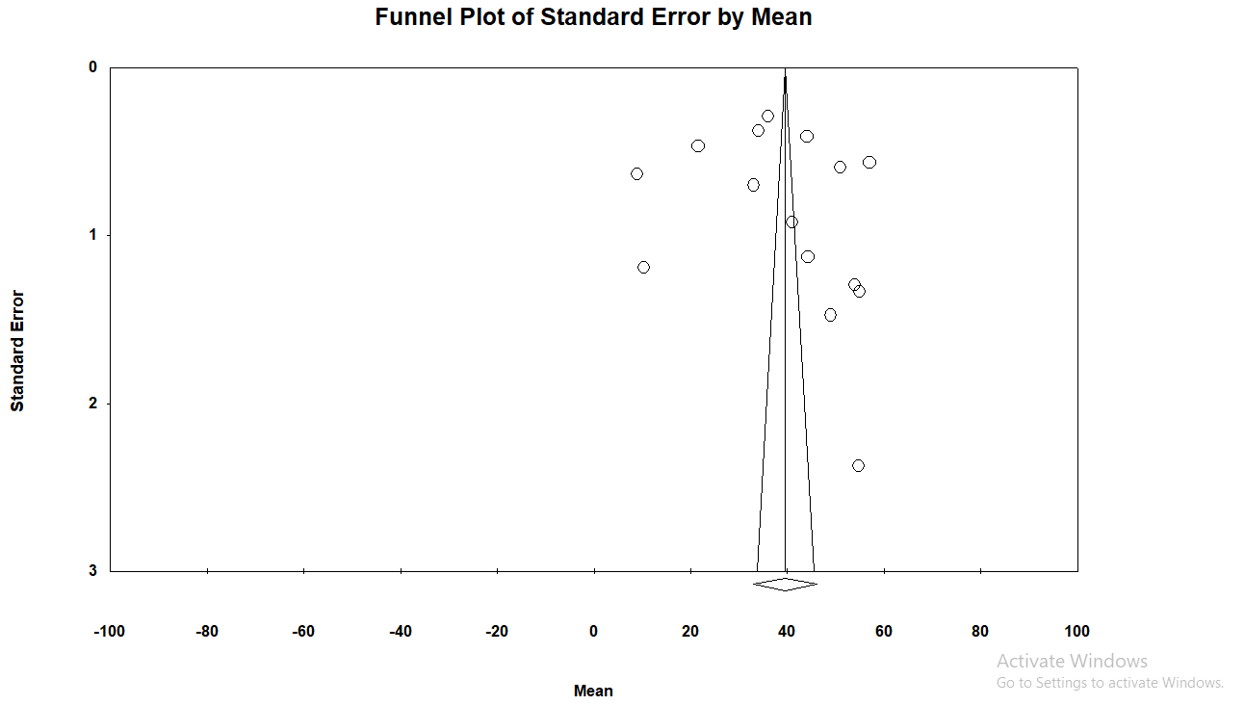

Egger's Test t= 0.50, df=13, p-value =0.30

- Funnel Plot of depersonalisation prevalence

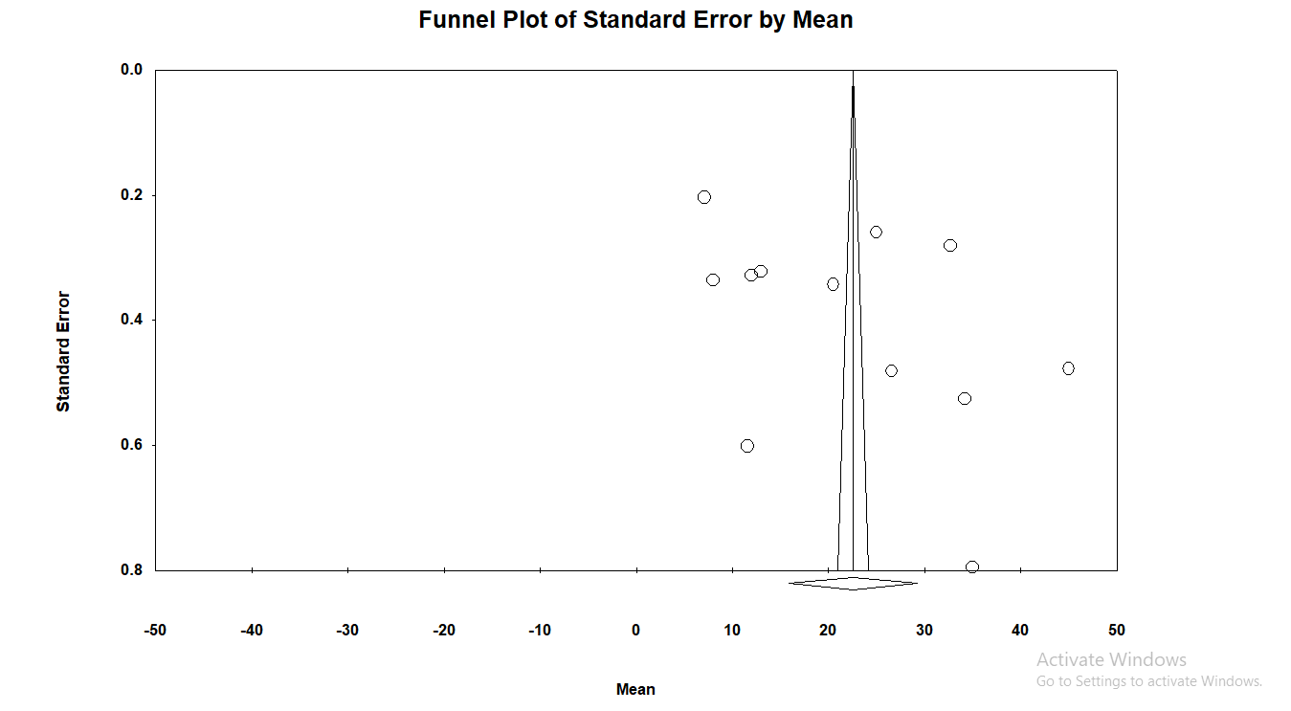
Egger’s Test t=1.61, df=10, p=0.07

- Funnel Plot of personal accomplishment prevalence

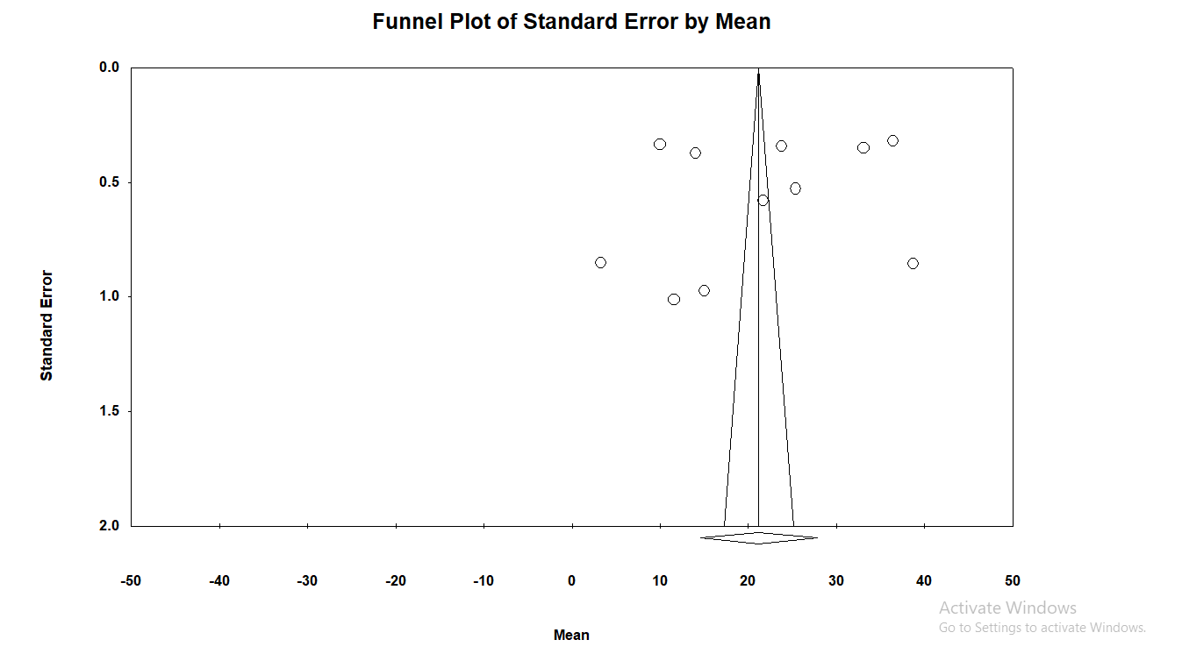

Egger’s Test t=0.63, df=9, p=0.26

