**Supplementary Material**

Figure A.1. The Monetary Incentive Delay task (revised version).

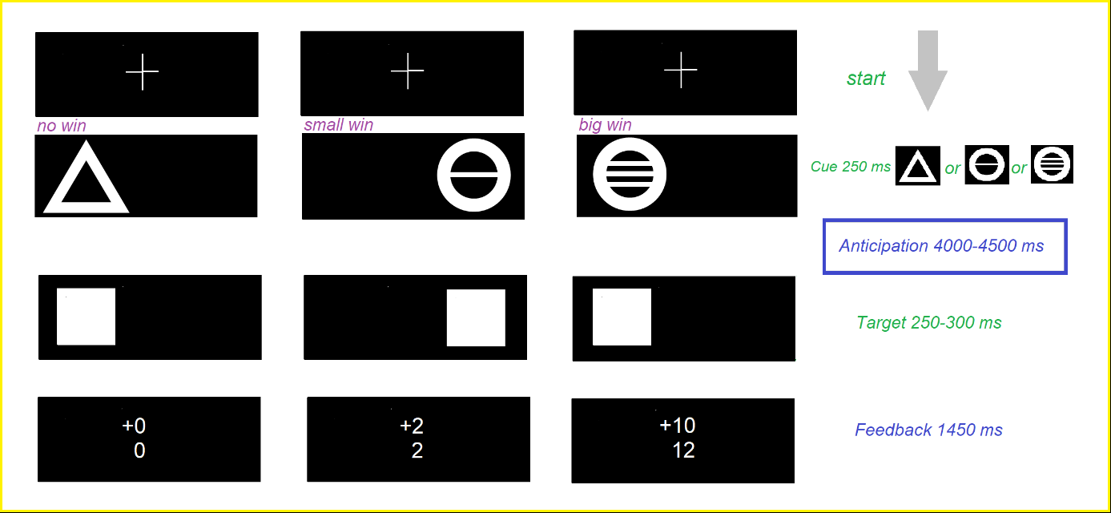

Volunteers performing the MID Task were expected to respond by pushing a button with their right or left index finger to a target stimulus (white square) that was always preceded by different cues appearing on the left or right hand side of the screen. Cues indicated that an accurate response to the target stimuli would result in no reward outcome (triangle), low reward outcome (circle with horizontal one line) and high reward (a circle with three horizontal parallel lines). Each cue appeared on the monitor for precisely 250ms. Then a black screen period followed (delay, 4000-4500ms) before having to make a response. The length of time the target stimulus (white square) appeared on the screen did not exceed 300ms (target 250-300ms). Immediately after the response, feedback was presented for precisely 1450ms. At this point the volunteer was informed whether he or she had won or lost points as well as the total amount of points won visually with text on the screen (Knutson et al., 2000). The MID task allows to measure the brain activation during the anticipation and feedback phases using contrasts of two conditions. Here, the procedure involves subtracting the difference in activity between a condition involving a process of anticipation of a big win *and* a condition involving a process of anticipation of a small win (contrast of anticipation of a big *versus* small win).

Appendix A.1. The Go/No-Go and Hayling tests.

The Go/No-Go test (54)

The Go and No-Go stimuli were always preceded by a fixation stimulus that appeared at the centre of the monitor. The circles that appeared at the top right and bottom left corners served as Go stimuli, to which the participants had to respond by pressing a button as quickly as possible. The No-Go stimuli, to which the participants were asked to withhold their response, appeared at the top left and bottom right corners. After a non-recorded practice phase, the experiment consisted of twenty Go and twenty No-Go trials. The participants were instructed to press a button as quickly as possible whenever they saw a circle in either the top right or bottom left corner. Our dependent variable was the total number of errors of commission and omission during the Go/No-Go test.

The Hayling test (55)

The Hayling test, which measures inhibition control, is divided in two conditions (Automatic and Inhibition), for which two different sets of 15 sentences are assigned. In the “Automatic” condition, the experimenter reads aloud unfinished sentences and participants have to complete them aloud by using the most congruent word as quickly as possible (e.g. “London is a very beautiful TOWN”), yielding a simple measure of response initiation speed. In the “Inhibition” condition, participants are told to complete aloud as quickly as possible unfinished sentences with an incongruent word that is completely unrelated to it and nonsensical in the context of that sentence (e.g. “He mailed his letter and forgot to put SCISSORS”). The time latency, number of penalties and correct answers provide measures of response suppression ability. Our dependent variables were the time latency, number of penalties and correct answers.

Supplementary Figure B.1. Regions with reduction in grey matter volumes in FH+ participants compared to FH- participants with tobacco use as confounding variable.

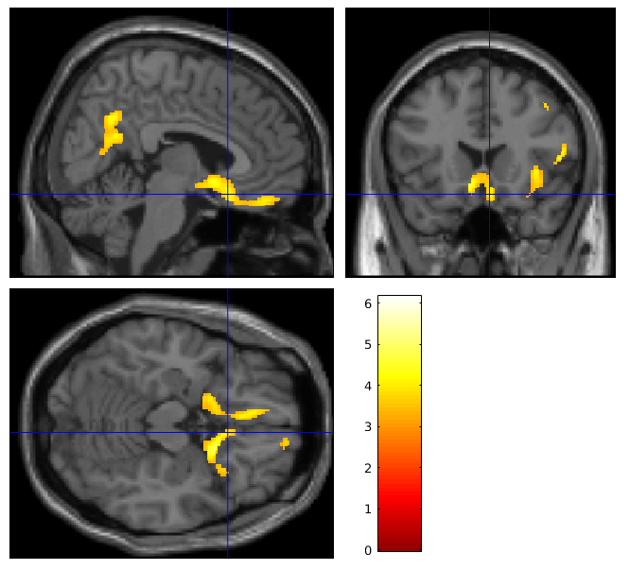

Extent threshold at *p*<0.05 Family-Wise Error (FWE) corrected (cluster size > 520 voxels); Height threshold at *p*<0.001 uncorrected. *p* values in bold are statistically significant (*p*<0.05 FWE corrected). Sample size: n=37 FH+ and n=36 FH-.

Supplementary Figure B.2. Regions with increased BOLD signal during anticipation of a big versus small win in FH- participants compared to FH+ participants with tobacco use as confounding variable.

Extent threshold at *p*<0.05 Family-Wise Error (FWE) corrected (cluster size > 80 voxels); Height threshold at *p*<0.001 uncorrected. *p* values in bold are statistically significant (*p*<0.05 FWE corrected). Sample size: n=31 FH+ and n=29 FH-.

Supplementary Figure C.1. The effects of childhood maltreatment on brain structure in participants with a family history of alcohol use disorder.

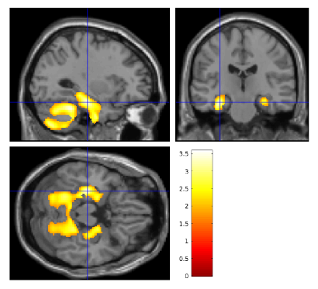

The higher the Childhood Trauma Questionnaire score, the smaller the grey matter volumes in the colored regions. Color bar indicates *T* values. Crosshair is at MNI coordinates x= -30, y= -21, z= -20. Height threshold was set at *p*<0.05 uncorrected and cluster size > 350 voxels. Sample size: n=37.

Supplementary Table A.1. Regions of negative correlations between the grey matter volumes and Childhood Trauma Questionnaire score in participants with a family history of alcohol use disorder.

|  |  |  |  |  |  |  |  |
| --- | --- | --- | --- | --- | --- | --- | --- |
| **Region** | **Cluster level** | | **Peak level** | | **MNI Coordinates** | | |
|  | **Cluster size**  **(in voxels)** | ***p* value uncorrected** | ***T*** | ***p* value uncorrected** | **x** | **y** | **z** |
| L Lobule VIII of cerebellar hemisphere | 24147 | **1.1495e-07** | 3.58 | 3.2581e-04 | -21 | -64 | -51 |
| L Lobule VI of cerebellar hemisphere |  |  | 3.51 | 4.0466e-04 | -28 | -44 | -27 |
| R Lobule VIII of cerebellar hemisphere |  |  | 3.49 | 4.3177e-04 | 24 | -52 | -52 |
| R Lobule VIIB of cerebellar hemisphere |  |  | 3.42 | 5.4515e-04 | 34 | -69 | -50 |
| R Crus II of cerebellar hemisphere |  |  | 3.40 | 5.8653e-04 | 34 | -72 | -46 |
| L Crus II of cerebellar hemisphere |  |  | 3.03 | 0.0018 | -20 | -78 | -44 |
| Lobule VII of vermis |  |  | 3.04 | 0.0017 | 2 | -68 | -28 |
| R Hippocampus |  |  | 3.30 | 7.8906e-04 | 30 | -30 | -9 |
| L Hippocampus |  |  | 3.06 | 0.0016 | -28 | -32 | -9 |
| L Parahippocampal gyrus |  |  | 3.40 | 5.7426e-04 | -30 | -21 | -20 |

MNI: Montreal Neurological Institute (coordinates in mm); R: Right; L: Left; Height threshold at *p*<0.05 uncorrected and extent threshold at *p*<0.05 Family-Wise Error corrected (cluster size > 8000 voxels). *p* values in bold are statistically significant (*p*<0.05 cluster-level FWE corrected). Sample size: n=37.

Supplementary Figure D.1. Regions with reduction in grey matter volumes in FH+ participants compared to FH- participants with cannabis use as confounding variable.

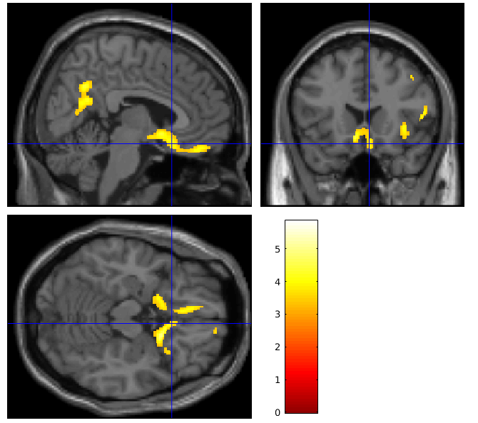

Extent threshold at *p*<0.05 Family-Wise Error (FWE) corrected (cluster size > 520 voxels); Height threshold at *p*<0.001 uncorrected. *p* values in bold are statistically significant (*p*<0.05 FWE corrected). Sample size: n=37 FH+ and n=36 FH-.

Supplementary Figure D.2. Regions with increased BOLD signal during anticipation of a big versus small win in FH- participants compared to FH+ participants with cannabis use as confounding variable.

Extent threshold at *p*<0.05 Family-Wise Error (FWE) corrected (cluster size > 80 voxels); Height threshold at *p*<0.001 uncorrected. *p* values in bold are statistically significant (*p*<0.05 FWE corrected). Sample size: n=31 FH+ and n=29 FH-.

Supplementary Figure C.2. The effects of childhood maltreatment on brain activation in participants with a family history of alcohol use disorder.

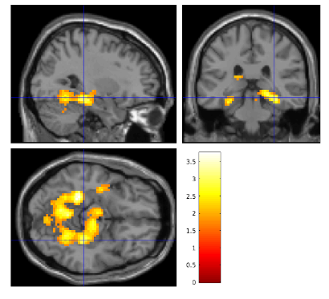

The higher the Childhood Trauma Questionnaire score, the greater the BOLD signal in the colored regions during the processing of big win *vs* small win. Color bar indicates *T* values. Crosshair is at MNI coordinates x= 30, y= -31, z= -13. Height threshold was set at *p*<0.05 uncorrected and cluster size > 350 voxels. Sample size: n=31.

Supplementary Table A.2. Regions of positive correlations between the BOLD signal in response to big win *vs* small win and Childhood Trauma Questionnaire score in participants with a family history of alcohol use disorder.

|  |  |  |  |  |  |  |  |
| --- | --- | --- | --- | --- | --- | --- | --- |
| **Region** | **Cluster level** | |  | **Peak level** | **MNI Coordinates** | | |
|  | **Cluster size**  **(in voxels)** | ***p* value uncorrected** | ***T*** | ***p* value uncorrected** | **x** | **y** | **z** |
| L Fusiform gyrus | 1722 | **2.0294e-04** | 3.71 | 2.4649e-04 | -24 | -40 | -13 |
| R Fusiform gyrus |  |  | 2.81 | 0.0034 | 24 | -55 | -13 |
| R Lingual gyrus |  |  | 2.80 | 0.0035 | 21 | -52 | -10 |
| L Lingual gyrus |  |  | 3.42 | 5.9973e-04 | -9 | -67 | -4 |
| L Lobule IV, V of cerebellar hemisphere |  |  | 3.33 | 7.9589e-04 | -9 | -58 | -10 |
| R Inferior frontal gyrus, pars orbitalis |  |  | 3.12 | 0.0014 | 30 | -31 | -13 |
| R Parahippocampal gyrus |  |  | 3.08 | 0.0016 | 24 | -34 | -10 |
| L Parahippocampal gyrus |  |  | 2.85 | 0.0031 | -24 | -49 | 2 |

MNI: Montreal Neurological Institute (coordinates in mm); R: Right; L: Left; Height threshold at *p*<0.05 uncorrected and extent threshold at *p*<0.05 Family-Wise Error corrected (cluster size > 1250 voxels). *p* values in bold are statistically significant (*p*<0.05 cluster-level FWE corrected). Sample size: n=31.