Supplementary Figure 1. Bootstrapped confidence intervals of edge-weights of restrictive group.
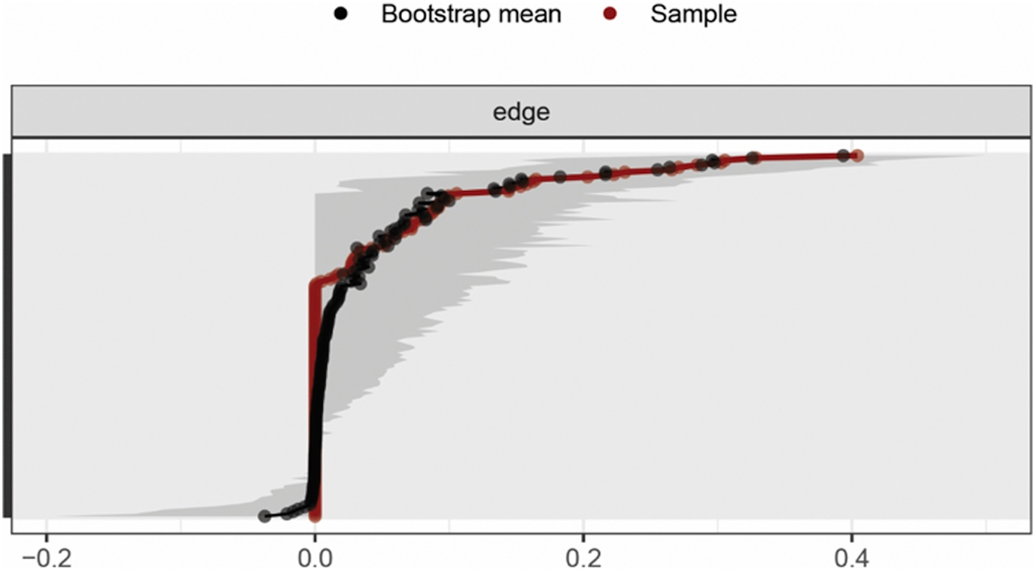
Supplementary Figure 2. Bootstrapped confidence intervals of edge-weights of binge-purging group.

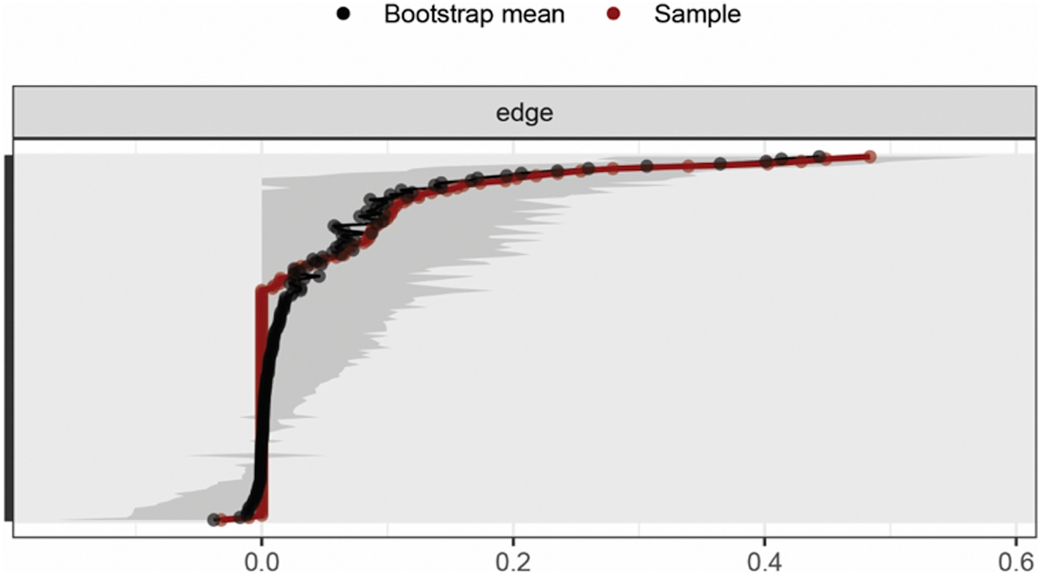
Appendix. Code used for network analysis with RStudio in the present paper
library(“readxl”)
library("qgraph")
library("bootnet")
library("huge")
anr <- read_excel("C:/Users/…/ANR.xlsx")
anromit <- na.omit(anr)
names(anromit) <- c ("IN", "MF", "SI", "BD", "P", "ID", "IR", "DT", "BU", "IA", "ASC", "EN", "EA", "SA", "PN", "PA", "STAI-S", "STAI-T")
corMatanr <- huge.npn(anromit, npn.func='skeptic')
Names <- scan("C:/Users/… /names.txt", what = "character", sep = "\n")
Graph_lassoanr <- qgraph(corMatanr, graph = "glasso", layout = "spring", tuning = 0.5, sampleSize = nrow(anromit), minimum = 0.05, maximum = 1, details = FALSE, esize = 20, lambda.min.ratio = 0.01, cut = 0.15, groups = list("EDI"= 1:11, "CTQ"= 12:16, "STAI"= 17:18), nodeNames = Names, legend.cex = 0.3, vsize = 5, esize = 15, pastel = TRUE, posCol = "#003399", negCol = "#FF9933",color = c("orange", "green", "yellow"), borders = FALSE, vTrans = 200, details = TRUE)
pathways(Graph_lassoanr, from = c("EA","EN","PA","PN","SA"), to = c("IA","IN","IR","MF","P","ASC","BD","DT","BU", "SI", "ID"), fading = 0.25, lty = 3)
anrGraph <- estimateNetwork(anromit, default = "EBICglasso", tuning = 0.5, corMethod = "npn")
boot1anr <- bootnet(anrGraph, nCores = 8, nBoots = 2500, type = "nonparametric")
plot(boot1anr, order = "sample", labels = FALSE)
bp <- read_excel("C:/Users/… /BP.xlsx")
bpomit <- na.omit(bp)
names(bpomit) <- c ("IN", "MF", "SI", "BD", "P", "ID", "IR", "DT", "BU", "IA", "ASC", "EN", "EA", "SA", "PN", "PA", "STAI-S", "STAI-T")
corMatbp <- huge.npn(bpomit, npn.func='skeptic')
Graph_lassobp <- qgraph(corMatbp, graph = "glasso", layout = "spring", tuning = 0.5, sampleSize = nrow(bpomit), minimum = 0.05, maximum = 1, details = FALSE, esize = 20, lambda.min.ratio = 0.01, cut = 0.15, groups = list("EDI"= 1:11, "CTQ"= 12:16, "STAI" = 17:18), nodeNames = Names, legend.cex = 0.3, vsize = 5, esize = 15, pastel = TRUE, posCol = "#003399", negCol = "#FF9933",color = c("orange", "green", "yellow"), borders = FALSE, vTrans = 200, details = TRUE)
pathways(Graph_lassobp, from = c("EA","EN","PA","PN","SA"), to = c("BD","DT", "IA", "BU", "IR", "IN", "SI", "ID", "P", "MF", "P", "ASC"), fading = 0.25, lty = 3)
bpGraph <- estimateNetwork(bpomit, default = "EBICglasso", tuning = 0.5, corMethod = "npn")
boot1bp <- bootnet(bpGraph, nCores = 8, nBoots = 2500, type = "nonparametric")
plot(boot1bp, order = "sample", labels = FALSE)

