**APPENDIX**

Table S1. Mean values and standard deviation (SD) of clinical variables in selected sites for microbial sampling according to the patient characteristics (time of sampling in relation with therapy).

|  |  |  |  |  |  |
| --- | --- | --- | --- | --- | --- |
|  | Global  mean (SD) | Pre-SRP  mean (SD) | Post-SRP  mean (SD) | Post-periodontal surgery  mean (SD) | SPT  mean (SD) |
| n | 59 | 44 | 3 | 5 | 7 |
| PlI (%); mean (SD) | 70.67 (34.91) | 76.28 (34.39) | 62.50 (53.03) | 68.75 (42.69) | 42.86 (18.90) |
| BOP (%); median (IR) | 0 (37.50) | 100.00 (0) | 100.00 (-) | 0 (56.25) | 50.00 (75.00) |
| PD (mm) ; mean (SD) | 6.06 (1.92) | 6.91 (1.20) | 5.00 (0.87) | 3.75 (1.67) | 2.75 (0.66) |
| REC (mm) ; mean (SD) | 1.12 (1.02) | 1.18 (1.07) | 0.58 (0.52) | 1.62 (0.48) | 0.78 (1.01) |

*SRP: scaling and root planing; SPT: supportive periodontal therapy; SD: standard deviation; BOP: bleeding on probing; PD: probing depth; PlI: plaque index; REC: recession; IR: Interquartile range*

Figure S1. Boxplot of clinical variables according to time of sampling with therapy.

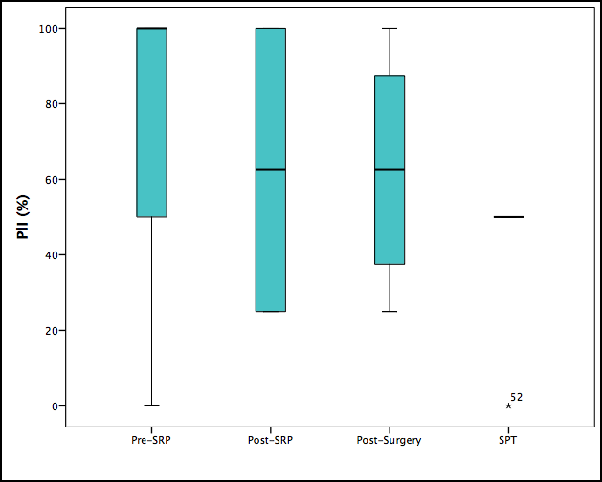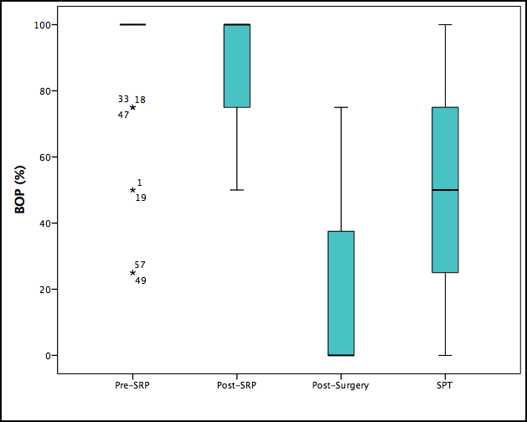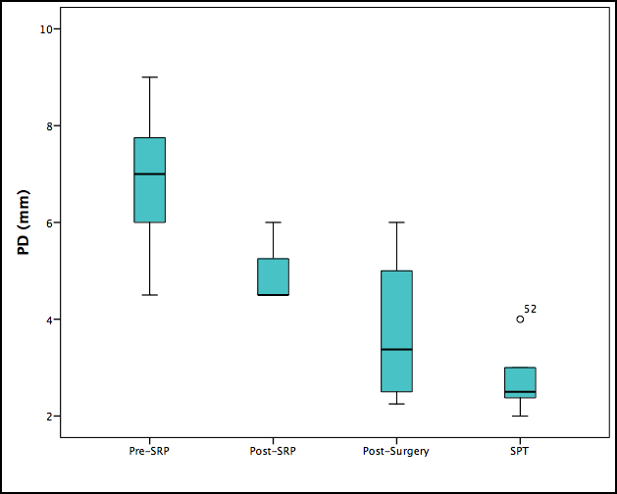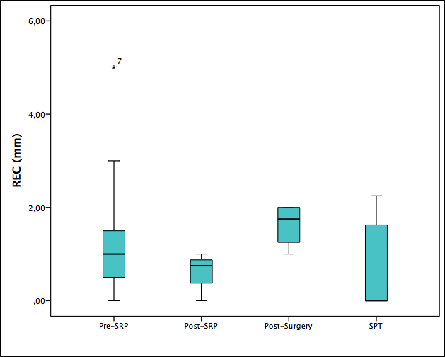

*SRP: scaling and root planing; SPT: supportive periodontal therapy; BOP: bleeding on probing; PD: probing depth; PlI: plaque index; REC: recession.*

**Per-SRP Post-SRP Post-surgery SPT**

Table S2: Mean values and standard deviation (SD) of clinical variables in selected sites for microbial sampling according the origin from the sample.

|  |  |  |  |  |  |  |
| --- | --- | --- | --- | --- | --- | --- |
|  | University | Private | Research 1 | Research 2 | Research 3 | Research 4 |
| n | 16 | 28 | 6 | 4 | 3 | 2 |
| PlI (%) | 78.33 (29.68) | 69.32 (41.49) | 50.00 (0.00) | 100.00 (20.41) | 50.00 (25.00) | 62.50 (53.03) |
| BOP (%) | 91.67 (18.09) | 90.22 (25.82) | 58.33 (34.15) | 68.75 (31.45) | 0.00 (0.00) | 75.00 (35.35) |
| PD (mm) | 7.13 (1.29) | 6.75 (1.08) | 2.54 (0.40) | 5.88 (1.88) | 3.00 (0.90) | 4.50 (0.00) |
| REC (mm) | 1.25 (1.24) | 1.08 (1.02) | 0.67 (1.04) | 1.44 (0.43) | 1.50 (0.50) | 0.88 (0.18) |

*BOP: bleeding on probing; PD: probing depth; PlI: plaque index; REC: recession; SD: standard deviation.*