SUPPLEMENTARY MATERIALS

SUPPLEMENTARY MATERIALS 1
Study protocol

SUPPLEMENTARY MATERIALS 2
Detailed information on search strategy

SUPPLEMENTARY MATERIALS 3
PRISMA flow diagram

SUPPLEMENTARY MATERIALS 4
Overview of excluded studies

STUDY PROTOCOL

Blood-brain barrier permeability and electroconvulsive therapy - a systematic review
Christoffer C. Lundsgaard^{1,2}, Krzysztof Gbyl^{1,2}, Poul Videbech^{1,2}
- Center for Neuropsychiatric Depression Research, Mental Health Centre Glostrup, Denmark
- Institute of Clinical Medicine, Faculty of Health and Medical Sciences, University of Copenhagen, Copenhagen, Denmark
Contact person: Christoffer C. Lundsgaard, e-mail: christoffer.cramer.lundsgaard@regionh.dk

OBJECTIVES
The objective is to examine if electrically induces seizures affect the permeability of the BBB in humans (ECT) and animal models (ECS).

METHODS
This review adheres to PRISMA rules (1,2).

CRITERIA FOR STUDY SELECTION

Inclusion criteria

Language

English
Design of studies
- Studies measuring BBB permeability before and after ECT/ECS
- Studies measuring BBB permeability after ECT/ECS compared with normative data or controls
Type of participants
- Animals (healthy or in a psychiatric disease model)
- Humans (healthy or diagnosed with a psychiatric disease)
Type of intervention
- Modified (muscular relaxation, anaesthetics and ventilation) electroconvulsive treatment used in humans or animals. Electroconvulsive treatment used in animals must be comparable to treatment used in humans.
Type of outcome measures
Changes in BBB permeability measured as either
- Permeability
- The permeability surface area-product
- The transfer coefficient, K_{i},
- The cerebrospinal fluid/serum or plasma albumin ratio
- The presence of an injected tracer in the CNS that were not present before treatment or not present in controls.

Exclusion criteria
Comment or letters to editor, grey literature, and conference abstracts. ECT/ECS used in non-psychiatric diseases or disease models known to affect the BBB permeability.

SEARCH METHODS
Electronic sources
- MEDLINE (searched through Pubmed) and Embase (searched through Ovid) databases are used
- The following search strategy is used
Blood brain barrier (controlled vocabulary i.e. Emtree/MeSH) | AND | Electroconvulsive therapy (controlled vocabulary i.e. Emtree/MeSH)
OR |  | OR
“blood brain barrier*” (text word) |  | “electroconvulsive therap*” (text word)
“blood-brain barrier*” (text word) |  | ECT (text word)
BBB (text word) |  | Electroconvulsive stimulation (text word)
 |  | “electroconvulsive shock” (text word)
 |  | “electroshock*” [text word]

Other sources
- Reference lists of obtained articles are scrutinized for studies not found in the electronic databases
- If necessary, authors of included articles are contacted to obtain additional information.

DATA COLLECTION AND ANALYSIS
Selection of studies
The search results in the electronic databases are checked for duplicates and then screened by reading the titles and/or abstracts by one reviewer. Full texts of the chosen articles are retrieved and assessed for inclusion by applying the above-stated eligibility criteria. The full-text screening is performed by two independent reviewers. Any disagreements will be resolved by consensus.

Data extraction and management
The following data is extracted
- Subject characteristics
- Number of participants/number of animals in study
- Gender (male/female)
- Age (mean)
- Diagnosis
- Medication status

- Study design
  - Method applied
  - Time of measurement after ECT/ECS

- ECT parameters
- Electrode placement: Right Unilateral (RUL) / Bilateral (BL) / both RUL- BL /Bifrontal
- Type of current (Brief/Ultrabrief/Sine wave)
- The number of ECT treatments
- Type of ECT machine
- Electrical current given (millicoulomb) (mean, SD)
- Duration of EEG seizure time (mean, SD)

- Study outcomes
  - Change in BBB permeability
Data extraction is undertaken by two reviewers. Any disagreements are resolved by consensus.

ASSESSMENT OF METHODOLOGICAL QUALITY OF STUDIES
Pre-post studies are assessed with the National Institute of Health pre-post assessment (4). Evaluations are undertaken by two reviewers (CL, PV). Disagreements are solved by consensus.
Only clinical studies are assessed for risk of bias and methodological quality.
1. Liberati A, Altman DG, Tetzlaff J, Mulrow C, Gøtzsche PC, Ioannidis JPA, et al. The PRISMA statement for reporting systematic reviews and meta-analyses of studies that evaluate health care interventions: explanation and elaboration. J Clin Epidemiol. 2009 Oct;62(10):e1-34.
2. Page MJ, McKenzie JE, Bossuyt PM, Boutron I, Hoffmann TC, Mulrow CD, et al. The PRISMA 2020 statement: an updated guideline for reporting systematic reviews. BMJ. 2021 Mar 29;372:n71.
3. Gagnier JJ, Kienle G, Altman DG, Moher D, Sox H, Riley D, et al. The CARE guidelines: consensus-based clinical case report guideline development. J Diet Suppl. 2013 Dec;10(4):381–90.
4. https://www.nhlbi.nih.gov/health-topics/study-quality-assessment-tools (2 June 2022).

DETAILED INFORMATION ON SEARCH STRATEGY

PubMed/Medline

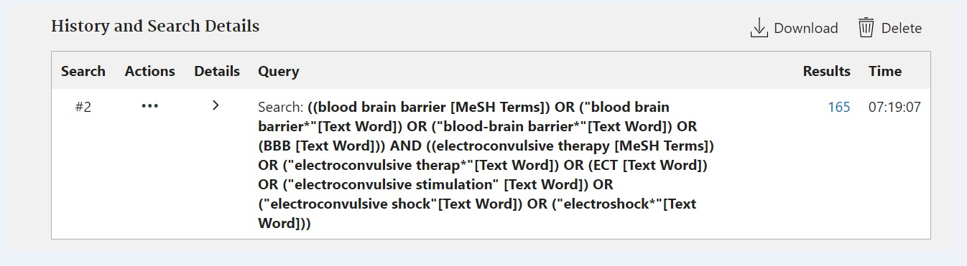

Embase/Ovid

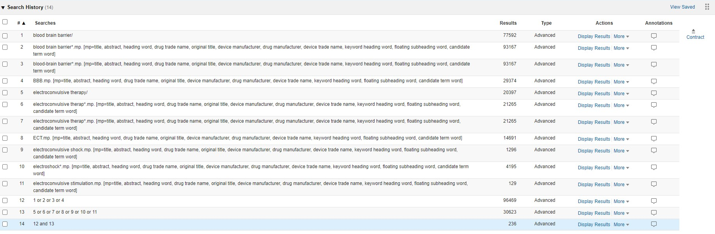

PRISMA FLOW DIAGRAM

Identification of studies via databases

Records removed before screening:
Duplicate records removed
n = 86
Records identified from Medline
n=165
Records identified from Embase
n=236

Identification

Records screened
n = 315
Records excluded
n = 282

Reports sought for retrieval
n = 33
Reports not retrieved
n = 0

Screening

Reports excluded (human):
No direct measurement of BBB permeability (n = 4)
Not modified ECT (n = 1)
Reports excluded (animals)
Wrong study design (n = 2)
No direct measurement of BBB permeability (n = 2)
Electroconvulsive stimulation not comparable to treatment used in humans (n = 17)
Reprint of data previously reported (n=1)

Reports assessed for eligibility
n = 33

Studies included in review (human) n = 2
Studies included in review (animals) n = 4
Included

From: Page MJ, McKenzie JE, Bossuyt PM, Boutron I, Hoffmann TC, Mulrow CD, et al. The PRISMA 2020 statement: an updated guideline for reporting systematic reviews. BMJ 2021;372:n71. doi: 10.1136/bmj.n71

OVERVIEW OF EXCLUDED STUDIES

 | Study | Reason for exclusion
1 | Alexopoulos GS, Kocsis JH, Stokes PE. Increase in CSF protein in association with ECT. J Neurol Neurosurg Psychiatry. 1978 Dec;41(12):1145-6. doi: 10.1136/jnnp.41.12.1145. PMID: 731258; PMCID: PMC493245. | No direct measurement of BBB permeability
2 | Angel C, Hartman AM, Burkett ML, Roberts AJ. Effects of electroshock and trypan red on the blood-brain barrier and response retention in the rat. J Nerv Ment Dis. 1965 Jun;140(6):405-11. doi: 10.1097/00005053-196506000-00002. PMID: 5827241. | Electroconvulsive stimulation not comparable to treatment in humans
3 | Angel C, Roberts AJ. Effect of electroshock and antidepressant drugs on cerebrovascular permeability to cocaine in the rat. J Nerv Ment Dis. 1966 Apr;142(4):376-80. doi: 10.1097/00005053-196604000-00008. PMID: 5946050. | Electroconvulsive stimulation not comparable to treatment in humans
4 | Awasthi PK, Shanker K, Gulati A, Dhawan KN, Bhargava KP. Increased permeability of blood brain barrier after electro-convulsive shocks (ECS). Pharmacol Res Commun. 1982 Nov;14(10):983-92. doi: 10.1016/s0031-6989(82)80063-5. PMID: 7156177. | Electroconvulsive stimulation not comparable to treatment in humans
5 | Barkai AI. Long-term effect of electroshock treatment on the entry of calcium into the cerebroventricular fluid in the rat. J Neurosci Res. 1983;9(2):165-71. doi: 10.1002/jnr.490090208. PMID: 6842624. | Electroconvulsive stimulation not comparable to treatment in humans
6 | Blair-West JR, Denton DA, Gibson AP, McKinley MJ. Opening the blood-brain barrier to zinc. Brain Res. 1990 Jan 15;507(1):6-10. doi: 10.1016/0006-8993(90)90513-b. PMID: 2302580. | No direct measurement of BBB permeability
7 | Bolwig TG, Fuglsang-Frederiksen A. Electrolytes in brain, liver, diaphragm, and blood after electroshock in rats. Acta Psychiatr Scand. 1972;48(5):386-93. doi: 10.1111/j.1600-0447.1972.tb04382.x. PMID: 4657462. | No direct measurement of BBB permeability
8 | Carroll BJ, Steven L, Pope RA, Davies B. Sodium transfer from plasma to CSF in severe depressive illness. Arch Gen Psychiatry. 1969 Jul;21(1):77-81. doi: 10.1001/archpsyc.1969.01740190079011. PMID: 5793683. | No direct measurement of BBB permeability
9 | CLARK G, SARKARIA DS. Acid fuchsin convulsions and electroshock in the mouse. J Neuropathol Exp Neurol. 1958 Oct;17(4):612-9. doi: 10.1097/00005072-195810000-00008. PMID: 13588390. | Electroconvulsive stimulation not comparable to treatment in humans
10 | EDSTROEM R. AN ATTEMPT TO MEASURE THE TWO-WAY PERMEABILITY IN THE BLOOD-BRAIN-CSF SYSTEM. Acta Physiol Scand. 1964 Jul;61:212-8. doi: 10.1111/j.1748-1716.1964.tb02960.x. PMID: 14196577. | Electroconvulsive stimulation not comparable to treatment in humans
11 | Goldfarb S, Fainstein N, Ganz T, Vershkov D, Lachish M, Ben-Hur T. Electric neurostimulation regulates microglial activation via retinoic acid receptor α signaling. Brain Behav Immun. 2021 Aug;96:40-53. doi: 10.1016/j.bbi.2021.05.007. Epub 2021 May 12. PMID: 33989746. | Electroconvulsive stimulation not comparable to treatment in humans
12 | Gulati A, Srimal RC, Dhawan KN, Dhawan BN. On the mechanism of potentiation of apomorphine-induced stereotypy due to electroconvulsive shock. Neuropharmacology. 1987 Dec;26(12):1733-7. doi: 10.1016/0028-3908(87)90125-0. PMID: 3437939. | Electroconvulsive stimulation not comparable to treatment in humans
13 | HARTMAN AM, ANGEL C. THE EFFECT OF TRYPAN RED AND ELECTROCONVULSIVE SHOCK ON RESPONSE ACQUISITION IN THE RAT. J Nerv Ment Dis. 1964 Oct;139:387-92. doi: 10.1097/00005053-196410000-00012. PMID: 14205647. | Electroconvulsive stimulation not comparable to treatment in humans
14 | Hirano A, Becker NH, Zimmerman HM. The use of peroxidase as a tracer in studies of alterations in the blood-brain barrier. J Neurol Sci. 1970 Mar;10(3):205-13. doi: 10.1016/0022-510x(70)90150-4. PMID: 5441552. | Electroconvulsive stimulation not comparable to treatment in humans
15 | Ito M, Bolati K, Kinjo T, Ichimura K, Furuta A, McLoughlin DM, Suzuki T, Arai H. Electroconvulsive stimulation transiently enhances the permeability of the rat blood-brain barrier and induces astrocytic changes. Brain Res Bull. 2017 Jan;128:92-97. doi: 10.1016/j.brainresbull.2016.11.011. Epub 2016 Nov 30. PMID: 27915091. | Electroconvulsive stimulation not comparable to treatment in humans
16 | Khadka N, Bikson M. Neurocapillary-Modulation. Neuromodulation. 2020 Dec 19:10.1111/ner.13338. doi: 10.1111/ner.13338. Epub ahead of print. PMID: 33340187; PMCID: PMC8213863. | Wrong study design
17 | Laursen H, Gjerris A, Bolwig TG, Barry DI. Cerebral Edema and Vascular Permeability to Serum Proteins Following Electroconvulsive Shock in Rats. Convuls Ther. 1991;7(4):237-244. PMID: 11941128. | Electroconvulsive stimulation not comparable to treatment in humans
18 | Nomikos GG, Zis AP, Damsma G, Fibiger HC. Electroconvulsive shock increases interstitial concentrations of uric acid in the rat brain. Brain Res. 1994 Oct 10;660(1):50-6. doi: 10.1016/0006-8993(94)90837-0. PMID: 7828001. | Electroconvulsive stimulation not comparable to treatment in humans
19 | Oztaş B, Kaya M. Blood-brain barrier permeability during acute and chronic electroconvulsive seizures. Pol J Pharmacol Pharm. 1991 Jul-Aug;43(4):259-63. PMID: 1811218. | Electroconvulsive stimulation not comparable to treatment in humans
20 | Oztas B, Kaya M, Camurcu S. Age related changes in the effect of electroconvulsive shock on the blood brain barrier permeability in rats. Mech Ageing Dev. 1990 Feb 1;51(2):149-55. doi: 10.1016/0047-6374(90)90097-y. PMID: 2308390. | Electroconvulsive stimulation not comparable to treatment in humans
21 | Oztas B., Sandalci U. Blood-brain barrier permeability after pentylenetetrazol and electrically induced seizure. IRCS MED. SCI. 1984;12(6):488-489. Cited in: Embase at http://ovidsp.ovid.com/ovidweb.cgi?T=JS&PAGE=reference&D=emed3&NEWS=N&AN=14113475. | Electroconvulsive stimulation not comparable to treatment in humans
22 | ROSENBLATT S, CHANLEY JD, SOBOTKA H, KAUFMAN MR. Interrelationships between electroshock, the blood-brain barrier, and catecholamines. J Neurochem. 1960 Feb;5:172-6. doi: 10.1111/j.1471-4159.1960.tb13350.x. PMID: 14438966. | Wrong study design
23 | Suzuki O, Takanohashi M, Yagi K. Protective effect of dexamethasone on enhancement of blood-brain barrier permeability caused by electroconvulsive shock. Arzneimittelforschung. 1976 Apr;26(4):533-4. PMID: 989006. | Electroconvulsive stimulation not comparable to treatment in humans
24 | Taydas O, Ogul H, Ozcan H, Kantarci M. Gadolinium-Based Contrast Agent Extravasation Mimicking Subarachnoid Hemorrhage After Electroconvulsive Therapy. World Neurosurg. 2018 Jun;114:130-133. doi: 10.1016/j.wneu.2018.03.063. Epub 2018 Mar 15. PMID: 29551720. | Not described if modified ECT – author contacted without reply.
25 | Webb MG, O'Donnell MP, Draper RJ, Horner B, Phillips JP. Brain-type creatine phosphokinase serum levels before and after ECT. Br J Psychiatry. 1984 May;144:525-8. doi: 10.1192/bjp.144.5.525. PMID: 6733378. | No direct measurement of BBB permeability
26 | Westergaard E, Hertz MM, Bolwig TG. Increased permeability to horseradish peroxidase across cerebral vessels, evoked by electrically induced seizures in the rat. Acta Neuropathol. 1978 Jan 19;41(1):73-80. doi: 10.1007/BF00689560. PMID: 636839. | The relevant data is a reprint of Bolwig, T. G., Hertz, M. M. & Westergaard, E. Acute hypertension causing blood-brain barrier breakdown during epileptic seizures. Acta Neurol. Scand. 56, 335–342 (1977).
27 | Zimmermann R, Schmitt H, Rotter A, Sperling W, Kornhuber J, Lewczuk P. Transient increase of plasma concentrations of amyloid β peptides after electroconvulsive therapy. Brain Stimul. 2012 Jan;5(1):25-9. doi: 10.1016/j.brs.2011.01.007. Epub 2011 Mar 12. PMID: 22037136. | No direct measurement of BBB permeability

