Supplementary Information for

Lexical Stability of Psychiatric Clinical Notes from Electronic Health Records over a Decade

Lasse Hansen^{1,2}, Kenneth Enevoldsen³, Martin Bernstorff^{1,2}, Erik Perfalk^{1,2}, Andreas A. Danielsen^{2,4}; Kristoffer L. Nielbo³, Søren D. Østergaard^{1,2}

1. Department of Affective Disorders, Aarhus University Hospital – Psychiatry, Aarhus, Denmark
2. Department of Clinical Medicine, Aarhus University, Aarhus, Denmark
3. Center for Humanities Computing, Department of Culture and Society, Aarhus, Denmark
4. Psychosis Research Unit, Aarhus University Hospital - Psychiatry, Aarhus, Denmark

Corresponding Author
Lasse Hansen
Department of Clinical Medicine
Aarhus University
Palle Juul-Jensens Boulevard 175
8200 Aarhus C
Denmark
E-mail: lasse.hansen@clin.au.dk
Telephone: +45 2763 0310
Sensitivity analyses
To estimate the sensitivity of our analyses, we conducted three sensitivity analyses. One analysis assessing the robustness of the estimated changepoints with different window sizes for novelty, one analysis assessing the robustness of the estimated changepoints in the descriptive statistics using a different 10% sample of the data, and one using the dependency parser from Enevoldsen et al. (Enevoldsen et al., 2021).

Sensitivity analyses of novelty
The effect of using different window sizes (2,4, 6, and 8 quarters) for calculating novelty is visualised in Supplementary Figure 7 and 8. Supplementary Figure 7 shows that using different window sizes mainly changes the novelty value for the first 4 quarters, after which novelty is stable across window sizes. The deviations in the first extraction led to a changepoint being detected in 2017, Q3 for window sizes 6 and 8 where novelty seems to drop slightly and become more stable. Supplementary Figure 8 shows an equivalent figure to Figure 4 in the main manuscript, but shows the estimated changepoints for window sizes 2, 4, 6, and 8 quarters as well. In general, novelty with window size 4 finds very similar changepoints to window size 2, however with additional two additional ones for F4 – Neurotic & stress-related disorders around 2017. Using window sizes of 6 and 8 quarters also estimates changepoints for F4 – Neurotic & stress-related disorders around 2017, as well as changepoints on the aggregate level at the same time. Finally, using a window size of 8 quarters leads to two 2 changepoints around 2020 to be estimated for mental status examination.

Sensitivity analyses of sentence length, readability metrics, and syntactic complexity of clinical notes
The effect of using a different 10% sample of the data for extraction of descriptive statistics is explored in Supplementary Figure 9-13. Thanks to a comment from a reviewer, we also updated the dependency parsing component to use the state-of-the-art model for Danish instead of spaCy’s large model (Enevoldsen et al., 2021). Supplementary Figure 9 shows an equivalent figure to Figure 6 in the main manuscript but based on a different 10% random sample of the data. In general, the estimated changepoints are highly similar to Figure 6, with a build-up of changepoints around the time of COVID-19. Additional changepoints in mean dependency distance using DaCy large are found for the semi-structured diagnostic interview in 2015 Q2 and Q4, and for Appointment, Psychiatry in 2020 Q4. Supplementary Figures 10-13 show timeseries for the different note types for ARI, mean dependency distance, mean number of tokens, and proportion – equivalent to Supplementary Figures 3-6. Inspecting and comparing these reveals only changes between the two samples. The differences in estimated changepoints seem to mainly stem from the PELT changepoint model’s sensitivity, rather than major differences in extracted values between the samples. Future analyses might therefore benefit from tuning the PELT model’s sensitivity by e.g. changing the penalty (type 1 (false positive) error rate).

Supplementary Figure 1: Mean number of tokens per note on the aggregate level including 2011 and 2012.
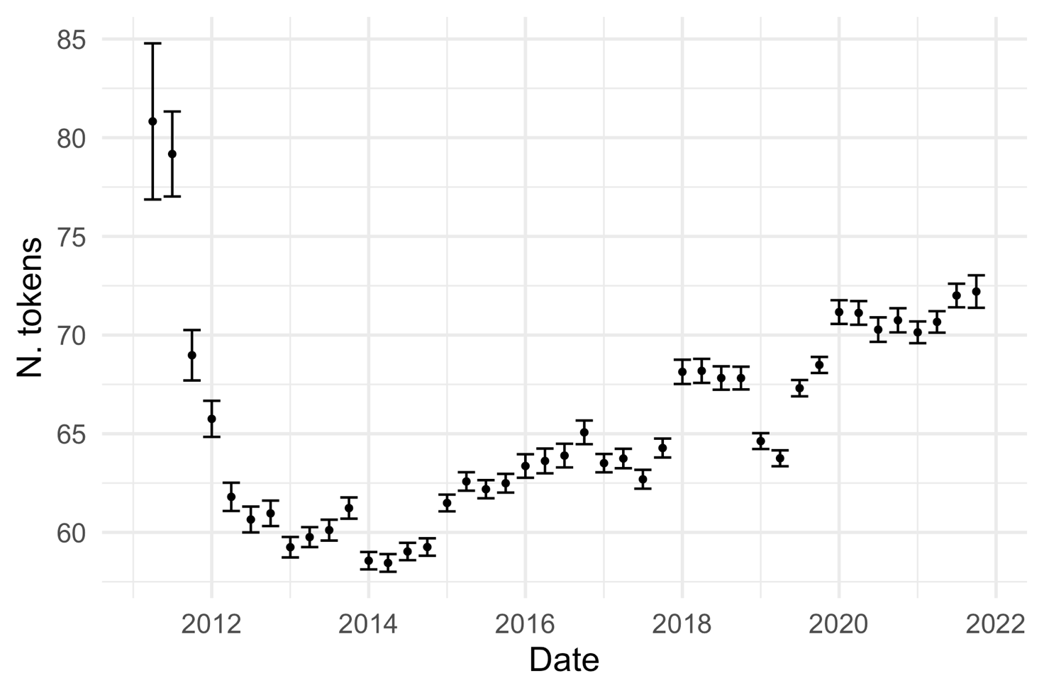Error bars indicate +- the standard error of the mean. Data before approximately Q2 2012 have higher variance and significantly higher means.

Supplementary Figure 2: Novelty over time for each category of words describing psychopathology.
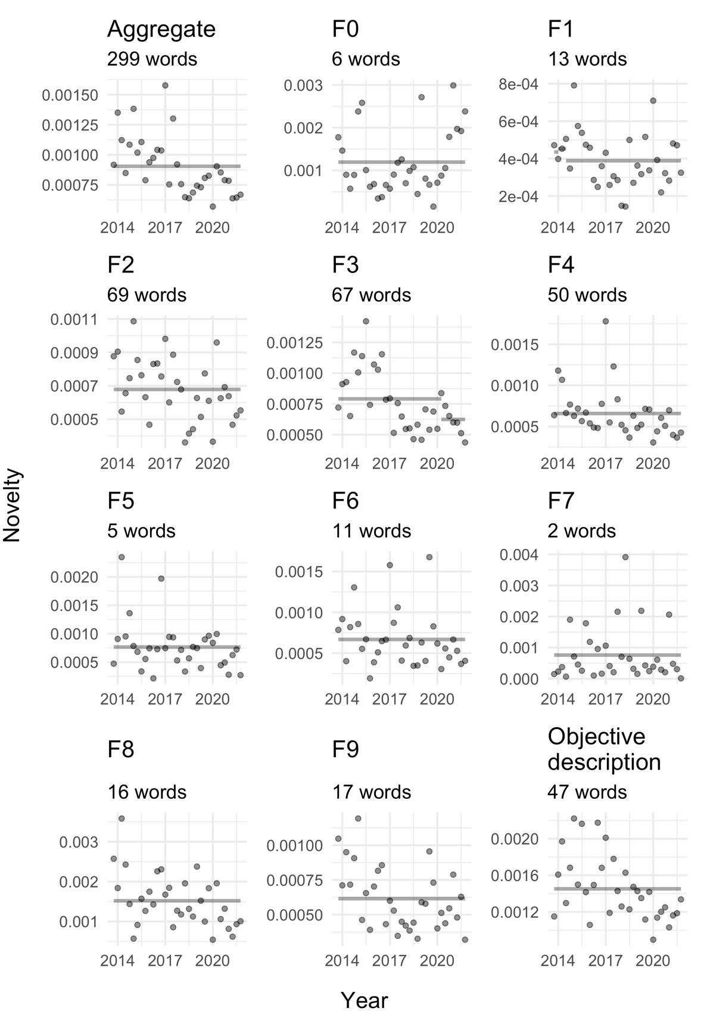
Grey lines indicate changepoints with lines showing the mean of the segment. The number of words in each category is shown in the subtitle of each plot.

Supplementary Figure 3: Mean number of tokens per note type with overlaid changepoint detection.
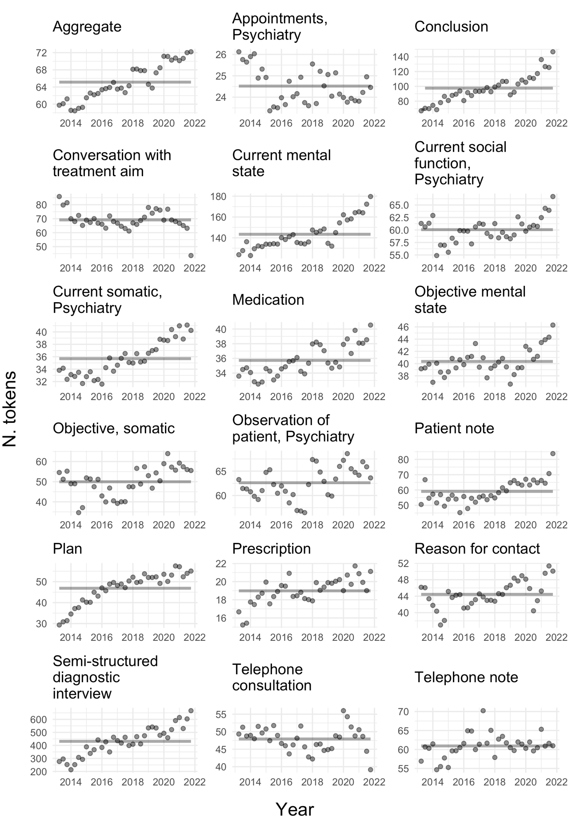

Supplementary Figure 4: Mean dependency distance per note type with overlaid changepoint detection.
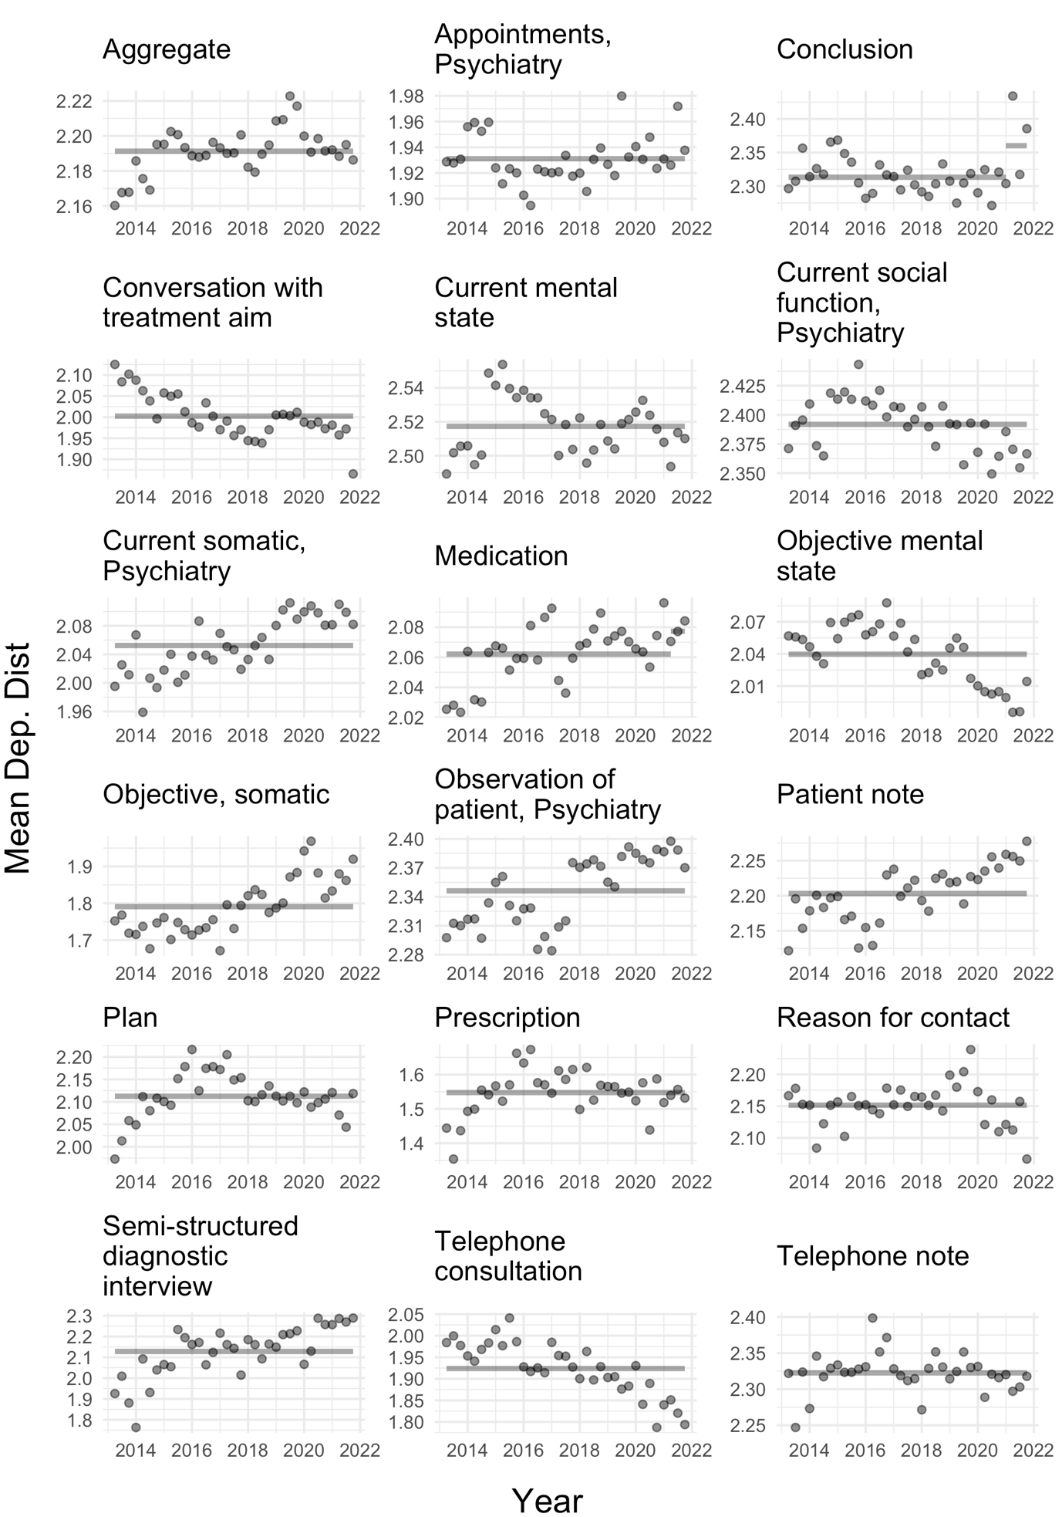

Supplementary Figure 5: Mean Automated Readability Index per note type with overlaid changepoint detection.
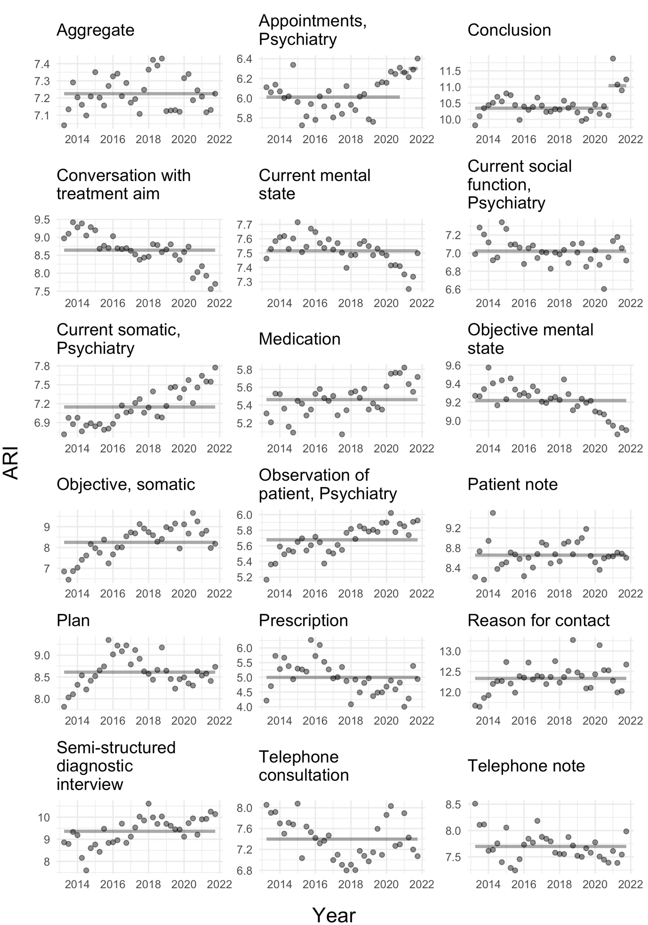
Supplementary Figure 6: Mean proportion of all notes per note type with overlaid changepoint detection.
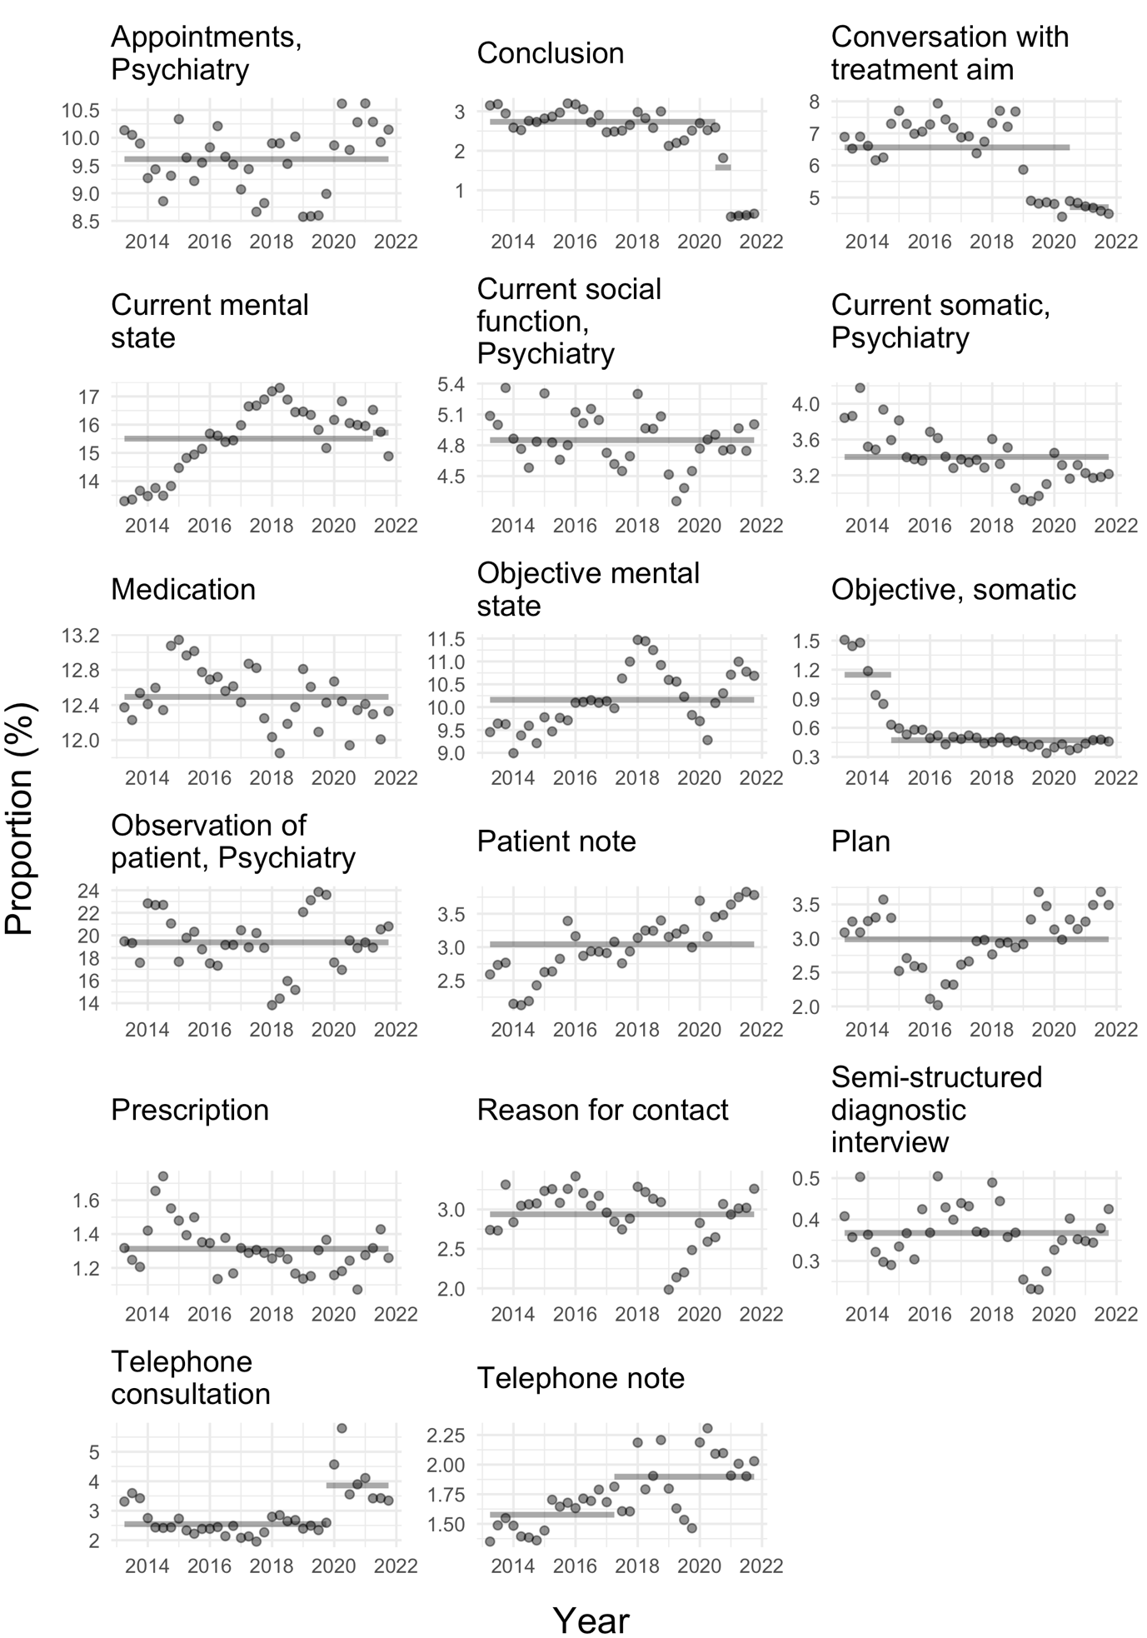
Note, proportion of notes for “Aggregate” cannot be calculated and is therefore not shown.

Supplementary Figure 7: Sensitivity analysis of novelty for different window sizes.
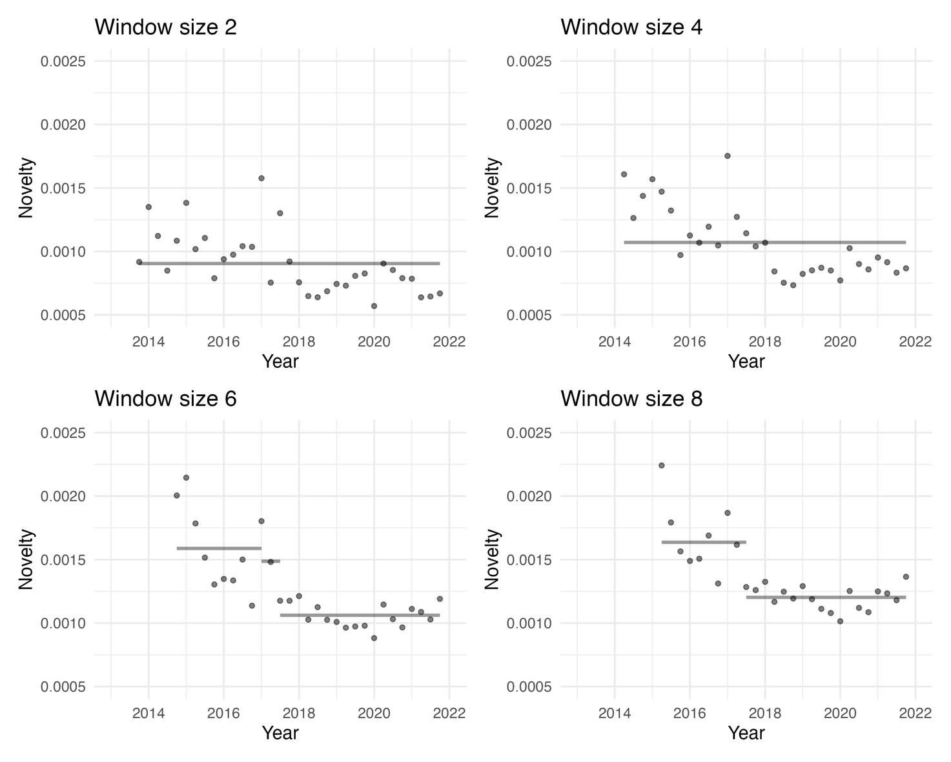 The plots show the novelty for all note types combined (aggregate) across 4 different window sizes. Note that the first point on the graph lies later the larger the window size. Grey lines indicate changepoints with lines showing the mean of the segment.

Supplementary Figure 8: Sensitivity analysis of novelty changepoint analysis with window sizes 2, 4, 6 and 8.
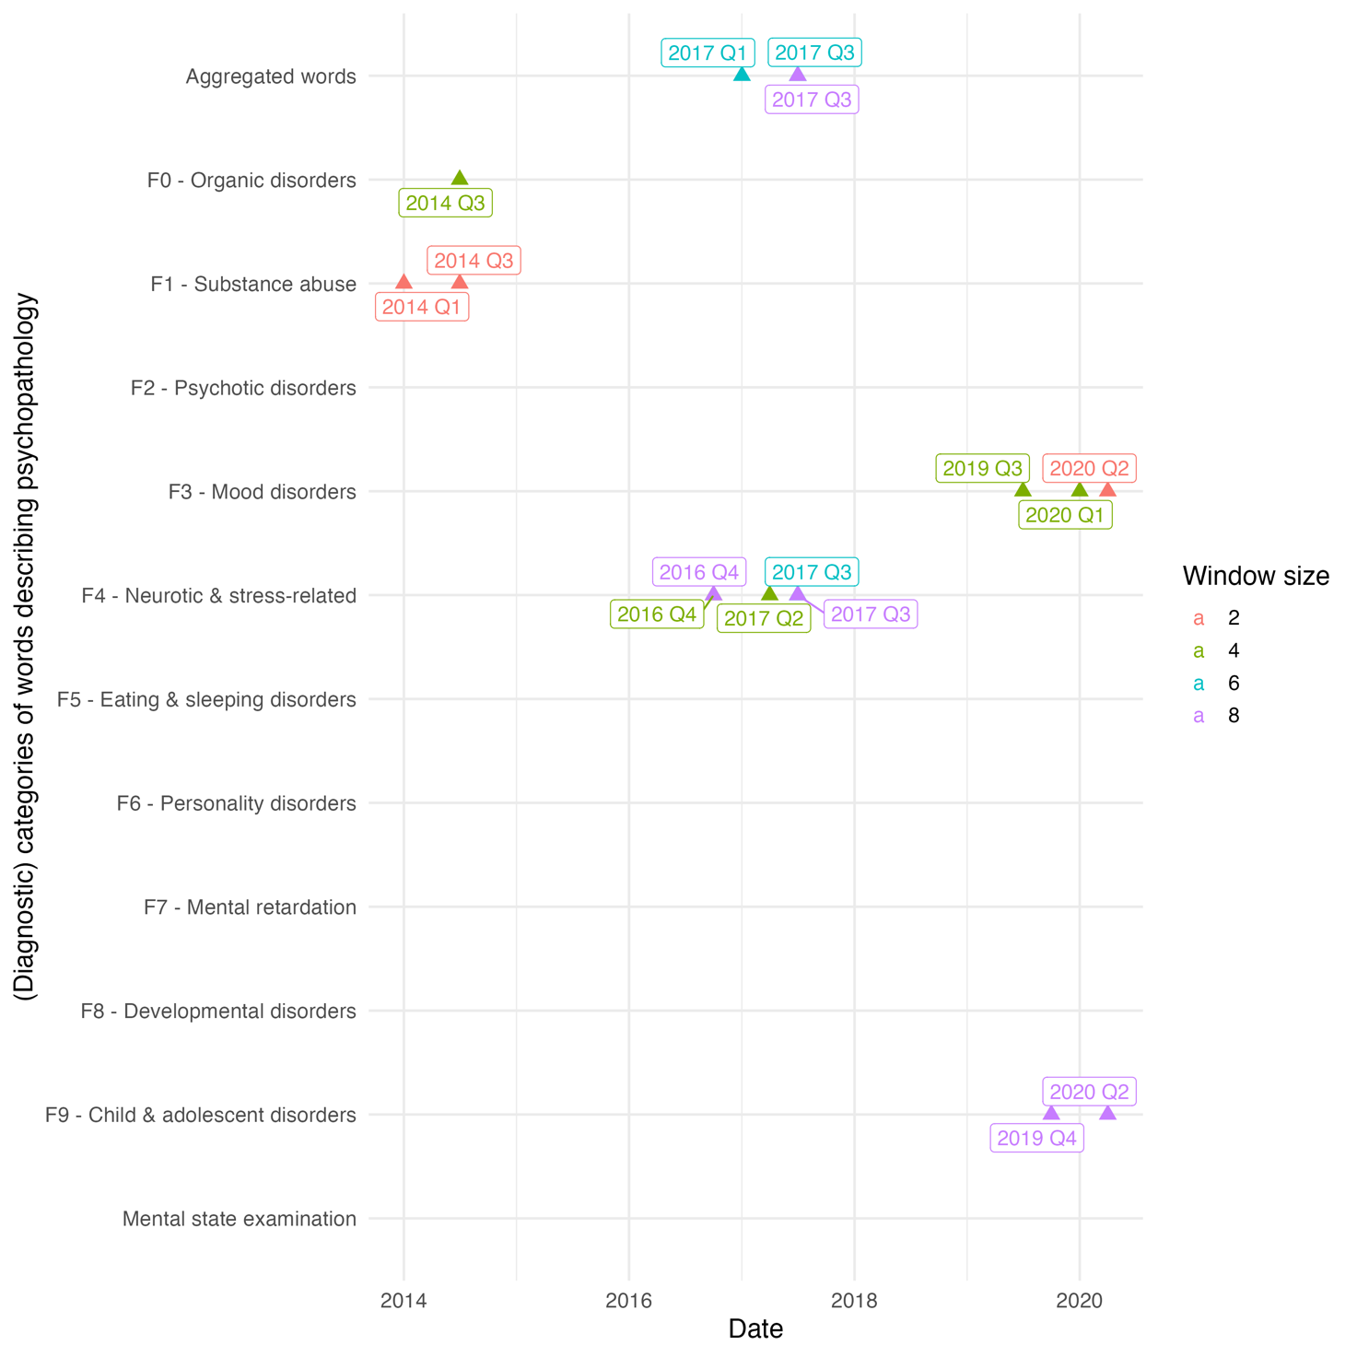
The colours indicate which window size finds the changepoint.

Supplementary Figure 9: Sensitivity analysis of figure 6 in the main manuscript with a different 10% sample of the data, and using the dependency parser from Enevoldsen et al.(2021).
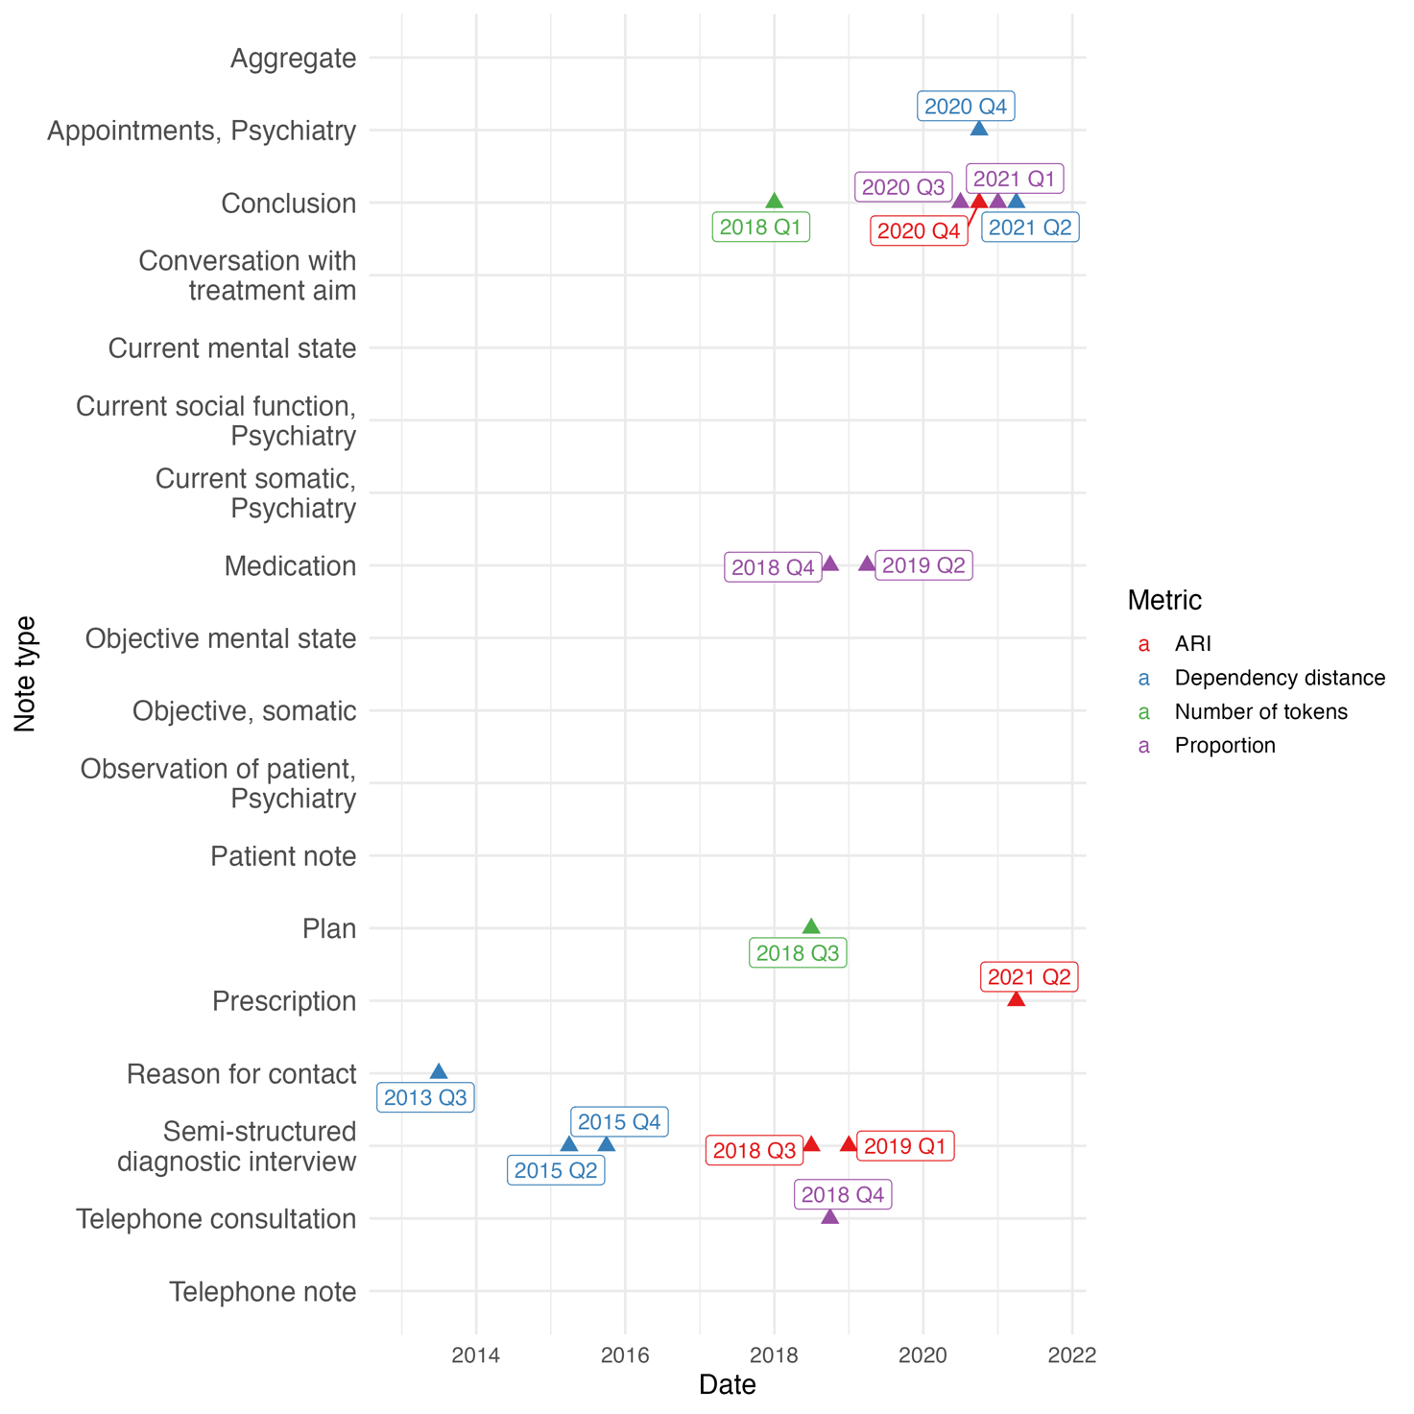

Supplementary Figure 10: Sensitivity analysis of ARI with a different 10% sample of the data.
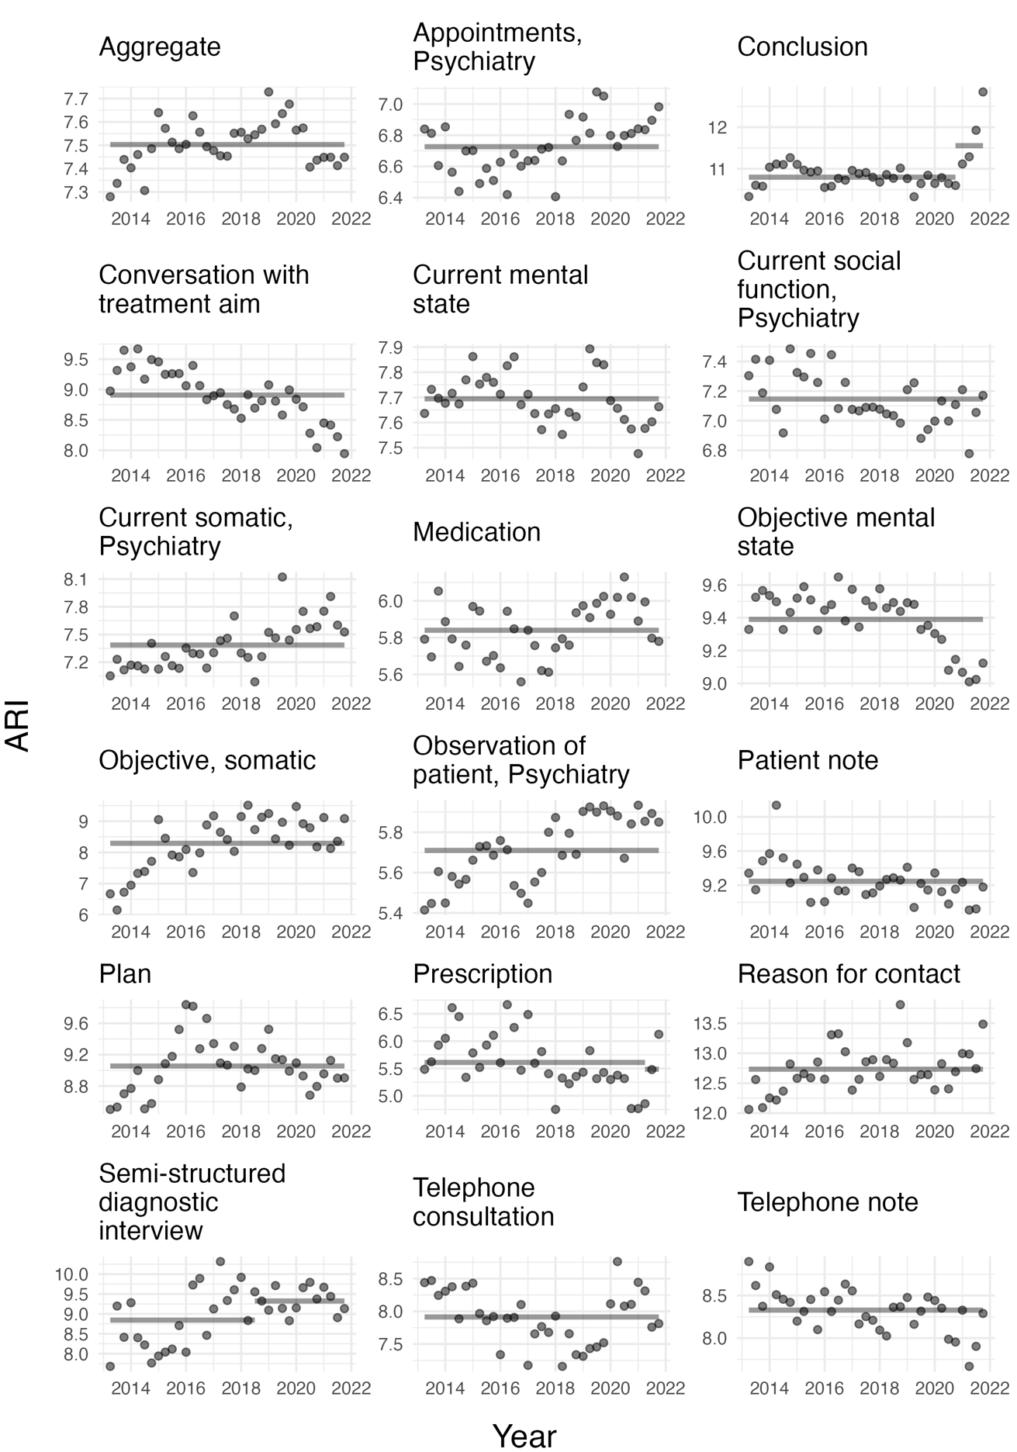

Supplementary Figure 11: Sensitivity analysis of mean dependency distance with a different 10% sample of the data and using the dependency parser from Enevoldsen et al. (2021).
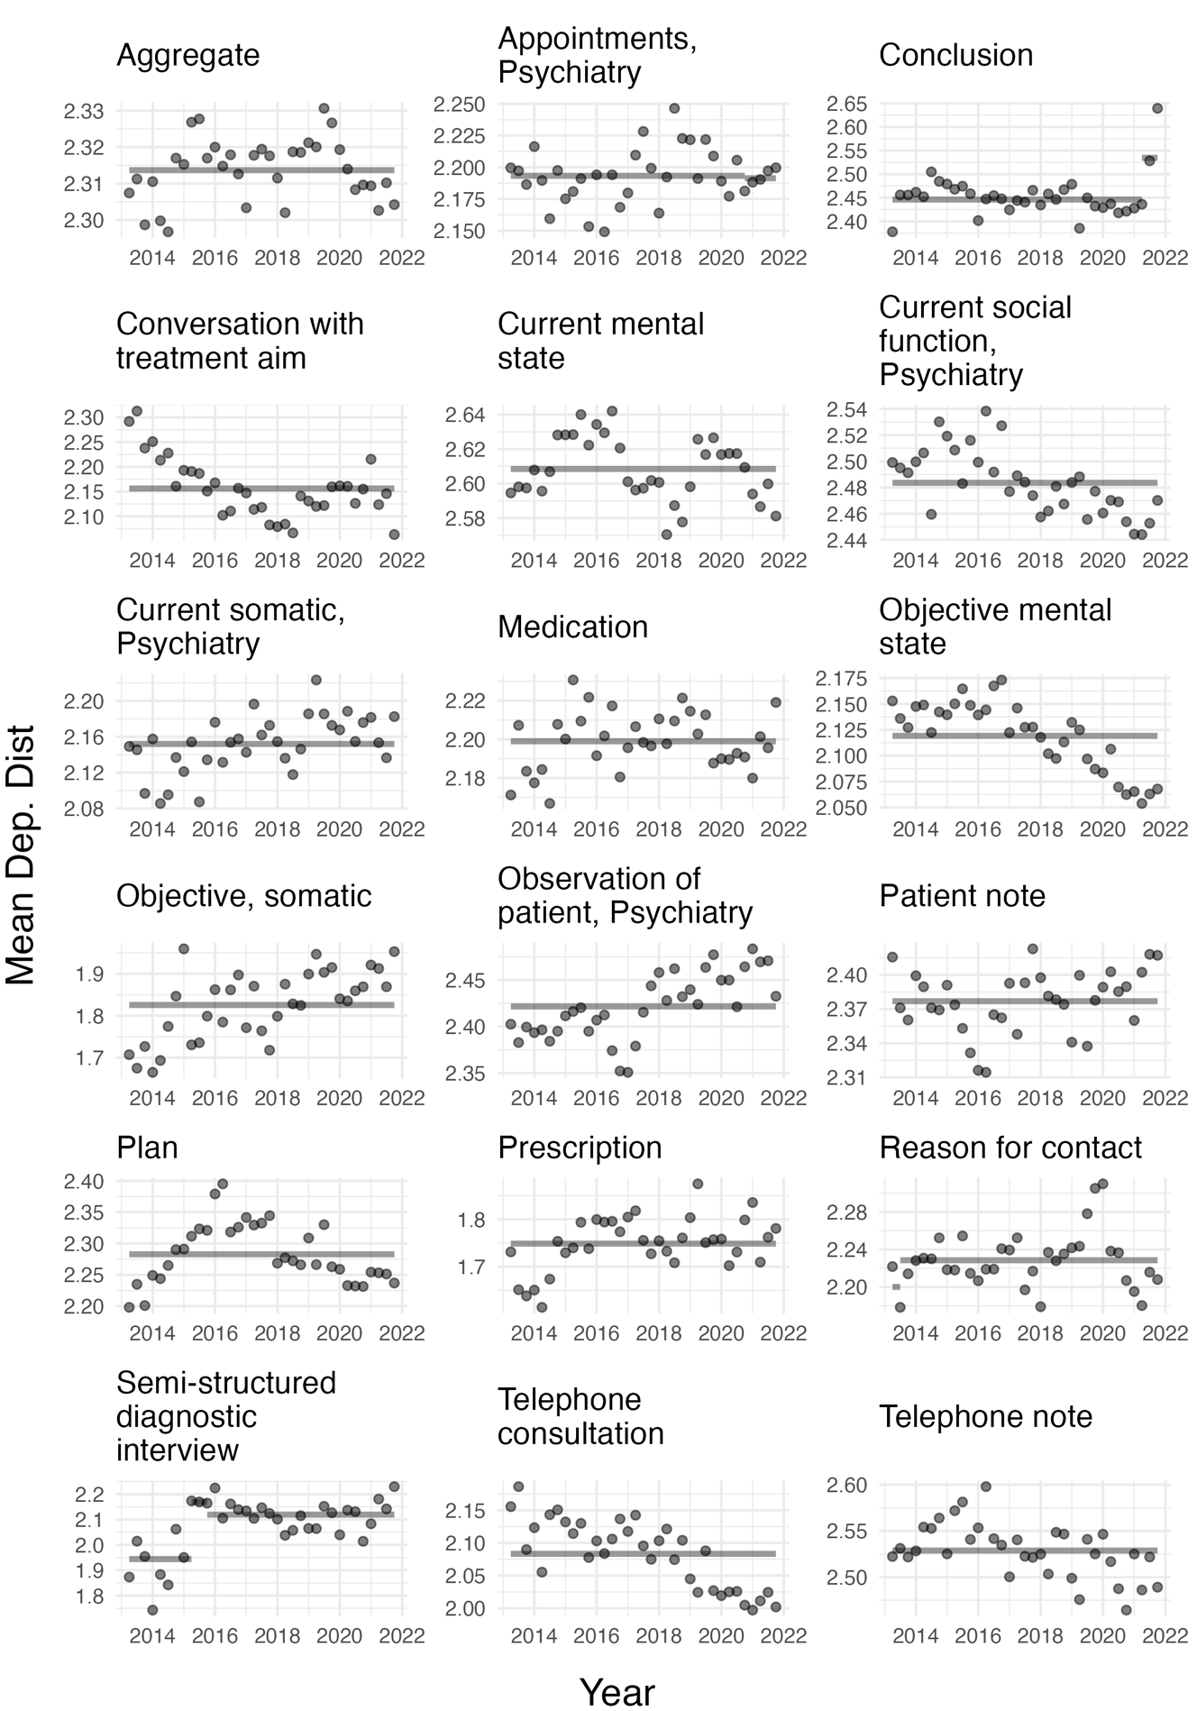

Supplementary Figure 12: Sensitivity analysis of mean number of tokens with a different 10% sample of the data.

Supplementary Figure 13: Sensitivity analysis of proportion of notes with a different 10% sample of the data.

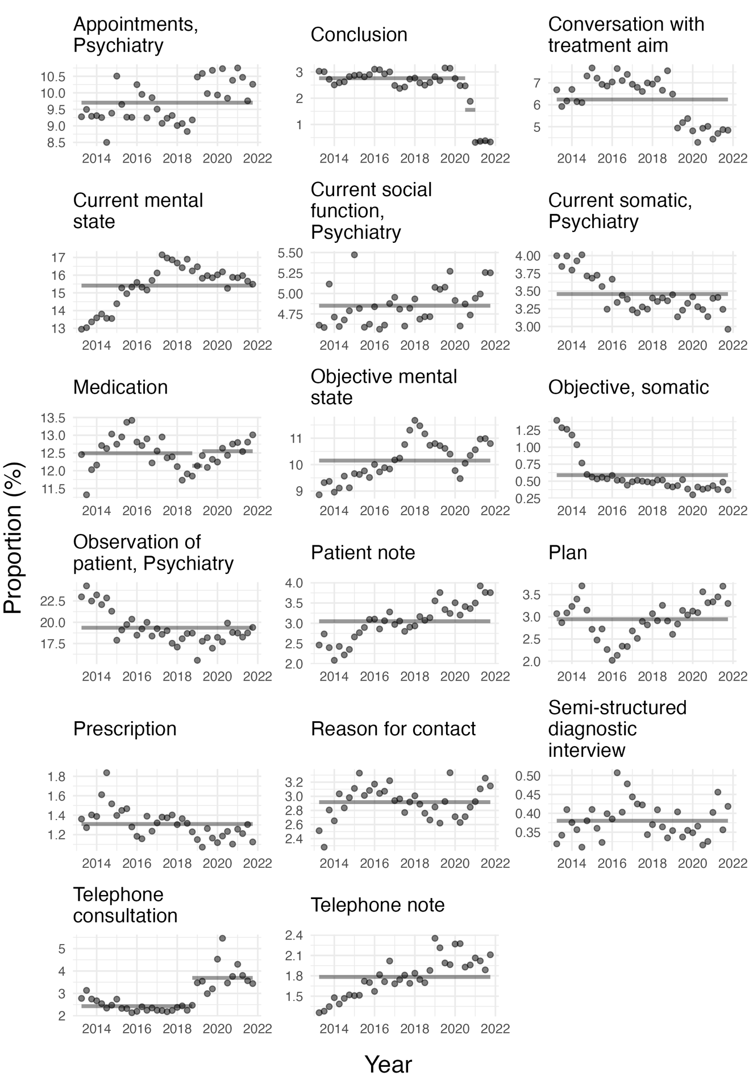

Supplementary Table 1: Description of the content of each of the note types.
Danish name | English name | Description
Aftaler, Psykiatri | Appointments, Psychiatry | Description of concrete care- and treatment-related appointments and agreements with and about the patient.
Aktuelt socialt, Psykiatri | Current social, Psychiatry | Description of the patient’s current social situation: relationship to the family, civil status, residential-, occupational-, and economic conditions, and contact with the social services. Documentation of ongoing treatment plans in relation to the patient’s social relationships.
Aktuelt psykisk | Current mental state | Description of the development, progress, and current status of the patient’s mental illness.
Aktuelt somatisk, Psykiatri | Current somatic, Psychiatry | Description of the patient’s current and chronic somatic illnesses and symptoms. Information on current treatment in relation to the patient’s physical condition.
Journalnotat | Journal note | Treatment notes that cannot be meaningfully described in another note type.
Konklusion | Conclusion | Aggregation and interpretation of all findings and decisions based on an interview (e.g in relation to an outpatient visit or during an inpatient stay).
Kontaktårsag | Reason of contact | The reason for the patient’s in- or outpatient treatment course.
Medicin | Medication | Documentation of indications and reasons for prescription of medication, adjustments in dose of medication, actions in relation to administration of medication.
Objektivt psykisk | Objective mental state | Objective assessment of the patient’s mental state, including state of consciousness, orientation, intelligence, psychomotor function, mood, delusions, psychotic symptoms, etc.
Objektivt, somatisk | Objective, somatic | Documentation of somatic assessments/examinations.
Observation af patient, Psykiati | Observation of patient, Psychiatry | Description of an inpatient’s mental symptoms, behaviour, reactions towards relatives, other patients, staff, etc.
Ordination | Prescription of examinations | Prescription of examinations such as blood pressure measurement, pulse measurement, weighing, medical imaging, laboratory tests, etc.
Plan | Plan | Acute or short-term plans for the patient.
Samtale med behandlingssigte | Conversation with treatment aim | Documentation of the conversation’s purpose and attendees.
Semistruktureret diagnostisk interview | Semi-structured diagnostic interview | Registration that a semi-structured diagnostic interview has been conducted. Description of the method and documentation of result and conclusion.
Telefonkonsultation | Telephone consultation | Documentation of telephone communication with the patient or the patient’s guardian as part of treatment or monitoring of disease progress.
Telefonnotat | Telephone note | Documentation of telephone conversations with a patient or the patient’s guardian of non-clinical character.

Supplementary Table 2: Demographic characteristics of the cohort. The table shows the number of unique patients grouped by their last ICD-10 diagnosis, age group at the first visit, and sex. * if less than ten patients in a group, the cell count is set at <10 to avoid the identification of individuals.
Age | < 18 |  | 18-30 |  | 31-50 |  | 51-70 |  | > 70
Last ICD-10 diagnosis | Females | Males | Females | Males | Females | Males | Females | Males | Females | Males
F00-F09 Organic, including symptomatic, mental disorders | <10* | 17 | 46 | 96 | 111 | 225 | 609 | 712 | 4466 | 2655
F10-F19 Mental and behavioural disorders due to psychoactive substance use | 58 | 167 | 175 | 739 | 345 | 952 | 372 | 681 | 57 | 74
F20-F29 Schizophrenia, schizotypal and delusional disorders | 480 | 362 | 1001 | 1615 | 1079 | 1801 | 829 | 820 | 247 | 106
F30-F39 Mood [affective] disorders | 1189 | 562 | 3404 | 2045 | 4229 | 2601 | 2754 | 2016 | 1629 | 804
F40-F48 Neurotic, stress-related and somatoform disorders | 3564 | 1868 | 3832 | 2666 | 4566 | 3767 | 1608 | 1595 | 475 | 263
F50-F59 Behavioural syndromes associated with physiological disturbances and physical factors | 1320 | 140 | 1235 | 226 | 402 | 209 | 103 | 98 | <10* | <10*
F60-F69 Disorders of adult personality and behaviour | 556 | 61 | 1932 | 501 | 1179 | 499 | 160 | 97 | 25 | <10*
F70-F79 Mental retardation | 289 | 462 | 323 | 348 | 245 | 296 | 154 | 170 | 22 | 36
F80-F89 Disorders of psychological development | 1748 | 5183 | 292 | 532 | 86 | 178 | <10* | 25 | <10* | <10*
F90-F98 Behavioural and emotional disorders with onset usually occurring in childhood and adolescence | 3999 | 8085 | 1562 | 2123 | 830 | 1226 | 78 | 96 | <10* | <10*
Others | 3623 | 3744 | 4382 | 4270 | 2811 | 3228 | 1335 | 1399 | 530 | 360

Supplementary Table 3: Psychopathological keywords used for the analysis. The table shows the keywords used for the novelty analysis in both Danish and English. An X in the ‘excluded’ column indicates that the keyword was not included in the analysis due to too few occurences. An “/” in the name indicates that the counts for the two words have been added.

Diagnostic chapter | Danish | English | Excluded
F0 | - | -
 | Demens | Dementia
 | Vaskulær demens | Vascular dementia
 | Alzheimer | Alzheimer
 | Lewy body | Lewy body
 | Delir | Delirium
 | Delirøs | Delirous
F1 | - | -
 | Misbrug | Drug abuse
 | Trang | Urge
 | Craving | Craving
 | Svigtende kontrol | Loss of control | X
 | Abstinenssymptomer | Withdrawal symptoms
 | Tolerans | Tolerance
 | Risikofyldt adfærd | Risky behaviour | X
 | Alkohol | Alcohol
 | Opioder | Opiods | X
 | Cannabis | Cannabis
 | Hash | Hash
 | Cannabinoider | Cannabinoids
 | Sedativa | Sedatives
 | Hypnotika | Hypnotics
 | Kokain | Cocaine
 | Centralstimulerende | Central stimulant
 | Hallucinogener | Hallucinogens | X
F2 | - | -
 | Skizofreni | Schizophrenia
 | Hebefren | Hebephrenic
 | Skizotypi | Schizotypal
 | Paranoid | Paranoid
 | Paranoia | Paranoia
 | Psykose | Psychosis
 | Psykotisk | Psychotic
 | Skizoaffektiv / skizo-affektiv | Skizoaffective
 | Positive symptomer | Positive symptoms
 | Auditive hallucinationer | Auditory hallucinations
 | Hørehallucinationer | Hearing hallucinations
 | Verbale | Verbal
 | Non-verbale | Non-verbal
 | 2. person / andenpersons | 2nd person / second person
 | 3. person / tredjepersons | 3rd person / third person
 | Kommenterende | Commenting
 | Diskuterende | Discussing
 | Depressiv | Depressive
 | Expansive | Expansive | X
 | Dissociative | Dissociative
 | Hypnagoge | Hypnogogic
 | Hypnopompe | Hypnopompic
 | Stemmer | Voices
 | Devaluerende | Devaluating
 | Synshallucinationer | Visual hallucinations
 | Uformede | Unformed
 | Formede | Formed
 | Sceniske | Scenic
 | Interne | Internal
 | Eksterne | External
 | Lugthallucinationer | Olfactory hallucinations
 | Taktile hallucinationer | Tactile hallucinations
 | Somatiske hallucinationer | Somatic hallucinations
 | Berøringshallucinationer | Hallucinations of touch sensations
 | Seksuelle hallucinationer | Sexual hallucinations
 | Legemlige fornemmelser | Bodily sensations | X
 | Tankeforstyrrelser | Thought disorders
 | Tankefradrag | Thought withdrawal
 | Tankepåføring | Thought insertion
 | Tankeudspredning | Thought broadcasting
 | Tankehørlighed | Loud thoughts
 | Tanke-ekko | Thought echo
 | Styringsoplevelser | Delusions of control
 | Påførte handlinger | Replaced control of actions
 | Fremmed vilje | Alien will | X
 | Påført tale | Replaced control of voice
 | Påført skriven | Replaced control of handwriting | X
 | Påførte følelser | Replaced control of affect
 | Fremmed magt | Alien force | X
 | Påførte impulser | Replaced control of impulses | X
 | Vrangforestillinger | Delusions
 | Vrangstemning | Delusional mood
 | Selvhenførende vrangforestillinger | Delusions of reference
 | Mistydning | Misinterpretation
 | Primær vrangsansning | Delusional perception
 | Persekutoriske vrangforestillinger | Delusions of persecution
 | Forfølgelsesforestillinger | Delusions of persecution
 | Forfulgt | Persecuted
 | Forgifte | Poison
 | Skade dig | Hurt you | X
 | Sammensværgelsesforestillinger | Delusions of conspiracy | X
 | Komplot | Plot
 | Religiøse forestillinger | Religious delusions
 | Guddommelig | divine
 | Religiøse budskaber | Religious messages | X
 | Overnaturlige forklaringer | Supernatural explanations | X
 | Okkult | Occult
 | Telepati | Telepathy
 | Seksuelle forestillinger | Sexual delusions | X
 | Jalousiforestillinger | Delusional jealousy | X
 | Fantastiske forestillinger | Fantasy delusions | X
 | Bizarre vrangforestillinger | Bizarre delusions
 | Førsterangssymptomer | First rank symptoms
 | Katatoni / kataton | Catatonia / catatonic
 | Negative symptomer | Negative symptoms
 | Koncentrationsbesvær | Concentration problems
 | Tab af følelser | Loss of emotions
 | Social tilbagetrækning | Social withdrawal
 | Formålsløs adfærd | Purposeless behaviour | X
 | Passitivitet | Passitivity | X
 | Manglende fremdrift | Lack of progress
 | Derealisation | Derealisation
 | Depersonalisation | Depersonalisation
 | Perceptionsforstyrrelse | Perception disorder
 | Fremmedfølelse | Alienation
F3 | - | -
 | Bipolar affektiv sindslidelse | Bipolar affective disorder
 | Bipolar | Bipolar
 | Mani / manisk | Mania / manic
 | Hypomani / hypomanisk | Hypomania / hypomanic
 | Expansivt stemningsleje | Expansive mood | X
 | Eretisme | Eretism | X
 | Øget energi | Increased energy
 | Hyperaktiv | Hyperactive
 | Tankepres | Pressing thoughts
 | Tankeflugt | Racing thoughts
 | Talepres | Pressure of speech
 | Taletrang | Overtalkativeness
 | Grandios | Grandiose
 | Grandiose vrangforestillinger | Grandiose delusions
 | Megalomane | Megalomanic
 | Særlig mission | Special mission | X
 | Usædvanlige krafter | Unusual power | X
 | Usædvanlige evner | Unusual skills
 | Berømt | Famous
 | Letafledlighed | Ease of diversion | X
 | Købetrang | Urge for spending
 | Over-optimisme | Overoptimism
 | Kompromitterende adfærd | Socially embarassing behavior
 | Hæmningsløs | Unhibited
 | Overmodig | Overconfident
 | Overfamiliaritet | Over-familiarity
 | Ukritisk adfærd | Uncritical behaviour | X
 | Hensynsløs | Reckless
 | Uansvarlig adfærd | Irresponsible behavor
 | Nye interesser | Novel interests
 | Distraktibilitet | Distractibility | X
 | Nedsat søvnbehov | Decreased need for sleep
 | Øget seksualtrang | Increased sexual urge
 | Øget sex-drift | Increased sexual drive | X
 | Depression | Depression
 | Nedtrykthed | Sadness
 | Nedsat stemningsleje | Depressed mood
 | Nedsat humør | Depressed mood
 | Nedsat energi | Loss of energy
 | Trætbarhed | Fatigue
 | Nedsat interesse | Loss of interests
 | Nedsat lyst | Decreased desire
 | Interessetab | Loss of interests
 | Håbløshed | Hopelessness
 | Hæmning | Inhibition
 | Rumination | Rumination
 | Pessimisme | Pessimism
 | Grådtendens | Tearfullnees
 | Dødstanker | Thoughts of death
 | Selvmordstanker | Suicidal ideation
 | Selvmord | Suicide
 | Selvmordforsøg | Suicide attempt
 | Selvskade | Self-harm
 | Nedsat selvtillid | Loss of self-confidence
 | Selvbebrejdelser | Self-Blame
 | Vægttab | Loss of weight
 | Nedsat libido | Loss of libido
 | Nedsat sexlyst | Loss of libido
 | Nedsat appetit | Lack of appetite
 | Initiativløshed | Lack of iniative
 | Søvnløs | Insomnia
 | Søvnbesvær | Insomnia
 | Tidlig opvågen | Early waking
 | Tidlig opvågning | Early waking
 | Melankoliform | Somatic syndrome
 | Depressive vrangforestillinger | Delusions in the context of depression
 | Skyldsforestillinger | Delusions of guilt
 | Skyldfølelse | Feeling of guilt
 | Selvforringende | Self-deteriorating
 | Dårligt menneske | Bad person
 | Uduelig | Incompetent
 | Betydningsløs | Insignificant | X
 | Forarmningsforestillinger | Delusions of impoverishment | X
 | Ruineret | Ruined | X
 | Verdens undergang | The end of the world
 | Hypokondre forestillinger | Hypochondrical delusions | X
 | Nihilistiske forestillinger | Nihilistic delusions
 | Rådne | Rot
 | Cotard’s syndrom | Cotard syndrome | X
 | Dysmorfofobe forestillinger | Delusions of dysmorphophobia | X
 | Derealisationsvrangforestillinger | Delusions of derealisation
 | Capgras syndrom | Capgras syndrome | X
 | Cyklothymi | Cyclothymia
 | Dysthymi | Dysthymia
F4 | - | -
 | Fobi | Phobia
 | Agorafobi | Agoraphobia
 | Socialfobi | Social phobia
 | Social angst | Social Anxiety
 | Enkelfobi | Specific phobia
 | Generaliseret angst | Generalized anxiety
 | Belastningsreaktion | Acute stress reaction
 | Tilpasningsreaktion | Adjustment disorders
 | Dissociativ | Dissociative
 | Somatoform | Somatoform
 | Bekymringstendens | Worry
 | Anspændt | Tense
 | Generel muskelspænding | General muscle tension | X
 | Angst | Anxiety
 | Bange | Afraid
 | Undgåelse | Avoidance
 | Panikanfald | Panic attack
 | Panikangst | Panic disorder
 | Hjertebanken | Palpitations
 | Smerter i brystet | Chest pain
 | Trykken for brystet | Chest discomformt
 | Åndedrætsbesvær | Difficulty breathing
 | Kvælningsfornemmelse | Feeling of choking
 | Kvalme | Nausea
 | Maveuro | Abdominal distress
 | Hedeture | Hot flushes
 | Kuldegysninger | Cold chills
 | Sveden | Sweating
 | Mundtørhed | Dry mouth
 | Rysten | Trembling
 | Sitren | Tingling sensations
 | Dødsangst | Fear of dying
 | Synkebesvær | Difficulty with swallowing
 | Klump i halsen | Sensation of a lump in the throat
 | Uvirkelighedsfølelse | Feeling of unreality
 | Undgåelsesadfærd | Avoidance behavior
 | Paræstesier | Paraesthesias
 | Føleforstyrrelser | Sensory disturbances
 | PTSD | PTSD
 | Posttraumatisk belastningsreaktion | Post-traumatic stress disorder
 | Flashbacks | Flashbacks
 | Mareridt | Nightmare
 | Hypervigilitet | Hypervigilant
 | Katastrofe | Catastrophe
 | Traume | Trauma
 | Obsessiv-kompulsiv tilstand | Obsessive-Compulsive Disorder
 | OCD | OCD
 | Tvangstanker | Obsessions
 | Tvangshandlinger | Compulsions
 | Fugue | Fugue
 | Tranceoplevelser | Experiences of trance | X
 | Besættelsesoplevelse | Possession disorders
F5 | - | -
 | Spiseforstyrrelse | Eating disorders
 | Anorexi | Anorexi
 | Anoreksi | Anorexi
 | Anorexia nervosa | Anorexia nervosa
 | Bulimi | Bulimia
F6 | - | -
 | Personlighedsforstyrrelse | Personality disorders
 | Paranoid | Paranoid
 | Skizoid | Schizoid
 | Dyssocial | Dissocial
 | Emotionel ustabil personlighedsstruktur | Emotionally unstable personality disorder
 | Borderline | Borderline
 | Histrionisk | Histrionic
 | Tvangspræget | Anankastic
 | Ængstelig | Anxious
 | Evasiv | Avoidant
 | Dependent | Dependent
F7 | - | -
 | Mental retardering | Mental retardation
 | Lav IQ | Low IQ
F8 | - | -
 | Gennemgribende udviklingsforstyrrelser | Pervasive developmental disorders
 | Infantil autisme | Childhood autism
 | Autisme | Autism
 | Asperger | Asperger
 | Manglende blikkontakt | Lack of Eye-to-eye gaze
 | Nedsat blikkontakt | Decreased eye-to-eye gaze
 | Nedsat mimik | Decreased facial expression
 | Nedsat gestik | Decreased gesture
 | Stereotyp adfærd | Stereotyped behavior
 | Repetitivt | Repetitive
 | Impressivt sprog | Receptive language | X
 | Expressivt sprog | Expressive language | X
 | Nedsat spontan tale | Lack of spontaneous speech | X
 | Idiosynkratisk sprogbrug | Idiosyncratic use of words or phraeses
 | Indsnævrede interesser | Restricted patterns of interests
 | Afvigende socialt samspil | Abnormal social interaction
 | Afvigende kommunikation | Abnormal communication
 | Nedsat empati | Lack of empathy
 | Nedsat situationsfornemmelse | Lack of modulation of behavior in a social context
 | Emotionel dysregulering | Emotional dysregulation | X
F9 | - | -
 | Opmærksomhedsforstyrrelser | Attention disorders
 | Hyperkinetiske forstyrrelser | Hyperkinetic disorders
 | Hyperkinetisk | Hyperkinetic
 | ADHD | ADHD
 | ADD | ADD
 | Koncentrationsbesvær | Concentration difficulties
 | Skødesløse fejl | Careless mistakes
 | Besvær med at planlægge | Difficulties in planning | X
 | Mister ting | Looses items
 | Motorisk aktivitet | Motor activity
 | Hyperaktiv | Hyperactive
 | Impulsiv | Impulsive
 | Impulsivitet | Impulsivity
 | Afbryder | Interrupts
 | Søvnbesvær | Sleeplessness
 | Adfærdsforstyrrelse | Conduct disorder
 | Tics | Tics
 | Tourettes | Tourettes
Mental status examination | - | -
 | Perseveration | Perseveration
 | Konfabulation | Confabulation | X
 | Amnesi | Amnesia
 | Opmærksomhedssvækkelse | Lack of concentration | X
 | Desorientering | Desorientated
 | Apati | Apathy
 | Afasi | Aphasia
 | Træghed | Inertia
 | Opfattelsesbesvær | Perception difficulties | X
 | Apraksi | Apraxia
 | Stupor | Stupor
 | Initiativløshed | Lack of iniative
 | Monoton stemme | Monotone voice
 | Manglende øjenkontakt | Lack of eye-to-eye gaze
 | Letafledelig | Distractible
 | Rastløs | Restless
 | Agiteret | Agitated
 | Hyperaktiv | Hyperactive
 | Påfaldende udseende eller påklædning | Striking appearance or clothing | X
 | Usammenhængende adfærd | Incoherent behavior | X
 | Excentrisk adfærd | Excentric behavior | X
 | Selvforsømmelse | Self-neglect
 | Dårlig hygiejne | Bad hygiene
 | Kataton | Catatonic
 | Negativisme | Negativism | X
 | Automatisk lydighed | Automatic obedience | X
 | Katalepsi | Catalepsy | X
 | Flexibilitas cerea | Flexibilitas cera | X
 | Abnorm legemsholdning | Abnormal posture | X
 | Stirren | Stare
 | Grimasseren | Grimaces
 | Bevægelsesstereotypier | Motor stereotypes
 | Stereotypier | Stereotypes
 | Løftet stemningsleje | Elevated mood
 | Euforisk | Euphoric
 | Irritabel | Irritable
 | Forvirring / forvirret | Confusion / confused
 | Emotionel labilitet | Emotional lability
 | Mistroisk | Suspiscious
 | Histrionisk affekt | Histrionic affect | X
 | Ambivalens / ambivalent | Ambivalence / ambivalent
 | Indsnævret affekt | Restricted affect | X
 | Inadækvat affekt | Inadequate affect
 | Inkongruent affekt | Incongruity of affect
 | Aggressiv | Aggressive
 | Affektaffladning | Flattening of affect
 | Affektlabil | Lability of mood
 | Manglende emotionelt respons | Lack of emotional respons | X
 | Latenstid | Latency
 | Omstændelig | Elaborate
 | Springende tankegang | Flight of ideas
 | Associerer frit | Associating freely | X
 | Frit associerende | Freely associating
 | Tankeflugt | Racing thoughts
 | Usammenhængende tankegang | Incoherent thoughts
 | Usamlet | Incoherent
 | Kaotisk tankegang | Chaotic thoughts
 | Inkoherent tale | Incoherent speech | X
 | Neologismer | Neologisms
 | Metaforisk tale | Metaforical speech | X
 | Metonymier | Metonymi | X
 | Vaghed | Poverty of content of speech
 | Mutisme | Mutism
 | Mumler | Mumbling
 | Perseverationstendens | Perseveration

