Supplementary Figure 1.
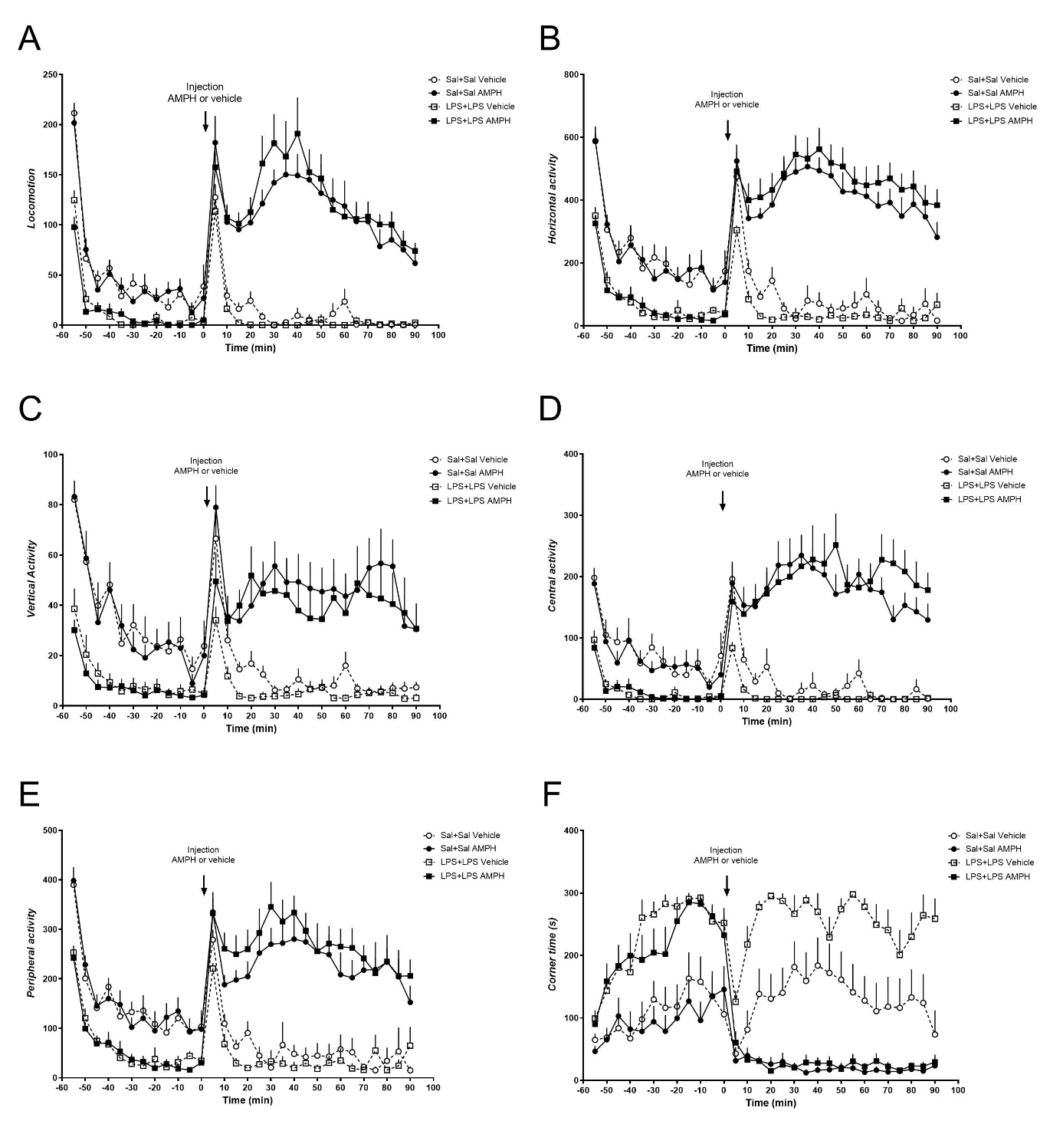
Supplementary Figure 1. D-amphetamine-induced hypermotility is increased in dual-LPS-treated rats versus controls. A) Locomotion, B) Horizontal activity, C) Vertical activity, D) Central Activity, E) Peripheral activity, and F) Corner time. Time 0 represents the baseline of activity prior to injection of D-amphetamine used for area under the curve calculations. N = 10 in each group. AMPH, d-amphetamine.

Supplementary Table 1(for Figure 2)
Behavior performance of dual-saline treated rats and dual-LPS treated rats during the habituation in the open-field test.
Measurement |  | F | DFn, DFd | p
Locomotion | Time | 111 | 11, 418 | <0.0001
 | Treatment | 92.78 | 1, 38 | <0.0001
 | Interaction | 7.693 | 11, 418 | <0.0001
Horizontal activity | Time | 59.19 | 11, 418 | <0.0001
 | Treatment | 62.25 | 1, 38 | <0.0001
 | Interaction | 2.363 | 11, 418 | 0.0077
Vertical activity | Time | 34.76 | 11, 418 | <0.0001
 | Treatment | 33.45 | 1, 38 | <0.0001
 | Interaction | 6.588 | 11, 418 | <0.0001
Central activity | Time | 24.37 | 11, 418 | <0.0001
 | Treatment | 48.04 | 1, 38 | <0.0001
 | Interaction | 2.465 | 11, 418 | 0.0054
Peripheral activity | Time | 69.35 | 11, 418 | <0.0001
 | Treatment | 62.97 | 1, 38 | <0.0001
 | Interaction | 1.663 | 11, 418 | 0.0791
Corner time | Time | 13.81 | 11, 418 | <0.0001
 | Treatment | 46.83 | 1, 38 | <0.0001
 | Interaction | 2.387 | 11, 418 | 0.0071
N = 20 in each treatment group. Bold value refers to statistic significance.

Supplementary Table 2 (for figure 3)
Behavior performance of dual-saline treated rats and dual-LPS treated rats in the d-amphetamine induced locomotor test.
Measurement |  | F | DFn, DFd | p
Locomotion | Dual-LPS treatment | 4.985 | 1, 36 | 0.0319
 | AMPH treatment | 164.5 | 1, 36 | <0.0001
 | Interaction | 3.893 | 1, 36 | 0.0579
Horizontal activity | Dual-LPS treatment | 13.23 | 1, 36 | 0.0009
 | AMPH treatment | 257.0 | 1, 36 | <0.0001
 | Interaction | 13.12 | 1, 36 | 0.0009
Vertical activity | Dual-LPS treatment | 1.132 | 1, 36 | 0.2944
 | AMPH treatment | 50.10 | 1, 36 | <0.0001
 | Interaction | 1.383 | 1, 36 | 0.2473
Central activity | Dual-LPS treatment | 3.178 | 1, 36 | 0.0831
 | AMPH treatment | 136.1 | 1, 36 | <0.0001
 | Interaction | 3.762 | 1, 36 | 0.0603
Peripheral activity | Dual-LPS treatment | 11.28 | 1, 36 | 0.0019
 | AMPH treatment | 128.7 | 1, 36 | <0.0001
 | Interaction | 10.07 | 1, 36 | 0.0031
Corner time | Dual-LPS treatment | 17.13 | 1, 36 | 0.0002
 | AMPH treatment | 194.5 | 1, 36 | <0.0001
 | Interaction | 4.861 | 1, 36 | 0.0339
N = 10 in each treatment group. Bold value refers to statistic significance.

Supplementary Table 3 (for figure 4)
Behavior performance of dual-saline treated rats and dual-LPS treated rats in the delay fear conditioning test.
Test |  | F | DFn, DFd | p
Training | Treatment | 5.557 | 1, 17 | 0.0307
 | Training phase | 22.54 | 2, 34 | < 0.0001
 | Interaction | 1.647 | 2, 34 | 0.2075
Context | Treatment | 0.09646 | 1, 17 | 0.7599
 | Context | 6.439 | 6, 102 | < 0.0001
 | Interaction | 0.7602 | 6, 102 | 0.2075
Cue | Treatment | 1.090e⁻⁰⁰⁸ | 1, 17 | > 0.9999
 | Tone-cue | 8.169 | 9, 153 | < 0.0001
 | Interaction | 1.061 | 9, 153 | 0.3947
N = 9 in the SAL + SAL group, N = 10 in the LPS + LPS group. Bold value refers to statistic significance.

Supplementary Table 4 (for figure 6)
Behavior performance of dual-saline treated rats and dual-LPS treated rats in the novel object recognition test.
Test |  | F | DFn, DFd | p
Training | Treatment | 17.17 | 1, 20 | 0.0005
 | Object | 0.0015 | 1, 20 | 0.9694
 | Interaction | 0.09628 | 1, 20 | 0.7595
Test | Treatment | 0.0126 | 1, 20 | 0.0126
 | Object | 14.56 | 1, 20 | 0.0011
 | Interaction | 2.362 | 1, 20 | 0.1400
N = 11 in each treatment group. Bold value refers to statistic significance.

Supplementary Table 5 (for figure 7)
Striatal extracellular fluid tryptophan, kynurenine, and KYNA levels following dual-saline or dual-LPS treatment in rats.
Measurement |  | F | DFn, DFd | p
Tryptophan | Treatment | 4.439 | 1, 7 | 0.0731
 | Time | 0.5063 | 8, 50 | 0.8458
 | Interaction | 0.1987 | 8, 50 | 0.9898
Kynurenine | Treatment | 7.922 | 1, 7 | 0.0260
 | Time | 0.8529 | 8, 50 | 0.5617
 | Interaction | 0.3970 | 8, 50 | 0.9170
KYNA | Treatment | 7.586 | 1, 7 | 0.0283
 | Time | 2.524 | 8, 50 | 0.0217
 | Interaction | 0.6510 | 8, 50 | 0.7312
N = 4 in the SAL + SAL group, N = 5 in the LPS + LPS group. Bold value refers to statistic significance.

