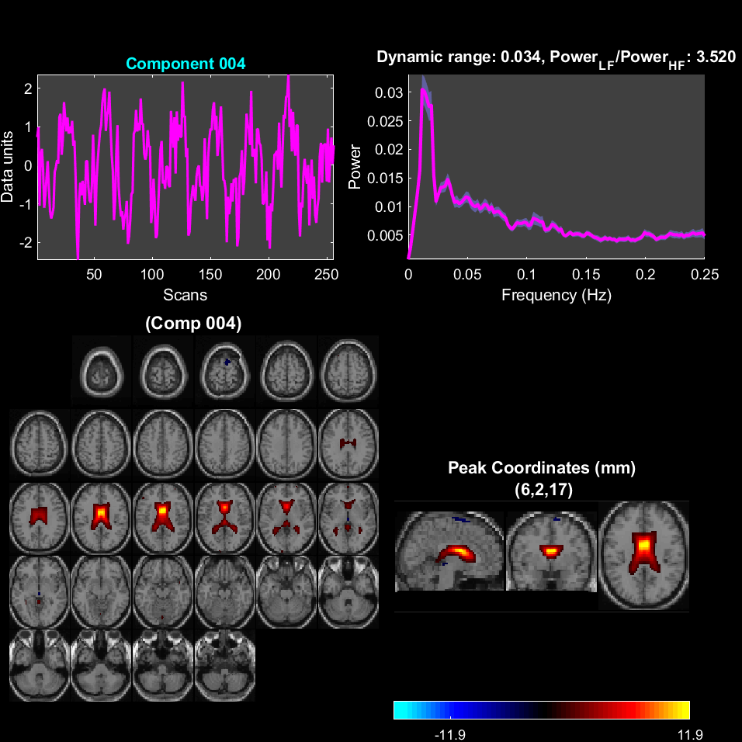
Fig. S1. The time series, power spectrum, and activity areas corresponding to the component #4, t-threshold 3.5. The regions of increased/decreased activation (DS vs no task) are shown in color.
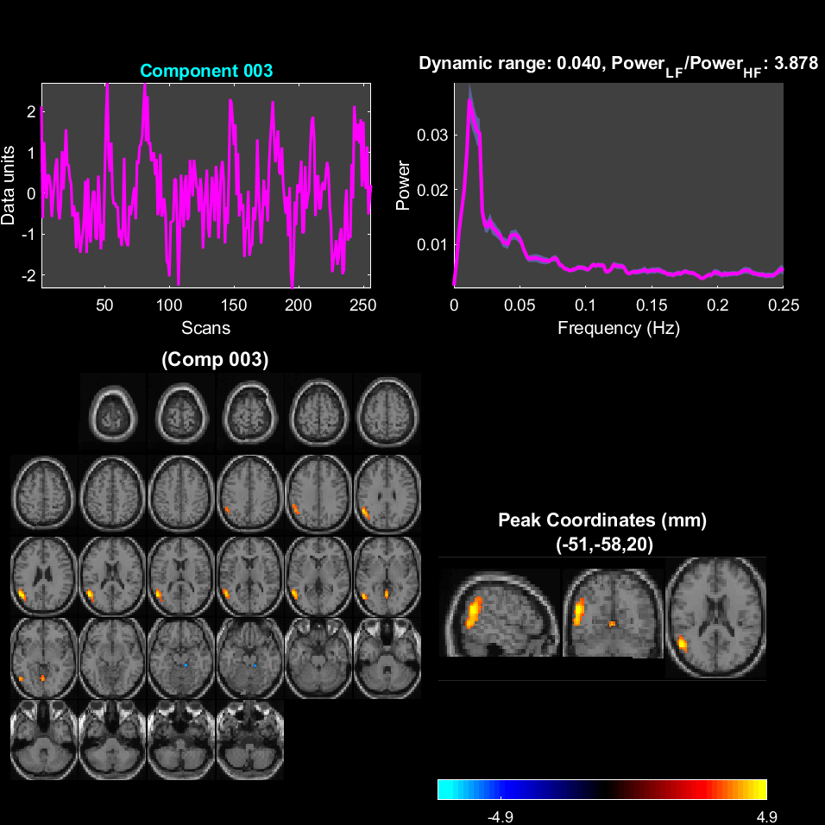
Fig. S2. The time series, power spectrum, and activity areas corresponding to the component #3, t-threshold 3.5. The regions of increased/decreased activation (DS vs DN) are shown in color.
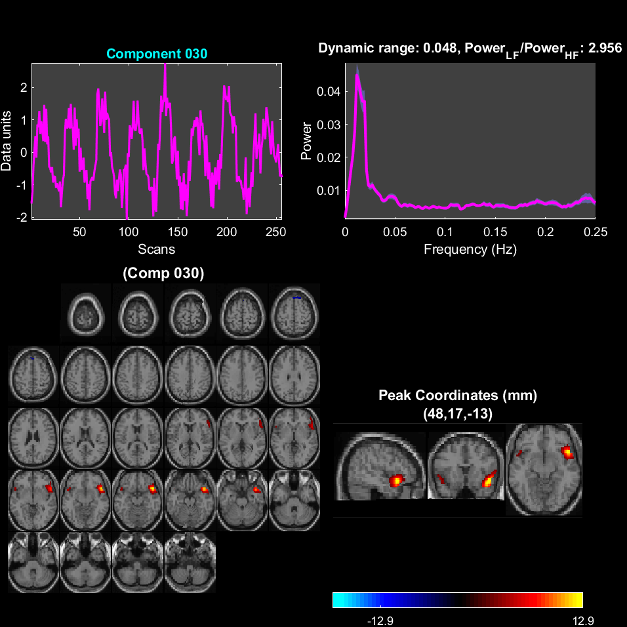
Fig. S3. The time series, power spectrum, and activity areas corresponding to the component #30, t-threshold 3.5. The regions of increased/decreased activation (DS vs DN) are shown in color.
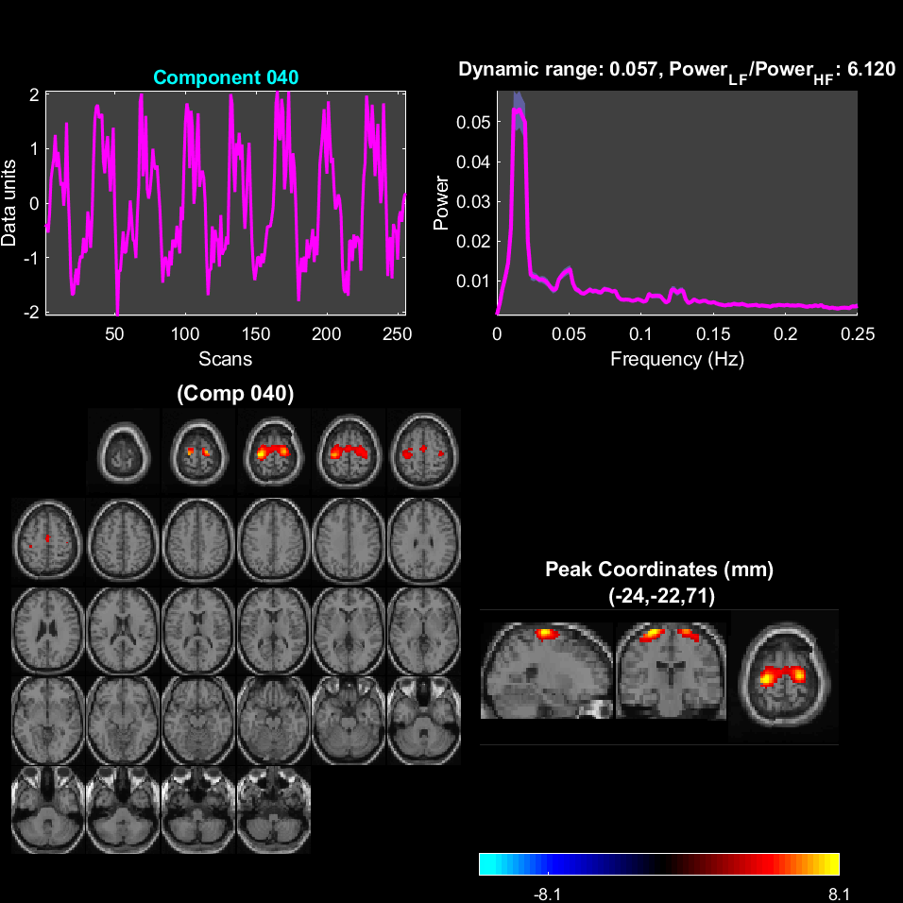
Fig. S4. The time series, power spectrum, and activity areas corresponding to the component #40, t-threshold 3.5. The regions of increased/decreased activation (DS vs DN) are shown in color.
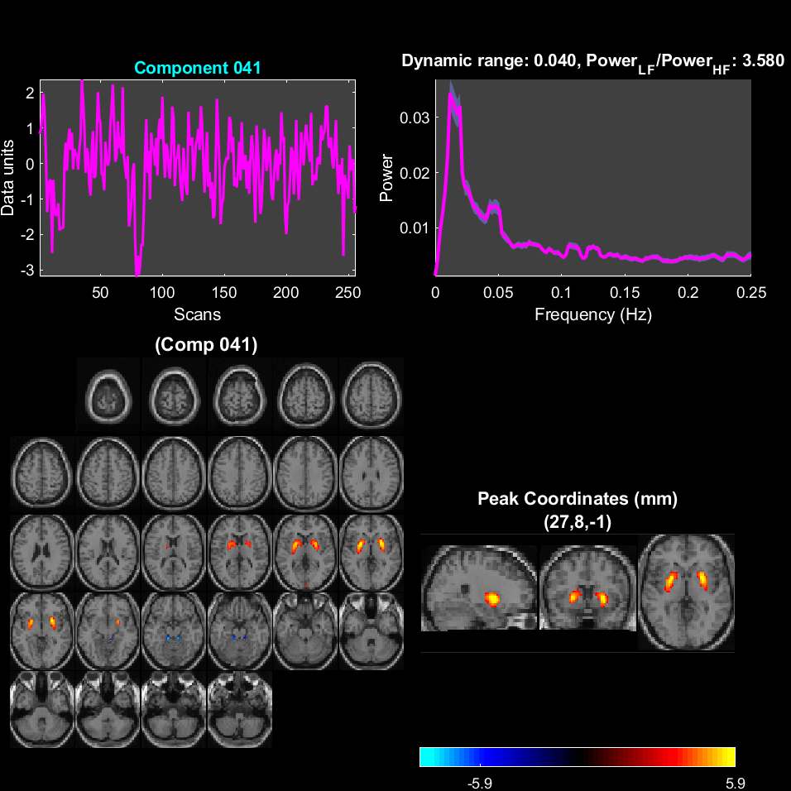
Fig. S5. The time series, power spectrum, and activity areas corresponding to the component #41, t-threshold 3.5. The regions of increased/decreased activation (DS vs DN) are shown in color.
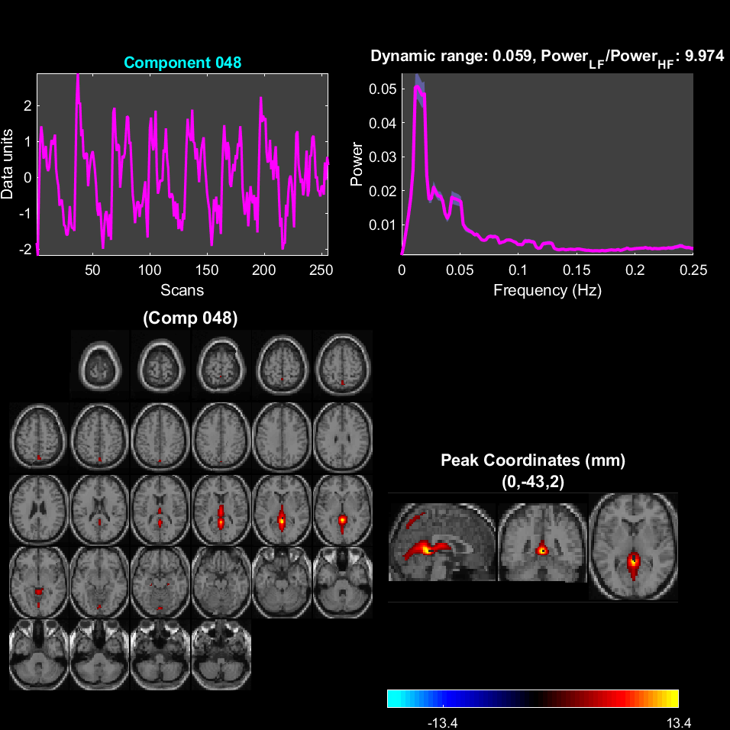
Fig. S6. The time series, power spectrum, and activity areas corresponding to the component #48, t-threshold 3.5. The regions of increased/decreased activation (DS vs DN) are shown in color.

