ELECTRONIC SUPLEMENTARY FILE (ESF)

Research and Diagnostic Algorithmic Rules (RADAR) for mood disorders, recurrence of illness, suicidal behaviors, and the patient’s lifetime trajectory

Michael Maes ^{a,b,c,d}, Juliana Brum Moraes ^{e}, Ana Congio ^{e}, Decio Sabbatini Barbosa ^{e}, Heber Odebrecht Vargas ^{e}, Sandra Odebrecht Vargas Nunes ^{e}

a) Department of Psychiatry, Faculty of Medicine, Chulalongkorn University, Bangkok, Thailand
b) Deakin University, IMPACT, the Institute for Mental and Physical Health and Clinical Translation, School of Medicine, Barwon Health, Geelong, Australia
c) Department of Psychiatry, Medical University of Plovdiv, Plovdiv, Bulgaria
d) Research Institute, Medical University Plovdiv, Plovdiv, Bulgaria
e) Health Sciences Graduate Program, Health Sciences Center, State University of Londrina, Av. Robert Koch 60; 86035-380, Londrina, PR, Brazil;

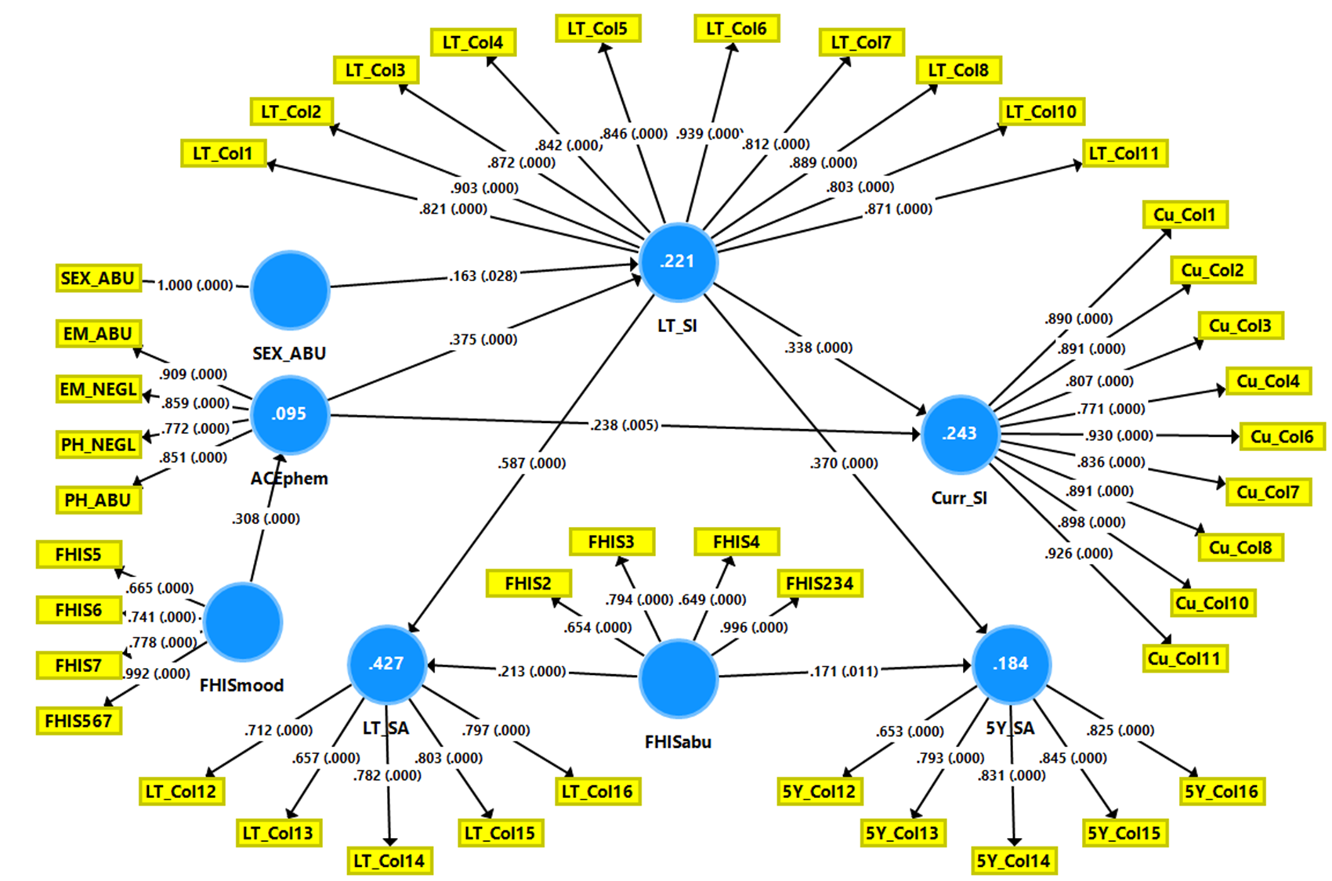
ESF, Figure 1 Partial Least Squares (PLS) model of suicidal behaviors in mood disorders.
The final outcome variables are current suicidal ideation (curr SI) and suicidal attempts, last 5 years (5Y SA). Predictors are adverse childhood experiences (ACE) including physical and emotional abuse (PH_ABU and EM_ABU) and physical and emotional neglect (PH_NEGL and EM_NEGL) (combined into ACEphem) and sexual abuse; a family history (FHIS) of depression (FHIS5), bipolar disorder (FHIS6) and suicide attempts (FHIS7) (combined into FHISmood) and FHIS of tobacco use disorder (FHIS2), alcohol use disorder (FHIS3), substance use disorders (illicit drugs: FHIS4) (combined into FHISabu). The effects of ACEs and HFIS on Curr SI and 5Y SA are mediated via lifetime (LT) SI and SA. All indicators are entered as latent vectors, except sexual abuse.
Only significant paths are shown. Displayed are path coefficients (with p values) and factor loadings (with p values). Figures in blue circles indicate explained variance.

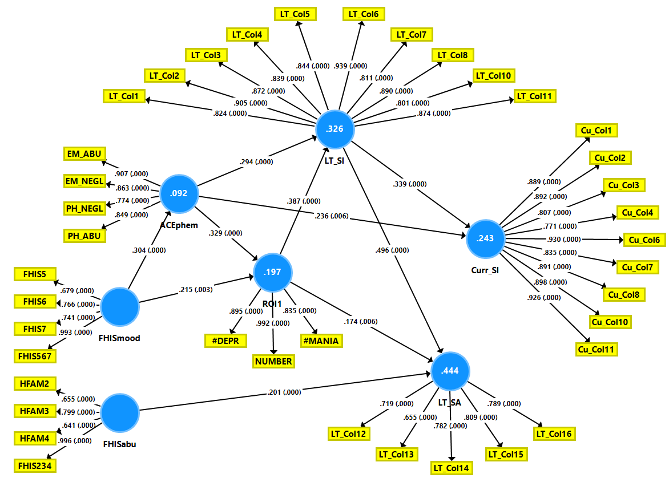

ESF, Figure 2. Partial Least Squares (PLS) model of suicidal behaviors and recurrence of illness (ROI) in mood disorders.
The final outcome variable is current suicidal ideation (curr SI). Predictors are adverse childhood experiences (ACE) including physical and emotional abuse (PH_ABU and EM_ABU) and physical and emotional neglect (PH_NEGL and EM_NEGL) (combined into ACEphem), and a family history (FHIS) of depression (FHIS5), bipolar disorder (FHIS6) and suicide attempts (FHIS7) (combined into FHISmood) and FHIS of tobacco use disorder (FHIS2), alcohol use disorder (FHIS3), substance use disorders (illicit drugs: FHIS4) (combined into FHISabu). The effects of ACEs and HFIS on Curr SI are mediated via lifetime (LT) SI and LT SA and ROI, conceptualized as a factor extracted from number of depression (#depr) and (hypo)mania (#mania) episodes and total number of episodes.
All indicators are entered as latent vectors extracted from the relevant indicators. Only significant paths are shown. Displayed are path coefficients (with p values) and factor loadings (with p values). Figures in blue circles indicate explained variance.

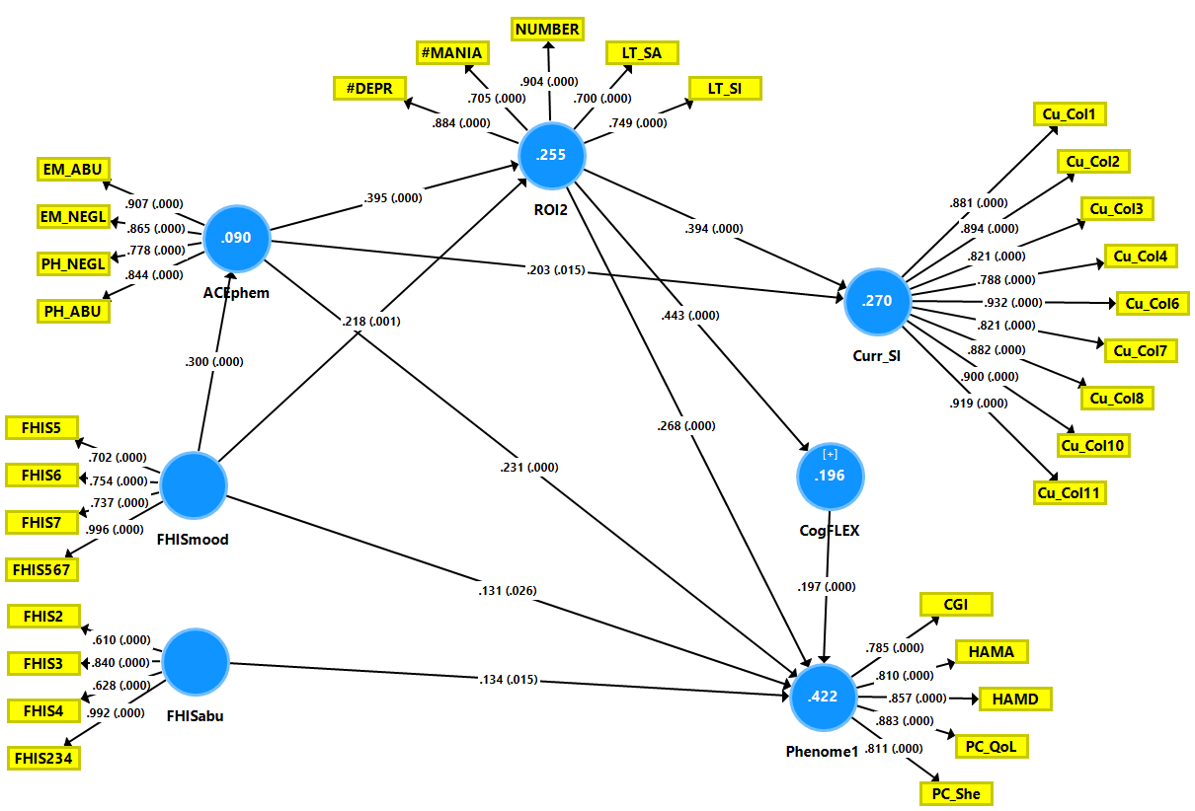

ESF, Figure 3. Partial Least Squares (PLS) model of suicidal behaviors, a comprehensive recurrence of illness (ROI2) index, cognitive deficits (CogFLEX) and the phenome of mood disorders.
The final outcome variables are current suicidal ideation (curr SI) and the phenome of mood disorders, conceptualized as a factor extracted from the phenome and phenomenome, comprising the Hamilton Depression and Anxiety Rating Scale (HAMD/HAMA) scores; four quality of life domains (PC_QoL); five disability Sheehan (PC_She..) scores; and the Clinical Global impression (CGI) score. Predictors are adverse childhood experiences (ACE) including physical and emotional abuse (PH_ABU and EM_ABU) and physical and emotional neglect (PH_NEGL and EM_NEGL) (combined into ACEphem), and a family history (FHIS) of depression (FHIS5), bipolar disorder (FHIS6) and suicide attempts (FHIS7) (combined into FHISmood) and FHIS of tobacco use disorder (FHIS2), alcohol use disorder (FHIS3), substance use disorders (illicit drugs: FHIS4) (combined into FHISabu). The effects of ACEs and HFIS on Curr SI and the phenome are mediated via ROI conceptualized as a factor extracted from lifetime (LT) SI and LT SA, number of depression (#depr) and (hypo)mania (#mania) episodes and total number of episodes, and CogFLEX, namely cognitive deficits in verbal fluency and executive functions.
All indicators are entered as latent vectors extracted from the relevant indicators, except CogFLEX which is entered as a single indicator. Only significant paths are shown. Displayed are path coefficients (with p values) and factor loadings (with p values). Figures in blue circles indicate explained variance.

ESF Table 1. Demographic data of the healthy controls (HC) and mood disorder patients divided into those with major dysmood disorder (MDMD) and simple dysmood disorder (SDMD).

Variables | HC (n=67) | SDMD (n=38) | MDMD (n=60) | F/χ2 | df | P
Age (Years) | 43.1 (11.6) | 45.5 (11.2) | 41.0 (10.2) | 1.90 | 2/162 | 0.153
Sex (F/M) | 44/23 | 30/8 | 50/10 | 5.67 | 2 | 0.059
BMI (kg/m2) | 26.32 (4.66) | 25.90 (4.59) | 27.35 (5.27) | 1.15 | 2/155 | 0.319
TUD (No/Yes) | 32/35 | 14/24 | 27/33 | 1.19 | 2 | 0.550
Education (years)y | 11.6 (5.6) | 10.3 (5.3) | 10.3 (4.4) | 3.88 | 2/161 | 0.023
MetS (No/Yes) | 40/26 | 26/12 | 35/25 | 1.05 | 2 | 0.593

Results are shown as mean (SD) or as ratios.: F: results of analyses of variance; χ2: results of analysis of contingency tables
BMI: body mass index; TUD: tobacco use disorder, MetS: metabolic syndrome.

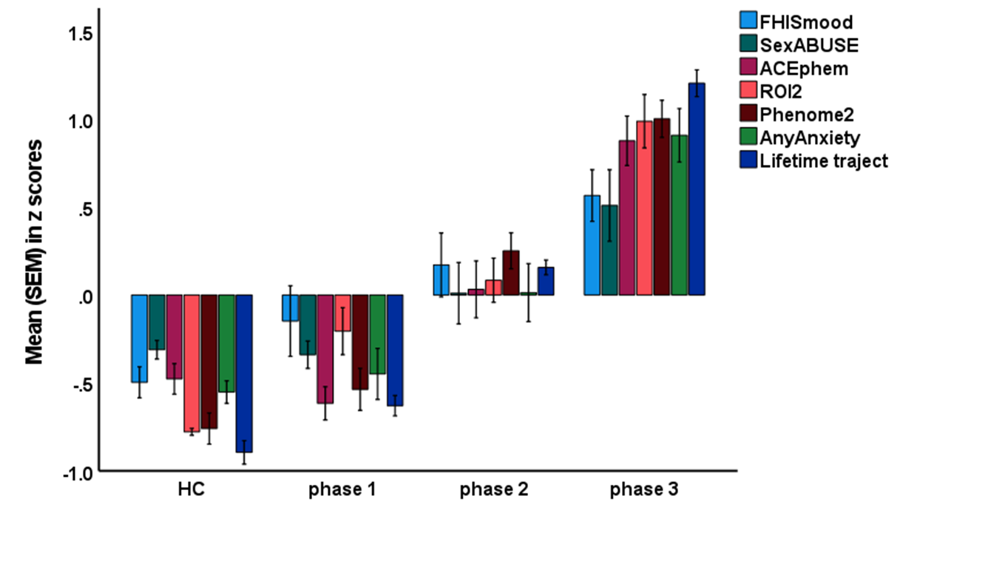

ESF Figure 4. Clustered bar graph showing the RADAR score differences between healthy controls (HC) and patients with mood disorders divided into three lifetime trajectory phases.
FHISmood: a family history of mood disorders and suicide; ACEphem: adverse childhood experiences (neglect and abuse); ROI2: recurrence of illness index; phenome2: an index of phenome and phenomenome; any anxiety: number of comorbid anxiety disorders.

ESF, Table 2. Results of multiple regression analysis with phenome2 as dependent variable.

Bootstrap for Coefficients
Model |  | B | Bootstrapª
 |  |  | Bias | Std. Error | Sig. (2-tailed) | 95% Confidence Interval
 |  |  |  |  |  | Lower | Upper
1 | (Constant) | -1.557 | -.002 | .060 | <.001 | -1.678 | -1.441
 | Currect SI | .034 | .000 | .006 | <.001 | .022 | .044
 | Total HAMD | .054 | 8.910E-5 | .007 | <.001 | .041 | .067
 | Total HAMA | .030 | .000 | .005 | <.001 | .020 | .039
 | CGI | .189 | .002 | .027 | <.001 | .138 | .246
a. Unless otherwise noted, bootstrap results are based on 1000 bootstrap samples
Current SI: sum of current (last month) C-CSSR items 1, 2, 3, 4, 5, and 7
HAMD/HAMA: the Hamilton Depression and Anxiety Rating Scale scores
CGI: Clinical Global impression score

ESF, Table 3. Results of multiple regression analysis with the lifetime trajectory score as dependent variable.

Bootstrap for Coefficients
Model |  | B | Bootstrapª
 |  |  | Bias | Std. Error | Sig. (2-tailed) | 95% Confidence Interval
 |  |  |  |  |  | Lower | Upper
1 | (Constant) | -4.313 | .001 | .105 | <.001 | -4.517 | -4.104
 | Total number depresions | .203 | -.001 | .014 | <.001 | .171 | .229
 | EM_ABU | .140 | .001 | .014 | <.001 | .114 | .169
 | HAMD | .062 | .001 | .012 | <.001 | .041 | .087
 | EM_NEGL | .092 | -.001 | .012 | <.001 | .068 | .117
 | Sheehan 1 | .093 | -.001 | .018 | <.001 | .053 | .126
 | Any Anxiety_yes/no | .758 | .002 | .122 | <.001 | .518 | 1.000
a. Unless otherwise noted, bootstrap results are based on 1000 bootstrap samples
EM_ABU: emotional abuse
HAMD: the Hamilton Depression Rating Scale score
EM_NEGL: emotional neglect
Sheehan 1: domain 1 score on the Sheehan disability scale
Any anxiety disorder: one of the DSM-IV anxiety disorders in diagnosed

ESF, Table 4. Point-biserial correlations between the drug state variables and a family history of mood disorders and suicidal attempts (FHISmood), adverse childhood experiences of physical and emotional abuse and neglect (ACEphem), recurrence of illness (ROI2) and the phenome-phenomenome index (phenome2).
Correlations
 |  | antidep. | Antipsy | lithium | moodst
FHISmood | Pearson Correlation | .203** | .208** | .311** | .268**
 | Sig. (2-tailed) | 0.010 | 0.008 | 0.000 | 0.001
 | N | 162 | 162 | 161 | 161
ACEphem | Pearson Correlation | 0.118 | .234** | .258** | .306**
 | Sig. (2-tailed) | 0.135 | 0.003 | 0.001 | 0.000
 | N | 162 | 162 | 161 | 161
ROI2 | Pearson Correlation | .276** | .363** | .412** | .438**
 | Sig. (2-tailed) | 0.000 | 0.000 | 0.000 | 0.000
 | N | 162 | 162 | 161 | 161
Phenome2 | Pearson Correlation | .290** | .267** | 0.120 | .308**
 | Sig. (2-tailed) | 0.000 | 0.001 | 0.128 | 0.000
 | N | 162 | 162 | 161 | 161
*. Correlation is significant at the 0.05 level (2-tailed).
**. Correlation is significant at the 0.01 level (2-tailed).
Antidep: antidepressants; antipsy: antipsychotics, moodst: mood stabilizers.

