Supplementary Table 1: Trials of antidepressant augmentation of clozapine
Author, year | Intervention | Sample size | Mean age in years | Gender distribution | Definition of clozapine resistance used | Duration in weeks | Outcome measure | Effect size | Confidence intervals Lower | Confidence intervals Upper
Buchanan et al. 1996 | Fluoxetine | 33 | Flu- 36.8 ±6.4  P- 32.8±6.0 | Flu- M- 15, F-3; P- M-8, F-7 | Despite adequate treatment with clozapine (300 mg/day for at least 6 months), continued to exhibit persistent positive or negative symptoms | 8 | BPRS-P | 0.111 | -0.574 | 0.797
Zoccali et al. 2004 | Mirtazapine | 24 | Mir- 30.7±6.5; P- 33.4±9.0 | Mir- M- 6, F-4;  P- M- 7, F-3 | Presence of persistent negative symptoms despite receiving  an adequate trial of clozapine | 8 | BPRS | 5.265 | 3.574 | 6.956
Berk et al., 2009 | Mirtazapine | 38 | Mir – 37.8±10.86; P- 35.9±9.20 | Mir- M-14; F-4; P- M-18, F-2 | Not mentioned specifically | 6 | PANSS-P | -0.570 | -1.229 | 0.072
Mico’ et al. 2011 | Duloxetine | 33 | D- 35.9±7.1  P- 34±6.8 | D- M- 13; P- 11 | Presence of persistent positive and negative symptoms (BPRS score of at least 25) despite an adequate trial of clozapine | 16 | PANSS | 1.229 | 0.553 | 1.905
BPRS: Brief Psychiatric Rating Scale; BPRS-P: Positive symptom subscale of BPRS; PANSS: Positive and Negative Syndrome Scale

Supplementary Table 2: Risk of bias in the included studies

 | Author(s),year | Random sequence | Allocation concealment | Blinding of participants and personnel | Blinding of outcome assessment | Incomplete outcome data | Jadad score
Risperidone | Josiassen et al.,2005 | + | + | + | + | + | 5
Risperidone | Anil Yagcioglu et al.,2005 | + | + | + | + | + | 5
Risperidone | Honer et al.,2006 | + | + | + | + | + | 5
Risperidone | Freudenreich et al.,2007 | + | + | + | ?NA | + | 4
Risperidone | Weiner et al.,2010 | ?NA | ?NA | + | + | + | 3
Sulpiride | Shiloh et al.,1997 | + | + | + | ?NA | ₊ | 4
Amisulpiride | Barnes et al.,2017 | + | + | + | + | + | 5
Aripiprazole | Chang et al., 2008 | + | + | + | + | + | 5
Aripiprazole | Fleischhackeret al., 2010 | + | + | + | + | + | 5
Aripiprazole | Muscatello et al.,2011 | + | + | + | + | - | 4
Sertindole | Nielsen et al.,2012 | + | + | + | + | + | 5
Pimozide | Friedman et al.,2011 | + | + | + | ?NA | ₁ | 4
Ziprasidone | Muscatello et al, 2014 | + | + | + | + | + | 5
Haloperidol | Mossaheb et al, 2006 | ?NA | ?NA | ?NA | ₊ | ?NA | 1
Lamotrigine | Tiihonen et al.,2003 | + | + | + | + | + | 5
Lamotrigine | Zoccali et al.,2007 | + | + | + | + | ?NA | 4
Lamotrigine | Vayisoglu et al.,2013 | + | + | + | + | ?NA | 4
Lamotrigine | Kremer et al.,2004 | + | + | + | + | + | 5
Lamotrigine | Goff et al.,2007 | + | + | + | + | + | 5
Topiramate | Muscatello et al.,2011 | + | + | + | + | - | 4
Topiramate | Behadni et al.,2011 | + | + | + | + | ?NA | 4
Topiramate | Tiihonen et al.,2005 | + | + | + | - | - | 3
Topiramate | Afshar et al.,2009 | + | + | + | + | + | 5
Fluoxetine | Buchanan et al.,1996 | ?NA | ?NA | + | + | ?NA | 2
Mirtazapine | Zoccali et al.,2004 | ?NA | ?NA | ₊ | ?NA | ?NA | 1
Duloxetine | Mico et al.,2011 | + | + | + | + | + | 5
Memantine | De Lucena et al, 2009 | + | ?NA | ?NA | ?NA | + | 2
Memantine | Veerman et al., 2016 | + | + | + | + | - | 4
Glycine | Potkin et al.,1999 | ?NA | + | + | + | - | 3
Glycine | Evins et al.,2000 | ?NA | ₊ | ?NA | ?NA | - | 1
Glycine | Diaz et al.,2005 | ?NA | ?NA | + | - | - | 1
D-Cycloserine | Goff et al.,1999 | ?NA | + | + | + | + | 4
D-serine | Tsai et al.,1999 | ?NA | + | + | ?NA | ₊ | 3
Sarcosine | Lane et al, 2006 | + | + | + | + | + | 5
AmpakineCX516 | Goff et al.,2001 | + | + | ?NA | ₊ | ?NA | 3
Ginkgo biloba | Doruk et al.,2008 | ?NA | + | + | + | + | 4
Minocycline | Kelly et al.,2015 | + | + | + | + | + | 5
Modafinil | Freudenreich et al.,2009 | + | + | + | ?NA | + | 4
N-Acetyl cysteine | Dean et al.,2015 | + | + | + | + | ?NA | 4
ECT | Petrides et al.,2015 | ?NA | + | + | + | + | 4
rTMS | Rosa et al.,2007 | ?NA | + | + | + | + | 4
rTMS | de Jesus et al.,2011 | ₊ | + | + | + | + | 5
OT | Buchain et al, 2003 | + | - | - | + | + | 3
CBT | Barretto et al, 2009 | ?NA | + | + | + | + | 4
CBT | Morrison et al.,2018 | + | + | + | + | + | 5
+ – Attribute present; − – Attribute not present; ? NA – Unclear/Not applicable

Supplement Figure 1: Forest plot of antipsychotic trials
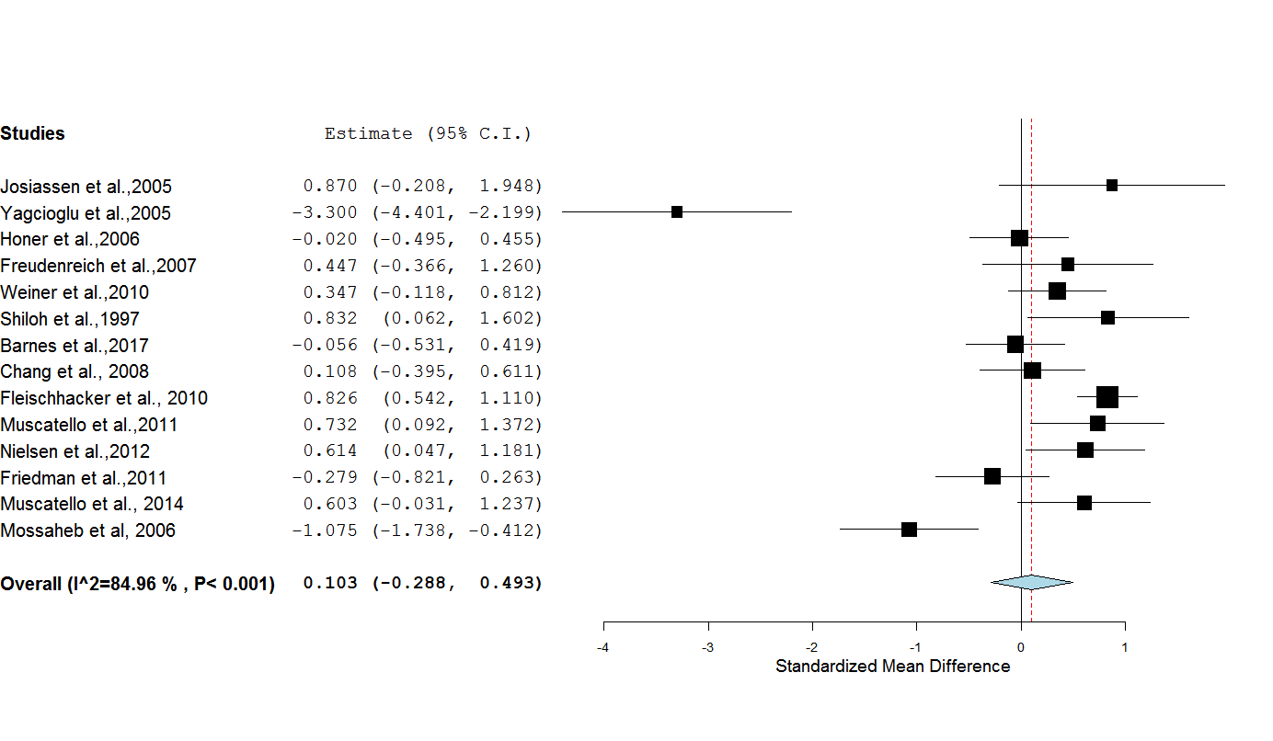
Shown as standardized mean differences, Values more than 0 favour intervention than placebo.

Supplementary Figure 2: Forrest plot of mood stabilizers and anticonvulsants for clozapine augmentation
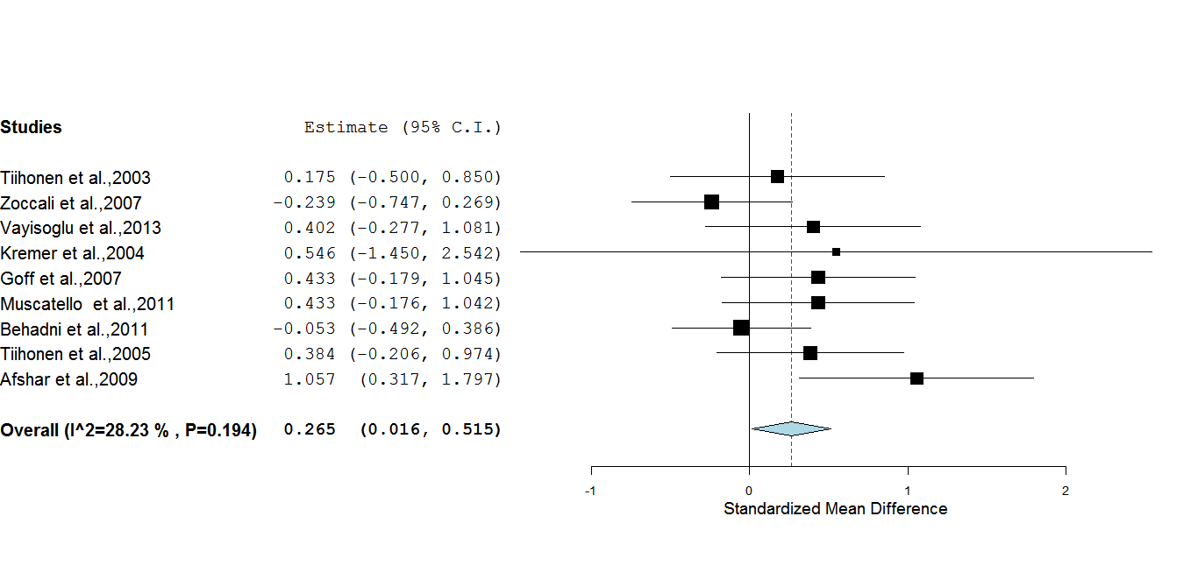
Shown as standardized mean differences, Values more than 0 favour intervention than placebo.

Supplementary Figure 3: Antidepressant trials for clozapine augmentation
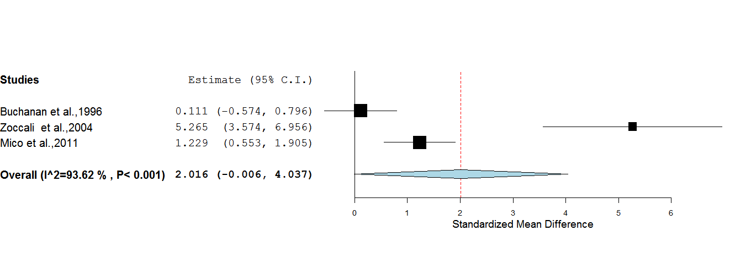
Shown as standardized mean differences, Values more than 0 favour intervention than placebo.

Supplementary Figure 4: Forest plot of memantine, amino acids and alternate treatments for augmentation of clozapine
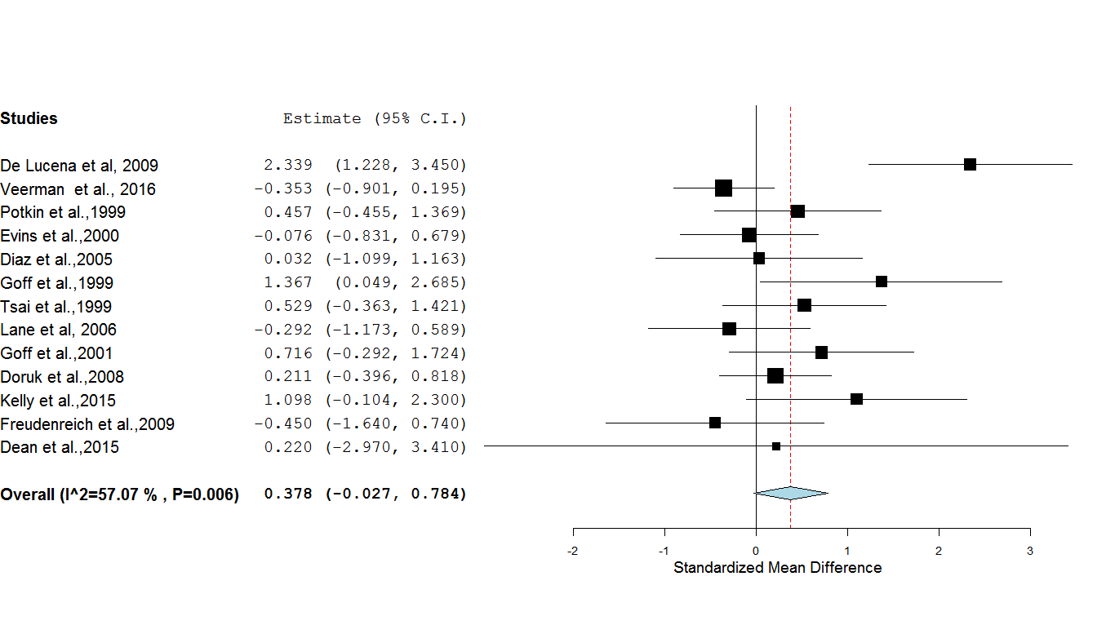
Shown as standardized mean differences, Values more than 0 favour intervention than placebo.

Supplementary Figure 5: Forest plot of other interventions for augmentation of clozapine
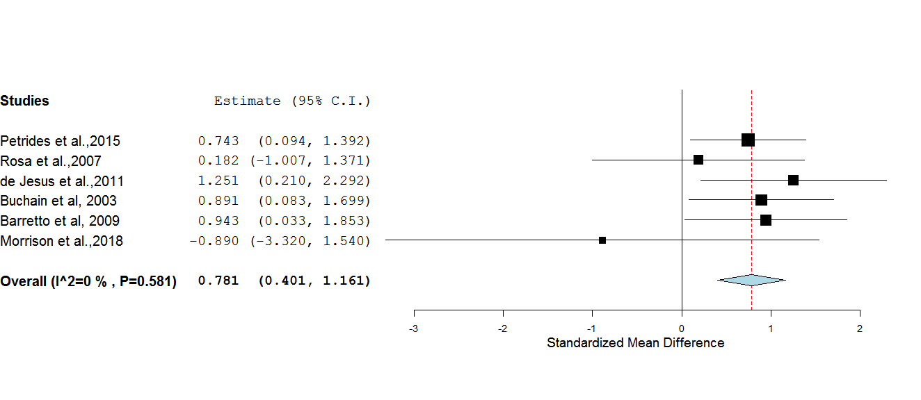
Shown as standardized mean differences, Values more than 0 favour intervention than placebo.

Supplementary Figure 6: Sub-group analyses by types of intervention
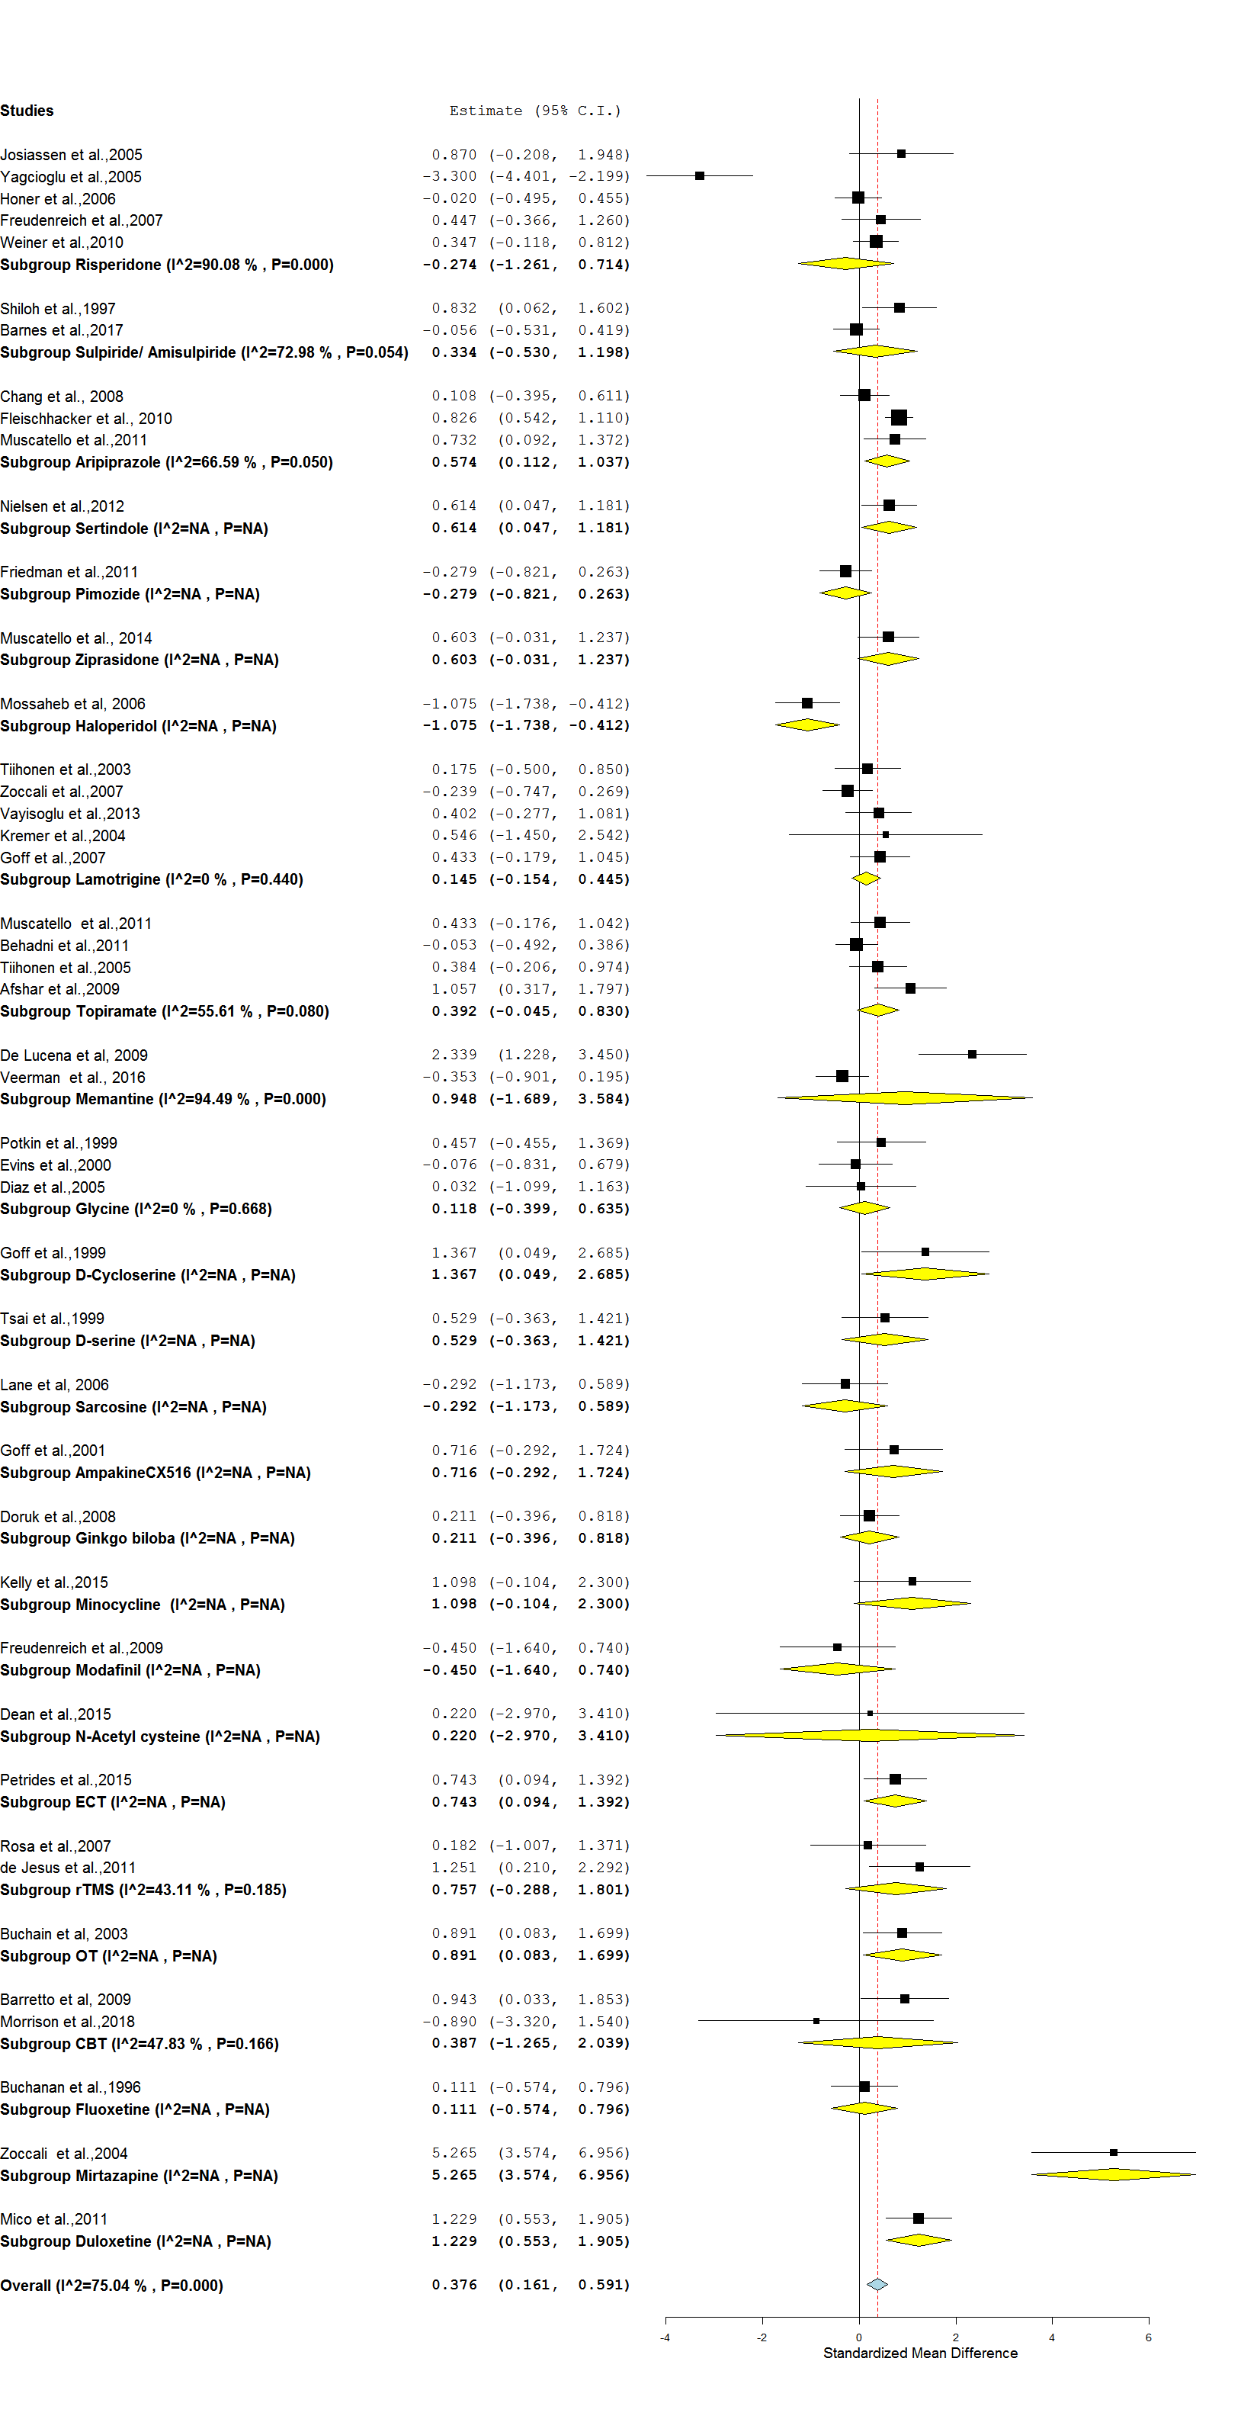
Shown as standardized mean differences, Values more than 0 favour intervention than placebo.

Supplementary Figure-7: Funnel Plot of the all the included studies

