Supplementary material

Supplementary table 1. Sample description.
Sex | 13 females : 10males
Age (years) | 23.65 (3.23) ª
Estimated IQ (MWT-B) | 102.90 (9.70) ª
Right-handedness in % (Edinburgh Handedness Inventory) | 82.70 (18.39) ª
ª mean (SD)
Supplementary material

Supplementary table 2. Rank correlation of WM and PPI (single sessions)
 | PPI (session 1)ª | PPI (session 2)
n-back (session 1)^{b} | .357 (p=.095) | .477 (p=.022)
n-back (session 2) | .330 (p=.124) | .649 (p=.001)
CDT (session 1)^{c} | -.077 (p=.735) | -.040 (p=.859)
CDT (session 2) | .194 (p=.400) | .367 (p=.101)
Notes. ª PPI = pooled across intensity levels; ^{b} n-back performance = correct answers from 2-back minus 0-back condition; ^{c} CDT performance = number of correct answers across conditions (i.e., “change” and “no change”).

Supplementary material

Supplementary table 3. Correlation of PPI (76 dB) and WM (n-back) pooled
across sessions and controlled for prepulse EMG activity.

 | 0b | 2b | 2b-0b | 2b res.
PPI 76 dB | .61** | .63** | .64** | .43*
Notes: Spearman-Rho is shown; ** = p<0.01; * = p<0.05.

Supplementary material

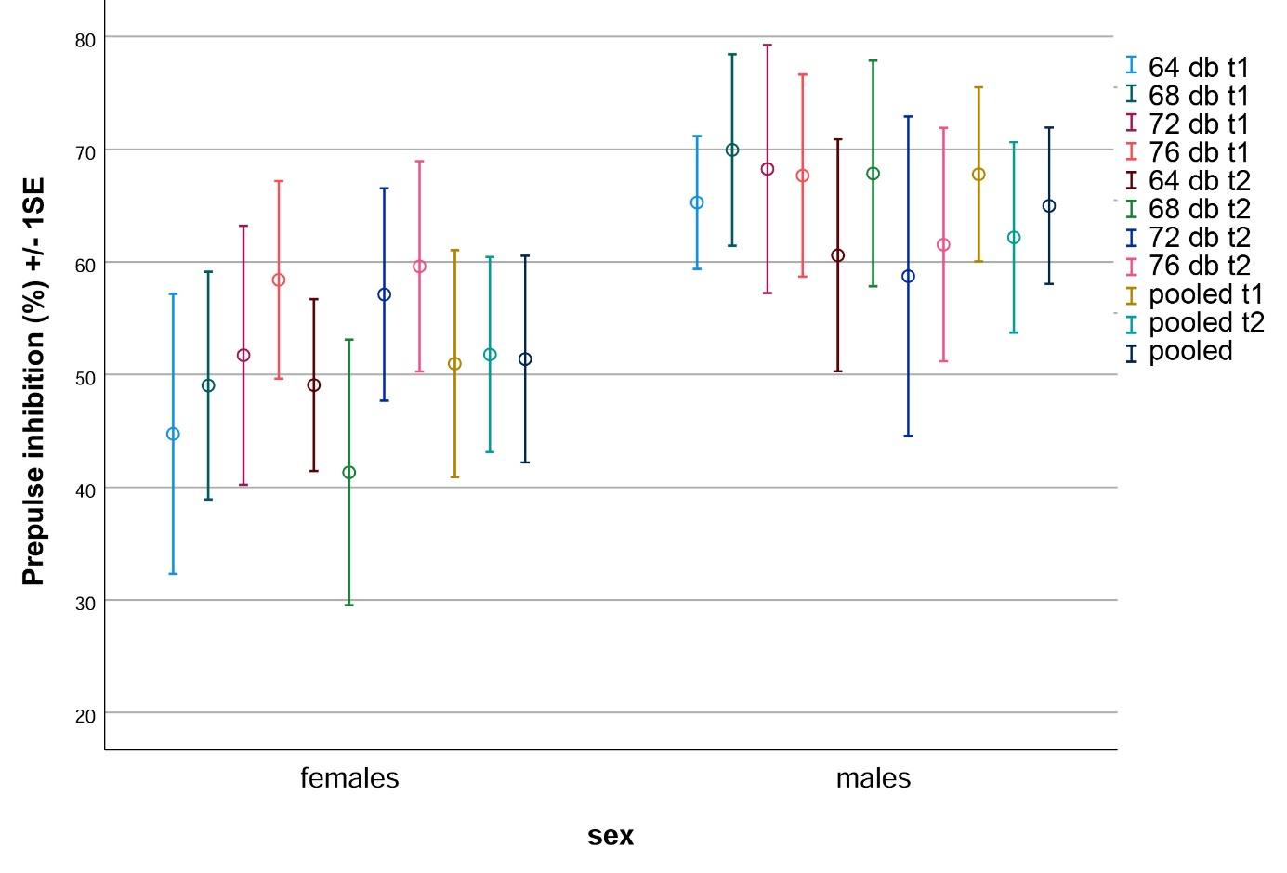
Supplementary Figure 1. PPI compared in females (N=12) compared to males (N=10). When tested by t-test for independent samples, no comparison was significant (alpha = 0.05; two-tailed). All p-values >0.11.

