Supplementary Material

Variation in psychological well-being and symptoms of anxiety and depression during the COVID-19 Pandemic: Results from a 3-wave panel survey
Sønderskov et al.

Supplementary Figure 1: WHO-5 mean values (and 95% CI) across waves – stratified by gender

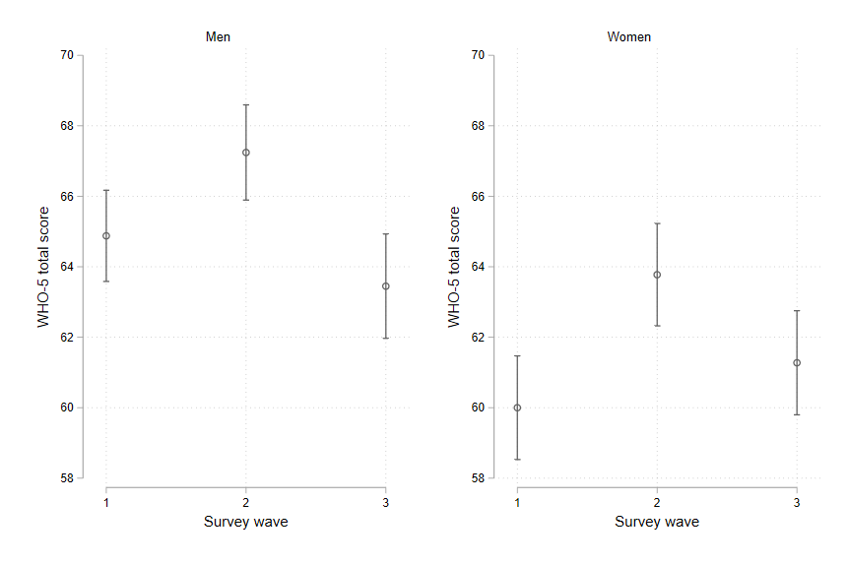

Supplementary Table 1: Difference in WHO-5 mean values across waves – stratified by gender

 | Comparing wave | Difference in mean WHO-5 | 95% CI
Men | 2 vs 1 | 2.37 | 1.28; 3.46
 | 3 vs 1 | -1.43 | -2.79; -0.07
 | 3 vs 2 | -3.79 | -5.09; -2.50
Women | 2 vs 1 | 3.77 | 2.74; 4.80
 | 3 vs 1 | 1.28 | -0.06; 2.61
 | 3 vs 2 | -2.50 | -3.71; -1.29
Supplementary Figure 2: Proportions (and 95% CI) with WHO-5 score <50 across waves – stratified by gender
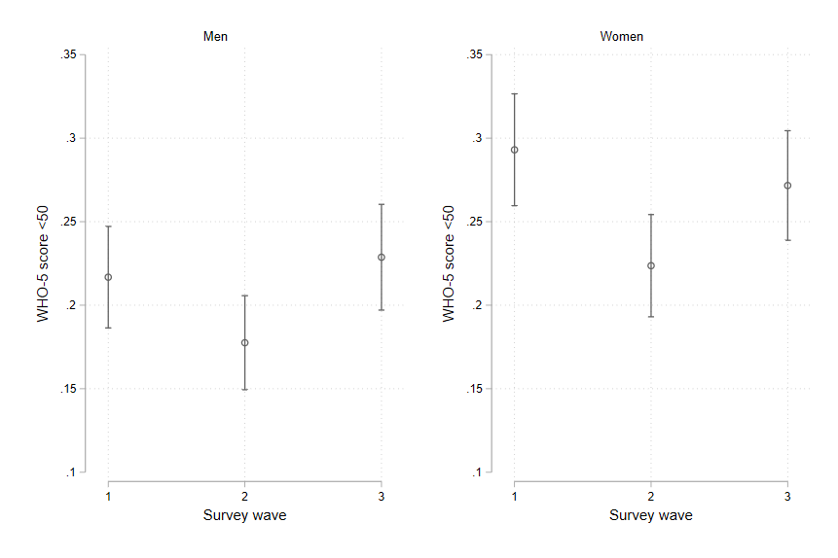

Supplementary Table 2: Difference in proportions with WHO-5 score <50 across waves – stratified by gender

 | Comparing wave | Difference | 95% CI
Men | 2 vs 1 | -0.04 | -0.07; -0.01
 | 3 vs 1 | 0.01 | -0.03; 0.05
 | 3 vs 2 | 0.05 | 0.02; 0.09
Women | 2 vs 1 | -0.07 | -0.10; -0.04
 | 3 vs 1 | -0.02 | -0.06; 0.01
 | 3 vs 2 | 0.05 | 0.02; 0.08

Supplementary Figure 3: Symptoms of anxiety and depression across waves – stratified by gender

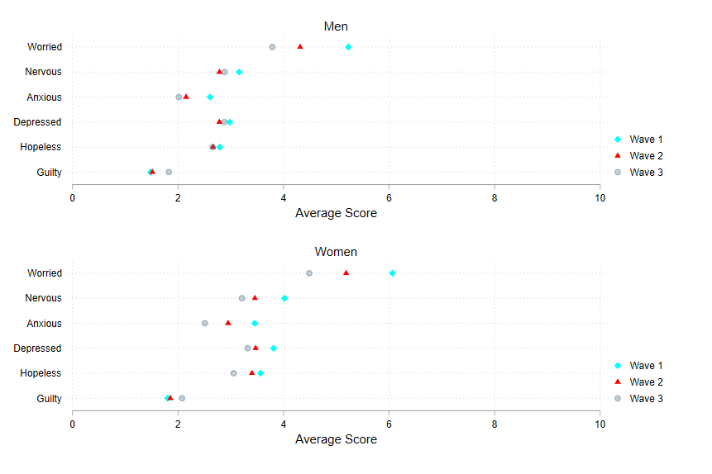

Supplementary Table 3: Differences in symptoms of anxiety and depression across waves – stratified by
gender

 | WHO-5 item | Comparing wave | Difference | 95% CI
Men | Worried | 2 vs 1 | -0.91 | -1.07; -0.74
 |  | 3 vs 1 | -1.42 | -1.63; -1.21
 |  | 3 vs 2 | -0.51 | -0.71; -0.32
 | Nervous | 2 vs 1 | -0.36 | -0.53; -0.19
 |  | 3 vs 1 | -0.24 | -0.45; -0.03
 |  | 3 vs 2 | 0.13 | -0.06; 0.31
 | Anxious | 2 vs 1 | -0.42 | -0.57; -0.27
 |  | 3 vs 1 | -0.57 | -0.75; -0.38
 |  | 3 vs 2 | -0.14 | -0.31; 0.02
 | Depressed | 2 vs 1 | -0.19 | -0.33; -0.04
 |  | 3 vs 1 | -0.08 | -0.27; 0.11
 |  | 3 vs 2 | 0.10 | -0.08; 0.29
 | Hopeless | 2 vs 1 | -0.12 | -0.29; 0.05
 |  | 3 vs 1 | -0.13 | -0.33; 0.08
 |  | 3 vs 2 | -0.01 | -0.20; 0.19
 | Guilty | 2 vs 1 | 0.03 | -0.13; 0.19
 |  | 3 vs 1 | 0.34 | 0.15; 0.52
 |  | 3 vs 2 | 0.31 | 0.14; 0.47
Women | Worried | 2 vs 1 | -0.86 | -1.02; -0.71
 |  | 3 vs 1 | -1.56 | -1.76; -1.36
 |  | 3 vs 2 | -0.69 | -0.89; -0.50
 | Nervous | 2 vs 1 | -0.59 | -0.77; -0.42
 |  | 3 vs 1 | -0.81 | -1.02; -0.60
 |  | 3 vs 2 | -0.22 | -0.42; -0.02
 | Anxious | 2 vs 1 | -0.50 | -0.67; -0.33
 |  | 3 vs 1 | -0.95 | -1.14; -0.76
 |  | 3 vs 2 | -0.45 | -0.64; -0.26
 | Depressed | 2 vs 1 | -0.36 | -0.52; -0.20
 |  | 3 vs 1 | -0.50 | -0.69; -0.32
 |  | 3 vs 2 | -0.14 | -0.33; 0.05
 | Hopeless | 2 vs 1 | -0.21 | -0.39; -0.03
 |  | 3 vs 1 | -0.52 | -0.73; -0.32
 |  | 3 vs 2 | -0.31 | -0.52; -0.11
 | Guilty | 2 vs 1 | 0.09 | -0.08; 0.26
 |  | 3 vs 1 | 0.30 | 0.10; 0.49
 |  | 3 vs 2 | 0.21 | 0.03; 0.39

Supplementary Table 4: Correlation between changes in symptoms of anxiety/depression and changes in
well-being from wave 2 to wave 3

Item | Pearson's R  All | Pearson's R  Men | Pearson's R  Women
Worry | −0.332 | -0.326 | -0.337
Nervousness | −0.430 | -0.426 | -0.432
Anxiety | −0.349 | -0.350 | -0.349
Depressed mood | −0.526 | -0.516 | -0.534
Hopelessness | −0.459 | -0.464 | -0.454
Guilt | −0.285 | -0.299 | -0.272

Pearson's correlation coefficients for the association between changes in the six self-reported symptoms of anxiety and depression from wave 2 to wave 3 and changes in WHO-5 scores from wave 2 to wave 3.
Observations: 3025-3067. All correlations are statistically significant (p<0.001).

Supplementary Figure 4: Individual WHO-5 item scores* across waves – stratified by gender

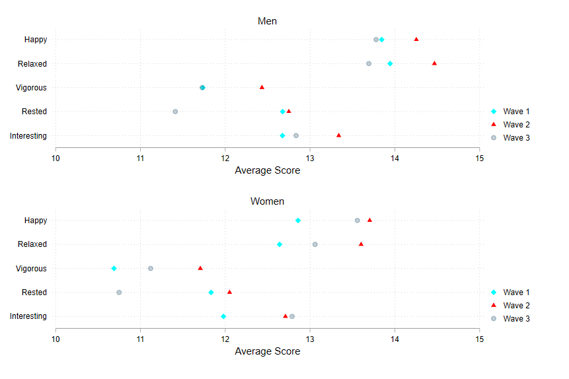

* The item scores were multiplied by 4 to match the total scores reported in the manuscript and elsewhere in
the supplement. The total score on the WHO-5 is calculated by adding the individual item scores and multi-
plying by four (hypothetical range: 0-100).
Supplementary Table 5: Differences in Individual WHO-5 item scores* across waves – stratified by gender

 | WHO-5 item | Comparing wave | Difference | 95% CI
Men | Happy | 2 vs 1 | 0.41 | 0.14; 0.68
 |  | 3 vs 1 | -0.07 | -0.39; 0.26
 |  | 3 vs 2 | -0.47 | -0.78; -0.17
 | Relaxed | 2 vs 1 | 0.52 | 0.23; 0.82
 |  | 3 vs 1 | -0.25 | -0.58; 0.08
 |  | 3 vs 2 | -0.77 | -1.10; -0.44
 | Vigorous | 2 vs 1 | 0.70 | 0.36; 1.03
 |  | 3 vs 1 | -0.01 | -0.40; 0.38
 |  | 3 vs 2 | -0.70 | -1.08; -0.33
 | Rested | 2 vs 1 | 0.07 | -0.24; 0.38
 |  | 3 vs 1 | -1.27 | -1.66; -0.87
 |  | 3 vs 2 | -1.34 | -1.70; -0.98
 | Interesting | 2 vs 1 | 0.66 | 0.35; 0.98
 |  | 3 vs 1 | 0.16 | -0.21; 0.54
 |  | 3 vs 2 | -0.50 | -0.84; -0.17
Women | Happy | 2 vs 1 | 0.85 | 0.58; 1.11
 |  | 3 vs 1 | 0.70 | 0.38; 1.01
 |  | 3 vs 2 | -0.15 | -0.44; 0.15
 | Relaxed | 2 vs 1 | 0.96 | 0.67; 1.25
 |  | 3 vs 1 | 0.42 | 0.05; 0.79
 |  | 3 vs 2 | -0.54 | -0.86; -0.22
 | Vigorous | 2 vs 1 | 1.02 | 0.72; 1.32
 |  | 3 vs 1 | 0.43 | 0.07; 0.80
 |  | 3 vs 2 | -0.59 | -0.94; -0.24
 | Rested | 2 vs 1 | 0.22 | -0.11; 0.55
 |  | 3 vs 1 | -1.08 | -1.49; -0.68
 |  | 3 vs 2 | -1.30 | -1.67; -0.94
 | Interesting | 2 vs 1 | 0.73 | 0.41; 1.05
 |  | 3 vs 1 | 0.81 | 0.45; 1.17
 |  | 3 vs 2 | 0.08 | -0.27; 0.43

* The item scores were multiplied by 4 to match the total scores reported in the manuscript and elsewhere in
the supplement. The total score on the WHO-5 is calculated by adding the individual item scores and multi-
plying by four (hypothetical range: 0-100).

