Supplementary material

Psychiatric Symptoms Related to the COVID-19 Pandemic

Coding of pandemic-related psychopathology

All records describing pandemic-related psychopathology were labeled based on the following code:

1. Substance abuse
2. Delusions
3. Hallucinations
4. Negative symptoms
5. Mania/hypomania/mixed state (”irritable”, ”restless”, overconfident or risky behavior etc.)
6. Depression (”sad”, ”unhappy”, ”lonely”, ”down”, ”hopeless”, ”guilty” etc.)
7. Suicidality/self-harm
8. Anxiety (”worried”, ”anxious”, ”tense”, ”frightened”, ”panicky”, + autonomic symptoms)
9. Trauma- or stressor-related symptoms (”alert”, ”vigilant”, “flashbacks”, ”nightmares”, etc.)
10. Obsessions or compulsions
11. Feeding or eating disorders (anorexia, bulimia, binge eating)
12. Autism spectrum symptoms (exacerbated internalizing or externalizing behaviors)
13. ADHD-related symptoms (impulsitivy, hyperactivity, attention difficulties)
14. Disruptive behaviour in children (antisocial, defiant, oppositional, violent)
15. Tics (motor/verbal)
16. Aggression (“anger”, “frustration”, “externalizing behaviors”)
17. Unspecific stress (”stressed”, ”under pressure”, ”dissatisfaction”/”decreased well-being”) not better accounted for by the above symptom domains.
18. Other symptoms / miscellaneous

Only one code (the dominant psychopathology) was given per clinical note. Two examples of potentially ambiguous cases are discussed and resolved below:

- Patients with psychotic depression or psychotic mania showing pandemic-related delusions or hallucinations were classified as ”2” (delusions) or ”3” (hallucinations), respectively.*

- Patients with any diagnosis (e.g. depression) among whom the pandemic appeared to have been related to self-harm, suicidal thoughts/behavior were classified as ”7” (suicidality/ self-harm).

* This rule was considered to be most informative because the affective aspect would be covered by the patients’ diagnosis (see Figure 1 in the manuscript).

Supplementary Figure 1

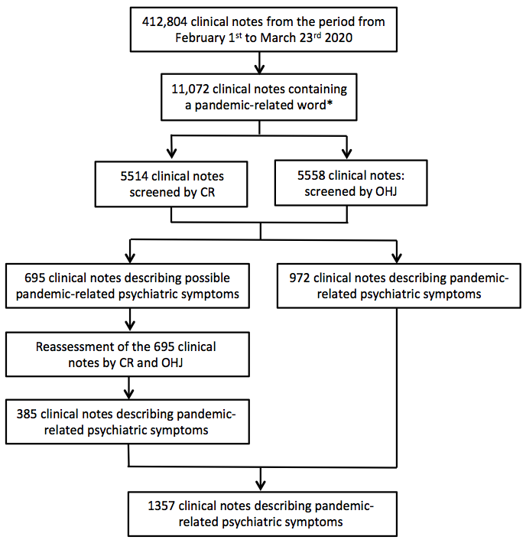

* “corona“, “COVID”, “virus”, “epidemic”, “pandemic”, “contaminate”

