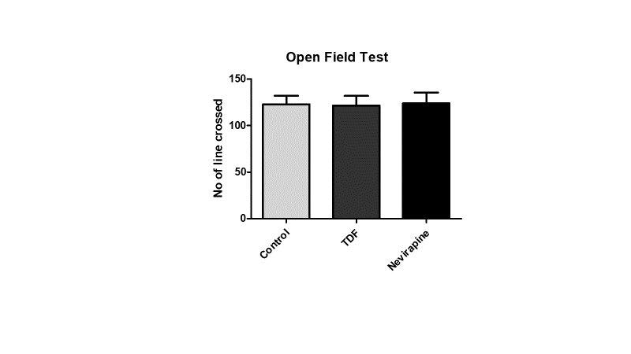

**Supplementary Figure S1.** The effect of chronic administration of TDF and nevirapine on locomotor activity. There were no significant differences on the number of lined crossed between groups. Data are presented as means ± SEM (n = 10 per group).