Supplementary material

Supplementary Figures 1 a-b: Associations between s-alpha-tocopherol and PUFA in acute and stable phases

Suppl. Fig. 1a: Acute phase

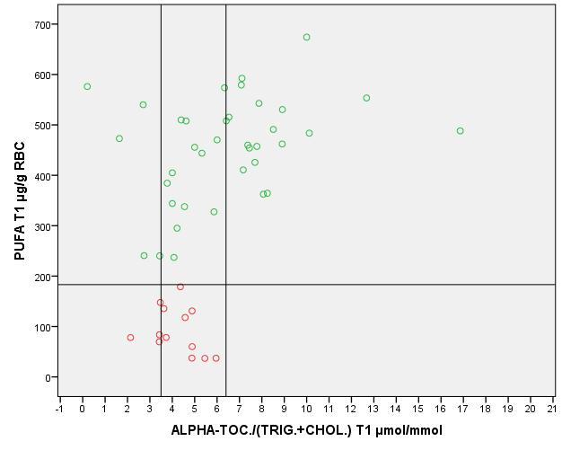

T1: acute phase.
PUFA: omega-3 + omega-6 polyunsaturated fatty acids in red blood cells (RBC)
ALPHA-TOC/(TRIG.+CHOL.): alpha-tocopherol / (s-triglycerides + s-cholesterol)
Each circle represents one patient. The horizontal line separates Low PUFA patients (≤183 µg/g RBC, acute phase, red circles) from High PUFA patients (>183 µg/g RBC, acute phase, green circles) (1). The vertical lines deliminate the reference interval for alpha-tocopherol/(triglycerides+cholesterol) in Norwegian healthy controls (3.5-6.4 µmol/mmol) (2).

Suppl. Fig. 1b: Stable phase

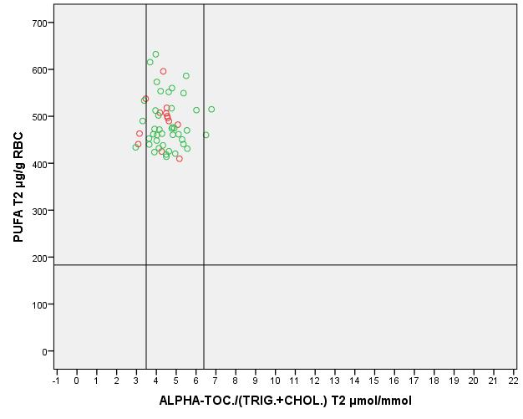

T2: stable phase. PUFA: omega-3 + omega-6 polyunsaturated fatty acids in red blood cells (RBC) .ALPHA-TOC/(TRIG.+CHOL.): alpha-tocopherol / (s-triglycerides + s-cholesterol)
Lines and circles are defined as for Suppl. Fig 1a.

References (supplement only)

1.Bentsen H, Solberg DK, Refsum H, Gran JM, Bohmer T, Torjesen PA, et al. Bimodal distribution of polyunsaturated fatty acids in schizophrenia suggests two endophenotypes of the disorder. Biol Psychiatry. 2011;70(1):97-105
2. Aasheim ET, Hofso D, Hjelmesaeth J, Birkeland KI, Bohmer T (2008): Vitamin status in morbidly obese patients: A cross-sectional study. Am J Clin Nutr 87:362–369.

