SUPPLEMENTARY MATERIAL
Prelimbic neuronal Nitric Oxide Synthase inhibition exerts antidepressant-like effects independently of BDNF signaling cascades.

Vitor Silva Pereira, PhD^{1,3*};Angélica C.D. Romano Suavinha, MSc ²; Gregers Wegener, MD, PhD, DSc, Professor ¹ ; Sâmia R.L. Joca, PhD, Professor ^{1,2*}.
¹Translational Neuropsychiatry Unit, Department of Clinical Medicine, Aarhus University, 8240 Risskov, Denmark
²Department of Physics and Chemistry, School of Pharmaceutical Sciences of Ribeirão Preto, Campus USP-Ribeirão Preto, Ribeirão Preto, SP 14040-904, Brazil.
³School of Medicine of Ribeirão Preto, Campus USP-Ribeirão Preto, Ribeirão Preto, SP 14040-904, Brazil.

- Microinjection sites in the vMPFC-PL
Illustration 1 represents the microinjections sites into the vmPFC-PL of all animals.

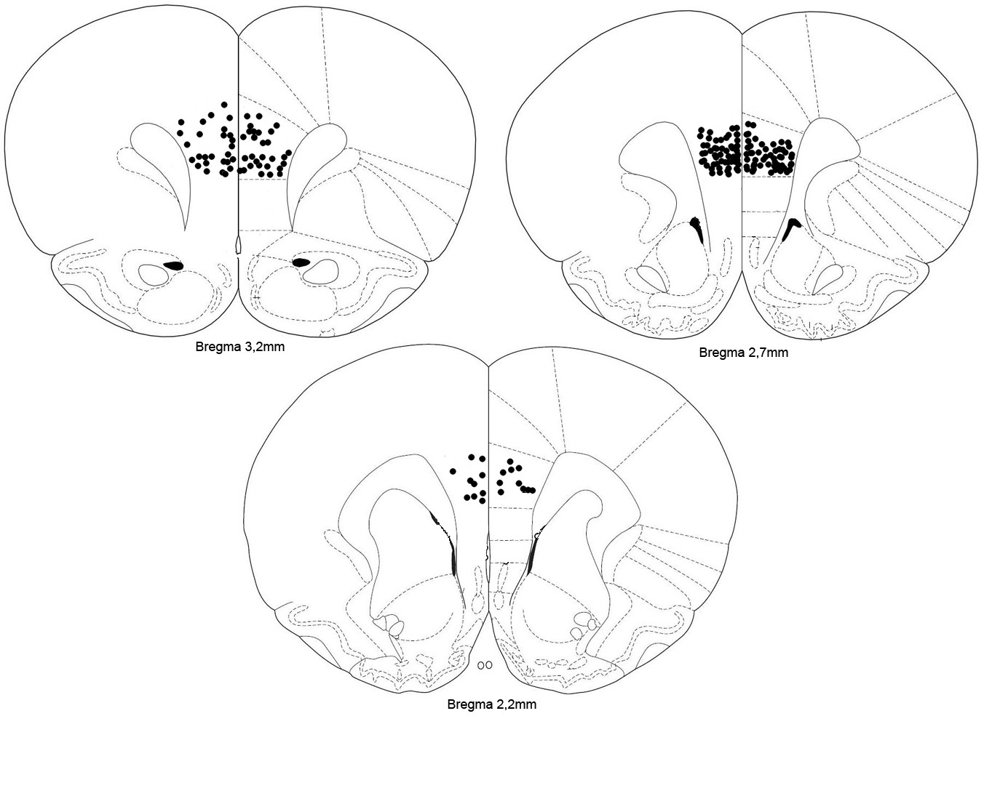
Illustration 1. Representative coronal brain sections showing bilateral microinjection sites in the vMPFC-PL.
- Forced Swim data
Dose-response experiments to determine the most effective dose of NPA, BDNF, Ketamine, and 7-NI in adult male Wistar rats exposed to the forced-swim test.

Effects of intra vmPFC-PL injection of NPA or BDNF on immobility time of adult male Wistar rats exposed to the forced-swim test
Bilateral injection of NPA (0.01 and 0.1 nmol/0.2µL/side ) into the vmPFC-PL, 5 minutes before the test, reduced the immobility time of animals exposed to the FST (F(2,16)= 5,942, P < 0.05; Dunnett). Similarly, bilateral injection of BDNF (0.1 and 0.2 nmol/0.2µL/side ) into the vmPFC-PL, 30 minutes before the test, reduced the immobility time of animals exposed to the FST (F(2,15)= 21.67, P < 0.05; Dunnett) (Supplementary Fig.2)

Supplementary Fig.1. Effects of bilateral NPA 0.01 and 0.1 nmol/0.2µL/side administration into the vmPFC-PL, 30 min before the test, on immobility time of rats exposed to the FST, *p < 0.05 (compared to vehicle group), Dunnett's posttest. Data represents mean ± SEM, n = 5-7.

Supplementary Fig.2. Effects of bilateral BDNF 0.1 and 0.2 nmol/0.2µL/side administration into the vmPFC-PL, 30 min before the test, on immobility time of rats exposed to the FST, *p < 0.05 (compared to vehicle group), Dunnett's posttest. Data represents mean ± SEM, n = 5-7.

Effects of systemic injection of Ketamine or 7-NI on immobility time of adult male Wistar rats exposed to the forced-swim test
The systemic injection of ketamine at 10 mg/kg, but not at 3 and 30 mg/kg, 60 minutes before the test, reduced the immobility time of animals exposed to the FST (F(4,25)= 9.912, P < 0.05; Dunnett). The systemic injection of 7NI at 30 mg/kg, but not at 15 mg/kg, 60 minutes before the test, reduced the immobility time of animals exposed to the FST (F(4,20)= 6.893, P < 0.05; Dunnett).
Both experiments used imipramine as a positive control. Imipramine (15 mg/kg) was injected three times via i.p. at 0h, 5h and 23h after the pre-test session of the FST. In both experiments, imipramine reduced the immobility time of animals exposed to the FST.
The vehicle for ketamine experiments were sterile saline, while the experiments with 7-NI were performed with 50% polyethyleneglycol (50% PEG) as vehicle. In order to show that these vehicles do not change the behavioral response of the animals we performed a separated T test with the data obtained from the experiments described above (T(12) = 0.7310) (Fig. 4.1).

Supplementary Fig.3. Effects of i.p. injection of Ketamine at 3, 10 and 30 mg/kg, 60 min before the test, on immobility time of rats exposed to the FST. Imipramine (15 mg/kg) was injected three times via i.p. at 0h, 5h and 23h after the pre-teste session of the FST. *p < 0.05 (compared to vehicle group), Dunnett's posttest. Data represents mean ± SEM, n = 4-8.

Supplementary Fig.4. Effects of i.p. injection of 7-NI at 15 and 30 mg/kg, 60 min before the test, on immobility time of rats exposed to the FST. Imipramine (15 mg/kg) was injected three times via i.p. at 0h, 5h and 23h after the pre-teste session of the FST. *p < 0.05 (compared to vehicle group), Dunnett's posttest. Data represents mean ± SEM, n = 4-6.
Supplementary Fig.4.1. Effects of i.p. injection of 50% PEG Solution (vehicle for 7-NI experiments) compared to Sterile Saline (regular vehicle), 60 min before the test, on immobility time of rats exposed to the FST. p > 0.05, Student’s T test. Data shown as mean ± SEM, n = 8-6.

- Open-field data
Effects of intra vmPFC-PL injection of BDNF on locomotor activity
Bilateral injection of BDNF (0.2nmol/0.2µL/side) into the vmPFC-PL, 30 minutes before the test, does not modify rat exploratory activity in the OFT (F(1,10) = 0.9996; P > 0.05; Dunnett) (Supplementary Fig.5)
Supplementary Fig.5. Effects of bilateral BDNF 0.2nmol/0.2µL/side administration into the vmPFC-PL, 30 min before the test, on the motor activity of rats exposed to the open field, p > 0.05 (compared to vehicle group), Dunnett's posttest. Data represents mean ± SEM, n = 7-9.

Effects of systemic injection of Ketamine or 7-NI on locomotor activity
The systemic injection of ketamine (10 mg/kg) or 7-NI (30 mg/kg), 1h before the test, does not modify rat exploratory activity in the OFT (F(2,13) = 2.048; P > 0.05; Dunnett) (Suplementary Fig.6).

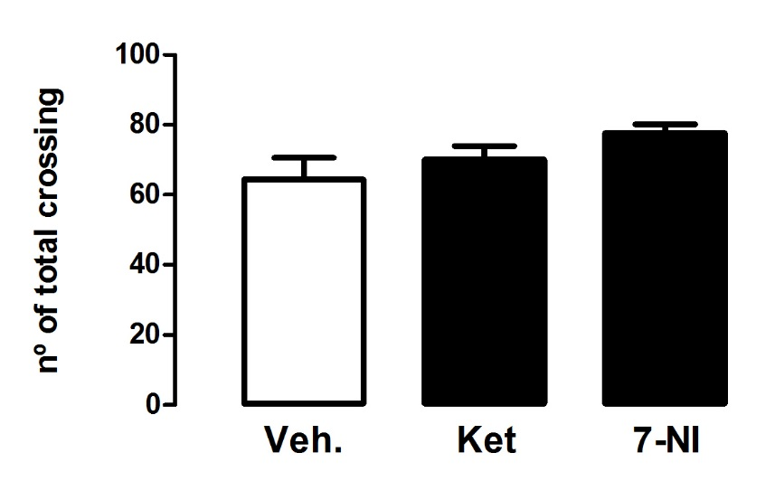
Suplementary Fig.6 Effects of systemic Ketamine (10mg/kg) and 7-NI (30 mg/kg) administration, 1h before the test, on the motor activity of rats exposed to the open field, p > 0.05 (compared to vehicle group), Dunnett's posttest. Data represents mean ± SEM, n = 5-6.

- Western blotting data
Effects of systemic injection of Ketamine or 7-NI on expression of pTrkB and pmTOR into the mPFC.
The i.p. injection of ketamine (10 mg/kg), 7-NI (30 mg/kg) or vehicle did not change the expression of total or phophorilated TrkB (F(3,26) = 0,1360; p > 0,05; Dunnett) (Supplementary Fig 4a). The same treatments did not change the expression of total or phophorilated mTOR (F(3,16) = 0,3526; p > 0,05; Dunnett) (Supplementary Fig 4b).

Supplementary Fig 7. a. Effects of i.p. injection of vehicle, Ketamine or 7-NI on the expression of pTrkB normalized by the expression of total TrkB. All mPFC samples were collected 1h after the injections. p > 0,05; n = 6-8 (Anova followed by Dunnett). b. Effects of i.p. injection of vehicle, Ketamine or 7-NI on the expression of pmTOR normalized by the expression of total mTOR. All mPFC samples were collected 1h after the injections. p > 0,05; n = 5/group (Anova followed by Dunnett).

Supplementary Fig 8. Representative image of the Western Blot membranes of mTOR, pmTOR, TrkB and pTrkB.

