Copyright Transfer Agreement:
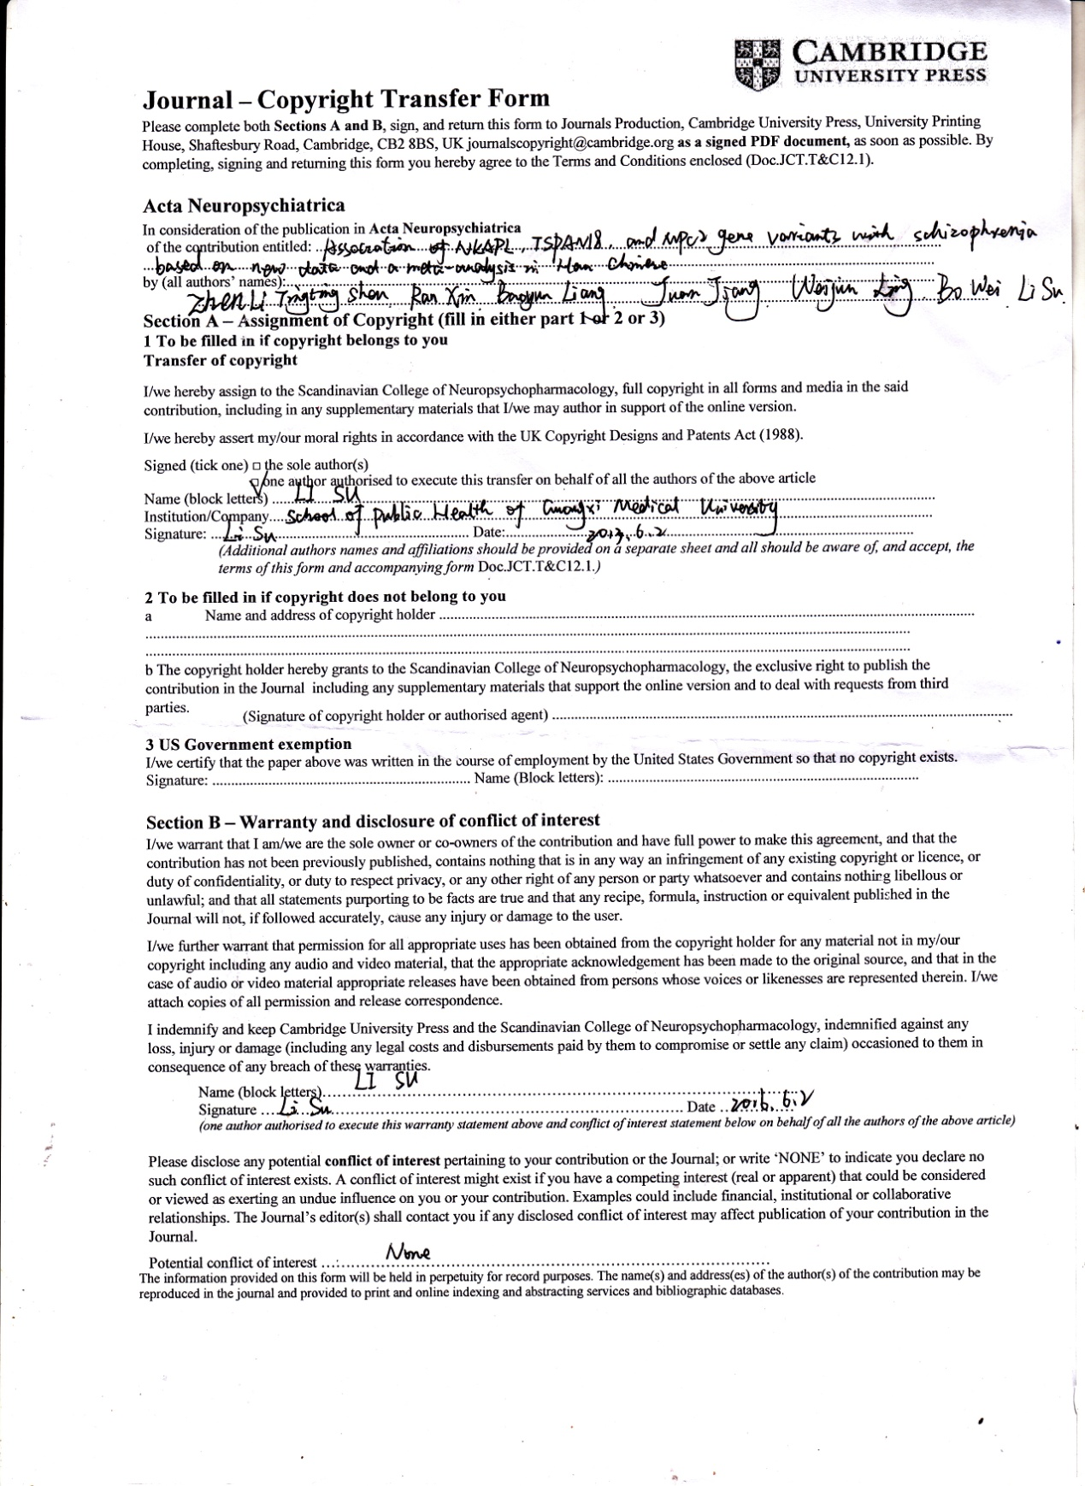

Supplementary figures
- Rs1635
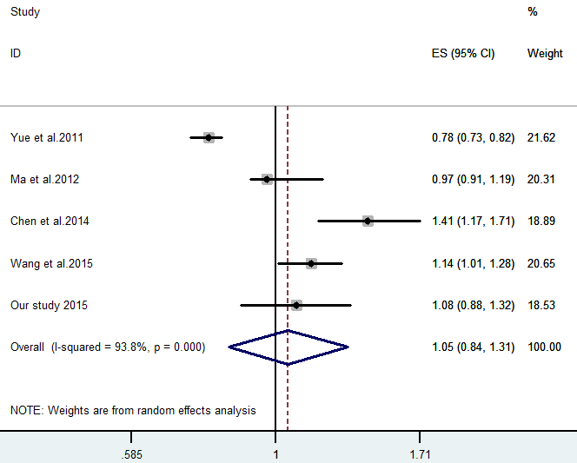
(b) Rs11038167
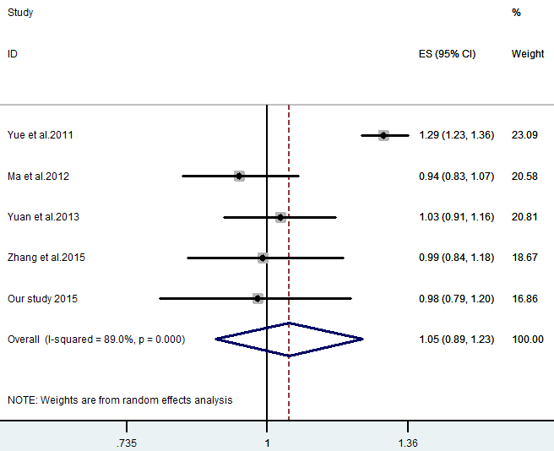
(c) Rs10489202
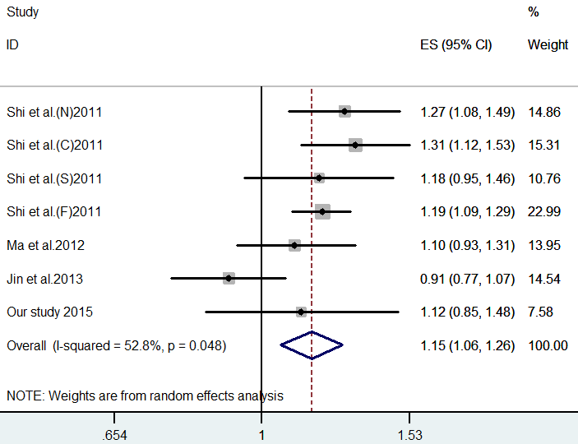
Supplementary Fig.1. Forest plots for the association of the SNP rs1635, rs11038167 and rs10489202 with SZ.

(a) Rs1635
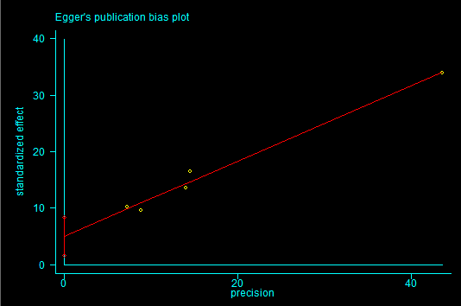
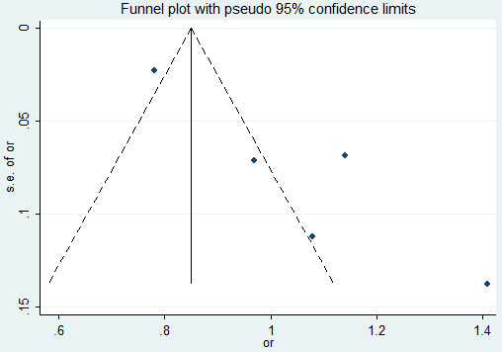

(b) Rs11038167
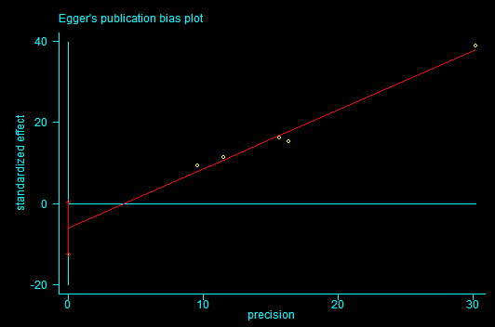
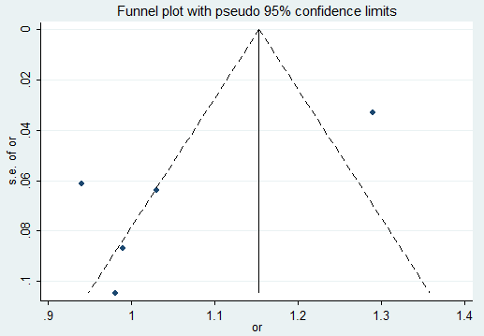
(c) Rs10489202
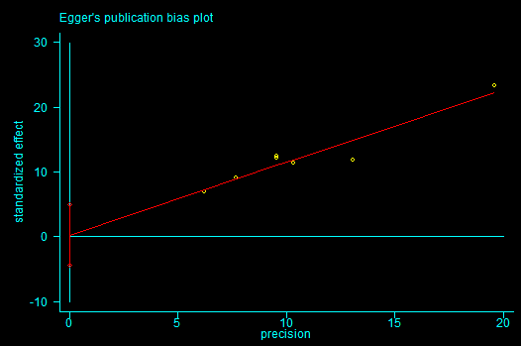
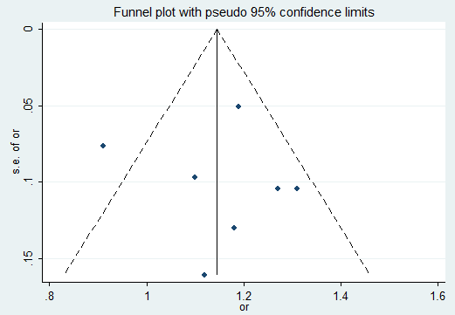
Supplementary Fig.2. Publication bias of each meta-analysis with funnel plots and Egger’s test.

