Annex to ‘Subsidiarity doesn’t win cases’

On the ECtHR’s own statistics
I have gathered the Court’s own statistics in one dataset for easy presentation of summary statistics. The data are the statistics that are published yearly by the Court and contain information on pending cases and processed cases and whether cases have been processed administratively or judicially, and by which type of judicial formation. They have changed over the years as the Court has also changed its policies on statistics and its working methods. There are a couple of Statistical overviews for violations from different states 1959-2019 and simplified yearly ones which I have used to fill in a few blanks. A couple of blanks have also been filled in by the numbers on early cases and inadmissible ones given by Ed Bates in the evolution of the european convention on human rights: From its inception to the creation of a permanent court of human rights (2010). The bulk of the data is made up however by the Courts yearly statistics reports which have been published consistently since 2006, though unilateral declarations and friendly settlements have for example only been included since 2009.

On the HUDOC searches
The data taken from the HUDOC database have been updated latest on 1.1.2022. These searches simply use the HUDOC’s own advanced search module and notes the information for each year in order to create simple descriptive statistics. In this dataset, and in general, I differentiate between ‘margin of appreciation’ keywords and ‘margin of appreciation’ searchwords. The keywords are allocated by the administrators of the HUDOC database, while searching for ‘margin of appreciation’ or ‘margin of discretion’ picks up all the cases where these phrases are mentioned somewhere in the judgment or separate opinion. All the empirical studies dealing with the margin of appreciation which are cited in this article rely on the searchword approach rather than the allocated keywords. It does not really make sense to make summary statistics on these searches in the usual way since they are not truly samples and are therefore used mainly for descriptive purposes in this article. Here are non-the-less some general information about the HUDOC dataset as of 1.1.2022.
Total judgments | 24564
Total decisions | 28867
Total judgments mentioning the margin of appreciation | 2731
Total decisions mentioning the margin of appreciation | 1928
Total judgments and decisions with margin of appreciation key-word | 1097

Development of margin key-words and textual appearances over time in absolute numbers:

Development in margin key-words and textual appearances over time compared to number of judgments and decisions

On the dataset of 21954 cases
Summary statistics

Categorical variables
Originating body:
Court (Grand Chamber) 504
Court (Plenary) 205
Court (Chamber) 1282
Court (Fifth Section Committee) 510
Court (Fifth Section) 2055
Court (First Section Committee) 385
Court (First Section) 4181
Court (Fourth Section Committee) 407
Court (Fourth Section) 3300
Court (Second Section Committee) 475
Court (Second Section) 4477
Court (Third Section Committee) 679
Court (Third Section) 3494

Respondent state
Albania 78
Andorra 7
Armenia 102
Austria 452
Azerbaijan 158
Belgium 273
Bosnia and Herzegovina 61
Bulgaria 663
Croatia 406
Cyprus 82
Czech Republic 234
Denmark 56
Estonia 59
Finland 196
France 1065
Georgia 88
Germany 376
Greece 963
Hungary 508
Iceland 27
Ireland 43
Italy 2484
Latvia 143
Liechtenstein 9
Lithuania 196
Luxembourg 44
Malta 91
Monaco 2
Montenegro 46
Netherlands 206
Norway 52
Poland 1159
Portugal 354
Republic of Moldova 357
Romania 1366
Russia 2458
San Marino 15
Serbia 189
several 56
Slovakia 369
Slovenia 361
Spain 165
Sweden 193
Switzerland 212
The former Yugoslav Republic of Macedonia 154
Turkey 3430 Ukraine 1304
United Kingdom 642

Year
1960 1
1961 2
1962 1
1967 1
1968 3
1969 4
1970 4
1971 4
1972 4
1973 2
1974 2
1975 4
1976 12
1978 8
1979 10
1980 14
1981 14
1982 22
1983 30
1984 36
1985 21
1986 34
1987 63
1988 50
1989 49
1990 57
1991 142
1992 161
1993 109
1994 78
1995 58
1996 138
1997 210
1998 212
1999 193
2000 695
2001 888
2002 844
2003 703
2004 718
2005 1107
2006 156
2007 1504
2008 1545
2009 1625
2010 1502
2011 1161
2012 1095
2013 917
2014 893
2015 822
2016 903
2017 886
2018 824
2019 9

Importance level
Key cases 915
One 1450
Two 4556
Three 15033

Separate opinions
No Yes NA's
18603 3350 1

Numerical variables
Number of decisions
Min. 1st Qu. Median Mean 3rd Qu. Max.
0.000 1.000 1.000 1.599 2.000 21.000

Inadmissible decisions
Min. 1st Qu. Median Mean 3rd Qu. Max.
0.0000 0.0000 0.0000 0.1171 0.0000 6.0000

Non_violation decisions
Min. 1st Qu. Median Mean 3rd Qu. Max.
0.0000 0.0000 0.0000 0.2361 0.0000 11.0000

Violation decisions
Min. 1st Qu. Median Mean 3rd Qu. Max.
0.000 1.000 1.000 1.246 2.000 12.000

Number of state wins
Min. 1st Qu. Median Mean 3rd Qu. Max.
0.0000 0.0000 0.0000 0.3532 1.0000 11.0000

Percent state win
Min. 1st Qu. Median Mean 3rd Qu. Max. NA's
0.00 0.00 0.00 17.60 33.33 100.00 1979

Dummy variables:

Margin key-word
Min. 1st Qu. Median Mean 3rd Qu. Max. NA's
0.00000 0.00000 0.00000 0.03726 0.00000 1.00000 1

Margin Searchword
Min. 1st Qu. Median Mean 3rd Qu. Max.
0.00000 0.00000 0.00000 0.08509 0.00000 1.00000

On the 202 Key and Level 1 cases

On the determination of which cases to include in this sample:
The sample includes all cases in the Key- or Level 1 importance category where the margin of appreciation is mentioned at least once. Searching the HUDOC database with a textual search for ‘margin of appreciation’ yielded 298 search-word cases, while using the database’s keyword search yielded 165 cases. After removing any doublets and non-cases from the list, the final list ended up with just 202 cases.
The complete list of cases is here:
Cases | D.l. V. Bulgaria | Libert v. France | S.j. V. Belgium
Ališić and others v. Bosnia and herzegovina, and others | Davydov and others v. Russia | Lindheim and others v. Norway | Söderman v. Sweden
Grudić v. Serbia | De souza ribeiro v. France | Lopes de sousa fernandes v. Portugal | Sabanchiyeva and others v. Russia
Guberina v. Croatia | De tommaso v. Italy | Lozovyye v. Russia | Sace elektrik ticaret ve sanayi a.ş. V. Turkey
Hamidovic v. Bosnia and herzegovina | Del río prada v. Spain | Lupeni greek catholic parish and others v. Romania | Şahin alpay v. Turkey
Kurić and others v. Slovenia | Delfi as v. Estonia | M.d. And others v. Malta | Sargsyan v. Azerbaijan
Lekic v. Slovenia | Dubská and krejzová v. The czech republic | M.l. And w.w. V. Germany | Satakunnan markkinapörssi oy and satamedia oy v. Finland [gc]
Medžlis islamske zajednice brčko and others v. Bosnia and herzegovina, | Dubská and krejzová v. The czech republic | M.n. And others v. San marino | Schatschaschwili v. Germany
Paunović and milivojević v. Serbia | E.s. V. Austria | Magyar helsinki bizottsãg v. Hungary | Scoppola v. Italy (no. 3)
Sašo gorgiev v. "the former yugoslav republic of macedo | Ebrahimian v. France | Magyar jeti zrt v. Hungary | Sigurður einarsson and others v. Iceland
Topčić-rosenberg v. Croatia | Eğitim ve bilim emekçileri sendikasi v. Turkey | Magyar keresztény mennonita egyház and others v. Hungar | Sindicatul "păstorul cel bun" v. Romania
Zubac v. Croatia | Elberte v. Latvia | Manole and "romanian farmers direct" v. Romania | Sitaropoulos and giakoumopoulos v. Greece
Öcalan v. Turkey (no. 2) | Erla hlynsdóttir v. Iceland | Maskhadova and others v. Russia | Strand lobben and others v. Norway
Österreichische vereinigung zur erhaltung, stärkung und | Eweida and others v. The united kingdom | Mehmet şentürk and bekir şentürk v. Turkey | Svinarenko and slyadnev v. Russia
Özgürlük ve dayanişma partisi (ödp) v. Turkey | Fábián v. Hungary [gc] | Meier v. Switzerland | Taddeucci and mccall v. Italy
A and b v. Norway | Fabris v. France | Mennesson v. France | Tahirov v. Azerbaijan
A.n. V. Lithuania | Fernández martínez v. Spain | Merabishvili v. Georgia | The national union of rail, maritime and transport work
Adyan and others v. Armenia | Fernandes de oliveira v. Portugal | Michaud v. France | Vallianatos and others v. Greece
Ahmet yildirim v. Turkey | Frăsilă and ciocîrlan v. Romania | Mihalache v. Romania | Vasiliauskas v. Lithuania
Ahrens v. Germany | Frumkin v. Russia | Molla sali v. Greece | Velyo velev v. Bulgaria
Aksu v. Turkey | G.i.e.m. S.r.l. And others v. Italy | Moreira ferreira v. Portugal (no. 2) | Vilnes and others v. Norway
Al-dulimi and montana management inc. V. Switzerland gc | Garib v. The netherlands | Morice v. France | Vinter and others v. The united kingdom
Al-dulimi and montana management inc. V. Switzerland ss | Gas and dubois v. France | Mouvement raëlien suisse v. Switzerland | Vistiņš and perepjolkins v. Latvia[gc]
Altay v. Turkey (no. 2) | Guðmundur andri ástráðsson v. Iceland | Murray v. The netherlands | Vistiņš and perepjolkins v. Latvia
Animal defenders international v. The united kingdom | Guimon v. France | Murtazaliyeva v. Russia | Vona v. Hungary
Armani da silva v. The united kingdom | Hämäläinen v. Finland | Naït-liman v. Switzerland [gc] | Winterstein and others v. France
Avotiņš v. Latvia [gc] | Haldimann and others v. Switzerland | Nada v. Switzerland | X and others v. Austria
Bédat v. Switzerland | Harakchiev and tolumov v. Bulgaria | National federation of sportspersons' associations and | X v. Latvia
Béláné nagy v. Hungary [gc] | Herrmann v. Germany | Natsvlishvili and togonidze v. Georgia | X v. Turkey
Babar ahmad and others v. The united kingdom | Hristozov and others v. Bulgaria | Navalnyy v. Russia | Y.y. V. Turkey
Baka v. Hungary | Hutchinson v. The united kingdom | Nazarenko v. Russia | Yefimenko v. Russia
Bărbulescu v. Romania [gc] | Ilbeyi kemaloğlu and meriye kemaloğlu v. Turkey | Nicolae virgiliu tanase v. Romania | Z.a. And others v. Russia
Bayev and others v. Russia | Ilias and ahmed v. Hungar'y | Novruk and others v. Russia | Zaieţ v. Romania
Becker v. Norway | Ilnseher v. Germany | Nusret kaya and others v. Turkey | Zolotas v. Greece (no. 2)
Beghal v. The united kingdom | Izzettin dogan and others v. Turkey | O'keeffe v. Ireland | Laurus invest hungary kft and others v. Hungary
Biao v. Denmark | J. And others v. Austria | Osmanoğlu and kocabaş v. Switzerland | Stichting mothers of srebrenica and others v. The netherlands
Bittó and others v. Slovakia | Janowiec and others v. Russia | O'sullivan mccarthy mussel development ltd v. Ireland | Willcox and hurford v. The united kingdom
Björk eiðsdóttir v. Iceland | Jones and others v. The united kingdom | Paradiso and campanelli v. Italy | A.p., garçon and nicot v. France
Burmych and others v. Ukraine | Károly nagy v. Hungary[gc] | Paradiso and campanelli v. Italy [gc] | Boulois v. Luxembourg
C.a.s. And c.s. V. Romania | Károly nagy v. Hungary | Parrillo v. Italy | Cengiz and others v. Turkey
Carvalho pinto de sousa morais v. Portugal | Karácsony and others v. Hungary [gc] | Pentikäinen v. Finland | Di trizio v. Switzerland
Catan and others v. The republic of moldova and russia | Khamtokhu and aksenchik v. Russia | Perinçek v. Switzerland | Güzelyurtlu and others v. Cyprus and turkey [gc]
Centro europa 7 s.r.l. And di stefano v. Italy | Khoroshenko v. Russia | Petropavlovskis v. Latvia | I.b. V. Greece
Chabauty v. France | Koch v. Germany | Piechowicz v. Poland | Jeunesse v. The netherlands
Chitos v. Greece | Kocherov and sergeyeva v. Russia | R.b. V. Hungary | Kotov v. Russia
Communist party of russia and others v. Russia | Konstantin markin v. Russia | Ramos nunes de carvalho e sã v. Portugal | Kotov v. Russia[gc]
Correia de matos v. Portugal | Kudrevičius and others v. Lithuania | Regner v. The czech republic | Mutu and pechstein v. Switzerland
Couderc and hachette filipacchi associés v. France | L.h. V. Latvia | Rohlena v. The czech republic | S.a.s. V. France
Creangă v. Romania | López ribalda and others v. Spain | Roman zakharov v. Russia | Tarantino and others v. Italy
Cumhuriyet halk partisi v. Turkey | Lambert and others v. France | Rooman v. Belgium | The church of jesus christ of latter-day saints v. The united kingdom
X v. Finland | Wenner v. Germany | Ruslan yakovenko v. Ukraine | Van der heijden v. The netherlands

On the coding of the 202-sample
The coding of the 202 cases took place using the qualitative analysis program MAXQDA, and then transferred to Excel and R for statistical analysis.

Narrow, Wide or just the Margin
For the initial coding of whether a margin mentioned was wide or narrow I relied on the following terminology for automatic coding, but with every code checked qualitatively to ensure that notions such as “not a wide margin” were not coded as ‘wide’ but rather as ‘narrow’ margins.
variable | what it includes - OR variables
All Margin | margin of appreciation, margin of discretion, certain margin, + all search terms related to wide or narrow margin
Wide margin | Wide margin, wider margin, margin should be wide, margin will be wide, margin is wide, margin wide, margin wider, wide discretion
Narrow margin | narrow margin, narrower margin, reduced margin, margin should be narrow, margin should be reduced, margin will be narrow, margin will be reduced, margin is narrow, margin is reduced, margin narrow, margin narrower
The vast majority of margin-mentions did not contain any information on its width, and the use of the ’narrow’ margin terminology was particularly rare.
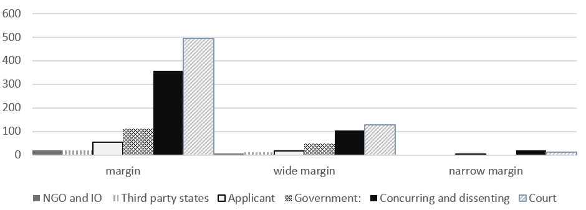
There were big differences in how often the margin was used in any one case. On average a margin of appreciation case mentions the doctrine 5,2 times, but there are notable outliers such as Correia de Matos v Portugal where the doctrine is mentioned no less than 50 times.
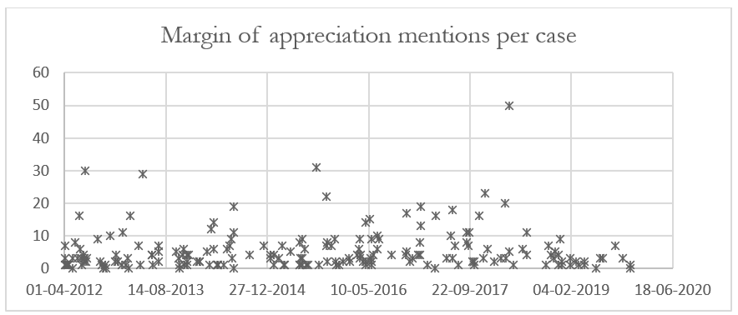

Who is using the margin
For the coding of which actors use the margin, this was done by hand using the headlines in the judgments as an indicator since in a few cases the submissions by the applicants were reported under the same headlines as the submissions by the respondent state, making automation unreliable. For example: Österreichische vereinigung zur erhaltung, stärkung und schaffung v. Austria.
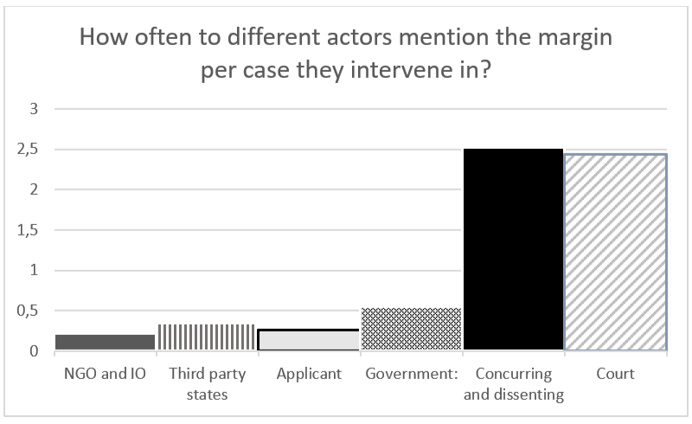
Court-actors whether the majority or separate opinions by judges were by far the most frequent users of margin of appreciation language. And yet there were 29 cases in the sample where the Court did not mention the margin. In 22 of these it did not engage with a subsidiarity argument at all. These cases were:
CASE OF CENTRO EUROPA 7 S.R.L. AND DI STEFANO v. ITALY
CASE OF MERABISHVILI v. GEORGIA
CASE OF RAMOS NUNES DE CARVALHO E SÃ v. PORTUGAL
CASE OF AHMET YILDIRIM v. TURKEY
CASE OF CENGIZ AND OTHERS v. TURKEY
CASE OF GÜZELYURTLU AND OTHERS v. CYPRUS AND TURKEY
CASE OF CREANGA v. ROMANIA
CASE OF BABAR AHMAD AND OTHERS v. THE UNITED KINGDOM
CASE OF JANOWIEC AND OTHERS v. RUSSIA
CASE OF WILLCOX AND HURFORD v. THE UNITED KINGDOM
CASE OF DEL RÍO PRADA v. SPAIN
CASE OF CASE OF ÖSTERREICHISCHE VEREINIGUNG ZUR ERHALTUNG, STÄRKUNG V AUSTRIA
CASE OF L.H. v. LATVIA
CASE OF SVINARENKO AND SLYADNEV v. RUSSIA
CASE OF ROHLENA v. THE CZECH REPUBLIC
CASE OF SCHATSCHASCHWILI v. GERMANY
CASE OF MAGYAR JETI ZRT v. HUNGARY
CASE OF FERNANDES DE OLIVEIRA v. PORTUGAL
CASE OF GUÐMUNDUR ANDRI ÁSTRÁÐSSON v. ICELAND
CASE OF SIGURÐUR EINARSSON AND OTHERS v. ICELAND
CASE OF Z.A. AND OTHERS v. RUSSIA
CASE OF KAROLY NAGY v. HUNGARY

On the coding of the use of the margin
This coding necessarily includes a measure of interpretation, but the categories have been attempted made as clear as possible to limit the impact of subjective understandings.
The full codebook is here:
Type | Subtype | Explanation
1. Empty and partially empty

 | 1.a. Empty - also simply concluding remarks | Any case in which the margin is mentioned, but where there does not appear to be any engagement with it in the argument in connection with which it is mentioned. This category also includes situations where the margin is simply used as a conclusion. It is not unusual for a case to first contain margin-arguments in other categories than this one, and then end with an empty margin.
 | 1.b. Balance between individual and society | Any case where the interference with a human right has a legitimate aim contains a balancing between individual and society, therefore this type of argument constitutes a type of empty mention of the margin.
 | 1.c. Explaining the margin | A margin-mention that does not apply the margin directly, but rather describes how it is to be applied in general or in the present case. Often contains a reference to existing caselaw or the description can be taken directly from another judgment.
2. Anti-margin mentions

 | 2.a. margin not applicable/misrepresented in present case | An argument that the margin is not or should not have been applied in the present case. Also includes cases in which one actor at the Court criticises another for their reliance on the margin.
 | 2.b. Notwithstanding the margin | The margin as something that may be relevant to the case, but which nonetheless cannot justify the situation. Related to 5.c. but incorporates a dichotomy-argument which 5.c. doesn't. Does not necessarily contain the word 'notwithstanding'.
3. Margin as Scope

 | 3.a. Scope of right | An argument that the right in question generally has a wide or narrow margin.
 | 3.b. Scope of situation | An argument that the width of the margin is determined by the specific type of case being treated - whether wide or narrow. Different from 5.c. in that the argument is not that the type of situation is particularly interfering or that the legitimate aim is particularly important, but rather that the width of the margin in these types of cases has already been determined in established caselaw.
4. Margin for domestic institutions

 | 4.a. Sovereignty and democratic legitimacy argument | An argument that the width of the margin should be determined by the quality/lack of quality of the debate at the domestic level as well as statements that the theme in question falls exclusively within the sovereignty of the state.
 | 4.b. Domestic Courts | An argument that the width of the margin is determined by the existence and/or quality (or lack thereof) of the treatment of the case by national courts.
 | 4.c. procedural general | General arguments that the margin should be determined by the quality (whether high or low) of the procedural protections at the domestic level.
5. Margin as part of the proportionality assessment

 | 5.a. Balancing between individuals | This category includes arguments that the margin is determined by the requirement that the state balances the rights and interests of several (specific) individuals - so not between individuals and the more vaguely determined 'societal interests' or other legitimate aims.
 | 5.b. European consensus | This category includes any incorporation of a European consensus argument as determination of the width of the margin, whether to argue that such a consensus is absent or present.
 | 5.c. Interference versus legitimate aim | This category includes statements on vulnerability and importance of the right for the applicants, and the existence/absence of attempts at mitigating the interference, but also statements on the importance of the legitimate aim, including national security arguments.
6. Margin as better placed argument

 | 6.a. Policy/economic/scientific choices where reasonable minds may differ | An argument that the case concerns a theme on which reasonable minds may differ for policy reasons or because the situation at hand deals with legislature implementing social or economic policies. This category also includes cases where 'delicate moral' concerns are cited in favour of granting a (wide) margin.
 | 6.b. Pragmatic better placed argument | Any argument for the determination of the width of the margin on the basis that national authorities are better placed because of access to information or intimate knowledge- often applied in cases on family life and the removal of children from parental care.
7. Other |  | Margin-usages that do not appear to fit into any of the other categories. This includes cases where the margin discussed relates to internal relationships in the respondent state (margin afforded to experts, prosecutors etc.) and cases where the margin is an element in determining relationships with other international bodies than the ECtHR.

