Supplementary Material

Supplementary Figure 1 – VRE-positive urine rates

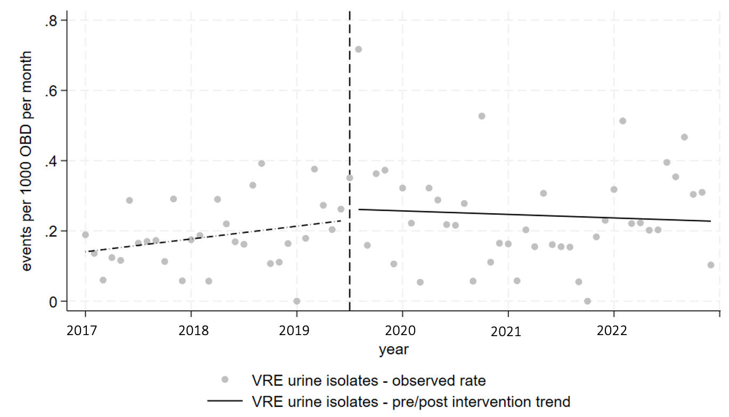

Pre-intervention trend - 0.003 events/1000 OBD per month (95% CI -0.001-0.007, p= 0.111)
Post-intervention level change - 0.03 events/1000 OBD per month (95% CI -0.1-0.161, p= 0.644)
Post-intervention trend - -0.004 events/1000 OBD per month (95% CI -0.010-0.002, p= 0.187)

