Supplementary Material

eFigure 1. Ct value trajectory for three individuals
eTable 1. Median number of days since symptom onset grouped by comorbidities
eFigure 2. Ct value distributions by PCR instrument for RSV and influenza

eFigure 1. Individual courses of Ct value progression since symptom onset (vertical line) for A) Parainfluenza positive 80-year-old female with immunodeficiency, heart disease, and diabetes, B) Rhinovirus positive 50-year-old female with immunodeficiency and kidney disease, and C) Rhinovirus positive 34-year-old male with immunodeficiency, heart, lung, and liver disease.

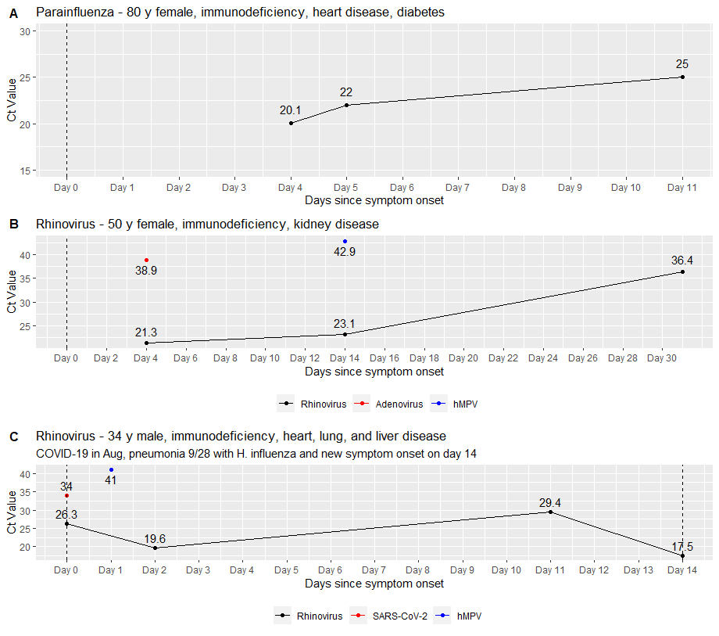

Exemplary courses of Ct values of three individual patients
Screening for individuals who had at least three tests within one month and were analyzed using the same assay resulted in no influenza, RSV, hMPV, and adenovirus cases. We identified 4 rhinovirus and 4 parainfluenza cases, all but one of which were immunocompromised. We exemplarily present three individual patients and the trajectory of their Ct values (Figure 2). An 80-year-old woman presenting on day 4 of symptoms with a parainfluenza-positive PCR (Figure 2A) with a Ct value of 20.1 showed an increase over a period of 8 days to a Ct value of 25. However, 11 days after symptom onset this immunocompromised patient still has a Ct value of 25. A rhinovirus-positive 50-year-old female (Figure 2B) displayed a slow increase of Ct values from 21.3 two days after symptom onset to 36.4 one month later. This immunocompromised patient also showed positive PCR results for adenovirus (Ct value 38.9) and hMPV (Ct value 42.9). A 34-year-old male (Figure 2C) presenting on the day of symptom onset (day 0) tested positive for rhinovirus with a Ct value of 26.3 and showed a decrease to 19.6 two days later, followed by a slow increase up to 29.4 on day 11 after symptom onset. This patient complained of new symptoms two weeks after the initial rhinovirus diagnosis and the again lower Ct Value of 17.5 suggests a reinfection with rhinovirus. Additionally, hMPV (Ct value 41) and SARS-CoV-2 (Ct value 34) were also PCR positive. The latter was interpreted as prolonged viral shedding in the context of the patient's immunosuppression since he had been hospitalized with COVID-19 more than one month prior. Likewise, pneumonia with Hemophilus influenza was diagnosed on the day of symptom onset, so that the symptoms cannot be assigned to one pathogen.

eTable 1. Median number of days since symptom onset among patients with Ct values of ≥30 and presenting with symptom onset 2-21 days before the positive test grouped by comorbidities. (*Immunodeficiency, diabetes, heart, lung, kidney, or liver disease).
 |  | Yes | No
Influenza  (total n=104) | Immunodeficiency (n=12) | 7.5 days | 7 days
 | Heart disease (n=24) | 8 days | 6 days
 | Lung disease (n=27) | 7 days | 6 days
 | Kidney disease (n=12) | 7 days | 7 days
 | Liver disease (n=6) | 7 days | 7 days
 | Diabetes (n=20) | 7 days | 7 days
 | No comorbidities* (n=47) | 5 days | 7 days
RSV  (total n=131) | Immunodeficiency (n=29) | 7 days | 6.5 days
 | Heart disease (n=29) | 7 days | 5.5 days
 | Lung disease (n=55) | 5 days | 7 days
 | Kidney disease (n=12) | 4.5 days | 7 days
 | Liver disease (n=14) | 6 days | 7 days
 | Diabetes (n=16) | 7 days | 6 days
 | No comorbidities* (n=43) | 7 days | 6 days
Parainfluenza  (total n=71) | Immunodeficiency (n=38) | 5 days | 6 days
 | Heart disease (n=32) | 5 days | 6 days
 | Lung disease (n=32) | 5 days | 6 days
 | Kidney disease (n=16) | 6.5 days | 5 days
 | Liver disease (n=6) | 5 days | 6 days
 | Diabetes (n=15) | 7 days | 5 days
 | No comorbidities* (n=7) | 7 days | 5 days
Rhinovirus  (total n=144) | Immunodeficiency (n=64) | 5 days | 7 days
 | Heart disease (n=46) | 5 days | 4 days
 | Lung disease (n=69) | 5 days | 4 days
 | Kidney disease (n=27) | 4 days | 4 days
 | Liver disease (n=12) | 5 days | 4 days
 | Diabetes (n=34) | 5 days | 4 days
 | No comorbidities* (n=15) | 4 days | 4 days
HMPV  (total n=81) | Immunodeficiency (n=44) | 5 days | 4 days
 | Heart disease (n=30) | 4 days | 5 days
 | Lung disease (n=44) | 4 days | 7 days
 | Kidney disease (n=20) | 4.5 days | 5 days
 | Liver disease (n=9) | 3 days | 5 days
 | Diabetes (n=16) | 5.5 days | 5 days
 | No comorbidities* (n=8) | 6 days | 5 days

eFigure 2. Comparison of instruments Cepheid and Panther for RSV and influenza
