**It is not all in our hands - Sink-traps are a major source for carbapenemase-producing Enterobacteriaceae transmission**

**\* Supplemental material \***

**Supplement 1. Whole genome sequencing methods**

The whole genome sequencing library preparation was performed using the SQK-LSK109 Ligation Sequencing Kit (Nanopore) following the manufacturer’s instructions, and then MinION sequencing was conducted using R9.4.1 flow cells for 48 hours. The statistics of the sequencing results were summarized in Table s1. Raw Nanopore reads were base-called using Guppy 3.0.3 (https://community.nanoporetech.com). The base-called reads were assembled with Unicycler (https://github.com/rrwick/Unicycler), and the resulting draft assemblies were further polished using Medaka[1]. Finally, the assembled circular plasmids were annotated with Prokka[2] and BLAST search against NCBI database.

*Annotation*

We annotated all circular plasmid contigs using PGAP. For plotting, we grouped annotated coding sequences (CDS) using both comparison with other databases and the presence of keywords in the inferred products. Antibiotic and stress resistance were first identified using AMRfinder, and the PGAP identified CDS were labelled accordingly when sharing with the same start or ending position. We manually verified that resistance loci identified by AMRfinder without corresponding CDS in PGAP were identified as pseudogenes. We then used the presence of the following keywords in PGAP products to additionally label resistant CDS, which we verified manually:

* STRESS: Tellurium {tellurium, TerD, tellurite}
* STRESS: Arsenic {arsenic}
* STRESS: Mercury {mercury}
* AMR: Aminoglycoside {aminoglycoside}
* AMR: Beta-lactamase {beta-lactamase}
* AMR: Macrolide {macrolide}

Plasmid and DNA mobility were first identified using Plascad which leverages the XXX Hidden markov models, and the PGAP identified CDS were labeled accordingly when sharing with the same start or ending position. We distinuished CDS assocated with plasmid mobility with those identified from the MOB HMM database. All other CDS identified by Plascad were labeled generically as "conjugation." We then used the presence of the following keywords in PGAP products to additionally label CDS associated with DNA mobility, which we verified manually:

* conjugation: mobility {Mob,mob}
* conjugation {conj,Tra,plasmid transfer protein}
* transposase/integrase/recombinase {transpos,recomb,integrase}

All other non-hypothetical CDS were labeled as "other".

*Alignment*

Shared plasmids were aligned to each other first using Nucmer to assess structural variation. SNPs were identified by aligning shared plasmids using mafft. The plasmid pair with large structural differences, contiguous regions of indels and inversions, were separated into non-inversion and inversion regions before aligning with mafft. Only SNPs that occurred in regions absent oflong stretches of gaps were considered in order to ignore alignment issues arising due to the indels.

**Table S1**. **Patients’ CPE isolates that were genetically identical (by PFGE) to a CPE strain isolated from a sink in the same hospital room as the patient.**

|  |  |  |  |  |  |  |
| --- | --- | --- | --- | --- | --- | --- |
| S-P days* | Date of Sink CPE detection | Date of patient CPE detection | Department | *bla* gene | Bacteria Sp. |  |
| 198 | 08/01/2018 | 25/07/2018 | SurgB | KPC | *E. cloacae* | 1 |
| 90 | 27/03/2019 | 25/06/2019 | ICU | KPC | *E. cloacae* | 2 |
| 32 | 01/07/2019 | 02/08/2019 | ICU | KPC | *E. cloacae* | 3 |
| -60 | 22/10/2018 | 23/08/2018 | IMC | KPC | *E. cloacae* | 4 |
| -117 | 08/01/2018 | 13/09/2017 | SurgB | KPC | *E. cloacae* | 5 |
| 245 | 22/05/2018 | 22/01/2019 | Hem | NDM | *E. cloacae* | 6 |
| 100 | 22/05/2018 | 30/08/2018 | Hem | NDM | *E. cloacae* | 7 |
| -67 | 12/09/2018 | 07/07/2018 | IMF | NDM | *E. cloacae* | 8 |
| 13 | 22/7/2019 | 4/8/2019 | IMB | NDM | *E. cloacae* | 9 |
| 253 | 14/03/2018 | 22/11/2018 | IME | VIM | *E. cloacae* | 10 |
| 11 | 21/12/2017 | 01/01/2018 | IME | VIM | *E. cloacae* | 11 |
| -301 | 27/5/2019 | 30/7/2018 | IMA | VIM | *E. cloacae* | 12 |
| -298 | 27/5/2019 | 2/8/2018 | IMA | VIM | *E. cloacae* | 13 |
| 274 | 25/09/2018 | 26/06/2019 | IMC | KPC | *K. pneumoniae* | 14 |
| 38 | 13/09/2018 | 21/10/2018 | IMB | KPC | *K. pneumoniae* | 15 |
| -3 | 06/09/2017 | 13/01/2019 | ICU | KPC | *K. pneumoniae* | 16 |
| -49 | 16/11/2017 | 28/09/2017 | ICU | KPC | *K. pneumoniae* | 17 |
| -142 | 03/10/2018 | 14/05/2018 | IMA | KPC | *K. pneumoniae* | 18 |
| -192 | 13/09/2018 | 05/03/2018 | IMB | KPC | *K. pneumoniae* | 19 |
| 104 | 1/1/2019 | 15/4/2019 | IMD | KPC | *K. pneumoniae* | 20 |
| 452 | 11/04/2018 | 07/07/2019 | IMB | NDM | *K. pneumoniae* | 21 |
| 238 | 22/10/2018 | 17/06/2019 | IMC | NDM | *K. pneumoniae* | 22 |
| 37 | 03/06/2019 | 10/07/2019 | IMA | NDM | *K. pneumoniae* | 23 |
| 28 | 01/07/2019 | 29/07/2019 | IMA | NDM | *K. pneumoniae* | 24 |
| -5 | 23/07/2017 | 18/07/2017 | Burn | NDM | *K. pneumoniae* | 25 |
| -9 | 22/10/2018 | 13/10/2018 | IMC | NDM | *K. pneumoniae* | 26 |
| -36 | 24/05/2018 | 23/04/2018 | IMB | NDM | *K. pneumoniae* | 27 |
| -74 | 22/10/2018 | 09/08/2018 | IMC | NDM | *K. pneumoniae* | 28 |
| -433 | 19/11/2018 | 12/09/2017 | SurgB | NDM | *K. pneumoniae* | 29 |
| -10 | 15/4/2019 | 5/4/2019 | IMD | NDM | *K. pneumoniae* | 30 |
| 77 | 15/4/2019 | 1/7/2019 | IMD | NDM | *K. pneumoniae* | 31 |
| 44 | 3/12/2018 | 16/1/2019 | IME | NDM | *K. pneumoniae* | 32 |
| 214 | 28/05/2017 | 28/12/2017 | ICU | OXA48 | *S. marcescens* | 33 |
| 211 | 28/05/2017 | 25/12/2017 | ICU | OXA48 | *S. marcescens* | 34 |
| 2 | 28/05/2017 | 30/05/2017 | ICU | OXA48 | *S. marcescens* | 35 |
| -21 | 28/05/2017 | 07/05/2017 | ICU | OXA48 | *S. marcescens* | 36 |
| -38 | 28/05/2017 | 20/04/2017 | ICU | OXA48 | *S. marcescens* | 37 |
| -38 | 28/05/2017 | 20/04/2017 | ICU | OXA48 | *S. marcescens* | 38 |
| -46 | 28/05/2017 | 12/04/2017 | ICU | OXA48 | *S. marcescens* | 39 |

Cases of temporal relation indicating sink-to-patient transmission (isolation from sink preceded isolation from patient) are highlighted in grey.

Figure S1. Examples of genetic relatedness of paired, sink-patient, isolates by PFGE patterns.



a.



b.

C.

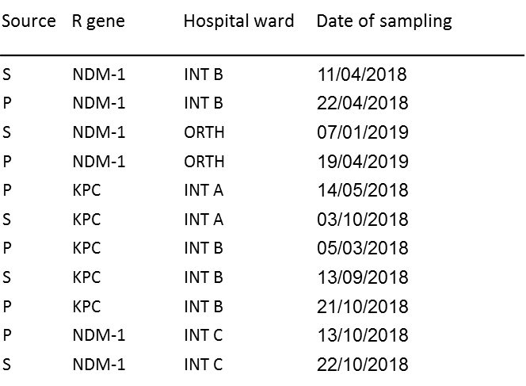

Distance indexes of A. *Klebsiella pneumonia*, B. *Serratia marcescens* and C. *Enterobacter cloacae*, with node distance indices. Carbapenemase genes are designated according to PCR results. S – sink, P- patient. Int B – Internal Medicine ward B; Orth – Orthopedic ward; Int A – Internal Medicine ward A; Int C – Internal Medicine ward C; ICU – Intensive care unit; Int E – Internal Medicine ward E; Surg B – Surgery ward A; HemOn – Hemato-oncology ward. Sampling date are registered.

Figure S2. Proportion of contaminated sinks in 9 departments where repeated sampling took place.

**% contaminated sinks during long-term follow-up**

# of screens denotes the number of samples per sink obtained in each of the departments.

Figure S3. Duration (in weeks) of persistent contamination of sinks by a single dominant CPE strain.

**N**

**1**

**1**

**13**

**7**

**7**

**8**

**1**

**1**

**11**

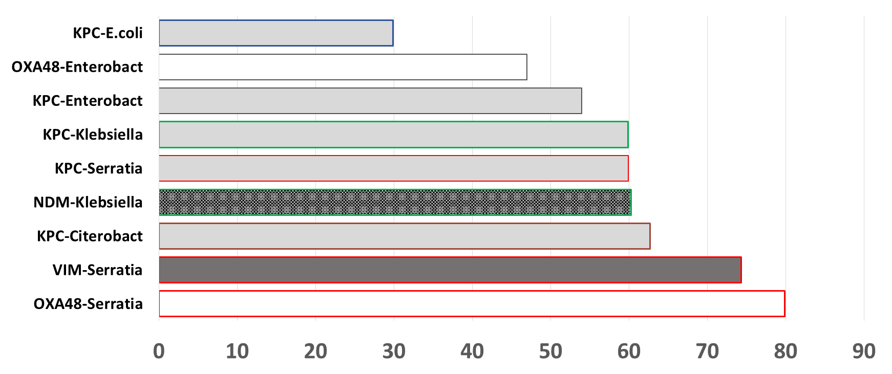

**Duration of persistent contamination (Weeks)**

N – denotes the number of sinks contaminated with that specific CPE species and gene. Bar filling color denotes the CP-gene (Grey-KPC, White-OXA48, Black-NDM, Dark Grey-VIM) the outline color denotes the bacterial species (Blue – *E. coli*, Grey – *Enterobacter sp*., Green – *Klebsiella sp*., Red – *S. marcescens*, Brown – *Citrobacter sp*.).

1. https://github.com/nanoporetech/medaka.
2. Seemann, T. Prokka: Rapid Prokaryotic Genome Annotation. Bioinformatics. 30, 2068-2069 (2014).