SUPPLEMENTAL MATERIALS

Supplemental Figure 1. Flow diagram of inpatient encounters included in analyses for the July 1, 2017 – June 30 2018, July 1, 2018 – June 30 2019, and July 1, 2019 – February 28, 2020 study years.
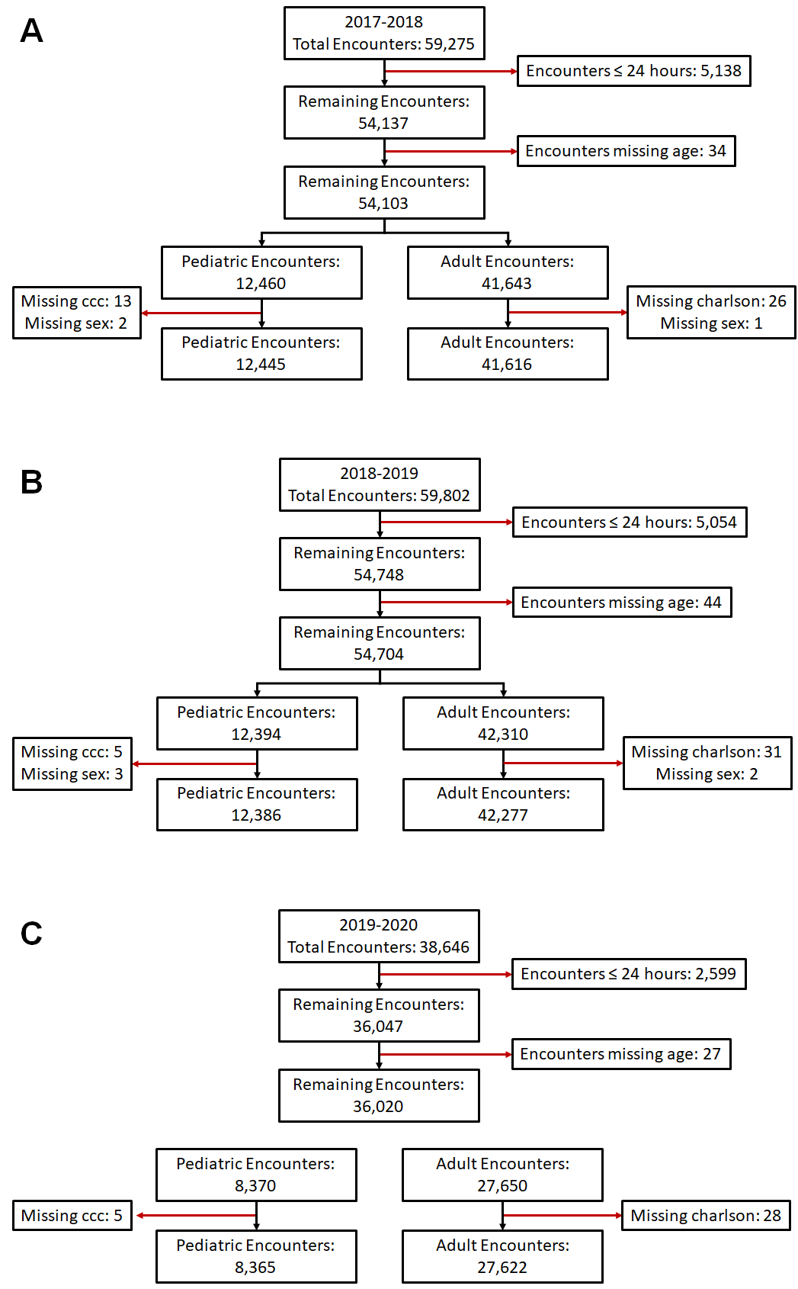

Supplemental Table 1. Risk factors for hospital-associated respiratory virus infection (HARVI) among adult inpatients. Competing risks analysis estimates direct and indirect (through length of stay) effects of factors on risk of HARVI; Fine-Gray analysis estimates absolute effects (combining direct and indirect effects) of factors on risk of HARVI.
 | Competing Risks Analysis |  | Fine-Gray Analysis
 | HARVI  Hazard Ratio (95% CI) | Discharge  Hazard Ratio (95% CI) | HARVI  Hazard Ratio (95% CI)
Age in years | 0.99 (0.98, 1.00) | 1.00 (1.00, 1.00) | 0.98 (0.98, 0.99)
Sex
Female | Ref. | Ref. | Ref.
Male | 1.10 (0.84, 1.43) | 0.88 (0.87, 0.89) | 1.29 (0.99, 1.68)
Race
NH Asian | 0.41 (0.10, 1.65) | 1.08 (1.04, 1.13) | 0.40 (0.10, 1.62)
NH Black | 0.78 (0.52, 1.18) | 0.93 (0.91, 0.95) | 0.80 (0.53, 1.21)
NH White | Ref. | Ref. | Ref.
Other/Unknown/Missing | 1.25 (0.74, 2.10) | 1.03 (1.00, 1.06) | 1.23 (0.74, 2.06)
Chronic Condition
Myocardial Infarction | 0.96 (0.67, 1.37) | 1.05 (1.03, 1.06) | 0.88 (0.62, 1.26)
Congestive Heart Failure | 1.67 (1.21, 2.31) | 0.81 (0.80, 0.82) | 2.49 (1.80, 3.43)
Peripheral Vascular Disease | 0.66 (0.47, 0.93) | 0.80 (0.79, 0.82) | 0.87 (0.62, 1.21)
Cerebrovascular Disease | 1.36 (0.95, 1.96) | 0.88 (0.86, 0.90) | 1.83 (1.31, 2.57)
Chronic Pulmonary Disease | 1.11 (0.84, 1.46) | 0.90 (0.89, 0.91) | 1.19 (0.91, 1.58)
Rheumatoid Disease | 1.26 (0.77, 2.05) | 0.90 (0.87, 0.92) | 1.38 (0.85, 2.26)
Peptic Ulcer Disease | 1.15 (0.70, 1.89) | 0.82 (0.80, 0.85) | 1.44 (0.88, 2.35)
Liver Disease | 0.98 (0.69, 1.38) | 0.88 (0.87, 0.90) | 1.11 (0.79, 1.56)
Diabetes | 1.06 (0.78, 1.43) | 0.93 (0.92, 0.95) | 1.13 (0.84, 1.52)
Hemiplegia or Paraplegia | 0.55 (0.32, 0.95) | 0.65 (0.63, 0.66) | 0.99 (0.58, 1.69)
Renal Disease | 1.48 (1.06, 2.05) | 0.88 (0.87, 0.89) | 1.77 (1.30, 2.40)
Cancer | 2.30 (1.76, 3.01) | 0.82 (0.81, 0.83) | 2.99 (2.29, 3.91)
≥2 SIRS Criteria | 0.98 (0.74, 1.28) | 0.76 (0.75, 0.77) | 1.45 (1.10, 1.89)
Admission Month
Jul | Ref. | Ref. | Ref.
Aug | 1.35 (0.43, 4.26) | 1.00 (0.98, 1.03) | 1.34 (0.43, 4.23)
Sep | 4.06 (1.52, 10.83) | 0.99 (0.96, 1.02) | 4.07 (1.53, 10.84)
Oct | 3.00 (1.09, 8.24) | 0.99 (0.97, 1.02) | 2.88 (1.04, 7.91)
Nov | 3.33 (1.23, 9.04) | 0.98 (0.96, 1.01) | 3.28 (1.20, 8.96)
Dec | 5.66 (2.22, 14.47) | 0.91 (0.88, 0.93) | 6.89 (2.69, 17.61)
Jan | 8.02 (3.18, 20.23) | 0.97 (0.95, 1.00) | 8.00 (3.16, 20.25)
Feb | 6.62 (2.57, 17.05) | 0.99 (0.96, 1.02) | 6.58 (2.55, 16.97)
Mar | 8.99 (3.49, 23.18) | 1.01 (0.98, 1.04) | 8.20 (3.17, 21.25)
Apr | 6.00 (2.24, 16.06) | 1.03 (1.00, 1.06) | 5.66 (2.11, 15.17)
May | 3.08 (1.06, 8.98) | 1.00 (0.97, 1.03) | 2.92 (1.00, 8.56)
Jun | 3.41 (1.19, 9.82) | 0.96 (0.93, 0.99) | 3.47 (1.21, 9.99)

Supplemental Table 2. Risk factors for hospital-associated respiratory virus infection (HARVI) among pediatric inpatients. Competing risks analysis estimates direct and indirect (through length of stay) effects of factors on risk of HARVI; Fine-Gray analysis estimates absolute effects (combining direct and indirect effects) of factors on risk of HARVI.
 | Competing Risks Analysis |  | Fine-Gray Analysis
 | HARVI  Hazard Ratio (95% CI) | Discharge  Hazard Ratio (95% CI) | HARVI  Hazard Ratio (95% CI)
Age in years | 0.97 (0.94, 0.99) | 0.97 (0.97, 0.97) | 0.96 (0.93, 0.99)
Sex
Female | Ref. | Ref. | Ref.
Male | 1.10 (0.82, 1.47) | 0.99 (0.97, 1.02) | 1.05 (0.79, 1.41)
Race
NH Asian | 0.16 (0.02, 1.19) | 1.01 (0.96, 1.06) | 0.20 (0.03, 1.41)
NH Black | 1.03 (0.69, 1.55) | 0.95 (0.92, 0.98) | 1.07 (0.73, 1.58)
NH White | Ref. | Ref. | Ref.
Other/Unknown/Missing | 1.04 (0.68, 1.59) | 0.98 (0.95, 1.02) | 1.35 (0.87, 2.10)
Chronic Condition
Neurologic and neuromuscular | 1.06 (0.77, 1.46) | 0.95 (0.92, 0.99) | 1.17 (0.84, 1.62)
Cardiovascular | 1.69 (1.21, 2.37) | 0.63 (0.61, 0.65) | 3.25 (2.27, 4.65)
Respiratory | 1.68 (1.19, 2.38) | 0.71 (0.68, 0.74) | 2.69 (1.88, 3.85)
Renal and urologic | 0.93 (0.63, 1.39) | 0.98 (0.94, 1.03) | 0.70 (0.47, 1.04)
Gastrointestinal | 1.13 (0.79, 1.62) | 0.87 (0.83, 0.91) | 1.20 (0.83, 1.75)
Hematologic and immunologic | 1.11 (0.76, 1.62) | 0.87 (0.83, 0.91) | 1.23 (0.84, 1.82)
Metabolic | 1.06 (0.78, 1.46) | 0.74 (0.71, 0.76) | 1.43 (1.02, 2.00)
Other congenital or genetic | 1.00 (0.72, 1.39) | 0.88 (0.84, 0.92) | 1.09 (0.77, 1.53)
Malignancy | 1.61 (1.09, 2.40) | 0.84 (0.80, 0.88) | 1.90 (1.27, 2.85)
Premature and neonatal | 0.54 (0.37, 0.78) | 0.53 (0.50, 0.55) | 1.07 (0.73, 1.56)
Medical device dependence | 1.74 (1.15, 2.62) | 0.89 (0.85, 0.93) | 2.97 (1.87, 4.74)
Transplantation | 1.44 (0.76, 2.72) | 0.98 (0.88, 1.10) | 1.83 (1.03, 3.25)
Admission Month
Jul | Ref. | Ref. | Ref.
Aug | 0.99 (0.52, 1.87) | 0.97 (0.93, 1.02) | 1.11 (0.55, 2.22)
Sep | 1.16 (0.60, 2.23) | 0.97 (0.92, 1.02) | 1.11 (0.55, 2.21)
Oct | 0.80 (0.40, 1.60) | 0.91 (0.87, 0.96) | 0.90 (0.44, 1.84)
Nov | 1.05 (0.54, 2.04) | 0.89 (0.85, 0.94) | 1.11 (0.55, 2.22)
Dec | 1.72 (0.97, 3.07) | 0.86 (0.81, 0.90) | 1.91 (1.03, 3.56)
Jan | 1.13 (0.57, 2.24) | 0.88 (0.83, 0.92) | 0.99 (0.49, 1.99)
Feb | 1.20 (0.63, 2.29) | 0.90 (0.86, 0.95) | 1.10 (0.55, 2.21)
Mar | 1.40 (0.66, 2.99) | 1.03 (0.97, 1.09) | 0.94 (0.43, 2.04)
Apr | 0.85 (0.39, 1.88) | 0.96 (0.91, 1.02) | 0.87 (0.40, 1.89)
May | 1.18 (0.60, 2.30) | 0.96 (0.91, 1.02) | 1.21 (0.60, 2.45)
Jun | 1.24 (0.60, 2.53) | 0.96 (0.91, 1.02) | 1.09 (0.50, 2.37)

