Supplement
SEIR model
We focused on estimating the impact on the effective reproductive number (how many persons will be infected from one index case) and built the model on the following assumptions: 1) symptomatic cases are moved to isolation quickly, thus the bulk of transmission occurs from asymptomatic and presymptomatic individuals, 2) cases among HCP are generally imported from the community at a constant rate (exogenous input), 3) lag time between a positive case and contact tracing is short (<1 day), 4) there is no indirect transmission via fomites so all potential close contacts at risk for transmission can be captured by a digital system.

For the SEIR model we used an average specificity of 0.86 and assumed no transmission occurred via fomites. We set the constant exogenous rate at 0.04 cases per day for all personnel combined. The false positive rate of BLE-based contact tracing was 0.14. After excluding administrative office workers, we assumed 2 positive cases daily among clinical HCP at the peak of the pandemic with 19 contacts on average weekly.
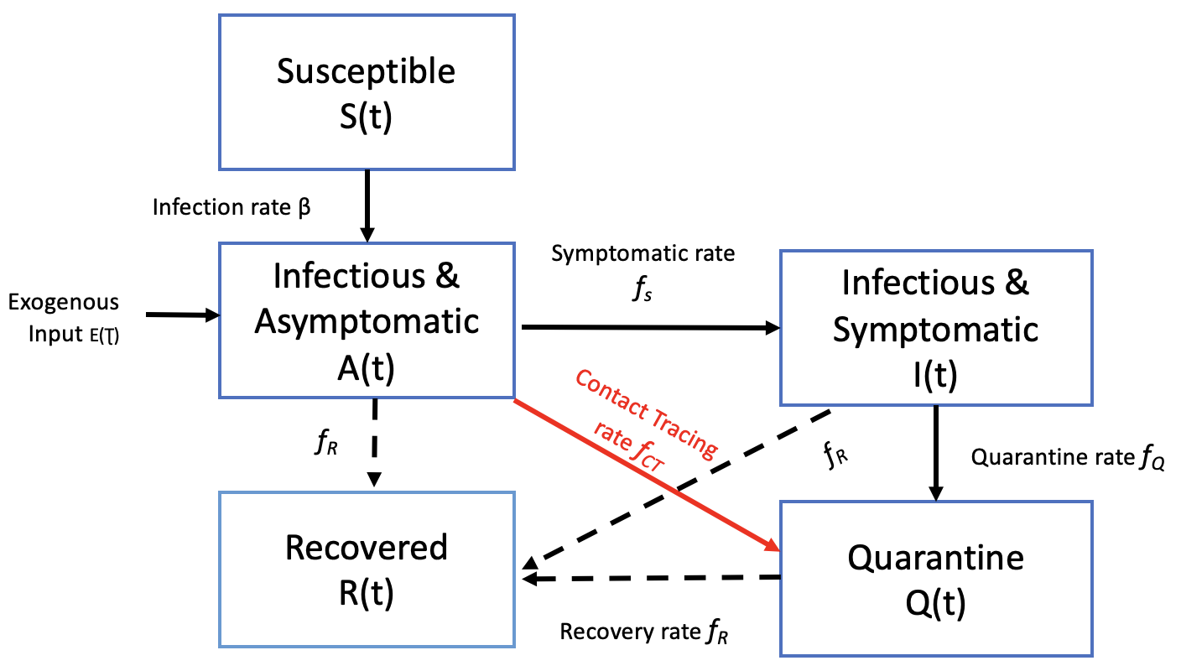
Fig.1: Susceptible (at risk), exposed, infected and recovered model to assess the impact of the Bluetooth low emission contact tracing on managing close contacts in hospital settings (adapted from Brown RA, Proc Natl Acad Sci U S A. 2021⁷)

Patients move from the susceptible state if infected at the infection rate β. The positive cases are considered to be exogenous, introduced from the community E(τ). Transition between states occurs at specified rates. Contact tracing will move individuals from the asymptomatic and presymptomatic state directly to quarantine. Then individuals may move transition to recovered after completing quarantine or if testing negative on confirmatory testing.

Equations for the SEIR model:
- $\frac{\text{ds}}{\text{dt}}\text{= -βSA- βSI-ES}$
- $\frac{\text{dA}}{\text{dt}}\text{=βSA+ βSI-} {\text{f}}_{\text{s}}\text{A-} {\text{f}}_{\text{R}}\text{A-} {\text{sf}}_{\text{CT}}\text{A+ES}$
- $\frac{\text{dI}}{\text{dt}}\text{=} {\text{f}}_{\text{S}}\text{A-} {\text{f}}_{\text{R}}\text{I-} {\text{f}}_{\text{Q}}\text{I}$
- $\frac{\text{dQ}}{\text{dt}}\text{=} {\text{f}}_{\text{Q}}\text{I+} {\text{sf}}_{\text{CT}}\text{A-} {\text{f}}_{\text{R}}\text{Q}$
- $\frac{\text{dR}}{\text{dt}}\text{=} {\text{f}}_{\text{R}}\text{Q+} {\text{f}}_{\text{R}}\text{I+}{\text{f}}_{\text{R}}\text{A=} {\text{f}}_{\text{R}}\left(\text{Q+I+A}\right)$
- $\text{I}\left(\text{t}\right)\text{≅}\left(\frac{{\text{S}}_{\text{s}}{\text{f}}_{\text{R}}}{{\text{f}}_{\text{Q}}}\right)\text{A}\left(\text{t}\right)\text{≪}\text{A}\left(\text{t}\right)$
- $\frac{\text{dA}}{\text{dt}}\text{=} \frac{{\text{R}}_{\text{0}}}{{\text{T}}_{\text{R}}} \left(\text{1-}\frac{\text{1}}{{\text{R}}_{\text{e}}}\right)\text{A}\left(\text{t}\right)\text{+} {\text{NE}}_{\text{0}}\text{p}\left(\text{t}\right)$
- ${\text{R}}_{\text{e}}\text{≡}\frac{{\text{R}}_{\text{0}}}{\left(\text{1+}{\text{S}}_{\text{S}}\text{+}{\text{sf}}_{\text{CT}}{\text{T}}_{\text{R}}\right)}$
- ${\text{R}}_{\text{e}}^{\text{CT}}\text{≡}\frac{{\text{R}}_{\text{e}}}{\left[\left(\text{1+}{\text{S}}_{\text{s}}\text{+}{\text{sf}}_{\text{CT}}{\text{T}}_{\text{R}}\right)\text{+σ}{\text{N}}_{\text{c}}\left({\text{S}}_{\text{s}}\text{+}{\text{sf}}_{\text{CT}}{\text{T}}_{\text{R}}\right)\right]}$

S=susceptible, A=asymptomatic, I=Infectious, R=recovered
N= total population, N_{c}=number of close contacts, σN_{c}= number of infected close contacts (σ is presumed 1/6), S_{s}=fraction of individuals who become symptomatic within one unit of time and S_{s}f_{R} depicts the transition from asymptomatic to symptomatic
R₀= reproduction number is considered between 1.5-3.5
R_{e}= effective reproduction number
Susceptible HCP may become infected from asymptomatic or symptomatic individuals at an infection rate β. For our model we assumed that the cases are introduced from the community at exogenous rate E(t)

