Supplemental Table
Clinical Scenario | Duration of Transmission-based Precautions
Symptomatic or asymptomatic patient with mild-to-moderate illness and not severely immunosuppressed | 10 days from symptoms or positive test and 24 hours of clinical improvement (if applicable)
Symptomatic inpatients requiring ICU level of care | Until two negative PCR tests or 3 weeks from initial positive test (and 24 hours of clinical improvement) whichever comes first
Symptomatic or asymptomatic patient that is severely immunosuppressed | Until at least two negative PCR tests 5-7 days apart; if PCR tests remain positive greater than 3 weeks from onset of illness, review with Infectious Diseases and Infection Prevention
Supplemental Table. Strategies to determine the duration of transmission-based precautions for COVID-19 infected patients prior to the implementation of a SARS-CoV-2 antigen test-based strategy.
Supplemental Figure
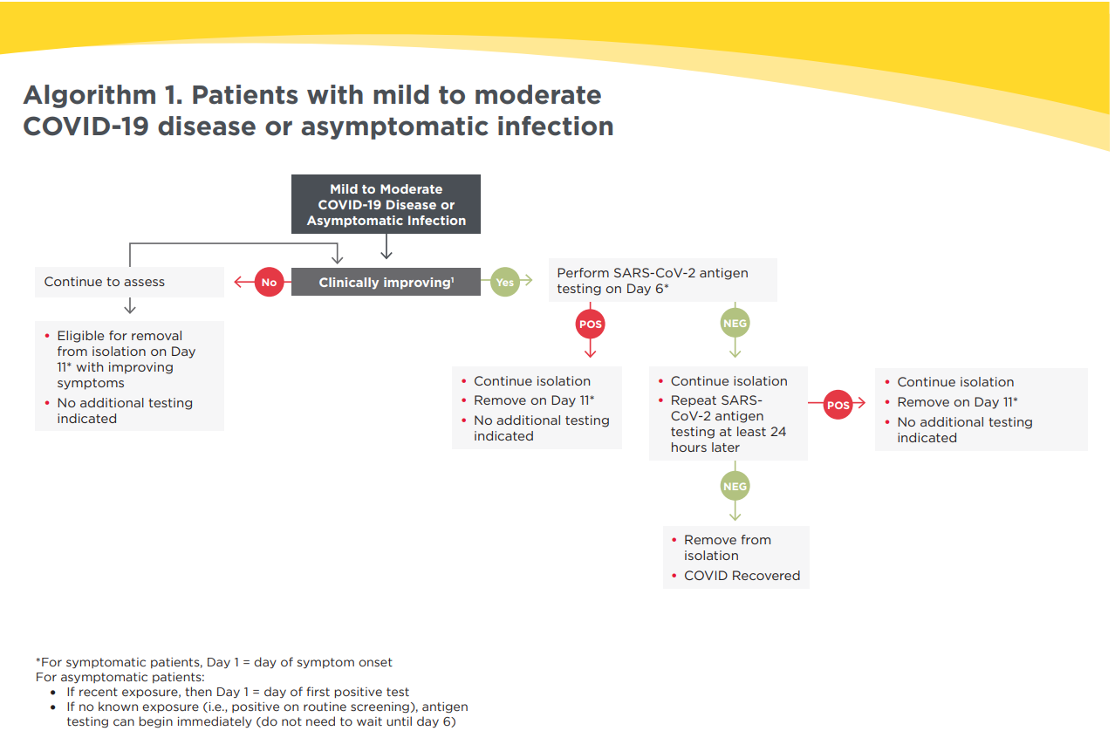
(a)
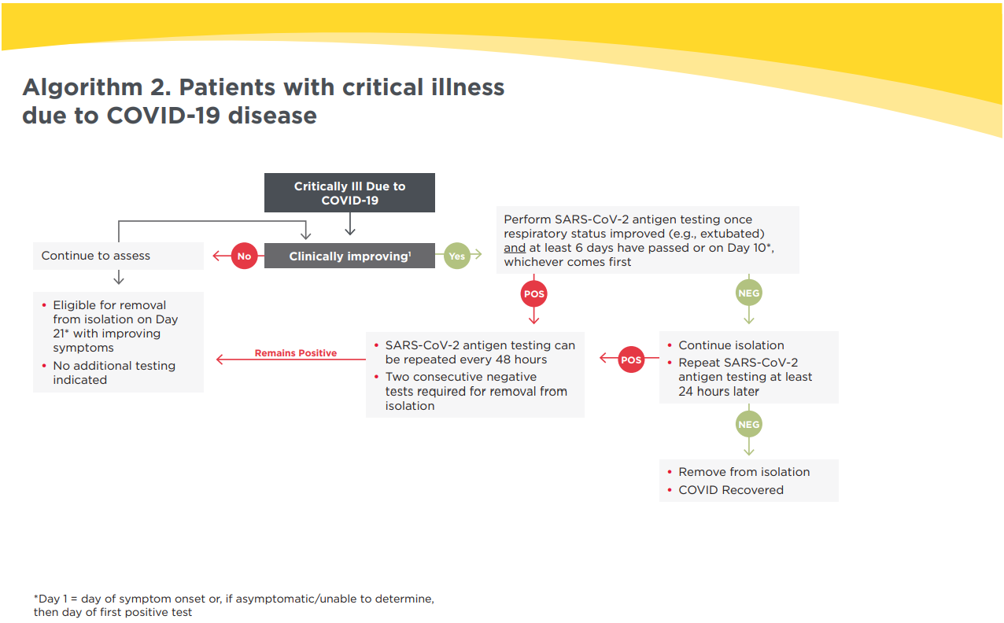
(b)
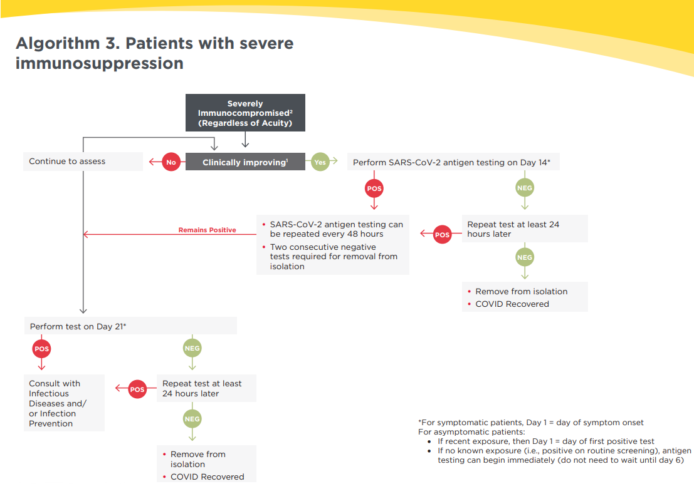
(c)
Supplemental Figure. Decision support algorithms for clinicians to determine the eligibility and timing of SARS-CoV-2 antigen tests to facilitate discontinuation of precautions. Three separate algorithms were created for different clinical scenarios: a) asymptomatic or mild-moderate COVID-19 disease, b) critical illness due to COVID-19, and c) patients with severe immunosuppression. Staff education was developed to ensure that nurses and ordering providers were aware of the availability and process of performing the antigen test-based strategy. These algorithms and other educational materials were distributed via normal hospital communication channels including email, team huddles, and hospital-wide town halls.

