SUPPLEMENTAL MATERIAL
Supplementary Figure 1. Antimicrobial Stewardship Custom Electronic Health Record Smartform.

Supplementary Figure 2. Example iVent Documentation in the Electronic Health Record.
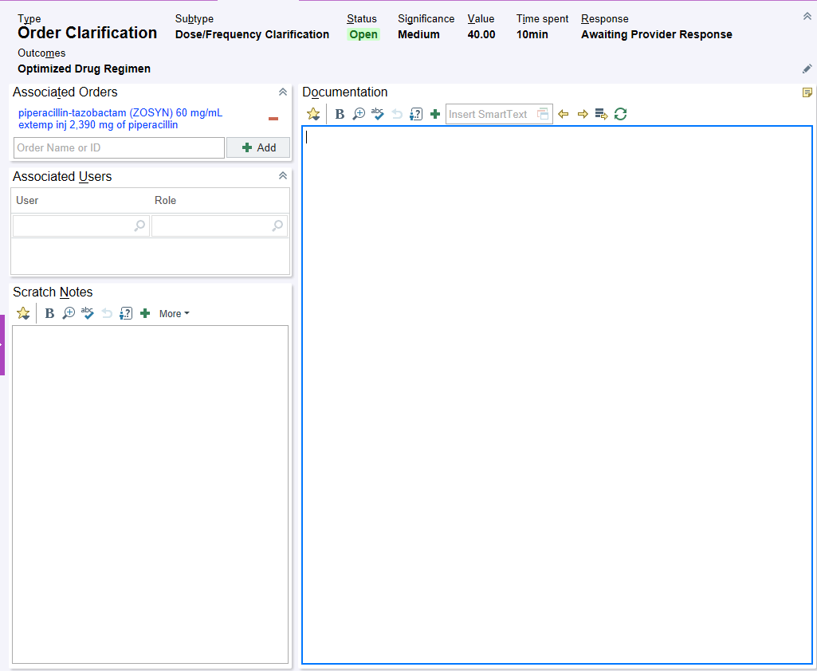
Supplementary Figure 3. Indication-Driven Order Panel in the Electronic Health Record for a) Cefazolin, b) Meropenem, and c) Piperacillin-tazobactam.
a)
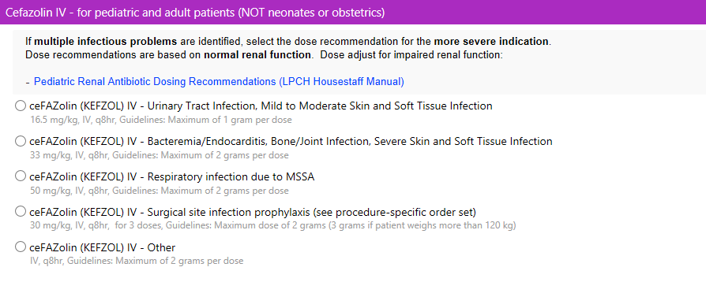
b) 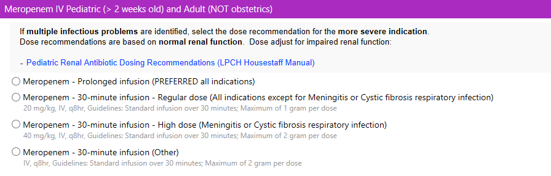c) 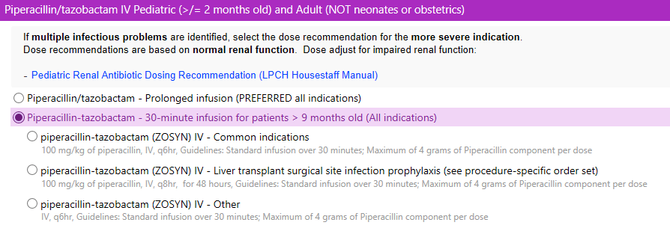
Supplementary Figure 4. Percentage of Prospective Audit with a Recommendation.
Note. The bolded line reflects the mean during the time period. The dashed lines represent the upper and lower control limits during the time period.
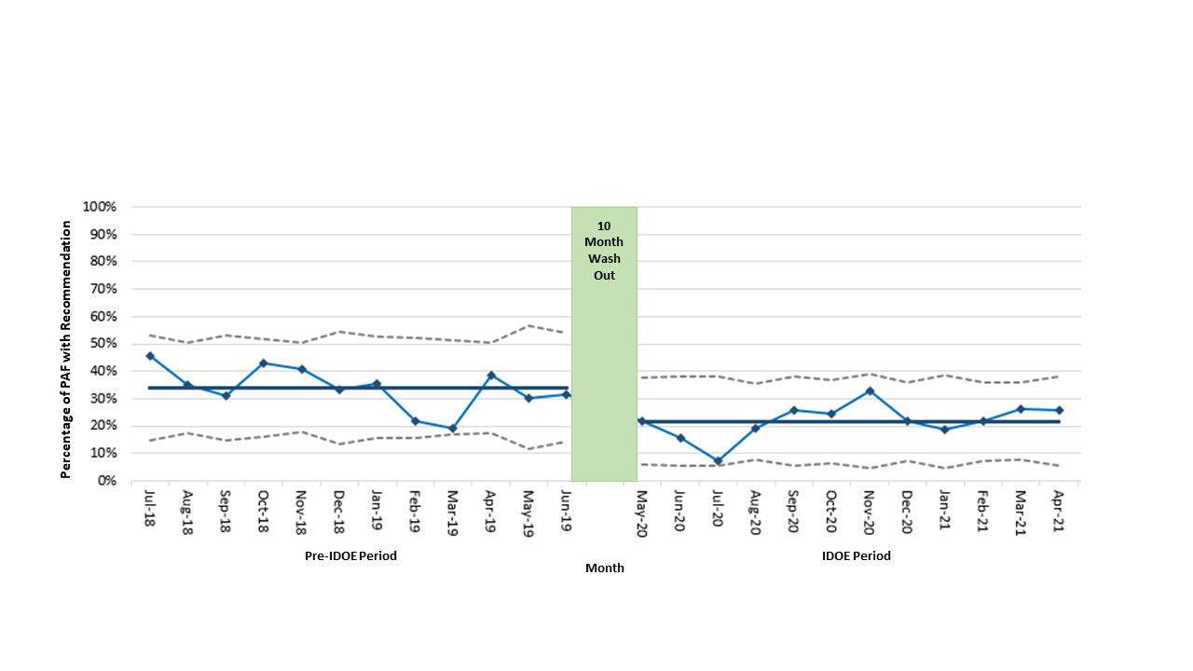

Supplementary Table 1. iVent Type
iVent type
Renal dose adjustment
Dose/frequency
Medication not indicated
Medication indicated
Alternative therapy
Decrease medication frequency
Discontinue medication
IV to PO
Note. IV, intravenous; PO, per os

Supplemental Table 2. Infectious Problems Associated with PAF Recommendations pre-IDOE versus IDOE.
Infectious Problem | Pre-IDOE (N = 246), No. (%) | IDOE (N = 166), No. (%)
Bacteremia | 19 (8) | 12 (7)
Bone and joint infection | 8 (3) | 1 (1)
CNS infection | 2 (1) | 3 (2)
Febrile neutropenia | 13 (5) | 8 (5)
Gastrointestinal/IAI | 32 (13) | 26 (16)
Non identified | 6 (2) | 3 (2)
Other | 19 (8) | 26 (16)
Prophylaxis | 51 (21) | 25 (15)
Respiratory infection | 41 (17) | 32 (19)
Sepsis | 43 (18) | 25 (15)
Urinary tract infection | 12 (5) | 5 (3)
Note. CNS, central nervous system; IAI, intra-abdominal infection

Supplemental Table 3. PAF Recommendation Types pre-IDOE versus IDOE
Recommendation type | Pre-IDOE  N = 246, No. (%) | IDOE  N = 166, No. (%)
Change agent | 77 (31) | 48 (29)
Clarify | 19 (8) | 20 (12)
Duration modification | 28 (11) | 22 (13)
IV to PO | 25 (10) | 8 (5)
Optimize dose or frequency | 26 (11) | 15 (9)
Other | 36 (15) | 20 (12)
Stop | 35 (14) | 33 (20)
Note. IDOE, indication-driven order entry; IV, intravenous; PO, per os

