Supplementary Materials

Treated, hospital-onset Clostridiodes difficile infection: an evaluation of predictors and feasibility of benchmarking comparing two risk-adjusted models among 265 hospitals
Kalvin C. Yu MD¹, Gang Ye PhD¹, Jonathan R. Edwards MStat², Raymund Dantes MD, MPH^{2,3}, Vikas Gupta PharmD¹, ChinEn Ai MPH¹, Kristina Betz MD PhD², Andrea L. Benin MD²
¹Becton, Dickinson and Company, 1 Becton Drive, Franklin Lakes, New Jersey, USA
²Centers for Disease Control and Prevention, Atlanta, Georgia, USA
³Emory University School of Medicine, Atlanta, Georgia, USA

Supplementary Table S1. Regression Coefficients and Standard Errors for the Simple Model.
Parameter | Regression Coefficient (In Logarithm Scale) | Standard Error
Intercept | -4.450 | 0.137
Year
2015 | 0.366 | 0.079
2016 | 0.403 | 0.059
2017 | 0.354 | 0.058
2018 | 0.218 | 0.058
2019 | 0.046 | 0.058
2020
COCDI prevalence | 1.039 | 0.035
Average LOS | 0.189 | 0.012
Bed size
1-50
51-100 | 0.523 | 0.113
101-200 | 0.586 | 0.107
201-300 | 0.844 | 0.107
301-500 | 0.878 | 0.106
500+ | 0.783 | 0.110
% ICU admissions
< 2nd quartile
3rd quartile | 0.130 | 0.031
4th quartile | 0.169 | 0.032
Not reported | 0.379 | 0.053
% patients aged 41-64 years | 0.005 | 0.002
Urban/rural status
Rural
Urban | 0.083 | 0.028

Note. COCDI, community-onset C. difficile infection; ICU, intensive care unit; LOS, length of stay.

Supplementary Table S2. Regression Coefficients and Standard Errors for the Complex Model.

Parameter | Regression Coefficient (In Logarithm Scale) | Standard Error
Intercept | -3.370 | 0.111
Year
Years other than 2017 and 2018
Year 2017 and 2018 | 0.078 | 0.020
COCDI prevalence
1st quartile
2nd quartile | 0.489 | 0.037
3rd quartile | 0.847 | 0.037
4th quartile | 1.175 | 0.041
Average LOS
≤ 3rd quartile
4th quartile | 0.106 | 0.026
Bed size
1-50
51-300 | 0.175 | 0.102
301+ | 0.212 | 0.101
HO testing intensity
1st quartile
2nd quartile | 0.371 | 0.043
3rd quartile | 0.516 | 0.045
4th quartile | 0.709 | 0.048
CO testing intensity
1st quartile
2nd quartile | -0.136 | 0.028
3rd quartile | -0.223 | 0.030
4th quartile | -0.349 | 0.035
HO testing prevalence
1st quartile
2nd quartile | 0.227 | 0.043
3rd quartile | 0.403 | 0.043
4th quartile | 0.544 | 0.047
% Females
1st quartile
2nd quartile | -0.088 | 0.027
3rd quartile | -0.077 | 0.029
4th quartile | -0.100 | 0.034
Teaching status (medical school affiliation)
Non-teaching
Teaching | 0.083 | 0.024

Note. CO, community-onset; COCDI, community-onset C. difficile infection; HO, hospital-onset; LOS, length of stay.
Supplementary Figure S1. Goodness-of-fit: Decile Plot of Observed vs Predicted cHT-CDI (HOCDI) events (quarterly average).
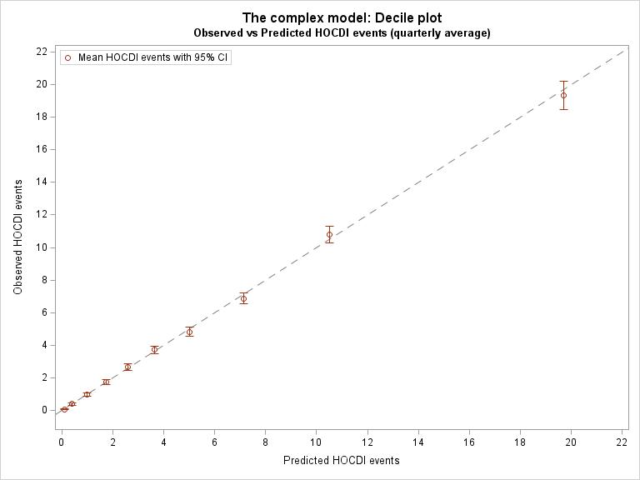
Note: cHT-CDI, candidate definition for healthcare facility-onset, treated C. difficile infection; HOCDI, hospital-onset C. difficile infection).
The decile plot shows no systematic pattern of deviation for the model predicted cHT-CDI events from the ‘perfect fit’ (gray dashline), which indicates a well-specified model (i.e., a model that matches the data).
Supplementary Figure S2. Goodness-of-fit: Observed vs Predicted cHT-CDI Events (HOCDI) (per Quarter).
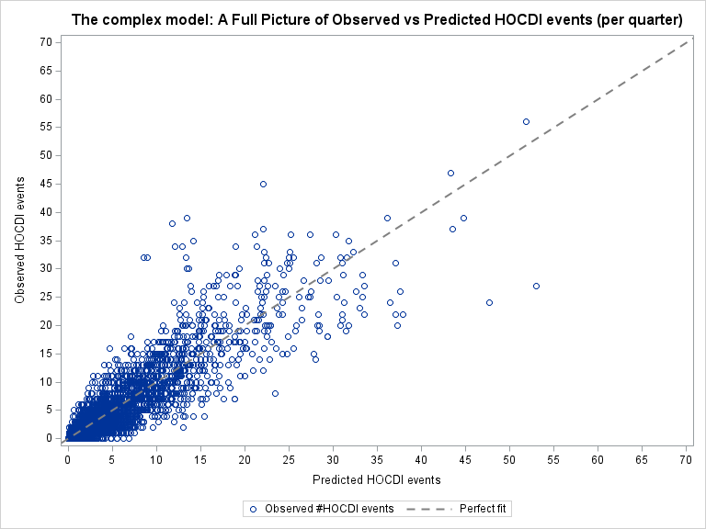
Note: cHT-CDI, candidate definition for healthcare facility-onset, treated C. difficile infection; HOCDI, hospital-onset C. difficile infection.

The random distribution of the scattered points of observed vs predicted events along the ‘perfect fit’ line indicates a well-specified model (i.e., a model that matches the data).

Supplementary Figure S3. Ranking change of hospitals for the top 25 percentile (4th quartile; worst performing) based on unadjusted observed cHT-CDI event rates (blue triangles) compared to the ranking based on the Complex Model SIR (orange diamonds). A more granular breakdown of these hospitals and the rank adjustment after applying Simple and Complex SIR is included in Figure S1.

Note: cHT-CDI, candidate definition for healthcare facility-onset, treated C. difficile infection; SIR, standardized infection ratio.

Among the 50 hospitals ranked in the 4th quartile of the unadjusted (observed) cHT-CDI rate, 19 hospitals (38%) remained in the same ranking category (4th quarter) of model-based (adjusted) SIR and 31 hospitals (62%) improved in ranking when using the Complex Model-based SIR ranking. Specifically, 21 hospitals (42%) improved their ranking to the 3rd quartile; 8 hospitals (16%) improved their ranking to the 2nd quartile; and 2 hospitals (4%) moved to the 1st quartile (from the worst-performing quartile to the best-performing quartile).

