Supplementary Appendix 1. COVID-19 vaccine schemes among 7,051 healthcare personnel (HCP)*

 |  | COVID-19 vaccine first dose N (%)
 |  | CoronaVac | [ChAdOx1] | Janssen | Pfizer/BioNTech
COVID-19 vaccine second dose N (%) | CoronaVac | 3,256 (100) | - | - | -
 | [ChAdOx1] | - | 3,209 (98.7) | - | -
 | Pfizer/BioNTech | - | 41 (1.3) | - | 148 (100)
 | Janssen | - | - | 5 (100) | -

Oxford-AstraZeneca [ChAdOx1]
*392 unvaccinated HCP (5.6%), 6,659 vaccinated HCP (94.4%)
5,124 had one booster and 1,284 had two boosters COVID-19 vaccines

Supplementary Appendix 2. Associated symptoms to the Long COVID
Symptoms | N (%)
Headache - Yes | 1,123 (53.4)
Myalgia or arthralgia | 980 (46.6)
Nasal congestion | 948 (45.1)
Fatigue or tiredness | 744 (35.4)
Fever | 736 (35.0)
Dyspnea | 716 (34.0)
Cough | 602 (28.6)
Sore throat | 592 (28.1)
Diarrhea | 345 (16.4)
Conjunctival congestion | 293 (13.9)
Nausea or vomiting | 238 (11.3)

Supplementary Appendix 3. Flowchart

No Long COVID (n = 5,118)
Long COVID (n = 1,933)
Laboratory confirmed COVID-19 infection
(n = 7,051)

Assessed for eligibility
(n = 18,340)
Excluded (n= 11,289)
♦ No laboratory confirmed COVID-19 test or symptoms

Supplementary Appendix 4. Multivariate analysis of predictors of long COVID.

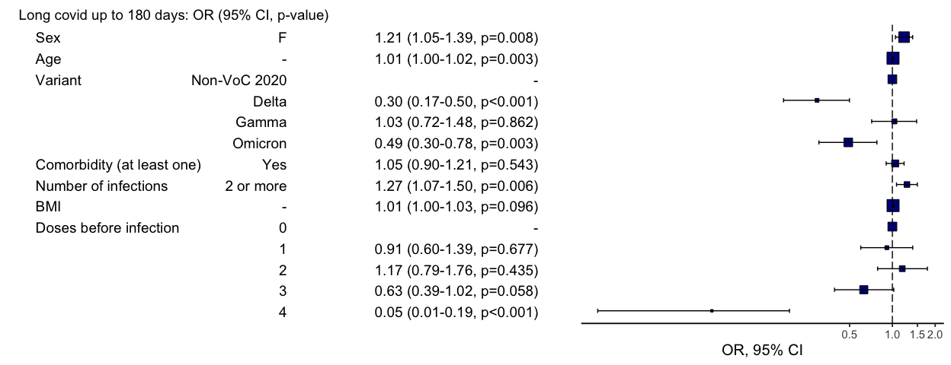

Supplementary Appendix 5. SARS-CoV-2 virus lineages sequenced (n=524)
Lineage | N | % | Agreement with dominant strain* (%)
Alpha | 1 | 0.2 | 0/1 (0)
B.1 | 1 | 0.2 | 1/1 (100)
B.1.1 | 2 | 0.4 | 1/2 (50)
B.1.1.28 | 3 | 0.6 | 1/3 (33)
Delta | 239 | 45.6 | 213/239 (89.1)
Gamma | 109 | 20.8 | 88/109 (80.7)
Omicron | 163 | 31 | 134/163 (82.2)
Zeta | 2 | 0.4 | 0/2 (0)
Inconclusive | 4 | 0.8
Total | 524 | 100.0

*% of agreement between the SARS-CoV-2 virus genomes sequenced with the dominant variant at the time the sample was obtained: 438/518 (84.6%).
.

