SUPPLEMENTARY MATERIALS

Supplementary Table 1. Mixed-effects Poisson regression of completed C.difficile orders to assess interaction of facility with the study intervention
Variable | Multivariable IRR (95% CI) | P-Value
Intervention | 0.84 (0.79 – 0.89) | <0.001
Facility  HUP  PPMC  PAH  CCH  PMPH | 1 (reference)  0.60 (0.42 – 0.85)  0.58 (0.41 -0.81)  0.83 (0.62-1.12)  0.47 (0.31 -0.71) | 0.004  0.002  0.23  <0.001
Interaction (Intervention & Facility)
HUP  PPMC  PAH  CCH  PMPH | 1 (reference)  0.96 (0.84 – 1.10)  1.10 (0.95 -1.26)  0.85 (0.73 -0.89)  0.78 (0.68 – 0.88) | 0.55  0.20  0.02  <0.001
NOTE. HUP, Hospital of the University of Pennsylvania; PPMC, Penn Presbyterian Medical Center; PAH, Pennsylvania Hospital; CCH, Chester County Hospital; PMPH, Penn Medicine Princeton Health. Hospital unit included as a random effect. All other covariates included as fixed effects.
Supplementary Table 2. Mixed-effects Poisson regression of completed C.difficile orders limited to hospitals where patients are cohorted by service line (HUP, PPMC, PAH)
Variable | Multivariable IRR (95% CI) | P-Value
Intervention | 0.82 (0.75 – 0.90) | <0.001
Service line  Medicine  Oncology  Cardiovascular  Surgery  Women’s Health | 1 (reference)  1.60 (1.03 -2.47)  0.80 (0.53 – 1.21)  0.63 (0.42 – 0.94)  0.31 (0.11 – 0.88) | 0.037  0.29  0.024  0.028
Interaction (Intervention & Service Line)
Medicine  Oncology  Cardiovascular  Surgery  Women’s Health | 1 (reference)  0.99 (0.84 – 1.17)  1.05 (0.84 – 1.17)  1.03 (0.91 -1.17)  0.92 (0.84 -1.02) | 0.92  0.43  0.68  0.13
NOTE: Hospital unit included as a random effect. All other covariates included as fixed effects.

Supplementary Figure 1. C.difficile Testing Pathway

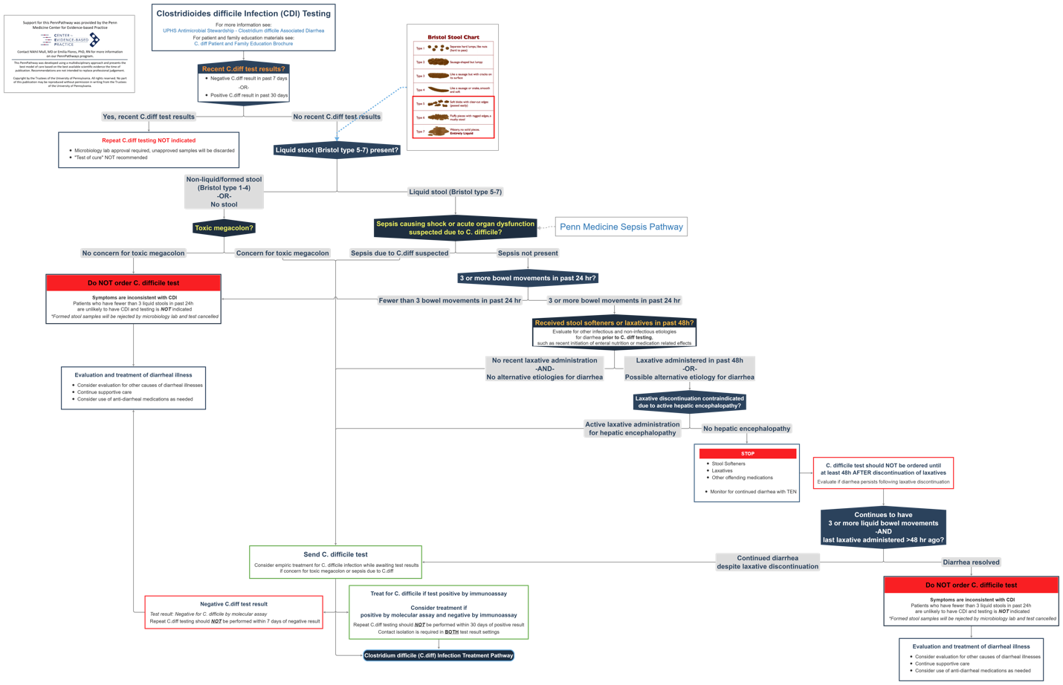

Supplementary Figure 2. Dynamic Order Panel A: Guidance for Recent C.difficile Testing
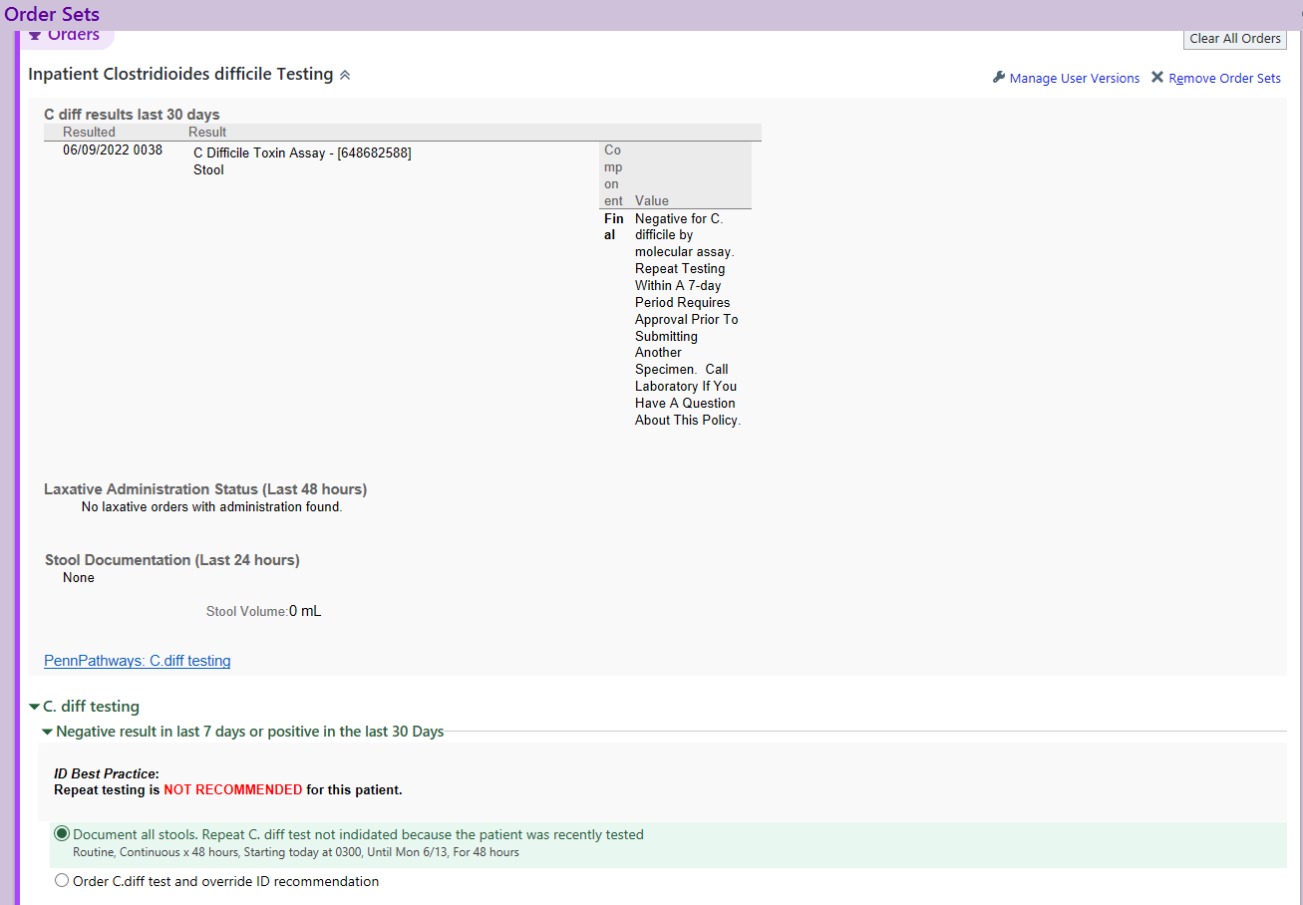

Supplementary Figure 3. Dynamic Order Panel B: Guidance for Recent Laxative Administration
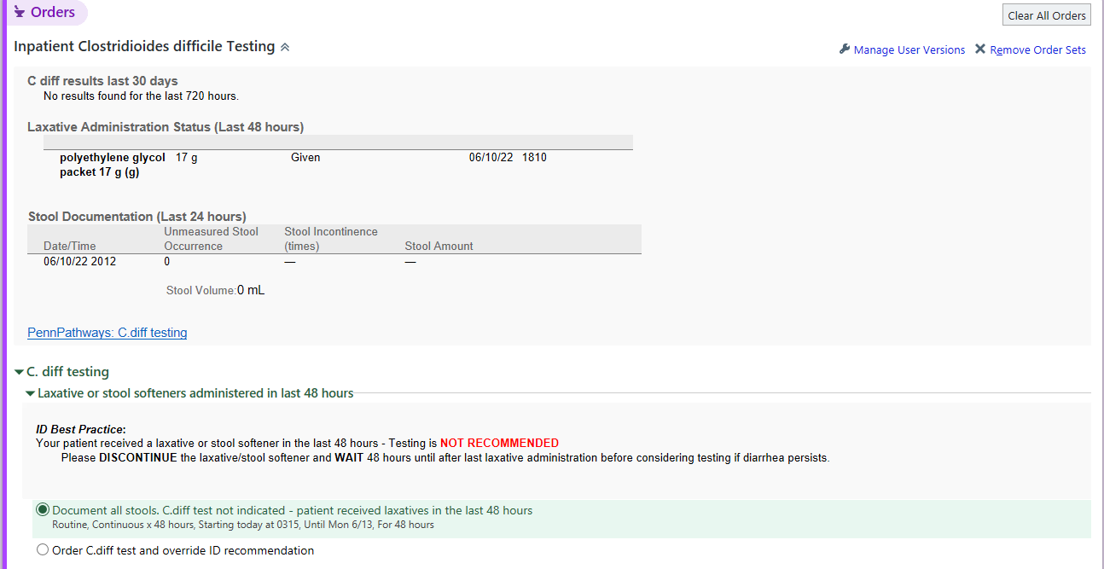
Supplementary Figure 4. Dynamic Order Panel C: Guidance for Inadequate Stool Documentation
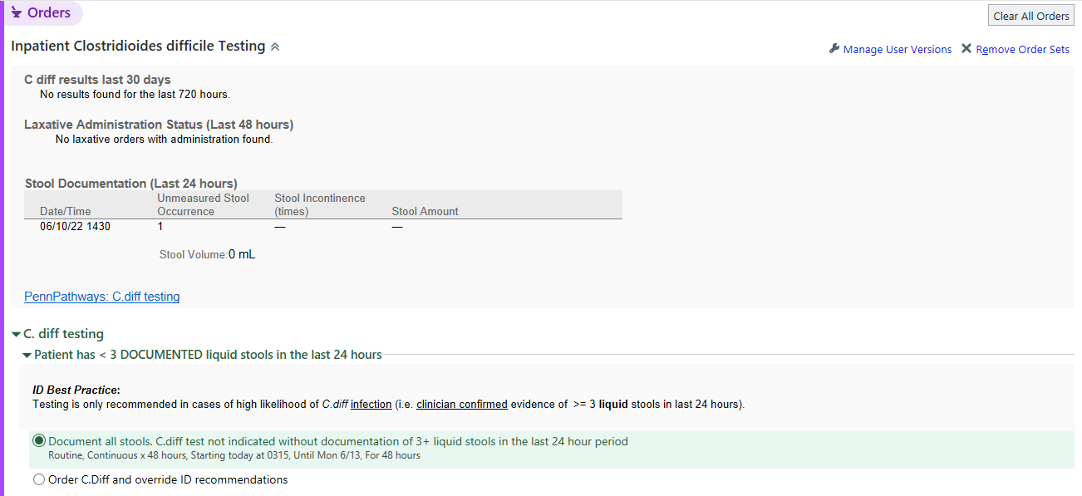

Supplementary Figure 5. Dynamic Order Panel: All Testing Criteria for Testing Fulfilled
