Supplementary Table 1. Comparison of Patients with and without Resistant Infections in the Cleveland Clinic Validation Set
 |  | Resistance to CAP Therapy
Factor | Total  (N=33,814) | No  (N=30,668) | Yes  (N=3,146)
Male | 16,812(49.7) | 15,059(49.1) | 1,753(55.7)
Admitted from SNF/ICF | 1,690(5.0) | 1,483(4.8) | 207(6.6)
Previous admission within 1 year | 11,865(35.1) | 10,412(34.0) | 1,453(46.2)
Resistant organism in previous year | 6,992(20.7) | 5,785(18.9) | 1,207(38.4)
Paralysis | 1,635(4.8) | 1,383(4.5) | 252(8.0)
COPD | 14,818(43.8) | 13,797(45.0) | 1,021(32.5)
Pressure ulcer | 3,022(8.9) | 2,525(8.2) | 497(15.8)
Smoker | 5,559(16.4) | 5,167(16.8) | 392(12.5)
Low functional status/weight loss | 4,278(12.7) | 3,844(12.5) | 434(13.8)
ICU | 13,813(40.8) | 11,984(39.1) | 1,829(58.1)
IMV | 1,685(5.0) | 1,373(4.5) | 312(9.9)
Vasopressor | 3,263(9.6) | 2,658(8.7) | 605(19.2)

Supplementary Figure 1

A.
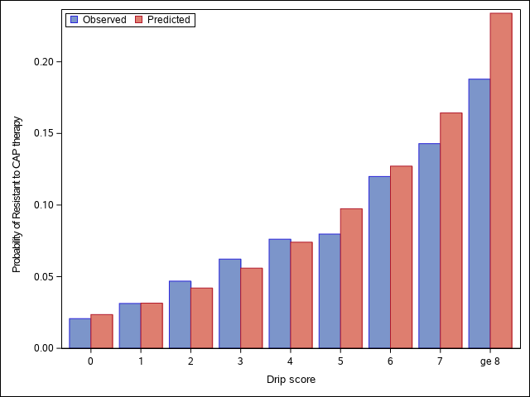
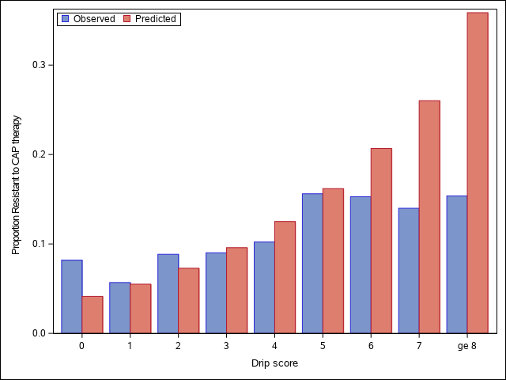
B.

Supplementary Figure 2

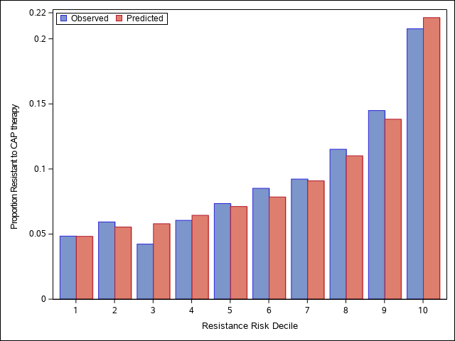
A.

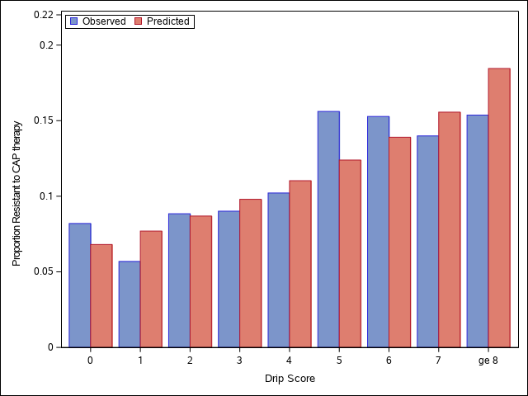
B.

