SUPPLEMENT
Supplemental Table 1. Overall CDI Incidence/100,000 Person-Years by Year and Type of Health Insurance in the MarketScan Population of Younger Persons aged 25-64 Years and in the Medicare Population of Elderly Persons aged 65 Years and Older, 2011-2017 with Incidence Rate Ratios (Medicaid:Commercial, Medicare + Medicaid:Medicare Only)
 | MarketScan Population (25-64 Years) |  |  | Medicare Population (>= 65 Years)
 | Commercial | Medicaid |  | Medicare Only | Medicare + Medicaid
Year | Rate (LCL, UCL) | Rate (LCL, UCL) | IRRª | Rate (LCL, UCL) | Rate (LCL, UCL) | IRR^{b}
2011 | 60.9 (60.0, 61.9) | 183.3 (174.2, 192.9) | 3.0 | 600.7 (586.9, 614.7) | 2,118 (2,056, 2,182) | 3.5
2012 | 67.0 (66.0, 68.0) | 206.9 (199.7, 214.2) | 3.1 | 622.3 (608.4, 636.6) | 2,096 (2,034, 2,160) | 3.4
2013 | 69.4 (68.3, 70.5) | 216.5 (209.7, 223.5) | 3.1 | 613.7 (599.8, 627.8) | 2,020 (1,958, 2,084) | 3.3
2014 | 76.4 (75.2, 77.5) | 210.7 (204.6, 217.0) | 2.8 | 615.6 (601.7, 629.8) | 2,031 (1,968, 2,096) | 3.3
2015 | 84.7 (83.2, 86.2) | 202.1 (196.6, 207.7) | 2.4 | 650.1 (635.8, 664.6) | 1,994 (1,930, 2,060) | 3.1
2016 | 87.9 (86.4, 89.4) | 187.6 (182.5, 192.7) | 2.1 | 639.1 (625.0, 653.4) | 1,791 (1,730, 1,854) | 2.8
2017 | 78.5 (77.0, 80.0) | 167.7 (163.0, 172.4) | 2.1 | 615.0 (601.1, 629.2) | 1,521 (1,464, 1,580) | 2.5
Total | 72.9 (72.5, 73.4) | 194.8 (192.5, 197.0) | 2.7 | 618.14 (612.8, 623.5) | 1,935 (1,912, 1,959) | 3.1

ªIncidence Rate Ratio (Medicaid:Commercial) all P < 0.001
^{b}Incidence Rate Ratio (Medicare + Medicaid:Medicare only) all P < 0.001

Supplemental Table 2. Incidence of Health Care Associated CDI/100,000 Person-Years and Community Associated CDI/100,000 Person-Years by Year and Type of Health Insurance in the MarketScan Population of Younger Persons aged 25-64 Years and in the Medicare Population of Elderly Persons aged 65 Years and Older, 2011-2017 with Incidence Rate Ratios (Medicaid:Commercial, Medicare + Medicaid:Medicare only)
 | MarketScan Population (25-64 Years) |  |  | Medicare Population (>= 65 Years)
 | Commercial | Medicaid |  | Medicare Only | Medicare + Medicaid
Year | Rate (LCL, UCL) | Rate (LCL, UCL) | IRRª | Rate (LCL, UCL) | Rate (LCL, UCL) | IRR^{b}
Health Care Associated CDI
2011 | 25.9 (25.3, 26.5) | 124.0 (116.5, 131.8) | 4.8 | 403.2 (391.9, 414.7) | 1,770 (1,713, 1,829) | 4.4
2012 | 27.0 (26.4, 27.7) | 139.1 (133.2, 145.1) | 5.1 | 397.6 (386.5, 409.0) | 1,718 (1,661, 1,776) | 4.3
2013 | 26.1 (25.4, 26.8) | 137.3 (131.9, 142.9) | 5.3 | 379.4 (368.5, 390.6) | 1,634 (1,578, 1,691) | 4.3
2014 | 28.0 (27.4, 28.7) | 131.9 (127.0, 136.9) | 4.7 | 370.1 (359.3, 381.1) | 1,613 (1,556, 1,671) | 4.4
2015 | 28.1 (27.2, 29.0) | 116.8 (112.6, 121.0) | 4.2 | 368.8 (358.1, 379.8) | 1,563 (1,506, 1,621) | 4.2
2016 | 28.4 (27.5, 29.3) | 106.7 (102.9, 110.6) | 3.8 | 346.1 (335.8, 356.7) | 1,407 (1,353, 1,462) | 4.1
2017 | 24.8 (24.0, 25.7) | 95.2 (91.7, 98.8) | 3.8 | 317.6 (307.6, 327.9) | 1,163 (1,113, 1,214) | 3.7
Community Associated CDI
2011 | 35.0 (34.3, 35.8) | 59.4 (54.3, 64.9) | 1.7 | 197.5 (189.6, 205.6) | 347.5 (322.4, 374.0) | 1.8
2012 | 40.0 (39.2, 40.7) | 67.8 (63.7, 72) | 1.7 | 224.7 (216.3, 233.3) | 378.4 (352.1, 406.2) | 1.7
2013 | 43.3 (42.4, 44.2) | 79.2 (75.1, 83.5) | 1.8 | 234.3 (225.7, 243.1) | 386.2 (359.4, 414.5) | 1.6
2014 | 48.3 (47.4, 49.2) | 78.8 (75.1, 82.7) | 1.6 | 245.5 (236.7, 254.5) | 418.4 (389.9, 448.5) | 1.7
2015 | 56.6 (55.4, 57.8) | 85.3 (81.8, 89.0) | 1.5 | 281.3 (271.9, 290.9) | 431.3 (401.7, 462.4) | 1.5
2016 | 59.5 (58.3, 60.8) | 80.8 (77.6, 84.2) | 1.4 | 293.0 (283.4, 302.7) | 384.6 (356.7, 414.1) | 1.3
2017 | 53.7 (52.5, 54.9) | 72.5 (69.4, 75.6) | 1.4 | 297.4 (287.7, 307.3) | 358.3 (330.9, 387.4) | 1.2

ªIncidence Rate Ratio (Medicaid:Commercial) all P < 0.001
^{b}Incidence Rate Ratio (Medicare + Medicaid:Medicare only) all P < 0.001

Supplemental Table 3. Incidence of Health Care Associated CDI/100,000 Person-Years by Year and Type of Health Insurance (Medicaid vs. Commercially Insured (< 65 Years) or Medicare Only (65+ Years)) in the MarketScan and Medicare Populations, 2011-2017, by Age Group
 | Incidence of Health Care Associated CDI/100,000 PY
 | 2011 |  | 2012 |  | 2013 |  | 2014 |  | 2015 |  | 2016 |  | 2017 |  | % Change 2011-2017ª
Age (years) | No Medicaid | Medicaid | No Medicaid | Medicaid | No Medicaid | Medicaid | No Medicaid | Medicaid | No Medicaid | Medicaid | No Medicaid | Medicaid | No Medicaid | Medicaid | No Medicaid | Medicaid
25-29 | 9 | 35 | 10 | 45 | 10 | 42 | 10 | 43 | 10 | 40 | 11 | 39 | 12 | 33 | 33.3 | -5.7
30-34 | 11 | 40 | 11 | 49 | 10 | 51 | 12 | 58 | 12 | 52 | 12 | 44 | 11 | 41 | 0.0 | 2.5
35-39 | 11 | 61 | 12 | 73 | 12 | 81 | 13 | 75 | 15 | 62 | 15 | 59 | 11 | 54 | 0.0 | -11.5
40-44 | 14 | 91 | 15 | 104 | 14 | 97 | 17 | 91 | 16 | 92 | 16 | 84 | 14 | 72 | 0.0 | -20.9
45-49 | 20 | 156 | 22 | 172 | 21 | 168 | 21 | 160 | 23 | 144 | 23 | 128 | 20 | 132 | 0.0 | -15.4
50-54 | 28 | 260 | 28 | 285 | 28 | 272 | 30 | 259 | 32 | 223 | 31 | 211 | 28 | 178 | 0.0 | -31.5
55-59 | 42 | 377 | 42 | 398 | 40 | 375 | 45 | 313 | 41 | 267 | 44 | 248 | 36 | 229 | -14.3 | -39.3
60-64 | 71 | 392 | 76 | 452 | 70 | 459 | 72 | 408 | 72 | 340 | 65 | 311 | 58 | 265 | -18.3 | -32.4
p^{b} | .004 | <.001 | .005 | <.001 | .004 | <.001 | .003 | <.001 | .003 | <.001 | .002 | <.001 | .003 | <.001
65-69 | 120 | 824 | 132 | 830 | 127 | 933 | 124 | 924 | 140 | 856 | 122 | 832 | 113 | 684 | -5.8 | -17.0
70-74 | 246 | 1,104 | 243 | 1,154 | 227 | 1,123 | 232 | 1,216 | 229 | 1,184 | 239 | 1,154 | 215 | 1,006 | -12.6 | -8.9
75-79 | 394 | 1,701 | 378 | 1,646 | 359 | 1,491 | 358 | 1,618 | 381 | 1,472 | 360 | 1,428 | 339 | 1,152 | -14.0 | -32.3
80-84 | 557 | 2,236 | 587 | 2,196 | 576 | 1,868 | 535 | 1,901 | 524 | 1,958 | 511 | 1,633 | 491 | 1,426 | -11.8 | -36.2
>=85 | 1,029 | 2,988 | 989 | 2,857 | 948 | 2,763 | 951 | 2,526 | 933 | 2,574 | 847 | 2,206 | 778 | 1,773 | -24.4 | -40.7
p^{c} | .012 | .001 | .009 | <.001 | .008 | .009 | .011 | .001 | .011 | .002 | .007 | .002 | .004 | <.001
ªPercentage change in incidence/100,000 PY from 2011 to 2017. Negative numbers represent a decrease in the incidence rate.
^{b}p for trend of CDI incidence with increasing age in the MarketScan population (25-29 to 60-64 years).
^{c}p for trend of CDI incidence with increasing age in the Medicare population (65-69 to >= 85 years).

Supplemental Table 4. Incidence of Community Associated CDI/100,000 Person-Years by Year and Type of Health Insurance (Medicaid vs. Commercially Insured (< 65 Years) or Medicare Only (65+ Years)) in the MarketScan and Medicare Populations, 2011-2017, by Age Group
 | Incidence of Health Care Associated CDI/100,000 PY
 | 2011 |  | 2012 |  | 2013 |  | 2014 |  | 2015 |  | 2016 |  | 2017 |  | % Change 2011-2017ª
Age (years) | No Medicaid | Medicaid | No Medicaid | Medicaid | No Medicaid | Medicaid | No Medicaid | Medicaid | No Medicaid | Medicaid | No Medicaid | Medicaid | No Medicaid | Medicaid | No Medicaid | Medicaid
25-29 | 22 | 24 | 25 | 38 | 30 | 42 | 32 | 39 | 35 | 41 | 40 | 44 | 34 | 37 | 54.5 | 54.2
30-34 | 25 | 44 | 28 | 42 | 30 | 58 | 32 | 54 | 40 | 56 | 40 | 57 | 36 | 52 | 44.0 | 18.2
35-39 | 23 | 36 | 28 | 50 | 31 | 67 | 35 | 60 | 41 | 69 | 46 | 61 | 40 | 61 | 73.9 | 69.4
40-44 | 27 | 66 | 30 | 70 | 32 | 76 | 35 | 90 | 44 | 87 | 49 | 86 | 43 | 75 | 59.3 | 13.6
45-49 | 30 | 66 | 35 | 91 | 37 | 95 | 43 | 102 | 51 | 113 | 54 | 102 | 50 | 92 | 66.7 | 39.4
50-54 | 39 | 109 | 42 | 98 | 47 | 130 | 53 | 115 | 63 | 141 | 64 | 136 | 58 | 102 | 48.7 | -6.4
55-59 | 48 | 118 | 56 | 143 | 59 | 146 | 65 | 146 | 73 | 146 | 79 | 129 | 70 | 125 | 45.8 | 5.9
60-64 | 64 | 135 | 73 | 133 | 77 | 144 | 86 | 138 | 96 | 150 | 94 | 144 | 88 | 137 | 37.5 | 1.5
p^{b} | .002 | <.001 | .002 | <.001 | .003 | <.001 | .002 | <.001 | <.001 | <.001 | .001 | <.001 | <.001 | <.001
65-69 | 103 | 207 | 109 | 238 | 110 | 245 | 136 | 266 | 142 | 316 | 155 | 260 | 153 | 239 | 48.5 | 15.5
70-74 | 157 | 279 | 171 | 353 | 197 | 294 | 209 | 483 | 246 | 349 | 278 | 378 | 280 | 341 | 78.3 | 22.2
75-79 | 203 | 371 | 244 | 370 | 266 | 417 | 277 | 381 | 311 | 567 | 334 | 387 | 314 | 408 | 54.7 | 10.0
80-84 | 262 | 499 | 339 | 482 | 363 | 488 | 309 | 422 | 393 | 495 | 375 | 364 | 425 | 368 | 62.2 | -26.3
>=85 | 359 | 422 | 393 | 476 | 374 | 522 | 421 | 544 | 484 | 493 | 486 | 555 | 496 | 476 | 38.2 | 12.8
p^{c} | .002 | .043 | <.001 | .014 | .003 | .003 | .002 | .151 | <.001 | .152 | .003 | .062 | .001 | .034
ªPercentage change in incidence/100,000 PY from 2011 to 2017. Negative numbers represent a decrease in the incidence rate.
^{b}p for trend of CDI incidence with increasing age in the MarketScan population (25-29 to 60-64 years).
^{c}p for trend of CDI incidence with increasing age in the Medicare population (65-69 to >= 85 years).

Supplemental Table 5. Incidence of CDI Treated During a Hospitalization /100,000 Person-Years by Year and Type of Health Insurance in the MarketScan Population of Younger Persons aged 25-64 Years and in the Medicare Population of Elderly Persons aged 65 Years and Older, 2011-2017 with Incidence Rate Ratios (Medicaid:Commercial, Medicare + Medicaid:Medicare Only)
 | MarketScan Population (25-64 Years) |  |  | Medicare Population (>= 65 Years)
 | Commercial | Medicaid |  | Medicare Only | Medicare + Medicaid
Year | Rate (LCL, UCL) | Rate (LCL, UCL) | IRRª | Rate (LCL, UCL) | Rate (LCL, UCL) | IRR^{b}
2011 | 35.8 (35.0, 36.5) | 151.9 (143.6, 160.6) | 4.2 | 362.9 (352.3, 373.8) | 1,201 (1,154, 1,249) | 3.3
2012 | 37.5 (36.7, 38.2) | 162.6 (156.3, 169.1) | 4.3 | 356.1 (345.5, 366.9) | 1,149 (1,103, 1,197) | 3.2
2013 | 36.9 (36.1, 37.7) | 163.5 (157.5, 169.6) | 4.4 | 348.0 (337.5, 358.6) | 1.087 (1,042, 1,134) | 3.1
2014 | 39.4 (38.6, 40.2) | 156.8 (151.5, 162.2) | 4.0 | 347.9 (337.5, 358.6) | 1,091 (1,045, 1,139) | 3.1
2015 | 40.7 (39.6, 41.7) | 144.7 (140.1, 149.4) | 3.6 | 348.5 (338.1, 359.2) | 1,077 (1,030, 1,126) | 3.1
2016 | 40.6 (39.6, 41.6) | 134.2 (129.9, 138.6) | 3.3 | 323.8 (313.8, 334.0) | 943.7 (899.7, 989.3) | 2.9
2017 | 36.6 (35.6, 37.6) | 116.8 (112.9, 120.8) | 3.2 | 299.2 (289.5, 309.1) | 777.9 (737.3, 820.2) | 2.6

ªIncidence Rate Ratio (Medicaid:Commercial) all P < 0.001
^{b}Incidence Rate Ratio (Medicare + Medicaid:Medicare only) all P < 0.001

Supplemental Figure 1. Percentage of CDI Cases Classified as Healthcare Associated by Year. A. MarketScan Aged 25-64 Years B. Medicare Aged 65 Years and Older

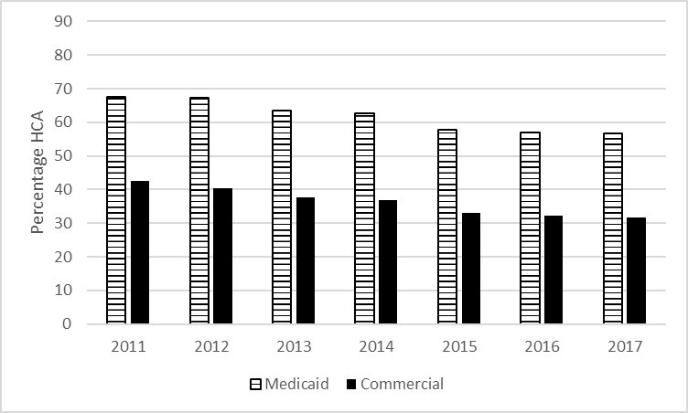

B.
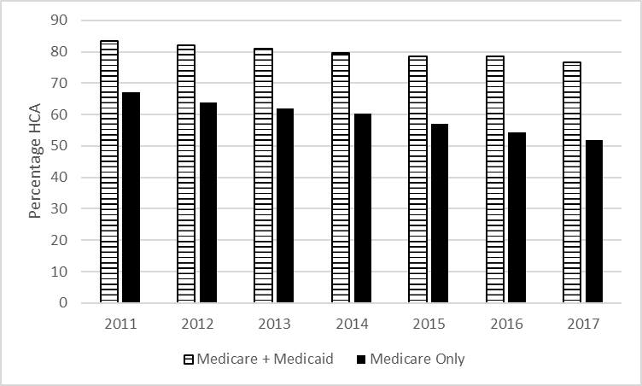

Supplement Figure 2. Rates of CDI Treated During a Hospitalization, 2011-2017
- MarketScan Aged 25-64 Years B. Medicare Aged 65 Years and Older

A.

B.

