Supplemental Material
Figures
Figure 1. Blood Culture Event Type by Age 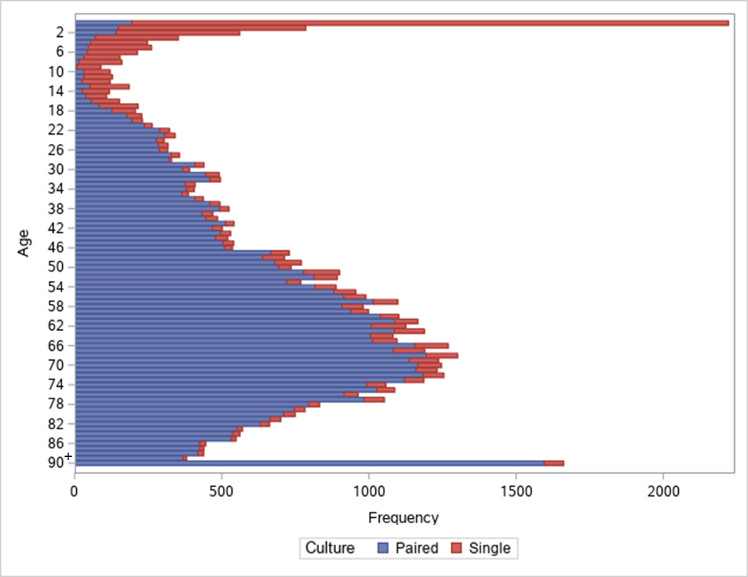
Figure 2. BCUR with Blood Culture Events by Day of the Week

Figure 3. BCUR with Blood Culture Events by Study Month

Tables
Table 1. Hospital Characteristics
N hospitals (%)
N = 6
Inpatient Bed size, median (range) | 373 (247-977)
Medium (150-350) | 3 (50)
Large (351-500) | 1 (17)
Very large (>500) | 2 (33)
Urban-Rural Classification
Rural | 2 (33%)
Urban | 4 (67%)
State
Georgia | 2 (33)
North Carolina | 4 (67)
Hospital Type
Major Academic Medical Center (AMC) | 1 (17)
Teaching, not affiliated with AMC | 1 (17)
Non-teaching | 4 (66)
Oncology unit | 3 (50)
Bone marrow transplant unit | 2 (33)
Overall median hospital Length of stay (IQR) | 2 (1-4)

