**Effecting the Culture: Impact of Changing Urinalysis with Reflex to Culture Criteria on Culture Rates and Outcomes**

Jessica A. Penney MD1, Angie Mae Rodday PhD2, Paola Sebastiani PhD2, David R. Snydman MD1, Shira Doron MD1

1 Division of Geographic Medicine and Infectious Disease, Tufts Medical Center, Boston, Massachusetts, United States

2 Institute for Clinical Research and Health Policy Studies, Tufts Medical Center, Boston, Massachusetts, United States

Urine tests

N = 17,220

3,707 tests excluded (multiple tests sent during admission)

Urine tests, first test from admission

N = 13,513

697 tests excluded for patients <18 years

Adult urine tests

N = 12,816

1,494 tests excluded for tests ordered as isolated urine culture

Adult urine tests

N = 11,322

**Figure 1: Data Selection for Urinalysis with Reflex Culture (UARC) Study Inclusion.**

Figure demonstrates the selection process to determine testing eligible for study inclusion and analysis.

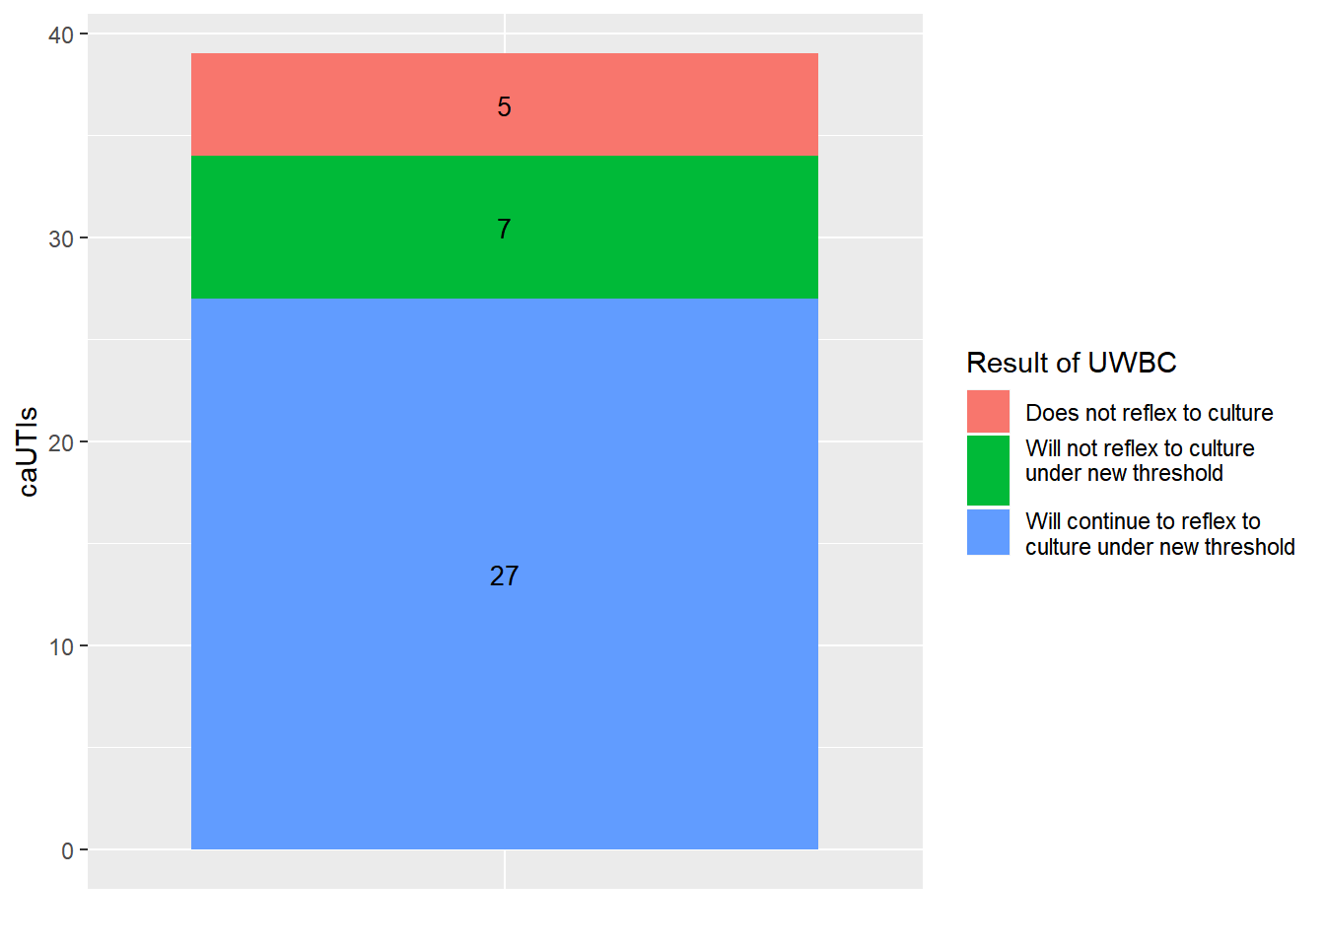

**Figure 2: Impact of Changing UARC Reflex Criterion to >15WBC on Institutional Catheter Associated Urinary Tract Infection (CAUTI) rates**

Figure demonstrates the impact of the proposed UARC criterion change to >15WBC on CAUTI diagnoses.

**Summary of pre-intervention analysis**: Poisson regression analysis was performed on institutional urine testing data from 2018. During this one-year period 7,549 UARC were performed and included in the analysis to evaluate the potential future impact of changing the reflex criterion to either >10WBC or >15WBC. The analysis concluded that if the criterion was changed to >10WBC, 3,633 UARC would have reflexed to culture, compared to 3,057 UARC if changed to >15WBC. This correlated to a 51.9% and 64% decrease in cultures reflexed from UARC, respectively. Because of the implication of this potential change on public reporting of CAUTIs, the analysis then focused specifically on the impact of this intervention on institutional CAUTI diagnoses. In 2018, there were 43 institutional CAUTIs diagnosed by culture that reflexed from UARC. The analysis found that 12 of the 43 UARCs would not have reflexed to culture if the criterion was changed to >15WBC (Supplemental Figure 2). These cases were reviewed by an infectious disease specialist, and 11 of those 12 patients were deemed with reasonable certainty to not have a urinary tract infection based on review of clinical data in the electronic medical record. The final patient was deemed to have a possible urinary tract infection with a fair amount of uncertainty. Limitations of this analysis include that it was performed from data collected over only a one year period of time, and included only a small number of CAUTI cases.

**Table 1: Interrupted Time Series (ITS) Analysis Pre- and Post-Intervention Results with Difference between Periods**

|  |  |  |  |  |  |  |  |  |  |  |  |  |  |  |  |  |  |  |  |  |
| --- | --- | --- | --- | --- | --- | --- | --- | --- | --- | --- | --- | --- | --- | --- | --- | --- | --- | --- | --- | --- |
|  | Pre-Intervention | | | | | | | | | Post-Intervention | | | | | | | Difference1 | | | |
|  | Beta | Exp(beta) | | | | | | | p | Beta | Exp(beta) | | | | | p | | Beta | p | |
| UARC rate (per 1000 patient days) | | | | | | | | | | | | | | | | | | | | |
| *Intercept2* | 3.48 | 32.50 | | | | <0.001 | | | | 2.16 | 8.67 | | | <0.001 | | | | -1.32 | <0.001 | |
| *Slope3* | -0.038 | | | | 0.96 | | | 0.001 | | 0.029 | | 1.029 | | | 0.013 | | | 0.067 | <0.001 | |
| Culture performance4 (%) | | | | | | | | | | | | | | | | | | | | |
| *Intercept* | -0.85 | | | 0.43 | | <0.001 | | | | -1.63 | | 0.20 | | <0.001 | | | | -0.78 | <0.001 | |
| *Slope* | -0.010 | | | | 0.99 | | | 0.13 | | 0.004 | | 1.04 | | | 0.60 | | | 0.015 | 0.17 | |
| Culture positivity5 (%) | | | | | | | | | | | | | | | | | | | | |
| *Intercept* | -1.06 | | 0.35 | | | <0.001 | | | | -0.48 | | 0.62 | | | 0.023 | | | 0.58 | 0.01 | |
| *Slope* | -0.009 | | | | 0.99 | | | 0.47 | | -0.012 | | | 0.99 | | 0.31 | | | -0.003 | | 0.87 |
| Antibiotic Prescription Rate (per 1000 patient days) | | | | | | | | | | | | | | | | | | | | |
| *Intercept* | 3.02 | 20.54 | | | | <0.001 | | | | 2.65 | 14.15 | | | <0.001 | | | | -0.37 | 0.047 | |
| *Slope* | -0.036 | | | | 0.96 | | <0.001 | | | 0.001 | | | 1.001 | | | 0.89 | | 0.038 | 0.009 | |
| CAUTI Rate (per 1000 urinary catheter days) | | | | | | | | | | | | | | | | | | | | |
| *Intercept* | 0.99 | 2.68 | | | | | | 0.022 | | -0.58 | | 0.56 | | | 0.68 | | | -1.57 | 0.29 | |
| *Slope* | -0.11 | | 0.90 | | | | | 0.15 | | 0.027 | | 1.03 | | | 0.72 | | | 0.14 | 0.20 | |
| 1 Difference calculated as post-intervention minus pre-intervention beta  2 Intercept represents rate at start of pre- and post-intervention period, respectively  3 Slope represents pre-and post-intervention trend, respectively  4 Culture performance measured as cultures reflexed from UARC/UARC ordered  5 Culture positivity measured as culture positive for organisms/culture reflexed from UARC | | | | | | | | | | | | | | | | | | | | |

**Table 2: Timing of Antimicrobial Prescription Relative to Urine Testing**

|  |  |
| --- | --- |
|  | NO (%) |
| Timing of Initiation Antimicrobial Therapy1 | **N = 82** |
| Prior to Urine Testing | 18 (22) |
| At the Time of Urine Testing | 47 (57) |
| After Urine Testing | 17 (21) |
| 1 Timing of initiation of antimicrobial therapy was determined by assessment of testing date and antimicrobial prescription start date as provided by pharmacy database | |

**Table 3: Sensitivity Interrupted Time Series (ITS) Analysis Removing COVID-19 Impacted Months**

|  |  |  |  |  |  |  |  |  |  |  |  |  |  |  |
| --- | --- | --- | --- | --- | --- | --- | --- | --- | --- | --- | --- | --- | --- | --- |
|  | Pre-Intervention | | | | | Post-Intervention | | | | Difference1 | | | | |
|  | Beta | Exp(beta) | | | p | Beta | Exp(beta) | | p | | Beta | | | p |
| UARC rate (per 1000 patient days) | | | | | | | | | | | | | | |
| *Intercept2* | 3.48 | 32.50 | | <0.001 | | 2.14 | 8.47 | <0.001 | | | -1.34 | <0.001 | | |
| *Slope3* | -0.038 | | 0.96 | 0.001 | | 0.029 | 1.029 | 0.012 | | | 0.067 | <0.001 | | |
| Culture performance4 (%) | | | | | | | | | | | | | | |
| *Intercept* | -0.85 | 0.43 | | <0.001 | | -1.63 | 0.20 | <0.001 | | | -0.78 | | <0.001 | |
| *Slope* | -0.010 | | 0.99 | 0.13 | | 0.005 | 1.01 | 0.60 | | | 0.015 | | | 0.17 |
| Culture positivity5 (%) | | | | | | | | | | | | | | |
| *Intercept* | -1.06 | 0.35 | | <0.001 | | -0.43 | 0.65 | 0.04 | | | 0.63 | | | 0.006 |
| *Slope* | -0.009 | | 0.99 | 0.47 | | -0.013 | 0.99 | 0.27 | | | -0.003 | | | 0.82 |
| Antibiotic Prescription Rate (per 1000 patient days) | | | | | | | | | | | | | | |
| *Intercept* | 3.02 | 20.53 | | <0.001 | | 2.62 | 13.78 | <0.001 | | | -0.4 | | | 0.028 |
| *Slope* | -0.036 | | 0.96 | <0.001 | | 0.001 | 1.001 | 0.91 | | | 0.037 | | | 0.006 |
| CAUTI Rate (per 1000 urinary catheter days) | | | | | | | | | | | | | | |
| *Intercept* | 0.99 | 2.68 | | 0.02 | | -0.58 | 0.56 | 0.68 | | | -1.57 | | | 0.29 |
| *Slope* | -0.11 | 0.90 | | 0.15 | | 0.031 | 1.03 | 0.68 | | | 0.14 | | | 0.18 |
| Sensitivity analysis performed by removing March-May 2020  1 Difference calculated as post-intervention minus pre-intervention beta  2 Intercept represents rate at start of pre- and post-intervention period, respectively  3 Slope represents pre-and post-intervention trend, respectively  4 Culture performance measured as cultures reflexed from UARC/UARC ordered  5 Culture positivity measured as culture positive for organisms/culture reflexed from UARC | | | | | | | | | | | | | | |