Supplementary
Supplementary Table 1: Surveillance case definitions and eligibility criteria.
Cerebrospinal fluid shunt surgical site infection CNISP surveillance definition:
Surveillance includes all patients undergoing placement or revision of a cerebrospinal fluid (CSF) shunting device. Those who acquired an infection within 1 year of surgery are included as cases.

CSF shunt-associated surgical site infection case definition:
An internalized CSF shunting device is in place AND a bacterial or fungal pathogen(s) is identified
from the cerebrospinal fluid AND is associated with at least ONE of the following:
- Fever (temperature ≥38º C)
- Neurological signs or symptoms
- Abdominal signs or symptoms
- Signs or symptoms of shunt malfunction or obstruction

Patient Exclusions:
•Patients with transcutaneous or external shunting devices or non-shunting devices (e.g. Ommaya reservoir).
•Patients whose CSF was culture positive (bacterial or fungal) at the time of placement of the shunt.
•Infections in which the device associated with the positive organism was not placed at the hospital where the infection was identified, i.e. the hospital should not report the infection.

Supplemental Figure 1. a. CSF shunt SSI rates by age within 12 months follow-up period, 2009-2018

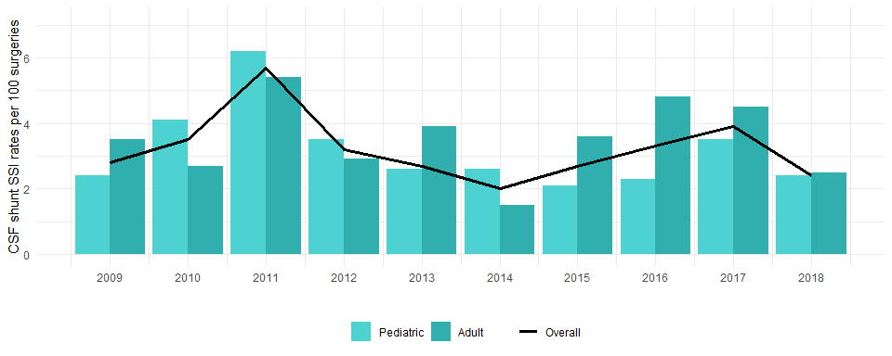

Supplemental Figure 1. b. CSF shunt SSI rates by primary vs. revision surgery within 12 months follow-up period, 2009-2018

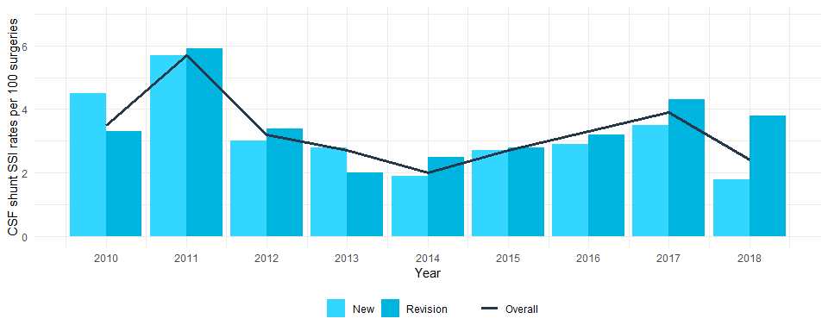

Supplemental Table 2. Patient characteristics of CSF shunt SSI cases by age group, Canada, 2009-2018

 | Adult (n=122) | Ped (n=147) | Total (n=269) | p-value
Age (years)
Mean (SD) | 47.5 (18.9) | 3.8 (5.3) | 23.9 (25.6)
Median (IQR) | 45.7 (29.9, 64.1) | 0.6 (0.2, 6.8) | 13.8 (0.5, 43.3)
Min – Max | 18.9 - 84.8 | 0.0 - 17.9 | 0.0 - 84.8
Sex |  |  |  | 0.077
Female | 72 (59.5%) | 70 (48.6%) | 142 (53.6%)
Male | 49 (40.5%) | 74 (51.4%) | 123 (46.4%)
Median Surgery to onset date (days), (IQR) | 36 (17, 74) | 27 (13, 48) | 29 (14, 64) | 0.035
Pathogens (n=279)ª |  |  |  | 0.013
Gram positive | 115 (90.6%) | 127 (83.6%) | 242 (86.7%)
Coagulase-Negative Staphylococcus sp. | 52 (40.9%) | 62 (40.8%) | 114 (40.9%)
Staphylococcus aureus | 31 (24.4%) | 41 (27.0%) | 72 (25.8%)
Cutibacterium species | 15 (11.8%) | 5 (3.3%) | 20 (7.2%)
Enterococcus faecalis | 6 (4.7%) | 5 (3.3%) | 11 (4.7%)
Other gram positives | 11 (8.7%) | 14 (9.2%) | 25 (9.0%)
Gram negative | 7 (5.5%) | 21 (13.8%) | 28 (10.0%)
Pseudomonas aeruginosa | 4 (3.1%) | 5 (3.3%) | 9 (3.2%)
Escherichia coli | 3 (2.4%) | 5 (3.3%) | 8 (2.9%)
Other Gram negatives | 0 (0.0%) | 11 (7.2%) | 11 (3.9%)
Fungi | 5 (3.9%) | 4 (2.6%) | 9 (3.2%)
Candida species | 3 (2.4%) | 3 (2.0%) | 6 (2.2%)
Other Fungi | 2 (1.5%) | 1 (0.7%) | 3 (1.1%)
Surgery type |  |  |  | 0.155
New placement | 61 (50.4%) | 84 (59.2%) | 145 (55.1%)
Revision | 60 (49.6%) | 58 (40.8%) | 118 (44.9%)
Shunt type |  |  |  | < 0.001
Ventriculo-peritoneal | 106 (90.6%) | 126 (88.7%) | 232 (89.6%)
Lumbo-peritoneal | 8 (6.8%) | 1 (0.7%) | 9 (3.5%)
Ventriculo-atrial | 2 (1.7%) | 1 (0.7%) | 3 (1.2%)
Other | 1 (0.9%) | 14 (9.9%) | 15 (5.8%)
Note: Missing or unknown values were excluded from the analysis.
Abbreviations: ped, pediatric; SD, standard deviation; IQR, interquartile range
a. In some cases, more than one pathogen per patient was included in the analysis

Supplemental Table 3. Patient characteristics of CSF shunt SSI cases for pediatric patients by age group, Canada, 2009-2018

 | Enfants (<one year of age)  (n=79) | Other pediatric patients (1<=year of age<18)  (n=65) | Total (n=144) | p-value
Age (years)
Mean (SD) | 0.3 (0.2) | 8.1 (5.2) | 3.8 (5.3)
Median (IQR) | 0.2 (0.1, 0.4) | 8.3 (3.1, 13.1) | 0.6 (0.2, 6.8)
Min – Max | 0.0 – 0.9 | 1.00 - 17.9 | 0.0 – 17.9
Sex |  |  |  | 0.254
Female | 35 (44.3%) | 35 (53.9%) | 70 (48.6%)
Male | 44 (55.7%) | 30 (46.1%) | 74 (51.4%)
Median Surgery to onset date (days), (IQR) | 23 (12, 49) | 27 (14, 46) | 27 (13, 48) | 0.779
Pathogens (n=152)ª |  |  |  | 0.114
Gram positive | 65 (82.3%) | 62 (84.9%) | 127 (83.6%)
Coagulase-Negative Staphylococcus sp. | 37 (46.8%) | 25 (34.3%) | 62 (40.8%)
Staphylococcus aureus | 15 (19.0%) | 26 (35.6%) | 41 (27.0%)
Cutibacterium species | 1 (1.3%) | 4 (5.5%) | 5 (3.3%)
Enterococcus faecalis | 6 (7.6%) | 1 (1.4%) | 7 (4.6%)
Other gram positives | 6 (7.6%) | 6 (8.2%) | 12 (7.9%)
Gram negative | 12 (15.2%) | 9 (12.3%) | 21 (13.8%)
Pseudomonas aeruginosa | 2 (2.5%) | 3 (4.1%) | 5 (3.3%)
Escherichia coli | 3 (3.8%) | 2 (2.7%) | 5 (3.3%)
Other Gram negatives | 7 (8.9%) | 4 (5.5%) | 11 (7.2%)
Fungi | 2 (2.5%) | 2 (2.8%) | 4 (2.6%)
Candida species | 2 (2.5%) | 1 (1.4%) | 3 (2.0%)
Other Fungi | 0 | 1 (1.4%) | 1 (0.6%)
Note: Missing or unknown values were excluded from the analysis.
Abbreviations: ped, pediatric; SD, standard deviation; IQR, interquartile range
a. In some cases, more than one pathogen per patient was included in the analysis

