Supplement Table 1. Infectious Diseases Society of America Emerging Infections Network adult practice data for survey respondents.
 |  | N (%)
Practice region | New England | 45 (8)
 | Mid Atlantic | 85 (15)
 | East North Central | 81 (14)
 | West North Central | 61 (11)
 | South Atlantic | 104 (18)
 | East South Central | 22 (4)
 | West South Central | 36 (6)
 | Mountain | 25 (4)
 | Pacific | 97 (17)
 | Puerto Rico | 1 (0.2)
 | Canada | 5 (5)
Years of experience since infectious diseases fellowship | < 5 y | 101 (18)
 | 5-14 y | 196 (35)
 | 15-24 y | 86 (15)
 | ≥ 25 y | 178 (32)
Employment | Hospital/clinic | 204 (36)
 | Private/group practice | 140 (25)
 | University/medical school | 198 (35)
 | VA and military | 37 (7)
Primary hospital type | Community | 151 (27)
 | Non-university teaching | 142 (25)
 | University | 198 (35)
 | VA hospital or DOD | 40 (7)
 | City/county | 31 (6)

Supplement Figure 1. ASP improved overall appropriateness of antibiotic prescribing in the last 2 years.
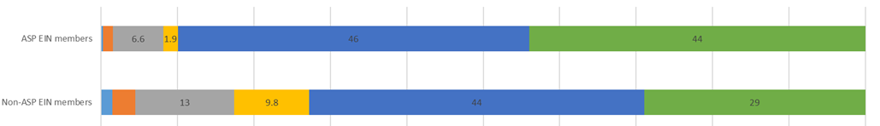
Note. ASP=Antimicrobial Stewardship Program. EIN=Emerging Infection Network. Numeric values represent percentages. Non-displayed values are as follows: 0.26% of ASP and 1.5% of non ASP EIN members strongly disagreed; 1.3% of ASP and 3.0 of non ASP EIN members disagreed. Missing responses=9 responses. P-value < 0.001.
Supplement Figure 2. The stewardship program in my hospital is too focused on reducing antimicrobial costs in a way that may interfere with providing appropriate care.
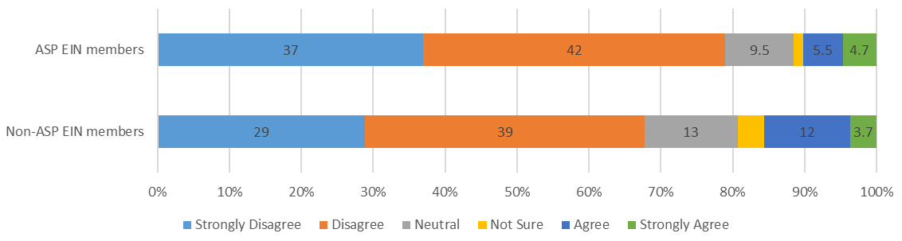
Note. ASP=Antimicrobial Stewardship Program. EIN=Emerging Infection Network. Analysis was restricted to adult EIN members. Numeric values represent percentage of respondents. Non-displayed values are as follows: 1.3% of ASP and 3.7% of non-ASP EIN members were not sure. Missing responses=5. P-value=0.018.

A copy of the disseminated emerging infections network survey is provided below.
EMERGING INFECTIONS NETWORK QUERY
Perspectives on Antimicrobial Stewardship Programs

Name:

1. Does the hospital where you primarily work have an antimicrobial stewardship program (ASP)?
__ Yes __ No, please STOP HERE

2a. Do you participate in this ASP?
__ Yes __ No
2b. If yes, what is your role?
__ Medical Director __ Co/Associate Director __Member of ASP committee __ Other

3. The ASP improved overall appropriateness of antibiotic prescribing in the last 2 years.
__ Strongly agree | __ Agree | __ Neutral | __ Disagree | __ Strongly disagree | __ Not sure

4. The stewardship program at my hospital is too focused on reducing antimicrobial costs in a way that may interfere with providing appropriate care in the last 2 years.
__ Strongly agree | __ Agree | __ Neutral | __ Disagree | __ Strongly disagree | __ Not sure

5. Please indicate your level of concern with the following issues and your facility’s ASP:
Issue | Very  concerned | Somewhat  concerned | Neutral | Not concerned
Unintended consequences of ASP guidance (increased morbidity, readmissions) | __ | __ | __ | __
ASP makes clinical diagnoses and recommendations without “seeing” patients | __ | __ | __ | __
Disagreement in antimicrobial management between ASP and ID consultants | __ | __ | __ | __
ASP decreases efficiency for prescribers | __ | __ | __ | __
ASP delays initiation of antibiotics | __ | __ | __ | __
ASP decreases prescriber autonomy | __ | __ | __ | __
Other issues:

6. ASPs should steward (manage) the antibiotic choices of their ID colleagues.
__ Yes __ No __ Not sure

7. Collectively, the physicians/clinicians in each of these groups at my institution prescribe antibiotics according to ASP principles (e.g. right drug, right dose, right duration at right time)…
 | Strongly  Agree | Agree | Neutral | Disagree | Strongly Disagree | Not sure
Critical care | __ | __ | __ | __ | __ | __
Surgical Specialties | __ | __ | __ | __ | __ | __
Hospitalists | __ | __ | __ | __ | __ | __
Infectious Diseases | __ | __ | __ | __ | __ | __
Oncology | __ | __ | __ | __ | __ | __
Neonatology (for peds) | __ | __ | __ | __ | __ | __
Please answer questions 8-11 only if you participate in your facility’s ASP.
8. Do you think the ASP has changed antibiotic prescribing practices in the following areas?
Area | Greatly improved | Somewhat improved | No impact | Somewhat worsened | Greatly worsened | Not sure
Antibiotic de-escalation | __ | __ | __ | __ | __ | __
Unnecessarily prolonged antibiotic duration | __ | __ | __ | __ | __ | __
Unnecessary surgical prophylaxis | __ | __ | __ | __ | __ | __
Appropriateness of discharge antibiotic prescribing | __ | __ | __ | __ | __ | __
IV to PO conversion | __ | __ | __ | __ | __ | __
Adherence to national guidelines | __ | __ | __ | __ | __ | __

9. Please indicate your level of concern with the following issues and your facility’s ASP:
Issue | Very  concerned | Somewhat  concerned | Neutral | Not concerned
Value not recognized by leadership | __ | __ | __ | __
Lack of support from ID colleagues | __ | __ | __ | __
Funding for physician effort | __ | __ | __ | __
Funding for other (non-MD) resources | __ | __ | __ | __

10. Do you think the ASP has affected any of the following outcomes in your primary institution?
Area | Greatly improved | Somewhat improved | No impact | Somewhat worsened | Greatly worsened | Not sure
Adverse drug events | __ | __ | __ | __ | __ | __
Antibiotic resistance | __ | __ | __ | __ | __ | __
Hospital-onset C. difficile | __ | __ | __ | __ | __ | __
Treatment failures | __ | __ | __ | __ | __ | __

11a. What type(s) of financial support do you receive for your ASP services?
__ No support
__ Percent of my FTE; what percent? ______
__ Contracted service for the hospital; what percent of total compensation is this? _____
__ Other:
11b. Does the financial support you receive reflect the amount of time you spend on stewardship?
__ Yes __ No __ Not sure

12. What future work should be done to improve antimicrobial stewardship programs?

Thank you for completing this survey!

