Appendix
Supplemental Figure 1. Balance plot from propensity model showing effects of inverse weighting with as-treated (ATT) propensity weights.
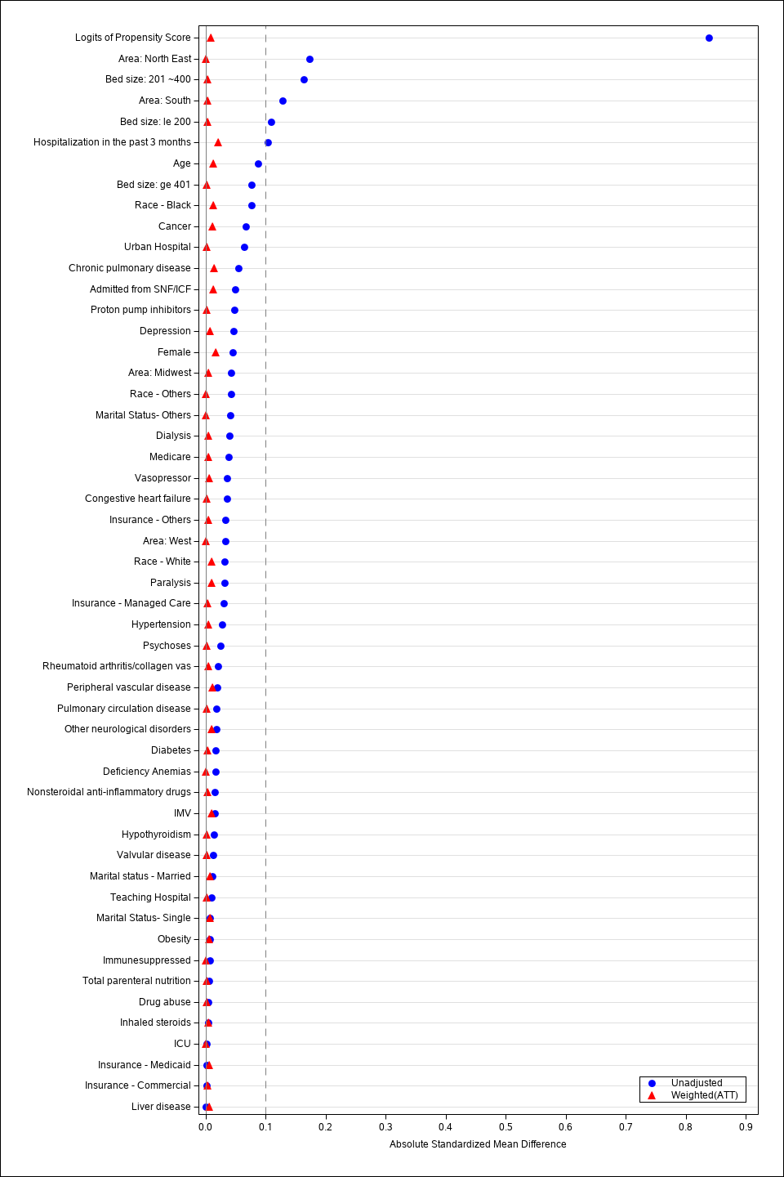
Supplemental Table 1. Resistance profile of the most common organisms in blood and respiratory cultures
Source: | Blood cultures |  | Respiratory cultures
Resistance to: | Macrolides+  cephalosporin | Quinolones | Macrolides+  cephalosporin | Quinolones
Organisms
Overall | 144/1246 (11.6) | 108/1190(9.0) | 496/1467 (33.8) | 258/1349(19.1)
MRSA | 39/46 (84.8) | 33/41(80.5) | 156/175 (89.1) | 105/124(84.7)
MSSA | 11/105 (10.5) | 21/79(26.6) | 29/272 (10.7) | 52/204(25.5)
S pneumoniae | 25/654 (3.8) | 25/786(3.2) | 41/560 (7.3) | 14/569(2.5)
E coli | 28/300 (9.3) | 44/295(14.9) | 26/182 (14.3) | 48/184(26.1)
P aeruginosa | 33/70 (47.1) | 5/59(8.5) | 234/291 (80.4) | 37/285(13.0)
K pneumoniae | 10/80 (12.5) | 2/76(2.6) | 22/128 (17.2) | 9/124(7.3)

Supplemental Table 2: : Clostridioides difficile testing, results, and classification by alternative diagnostic criteria, of patients admitted with pneumonia to hospitals contributing to the Premier Healthcare Database, July 2010-June 2015, and treated empirically with either macrolide + cephalosporin or quinolone tested day 3 or later
177 Premier/SafetySurveillor hospitals | Total (N=58,884) | Marcolides+ce-phalosporins (N=37,358) | Quinolones(N=21,526) | p-value
Positive test and 008.45 ICD9 code or readmit with C.difficile within coming 2 months, No. (%) | 220(0.37) | 143(0.38) | 77(0.36) | 0.63
Positive test or 008.45 ICD9 code or readmit with C.difficile within coming 2 months, No. (%) | 302(0.51) | 199(0.53) | 103(0.48) | 0.38
008.45 ICD9 code only, No. (%) | 169(0.29) | 114(0.31) | 55(0.26) | 0.28

Supplemental Table 3: Clostridioides difficile testing, results, and classification by alternative diagnostic criteria, of patients admitted with pneumonia to hospitals contributing to the Premier Healthcare Database, July 2010-June 2015, and treated empirically with either macrolide + cephalosporin or quinolone tested day 4 or later per 10,000 patient days.
177 Premier/SafetySurveillor hospitals | Total  N=58,060 | Macrolide +  Cephalosporin  (N=36,796) | Quinolones  N=21,264 | p-value
Positive test and 008.45 ICD9 code or readmit with C.difficile within coming 2 months, No. (%) | 6.2 | 6.4 | 5.8 | 0.47
Positive test or 008.45 ICD9 code or readmit with C.difficile within coming 2 months, No. (%) | 8.5 | 8.8 | 7.9 | 0.50
008.45 ICD9 code only, No. (%) | 4.6 | 4.9 | 4.0 | 0.25

