Comparison of Aerosol Mitigation Strategies and Aerosol Persistence in Dental Environments
(SUPPLEMENTARY APPENDIX)

APPENDIX
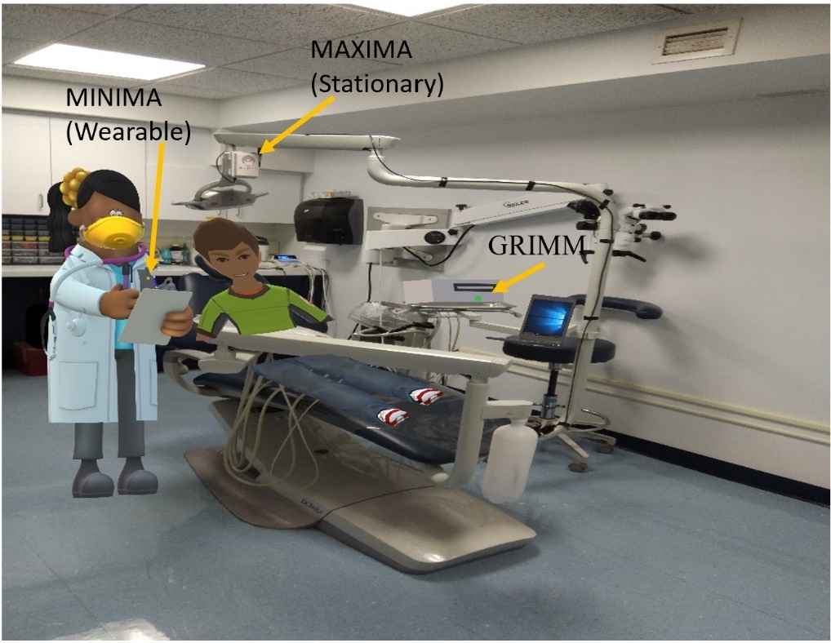
Figure 1. Position of dentist, patient, MAXIMA, MINIMA and GRIMM aerosol detection instruments in the dental setting

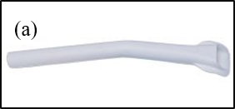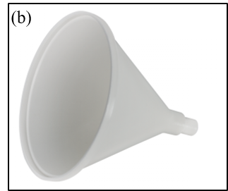
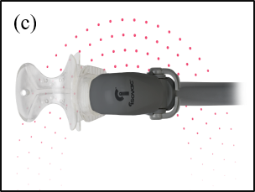
Figure 2 (a) Tip HVE, (b) Conical HVE, (c) Isovac® dental isolation adaptor for use with HVE

Figure 3 Size distribution of the aerosol emissions during operation on anterior and posterior teeth in (a) Orthodontics during use of high speed drill, (b) pediatrics during use of high speed drill, (c) periodontics during use of ultrasonic scalar

