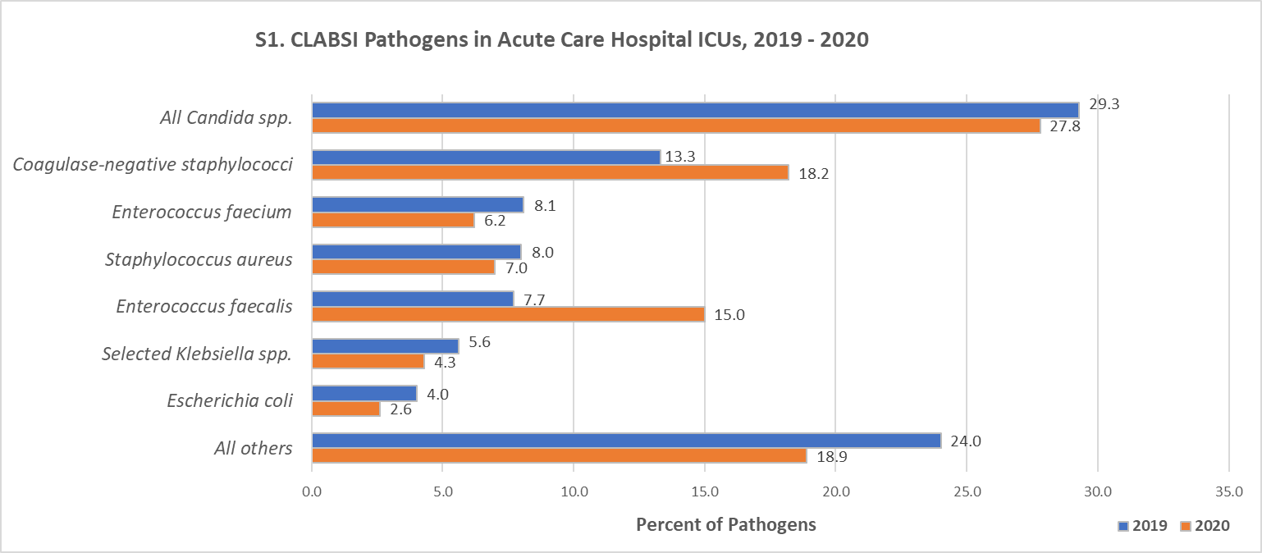
Supplement: Pathogens attributed to central-line associated bloodstream infections in US acute care hospitals during the first year of the COVID-19 pandemic
Note. CLABSI – central line-associated bloodstream infection; ICUs – intensive care units; spp – species;

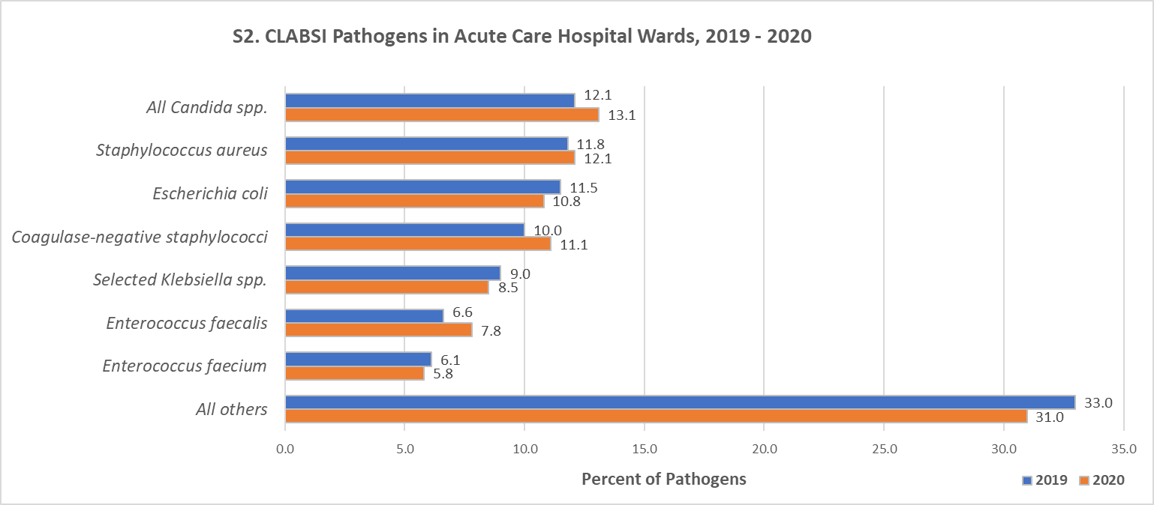
Note. CLABSI – central line-associated bloodstream infection; spp – species;

