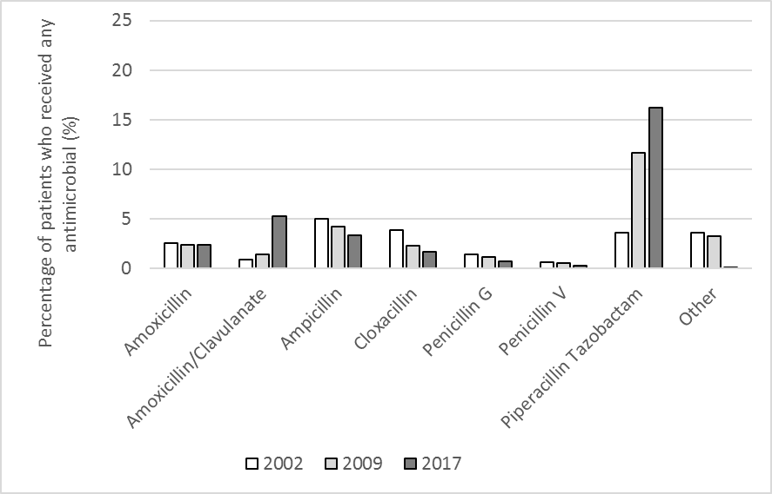

Supplemental Figure 1. Percentage of patients who received specific penicillin or penicillin combination class antibiotics out of all patients who received any antimicrobial agent in 2002, 2009, 2017

